Reflash WiFI-modul with uStepper GUI

- Install the ESP8266 package for Arduino IDE:
https://github.com/esp8266/Arduino
Board file: http://arduino.esp8266.com/stable/package_esp8266com_index.json

- Download and install ArduinoWebSockets (can be downloaded through Arduino IDE) https://github.com/Links2004/arduinoWebSockets

- Download and install the ESP8266 SPIFFS file uploader for Arduino (C:\Program Files (x86)\Arduino\tools): https://github.com/esp8266/arduino-esp8266fs-plugin

- (optional) Connect a USB to TTL converter directly to the WiFi-module (VCC, GND, RX and TX). Open a Serial monitor and set the baud rate to 74880. You should see some boot information if you press the reset button (“right” button, blue arrow)

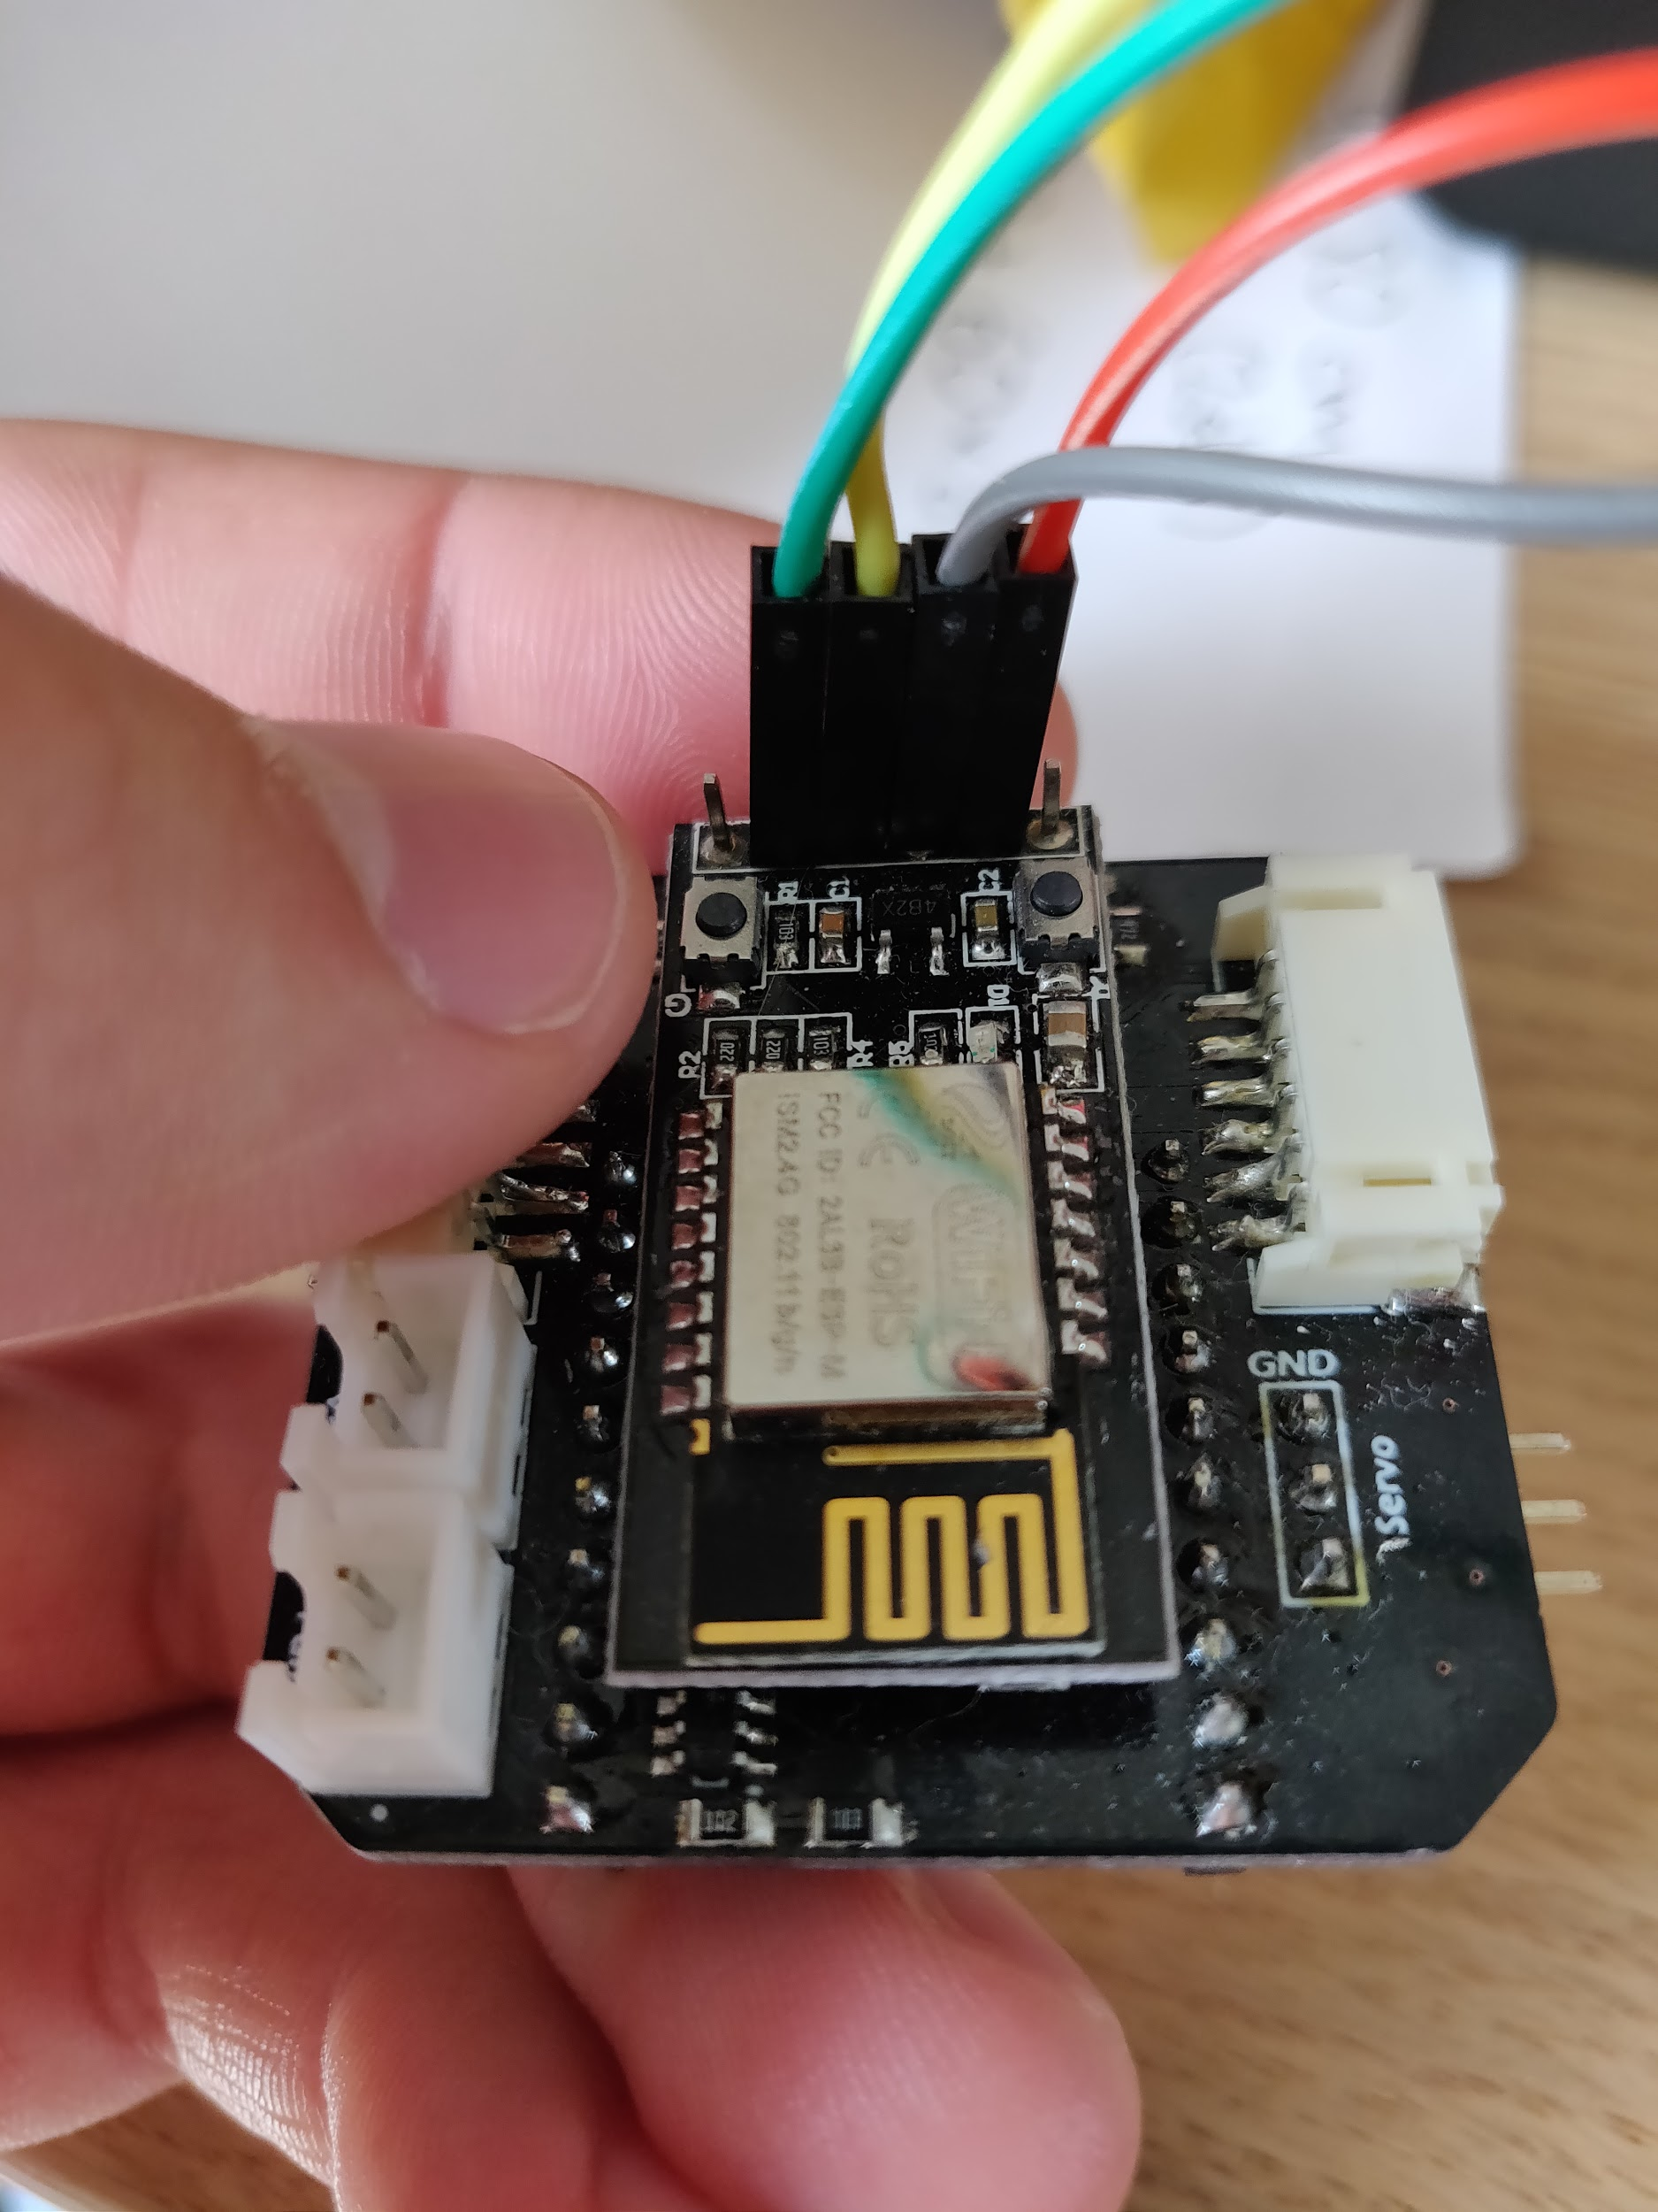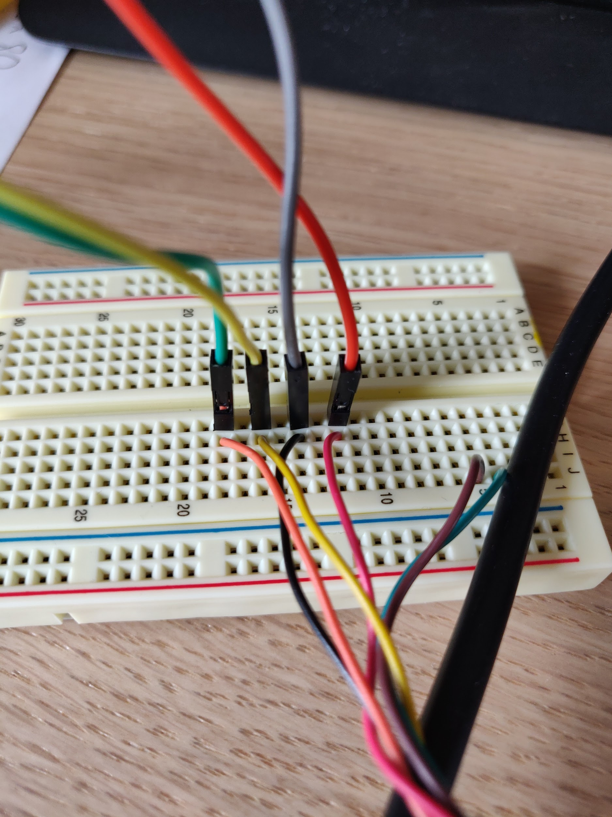

- Now to upload software the board needs to be in flash-mode. To enable flash-mode turn off the power to the module, and repower it while holding down the “left” button (see red arrow). The module can now be programmed.

- Select the board “Generic ESP8285 Module” and set the flash size to “1M (512K SPIFFS)”. Now Hit that upload button!’
