Reflash WiFI-modul with uStepper GUI

- Install the ESP8266 package for Arduino IDE:
https://github.com/esp8266/Arduino
Board file: http://arduino.esp8266.com/stable/package_esp8266com_index.json

- Download and install ArduinoWebSockets (can be downloaded through Arduino IDE) https://github.com/Links2004/arduinoWebSockets

- Download and install WebOTA library manually from:
https://github.com/uStepper/ESP-WebOTA

- Download and install the ESP8266 SPIFFS file uploader for Arduino (C:\Program Files (x86)\Arduino\tools): https://github.com/esp8266/arduino-esp8266fs-plugin

- Connect USB to UART converter as shown below
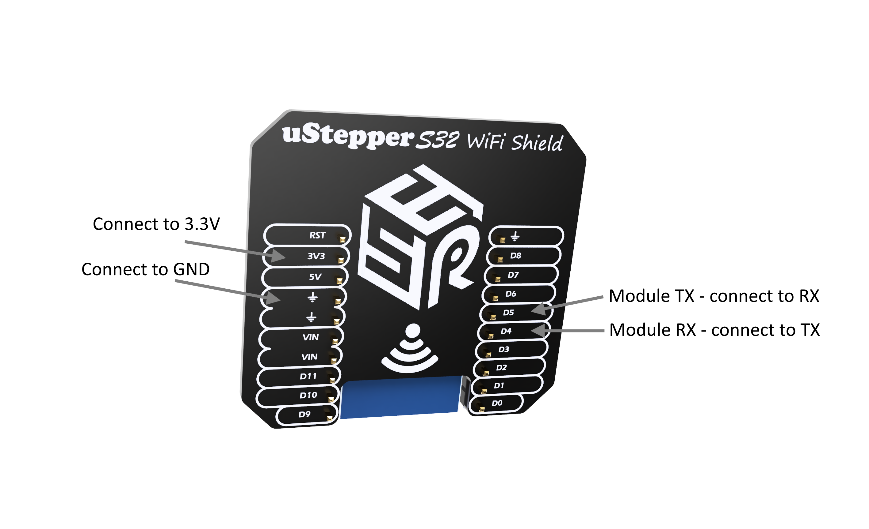
- Now to upload software the board needs to be in flash-mode. To enable flash-mode turn off the power to the module, and repower it while holding down the button located on the module backside. The module can now be programmed.
- Select the board “Generic ESP8266 Module” and set the flash size to “2M (1019K OTA)”. Now Hit that upload button!’
