CRV.Lesson2

Lesson 2 Dust Items Sprite

Mission content

-----------------------------------------------------------------------------------------------------------------------

Create a Dust Item Sprite and move the Cleaning Robot Sprite to the Dust Items Sprite location.

- Set the location of Dust Item sprite sequentially in 8 directions at a distance of 100 from the cleaning robot.

- Move direction and distance to move the cleaning robot sprite to the dust item sprite.

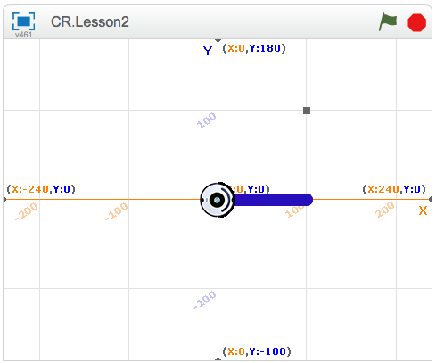

Main Learning Content

-----------------------------------------------------------------------------------------------------------------------

1. Create a new sprite in Paint Using bitmap mode.

2. Display sprite while constantly repositioning.

3. Move the cleaning robot to the specified location.

Usage command block

-----------------------------------------------------------------------------------------------------------------------

Event Category

[ when __ clicked ]

Motion Category

[ go to x:_ y"_ ]

[ point to direction _ ]

[ move _ steps ]

[ turn _ degrees ]

Control Category

[ repeat _ ]

Program Idea

-----------------------------------------------------------------------------------------------------------------------

**Coordinate System Showing Location**

The coordinate system is used to represent the exact position in a certain area. The total screen size is 480x360. The display is divided into x and y axes based on the center position.

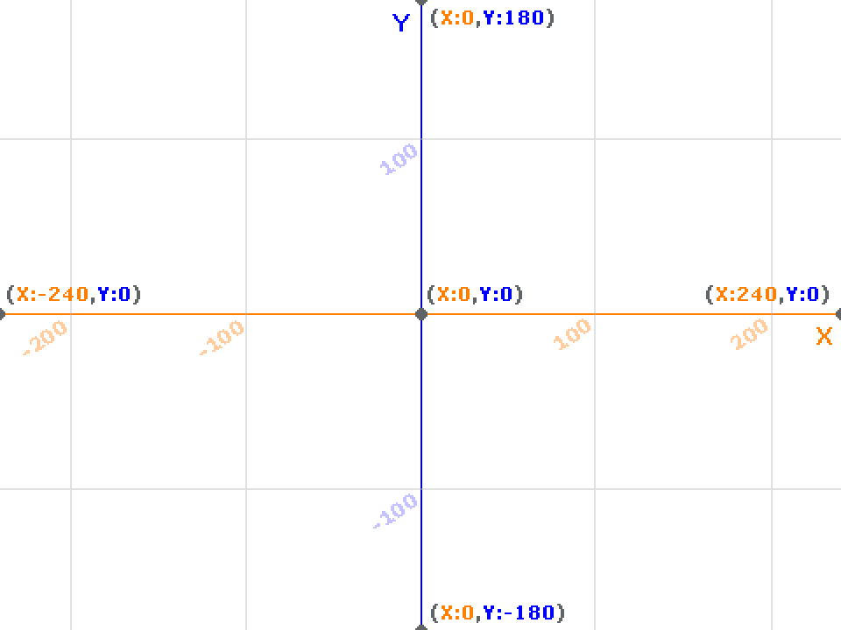

Program coding

-----------------------------------------------------------------------------------------------------------------------

**Dust Item Sprite**

**Making Sprite**

1. Create a new sprite. Select “Paint new Sprite” from the New Sprites menu.

2. Set color and size for drawing.

3. Zoom in the screen so you can draw in pixel unit.

4. Since one grid unit of the basic desktop is 4 Pixels, draw 8x8 size to be 2 grid units

.

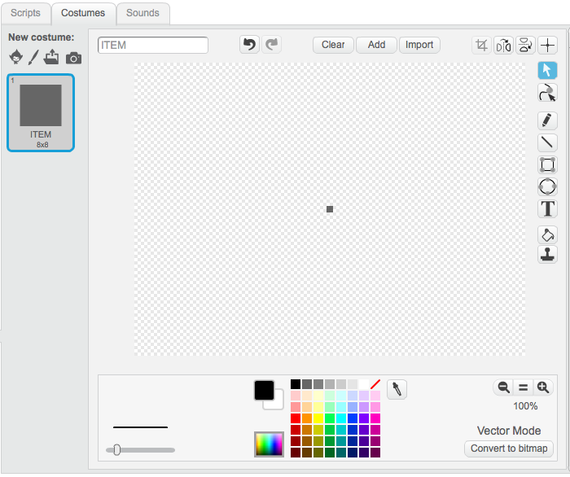

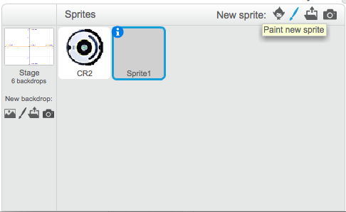

New sprites를 선택하고 Paint new sprites를 클릭 스프라이트 Costume그림판

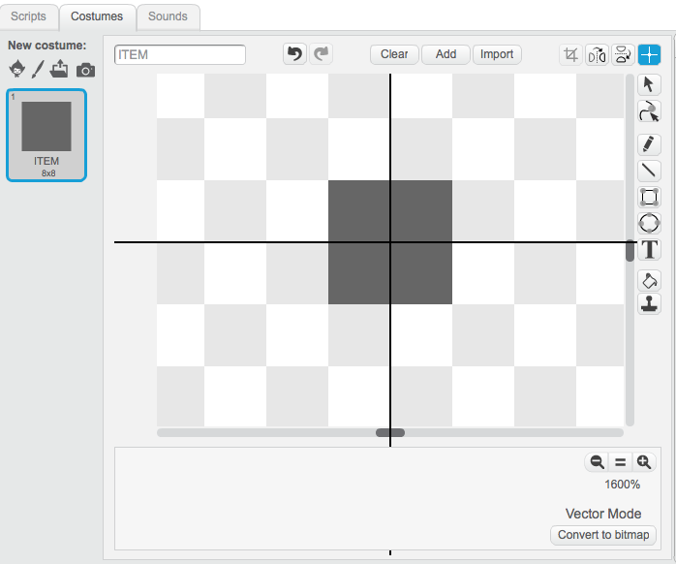

**Starting Sprite**

1. Move to the right position coordinate (100, 0).

2. Wait 5 seconds.

3. Move to the next position (100, 100).

4. Wait 5 seconds.

5. Move to next position (0, 100), (-100, 100), (-100, 0), (-100, -100), (0, -100), (100, -100) Repeat.

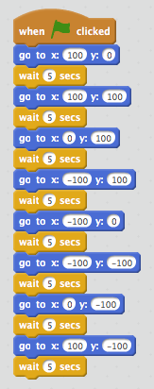

**Cleaning Robot Sprite – CRV - 2**

- When there is a dust item in the horizontal and vertical position

1. Reset the pen.

2. The initial position starts moving immediately without waiting time.

3. Set sprite direction to 90 degrees.

4. Repeat 10 times by 10 so 100 in total.

5. To get back into original position, repeat 10 times by -10.

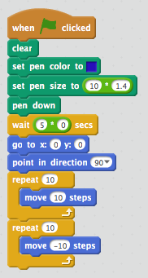

- When there is a dust item in the 45 degree direction

1. Wait for a multiple of 5 seconds in order.

2. Set the sprite direction to 45 degrees.

3. Repeat 10 times 10 times by 10 steps.

4. Repeat 10 times -10 to return to place.

