UTILITY MANAGEMENT SYSTEM
Use Case Diagram | Class Diagram | Sequence Diagrams
Name: Jasika Noor
Student ID: 22CSE002
Course: Software Engineering & System Design
Date: August 30, 2026

1. Use Case Diagram
System boundary and actor interaction model for Utility Management System.
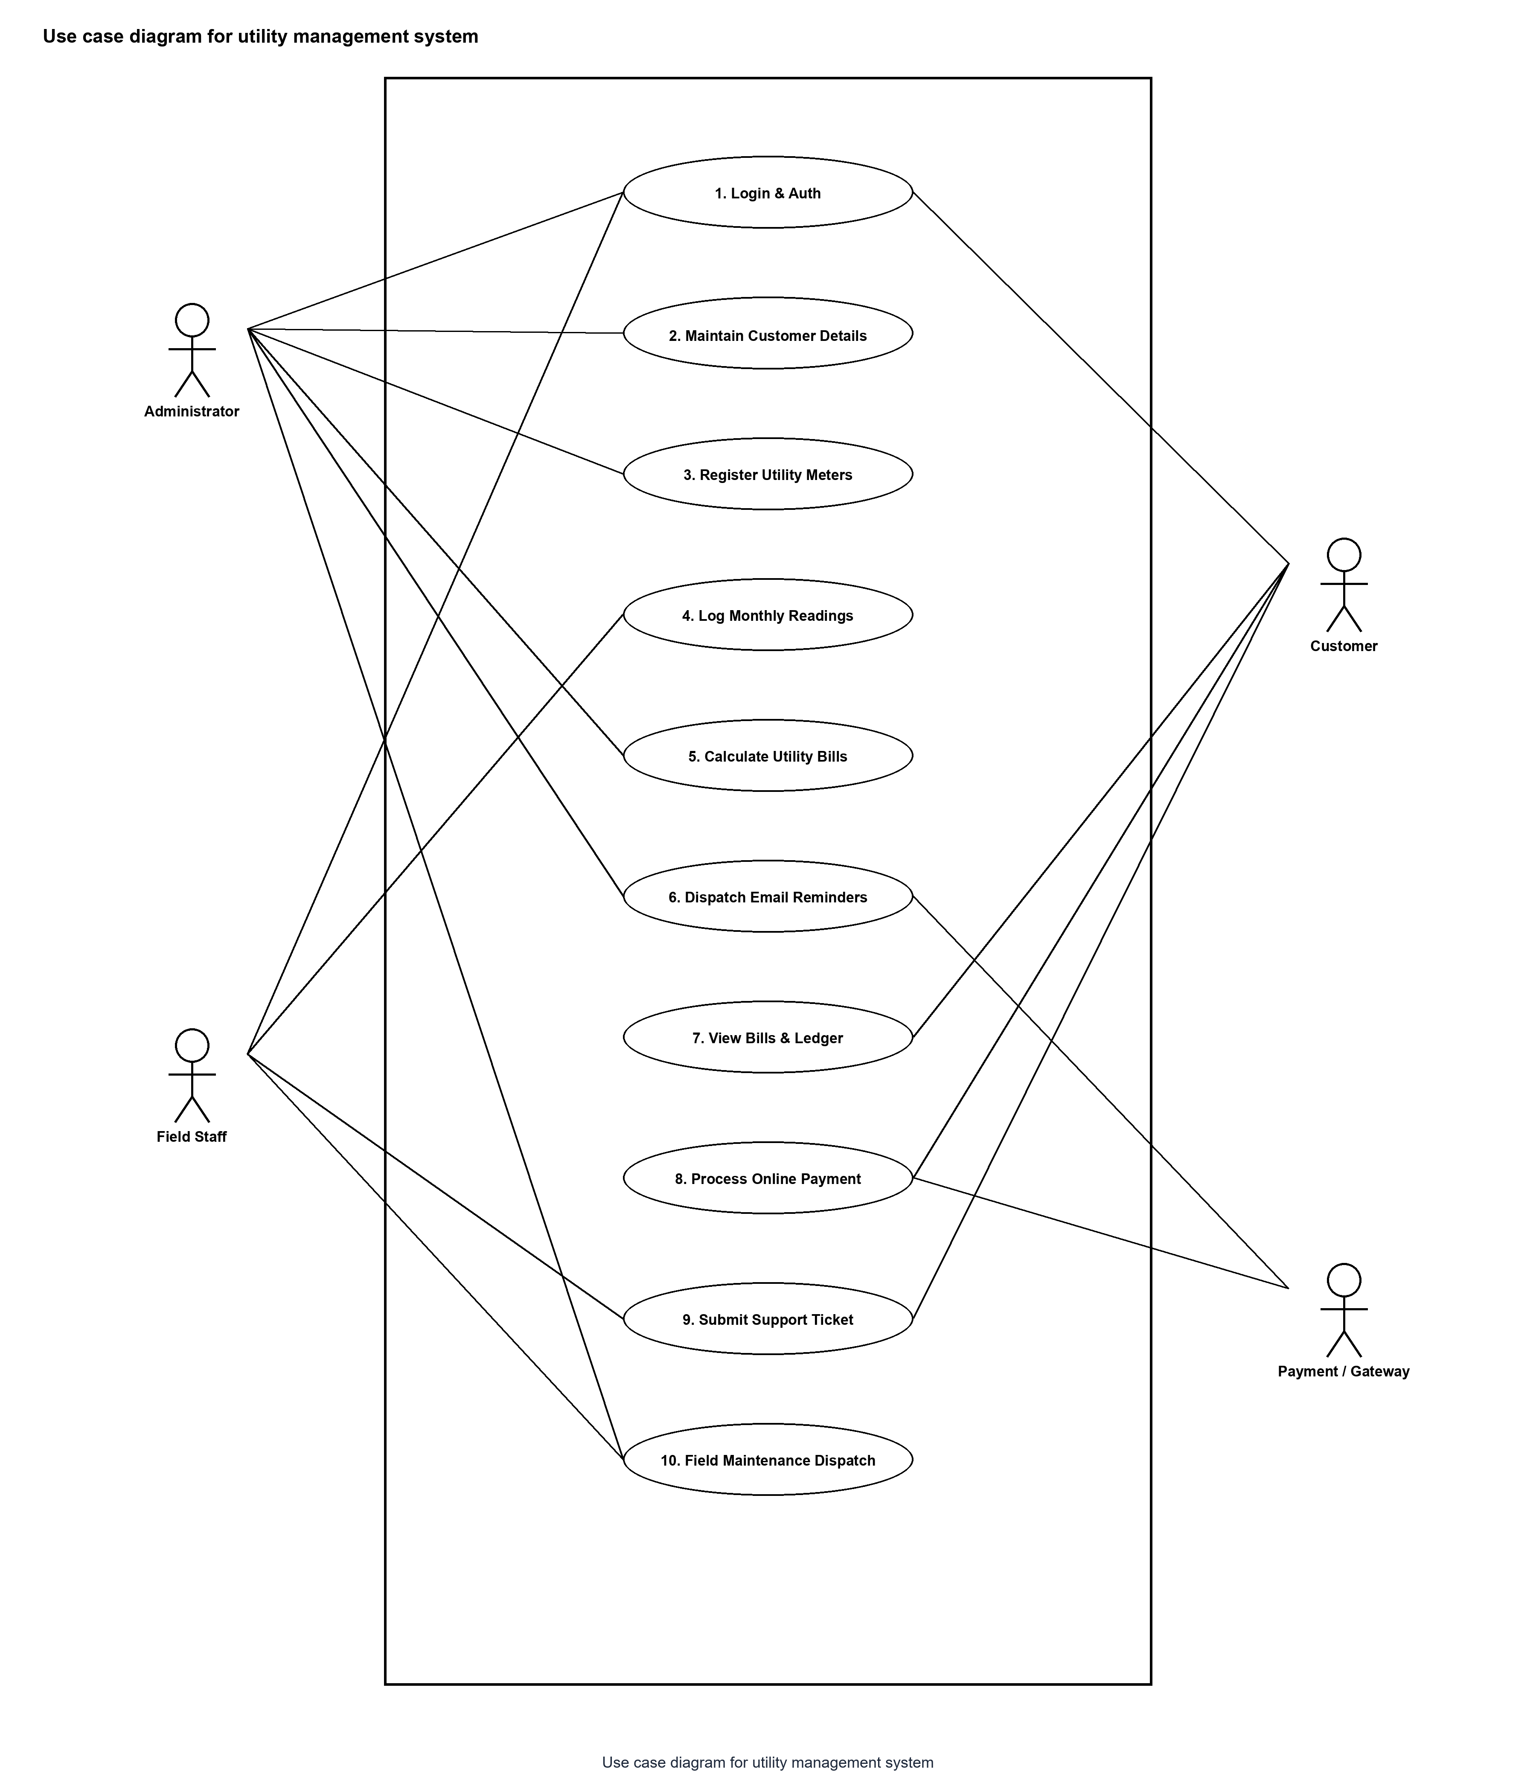

2. Class Diagram
Object-oriented static class structure detailing entities, attributes, methods, and multiplicities.
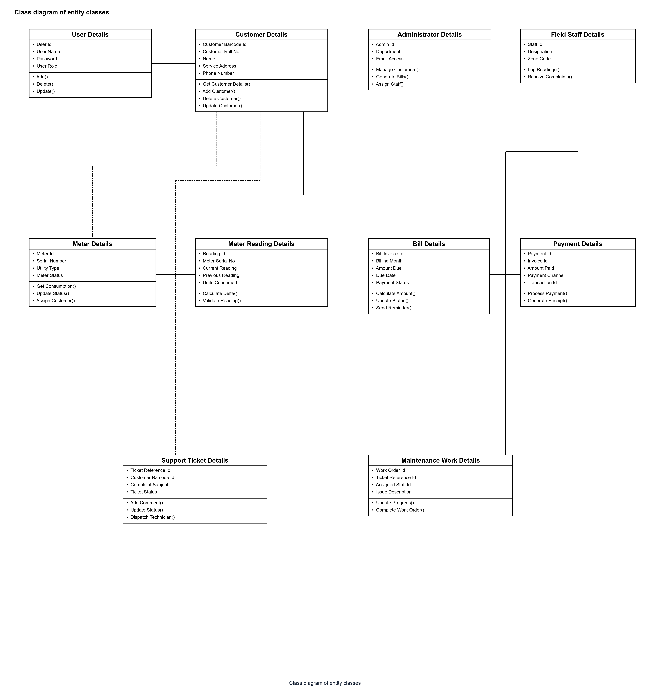

3. Sequence Diagrams
3.1 User Authentication & Session Creation
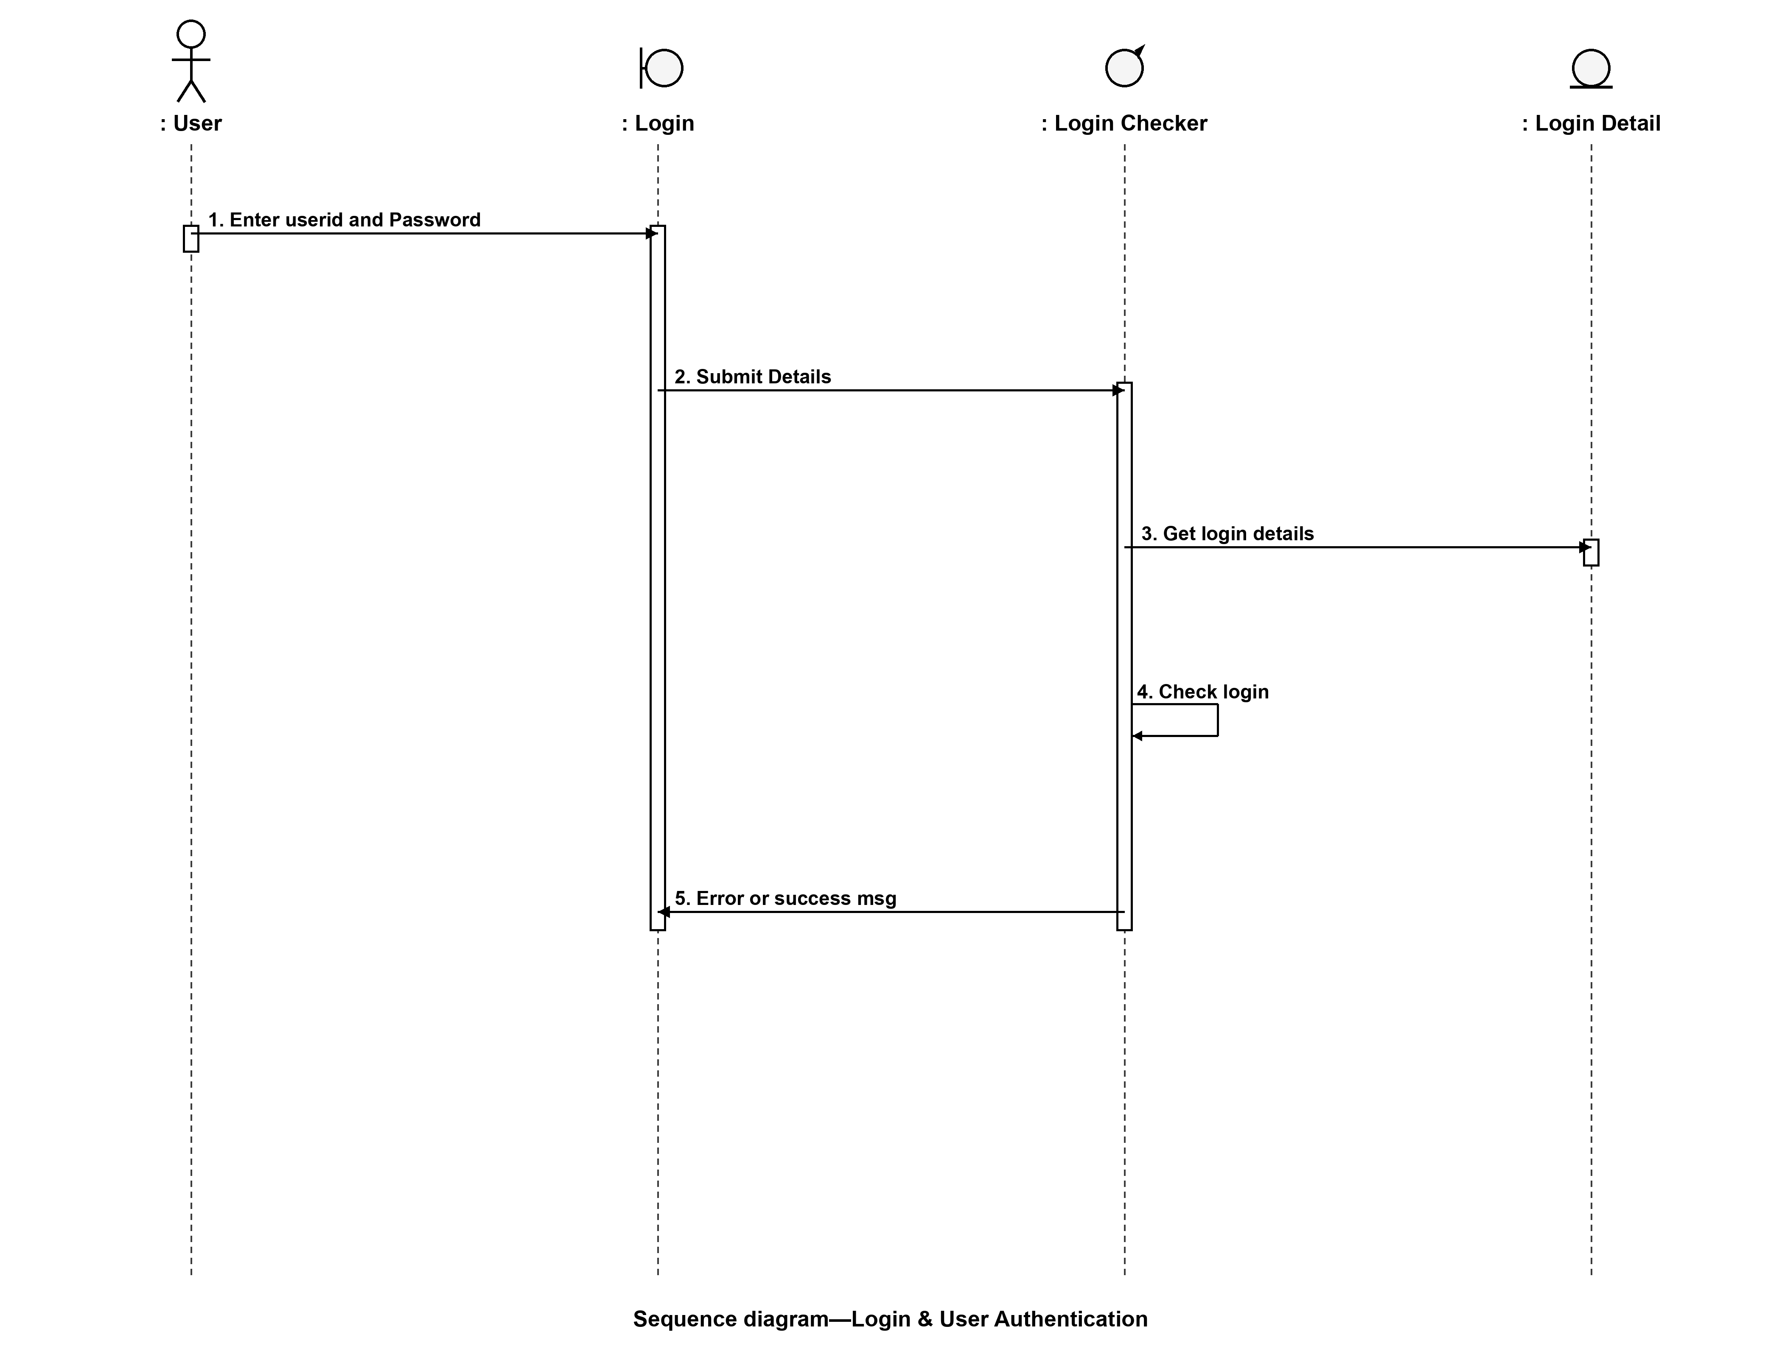

3.2 Meter Reading & Automated Billing Process
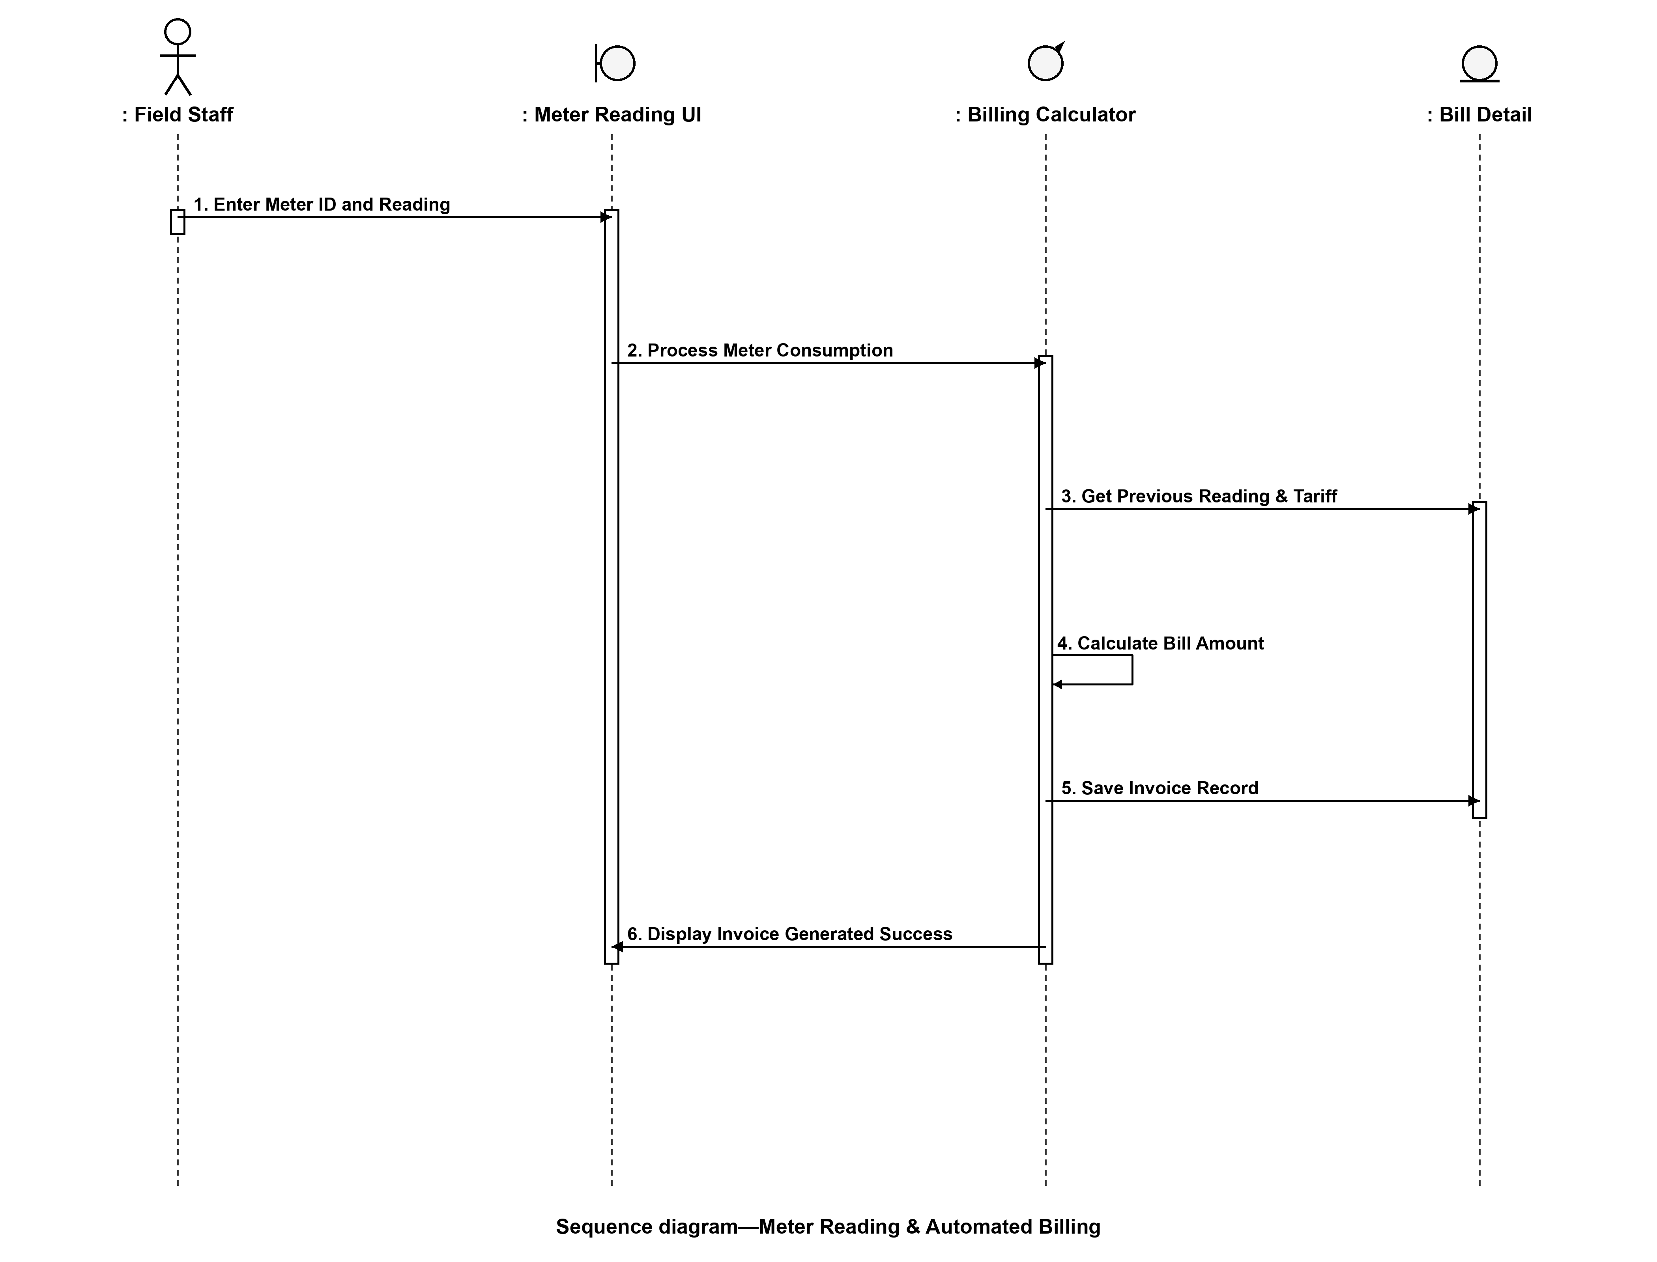

3.3 Online Bill Payment & Transaction Settlement
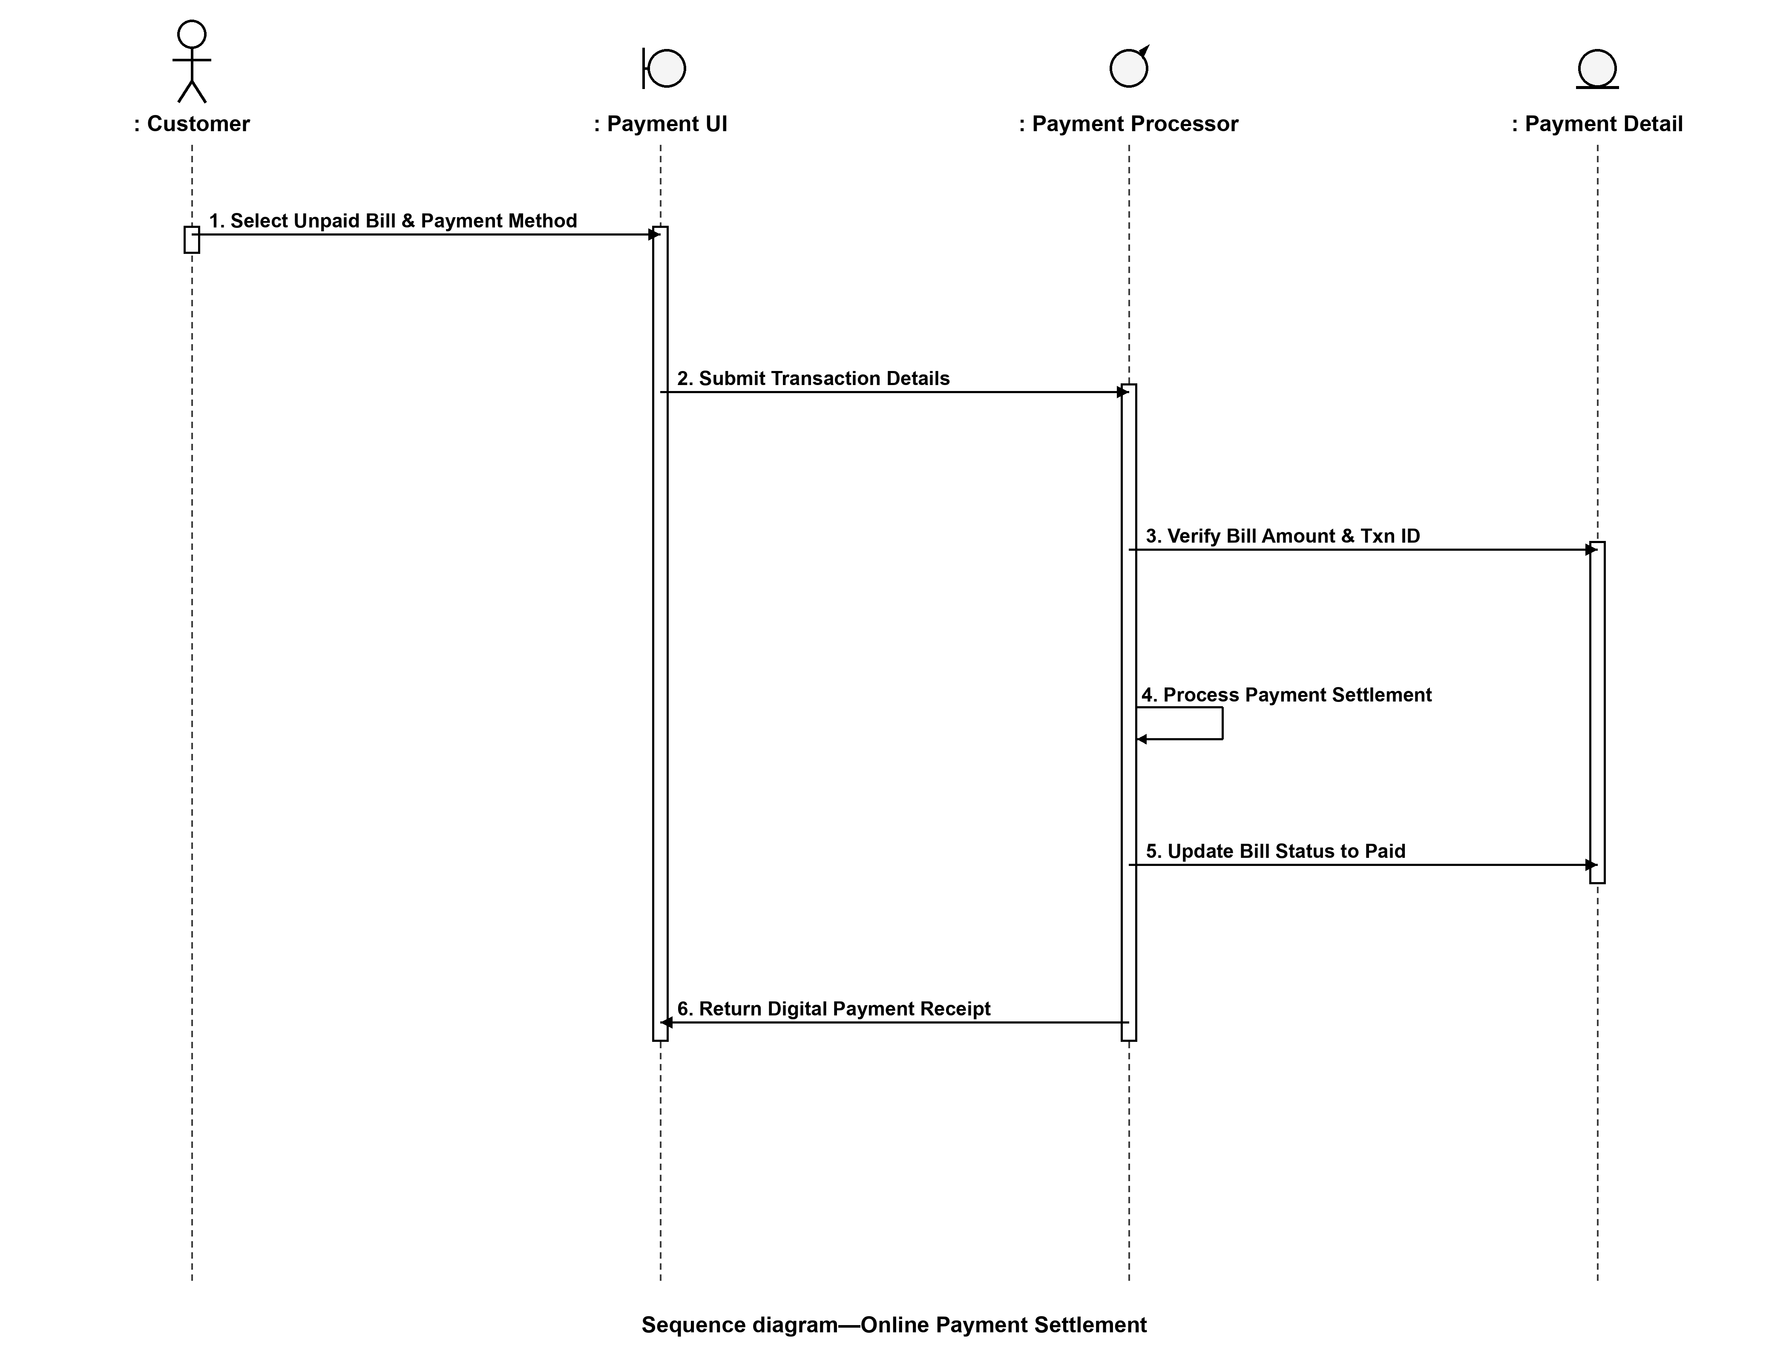

3.4 Support Ticket & Field Maintenance Dispatch
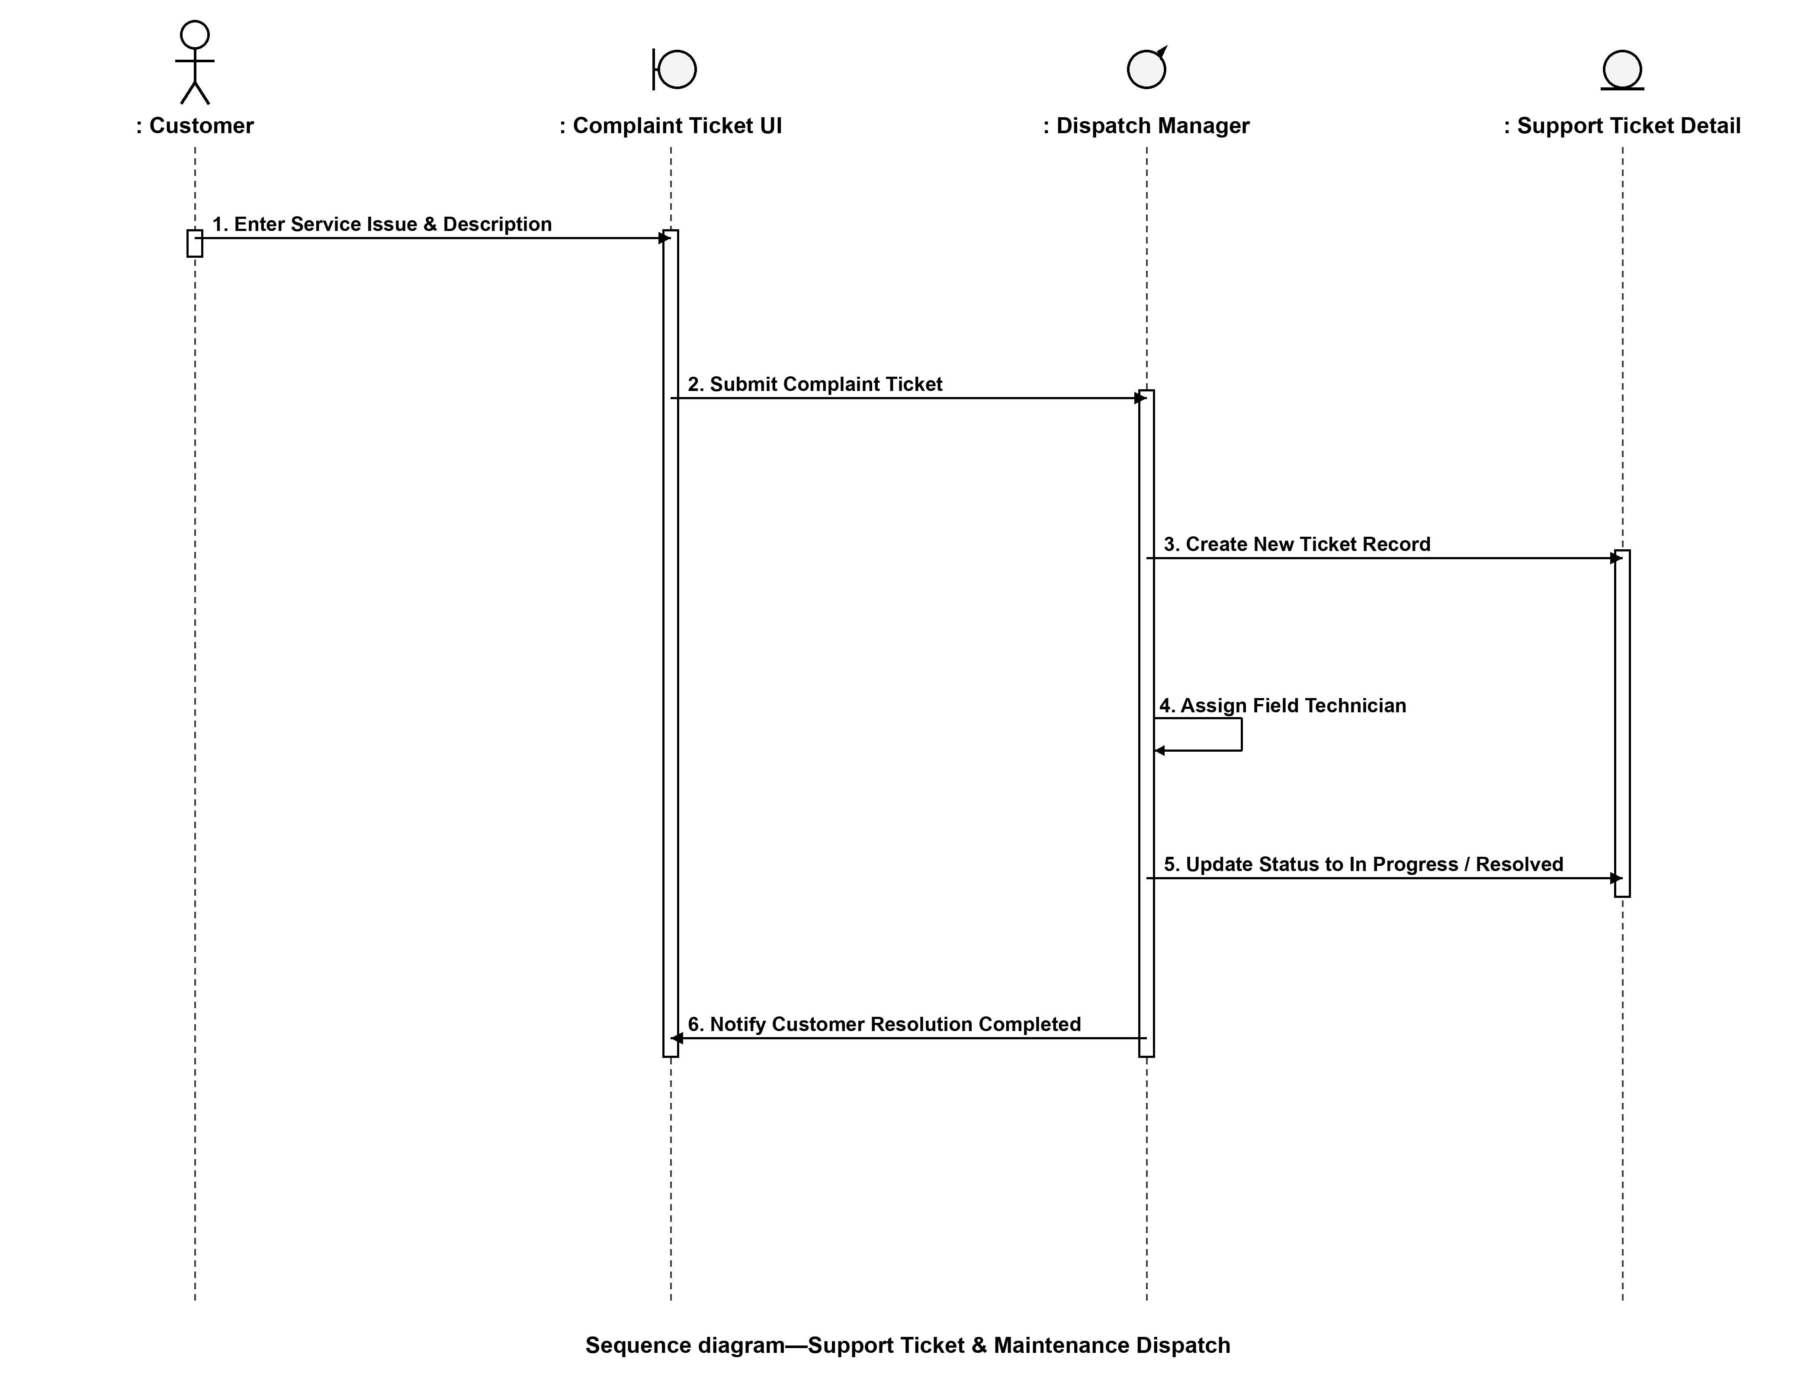

4. Software Design Diagrams Inventory & Summary
Diagram Name | UML Type | Key Lifelines / Entities | System Design Purpose
Use Case Diagram | Behavioral | System Boundary, 4 Actors, 10 Use Cases | Defines complete system functionality and user access permissions.
Class Diagram | Structural | 8 Core Classes (User, Customer, Meter, Bill...) | Models database entities, relationships, attributes, and methods.
Sequence Diagram 1 | Interaction | User, LoginUI, AuthController, UserDB | Triggers user credential validation and session token generation.
Sequence Diagram 2 | Interaction | Staff, BillingUI, BillingEngine, BillingDB | Executes meter reading delta calculation and invoice creation.
Sequence Diagram 3 | Interaction | Customer, PaymentUI, PaymentGateway, UtilisDB | Processes digital bill settlement and transaction status updates.
Sequence Diagram 4 | Interaction | Customer, ComplaintUI, Dispatcher, FieldStaff | Handles customer support ticketing and field technician assignment.

