UTILITY MANAGEMENT SYSTEM (utilis-app)
UML Use Case Diagram Architecture | Student: Jasika Noor (ID: 22CSE002)
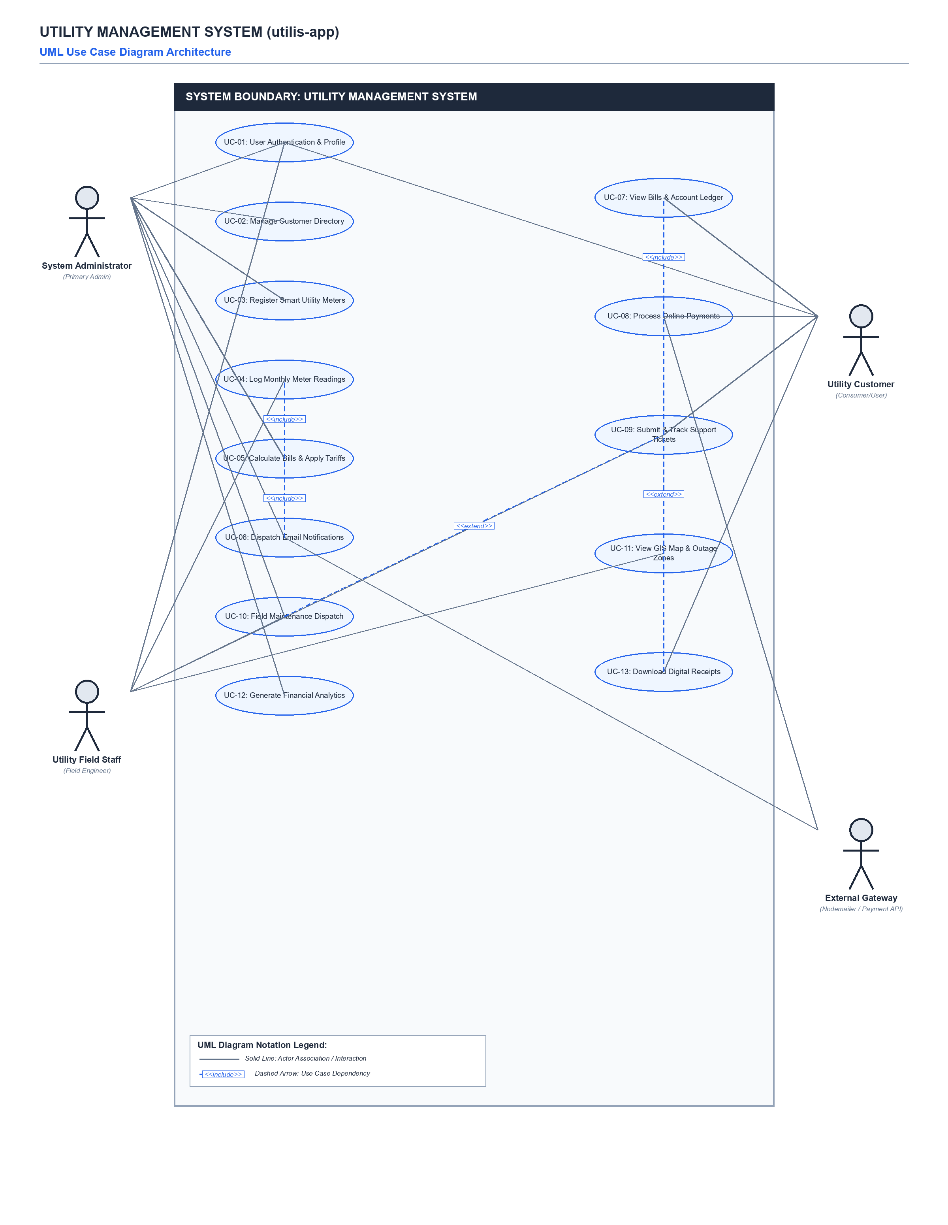

Use Case Diagram Elements & Actor Summary Legend
UC ID | Use Case Name | Associated Actor(s) | Core Functionality
UC-01 | User Authentication & Profile | Admin, Field Staff, Customer | Secure portal login, self-registration, session handling, and profile updates.
UC-02 | Manage Customer Directory | System Administrator | Create, edit, search customer profiles and link service addresses.
UC-03 | Register Smart Utility Meters | System Administrator | Register utility meters (Electricity, Water, Gas) and assign to customers.
UC-04 | Log Monthly Meter Readings | Field Staff, Customer | Log monthly consumption units and calculate delta (currReading - prevReading).
UC-05 | Calculate Bills & Apply Tariffs | System Administrator | Automated billing engine computing bill amount based on tiered tariffs.
UC-06 | Dispatch Email Notifications | Admin, External Nodemailer API | Automated Nodemailer email dispatch for new invoices and urgent payment reminders.
UC-07 | View Bills & Account Ledger | Utility Customer | Consumer access to unpaid bills, historical ledgers, and payment due dates.
UC-08 | Process Online Payments | Customer, External Payment API | Digital bill payment (bKash, Nagad, Bank) and automated bill status update.
UC-09 | Submit & Track Support Tickets | Customer, Field Staff | Customer complaint filing with interactive comment threads and status updates.
UC-10 | Field Maintenance Dispatch | Admin, Field Staff | Schedule emergency repair work orders, assign field technicians, and log resolutions.
UC-11 | View GIS Map & Outage Zones | Field Staff, Admin | Interactive Leaflet spatial mapping of customer meters and outage fault zones.
UC-12 | Generate Financial Analytics | System Administrator | Executive revenue collection charts, utility breakdown, and financial reports.
UC-13 | Download Digital Receipts | Utility Customer | Generate printable payment receipts featuring unique transaction reference IDs.

