SOFTWARE DESIGN SPECIFICATION
USE CASE MODEL & SPECIFICATIONS
Project: Utility Management System (utilis-app)
Structured in Accordance with Chapter 5: Software Design Principles
Prepared By: | Jasika Noor
Student ID: | 22CSE002
Course Title: | Software Engineering & Software Design
Academic Topic: | Chapter 5: Object-Oriented Software Design & UML Use Case Diagrams
Date: | August 30, 2026

1. Introduction & System Boundary Definition
The Use Case Model provides a formal functional decomposition of the Utility Management System (utilis-app) in accordance with standard software engineering design principles (Chapter 5: Software Design). The model defines the external actors interacting with the system, the system boundary enclosing core utility administration capabilities, and the exact interactions required to fulfill consumer utility needs (Electricity, Water, and Gas).
1.1 System Boundary
The system boundary encloses all automated workflows executed by the application backend (Node.js/Express.js REST APIs and MySQL relational storage) and front-end user portals. Interactivity across the boundary is established strictly via four identified external actors:
1. System Administrator (admin): Full administrative control over customer registries, smart meter inventories, tiered billing calculations, Nodemailer notification dispatches, field technician job assignments, GIS spatial mapping, and executive revenue reporting.
2. Utility Field Staff (employee): Operational staff handling physical monthly meter reading dispatches, meter health inspections, resolving logged technical complaints, and executing field maintenance tasks.
3. Utility Customer (customer): End-user consumers performing self-registration, inspecting active utility bills, settling balances via digital payment channels (bKash, Nagad, Bank), downloading payment receipts, and submitting service tickets.
4. External Systems & Gateways: External services interfacing with the system boundary including Nodemailer SMTP services for automated billing alert dispatches and Payment Gateway APIs for transaction settlement.
2. External Actor Specifications
The table below details all human and system actors interacting with the Utility Management System boundary, including their role classification and operational privilege matrix.
Actor Name | Actor Type | System Role & Scope | Access Permissions & Privileges
System Administrator | Primary Human Actor | Utility Executive & Portal Admin | Full CRUD operations on customers, meters, bill generation, email dispatch, technician dispatches, and financial dashboards.
Utility Field Staff | Primary Human Actor | Field Engineer & Meter Inspector | Permission to record monthly meter readings, inspect meter health, update complaint statuses, and resolve maintenance tickets.
Utility Customer | Primary Human Actor | Residential / Commercial Consumer | Role-restricted access to view personal utility bills, submit payments, log complaints, track tickets, and download receipts.
External Gateway | Secondary System Actor | Third-Party Email / Payment API | Automated system-to-system interfaces for Nodemailer email delivery and payment transaction verification.
3. Graphical Use Case Model & Diagram
Figure 1 below illustrates the formal UML Use Case Diagram for the Utility Management System, detailing all 13 core use cases within the system boundary, actor associations, and dependency relationships (<<include>> and <<extend>>).
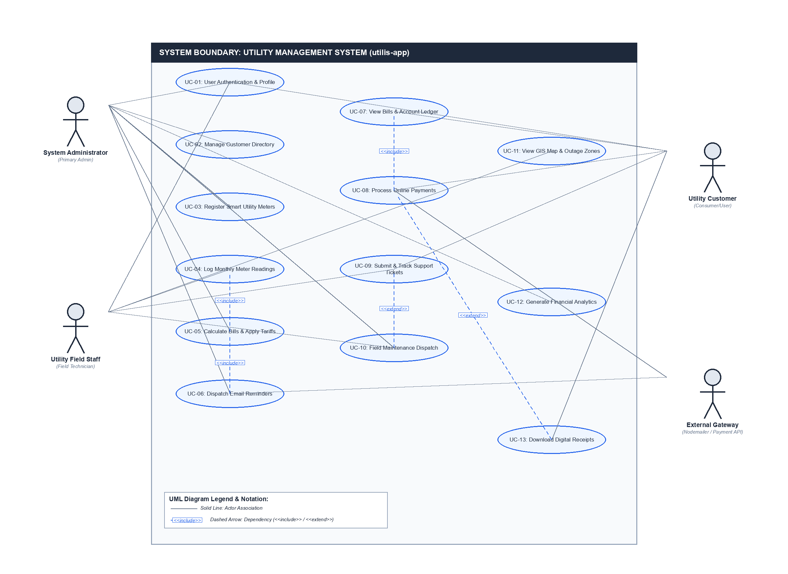
Figure 1: Complete UML Use Case Diagram — Utility Management System (utilis-app)
3.1 Use Case Inventory & Summary Table
UC ID | Use Case Name | Primary Actor | Secondary Actor | Summary Description
UC-01 | User Authentication & Profile | All Users | N/A | Secure user login, registration, session management, and profile update.
UC-02 | Manage Customer Directory | Administrator | N/A | Create, update, deactivate customer records and link service locations.
UC-03 | Register Smart Utility Meters | Administrator | N/A | Inventory tracking, assigning meters (Electricity, Water, Gas) to customers.
UC-04 | Log Monthly Meter Readings | Field Staff | Customer | Record monthly consumption units and calculate usage delta.
UC-05 | Calculate Bills & Apply Tariffs | Administrator | N/A | Automated billing engine computing amount = consumption * tariff rate.
UC-06 | Dispatch Email Reminders | Administrator | External Gateway | Trigger automated Nodemailer invoice notices and urgent payment reminders.
UC-07 | View Bills & Account Ledger | Customer | N/A | Consumer access to active unpaid bills, billing history, and due dates.
UC-08 | Process Online Payments | Customer | External Gateway | Digital bill settlement (bKash/Nagad/Bank) and automated invoice status update.
UC-09 | Submit & Track Support Tickets | Customer | Field Staff | Customer complaint filing with interactive comment threads and status updates.
UC-10 | Field Maintenance Dispatch | Administrator | Field Staff | Schedule emergency meter repairs, assign technicians, and log resolutions.
UC-11 | View GIS Map & Outage Zones | Field Staff | Administrator | Interactive Leaflet spatial mapping of customer meters and outage zones.
UC-12 | Generate Financial Analytics | Administrator | N/A | Executive revenue collection charts, utility breakdown, and financial reports.
UC-13 | Download Digital Receipts | Customer | N/A | Generate printable payment receipts with transaction reference IDs.

4. Detailed Use Case Specifications
This section presents formal software engineering specifications for each core use case, adhering to the standard Chapter 5 template (Pre-conditions, Post-conditions, Main Success Scenario, and Alternate Flows).
UC-01: User Authentication & Profile Management
Use Case ID & Name: | UC-01 — User Authentication & Profile Management
Primary Actors: | System Administrator, Utility Field Staff, Utility Customer
Description: | Allows any registered user to log into the application portal, maintain active session state, update contact profiles, or log out.
Pre-conditions: | User has an active account registered in the `users` database table.
Post-conditions: | Session token/data is stored in client `sessionStorage` with role permissions enforced.
Main Success Flow: | 1. User navigates to the Utility Management System portal login modal.  2. User enters registered Username/Email and Password credentials.  3. System validates credentials against stored password hashes in MySQL database.  4. System initializes session state with role type (`admin`, `employee`, or `customer`).  5. System redirects user to their respective role dashboard.
Alternative / Exception Flows: 3a. Invalid Credentials: System displays error message 'Invalid email or password' and prompts retry.
4a. Deactivated Account: System blocks authentication and prompts user to contact Administrator.
UC-02: Manage Customer Account Directory
Use Case ID & Name: | UC-02 — Manage Customer Account Directory
Primary Actors: | System Administrator
Description: | Provides administrative capabilities to create, edit, search, and update customer profile ledgers.
Pre-conditions: | Administrator is authenticated with `admin` privileges.
Post-conditions: | Customer record is updated in the `customers` database table.
Main Success Flow: | 1. Administrator selects 'Customer Management' from the navigation sidebar.  2. System retrieves and displays customer records in an interactive data table.  3. Administrator clicks 'Add Customer' button and enters customer details (Name, Address, Phone, Email).  4. Administrator submits form; System validates unique email constraint and persists record.  5. System updates customer table grid with real-time feedback notice.
Alternative / Exception Flows: 4a. Duplicate Email/User: System highlights duplicate field and prevents database submission.
4b. Deactivation: Administrator toggles account status flag to 'inactive'.
UC-03: Register & Assign Smart Utility Meters
Use Case ID & Name: | UC-03 — Register & Assign Smart Utility Meters
Primary Actors: | System Administrator
Description: | Enables registration of new physical utility meters (Electricity, Water, Gas) and assignment to customer service addresses.
Pre-conditions: | Customer account exists; Physical meter serial number is available.
Post-conditions: | New meter entry stored in `meters` table linked via foreign key `customer_id`.
Main Success Flow: | 1. Administrator opens 'Meter Inventory' module.  2. Administrator clicks 'Register New Meter' modal.  3. Administrator inputs Serial Number, Utility Category (Electricity/Water/Gas), and selects target Customer.  4. System creates meter record with default status 'active'.  5. System confirms successful meter registration.
Alternative / Exception Flows: 3a. Duplicate Serial Number: System alerts administrator that meter serial already exists.
UC-04: Log Monthly Meter Consumption Readings
Use Case ID & Name: | UC-04 — Log Monthly Meter Consumption Readings
Primary Actors: | Utility Field Staff / System Administrator
Description: | Logs monthly utility consumption figures recorded by field staff or smart meter telemetry.
Pre-conditions: | Meter status is marked as 'active'.
Post-conditions: | New reading record created in `meter_readings` table with consumption delta.
Main Success Flow: | 1. Field Staff opens 'Meter Readings' panel.  2. Staff selects target meter serial number and current billing month.  3. Staff enters current meter reading value (`currReading`).  4. System fetches previous reading (`prevReading`) and calculates delta: `consumption = currReading - prevReading`.  5. System saves reading record and logs timestamp.
Alternative / Exception Flows: 4a. Negative Consumption: If `currReading < prevReading`, system rejects input as invalid reading anomaly.
UC-05: Calculate Utility Bills & Apply Tariffs
Use Case ID & Name: | UC-05 — Calculate Utility Bills & Apply Tariffs
Primary Actors: | System Administrator
Description: | Automated billing engine computing monthly bill invoice amounts based on consumption and applicable tariff rates.
Pre-conditions: | Monthly meter reading is recorded for the billing cycle.
Post-conditions: | Invoice generated in `bills` table with status 'unpaid'.
Main Success Flow: | 1. Administrator triggers 'Generate Billing' for current cycle.  2. System fetches all active meter readings for the cycle.  3. System applies tariff formula: `totalAmount = unitsConsumed * tariffRate`.  4. System assigns billing month, billing year, and sets due date (15 days from issue).  5. Invoice is written to database with status 'unpaid'.
Alternative / Exception Flows: 2a. Missing Reading: System skips bill generation for meters without recorded readings and flags alert.
UC-06: Dispatch Email Notifications & Reminders
Use Case ID & Name: | UC-06 — Dispatch Email Notifications & Reminders
Primary Actors: | System Administrator (Primary), External Nodemailer Gateway (Secondary)
Description: | Sends automated email billing notices and urgent unpaid bill reminders directly to customer email addresses.
Pre-conditions: | Bill record exists in `bills` table; SMTP configuration is active.
Post-conditions: | Email dispatched to customer; notification record logged in `notifications` table.
Main Success Flow: | 1. Administrator clicks 'Send Bill Reminder' button on unpaid bill dashboard.  2. Backend fetches customer email, bill invoice ID, utility type, and due amount.  3. Nodemailer constructs formatted HTML email template.  4. System dispatches email via SMTP server.  5. System displays success alert and updates notification log.
Alternative / Exception Flows: 4a. SMTP Failure: System catches email server timeout error, logs failure, and alerts admin to check credentials.
UC-07: View Bills & Account Ledger
Use Case ID & Name: | UC-07 — View Bills & Account Ledger
Primary Actors: | Utility Customer
Description: | Allows consumers to view their active unpaid bills, historical payment ledgers, and breakdown of charges.
Pre-conditions: | Customer is logged into portal.
Post-conditions: | Customer receives full view of billing statements.
Main Success Flow: | 1. Customer navigates to 'My Bills' workspace.  2. System queries `bills` table matching customer's linked meter IDs.  3. System renders bill list with status badges ('Paid', 'Unpaid', 'Overdue').  4. Customer clicks 'View Details' to inspect consumption breakdown and due date.
Alternative / Exception Flows: 2a. No Bills Found: System displays friendly notice 'No active billing statements found'.
UC-08: Process Online Payment Settlement
Use Case ID & Name: | UC-08 — Process Online Payment Settlement
Primary Actors: | Utility Customer (Primary), External Payment API (Secondary)
Description: | Enables customers to pay unpaid bills online using digital mobile payment methods (bKash, Nagad, Bank).
Pre-conditions: | Bill status is 'unpaid' or 'overdue'.
Post-conditions: | Payment recorded in `payments` table; Bill status updated to 'paid'.
Main Success Flow: | 1. Customer clicks 'Pay Now' next to an unpaid bill invoice.  2. Customer selects payment method (bKash, Nagad, Rocket, Credit Card).  3. Customer enters payment details and transaction reference ID.  4. System verifies transaction input and records payment record.  5. System updates bill status in database to 'paid'.
Alternative / Exception Flows: 4a. Transaction Verification Failure: System prompts user to re-check transaction ID.
UC-09: Submit & Track Support Complaints
Use Case ID & Name: | UC-09 — Submit & Track Support Complaints
Primary Actors: | Utility Customer (Primary), Utility Field Staff / Admin (Secondary)
Description: | Customer ticketing system for lodging service complaints (meter fault, billing error) with live discussion threads.
Pre-conditions: | Customer is authenticated.
Post-conditions: | Ticket logged in `complaints` table with status 'Pending'.
Main Success Flow: | 1. Customer clicks 'Log Complaint' button.  2. Customer enters Complaint Subject, Utility Category, and detailed issue Description.  3. System generates unique ticket ID and notifies admin dashboard.  4. Staff responds via interactive comment thread and updates status ('In Progress' / 'Resolved').
Alternative / Exception Flows: 4a. Re-opening Ticket: Customer can add comments if issue remains unresolved.
UC-10: Field Maintenance Dispatch & Work Orders
Use Case ID & Name: | UC-10 — Field Maintenance Dispatch & Work Orders
Primary Actors: | System Administrator (Primary), Utility Field Staff (Secondary)
Description: | Schedules emergency repairs, assigns field technicians to technical service requests, and tracks completion.
Pre-conditions: | Technical complaint or maintenance request exists.
Post-conditions: | Work order updated in `maintenance` table with assigned technician ID.
Main Success Flow: | 1. Administrator reviews open maintenance requests in dashboard.  2. Administrator assigns available Field Staff technician to ticket.  3. Field Staff technician receives task assignment notification.  4. Technician inspects site, performs repair, and updates work order to 'Completed'.
Alternative / Exception Flows: 4a. Escalation: Technician logs requirement for replacement hardware.
UC-11: View GIS Spatial Map & Outage Zones
Use Case ID & Name: | UC-11 — View GIS Spatial Map & Outage Zones
Primary Actors: | Utility Field Staff, System Administrator
Description: | Interactive Leaflet GIS map displaying customer meter distribution, transformer nodes, and color-coded outage fault zones.
Pre-conditions: | Geographical coordinate data (Latitude/Longitude) present for meter locations.
Post-conditions: | Interactive spatial canvas rendered on screen.
Main Success Flow: | 1. User clicks 'GIS Map View' tab in sidebar.  2. System loads Leaflet map canvas centered on utility coverage area.  3. System renders custom color-coded map markers for active, faulty, and outage meters.  4. User clicks map marker to open popup tooltip showing customer details and meter health status.
Alternative / Exception Flows: 3a. No Coordinates: System places unmapped meters in default central substation hub.
UC-12: Generate Executive Analytics & Revenue Reports
Use Case ID & Name: | UC-12 — Generate Executive Analytics & Revenue Reports
Primary Actors: | System Administrator
Description: | Executive dashboard rendering financial collection summaries, monthly consumption trends, and export capabilities.
Pre-conditions: | Billing and payment records exist in system database.
Post-conditions: | Analytical charts and summary statistics displayed.
Main Success Flow: | 1. Administrator navigates to 'Analytics & Reports' tab.  2. System computes aggregate figures: Total Billed, Total Collected, Unpaid Outstanding, Active Meters.  3. System renders Chart.js bar and pie graphs illustrating utility revenue distribution.  4. Administrator clicks 'Export PDF/Print' to generate official financial report.
Alternative / Exception Flows: 4a. Date Filter: Administrator filters analytics by specific billing year or utility type.
UC-13: Download Digital Payment Receipts
Use Case ID & Name: | UC-13 — Download Digital Payment Receipts
Primary Actors: | Utility Customer
Description: | Generates clean, printable digital payment receipts for completed utility bill transactions.
Pre-conditions: | Bill payment status is 'paid'.
Post-conditions: | Printable digital receipt generated with transaction ID.
Main Success Flow: | 1. Customer views paid bill entry in account ledger.  2. Customer clicks 'Download Receipt' button.  3. System formats payment receipt containing Customer Name, Meter ID, Amount Paid, Payment Channel, and Transaction ID.  4. System opens browser print preview dialog.
Alternative / Exception Flows: 2a. Unpaid Bill: 'Download Receipt' button remains disabled until payment is verified.

5. Requirements Traceability Matrix
The matrix below maps project Functional Requirements (FR-01 to FR-42) to their corresponding Use Case implementations within Chapter 5 Software Design.
Functional Module | Functional Requirement Range | Implemented Use Case(s)
1. User Authentication & Profile | FR-01, FR-02, FR-03, FR-04, FR-05 | UC-01: User Authentication & Profile
2. Customer Account Directory | FR-06, FR-07, FR-08, FR-09 | UC-02: Manage Customer Directory
3. Smart Meter & Reading Tracking | FR-10, FR-11, FR-12, FR-13, FR-14 | UC-03: Register Smart Meters, UC-04: Log Meter Readings
4. Billing Engine & Tariff Processing | FR-15, FR-16, FR-17, FR-18, FR-19, FR-20 | UC-05: Calculate Bills & Apply Tariffs, UC-07: View Bills
5. Automated Email Reminders | FR-21, FR-22, FR-23, FR-24 | UC-06: Dispatch Email Reminders
6. Online Payment Settlement | FR-25, FR-26, FR-27, FR-28 | UC-08: Process Online Payments, UC-13: Download Receipts
7. Complaint Management & Tickets | FR-29, FR-30, FR-31, FR-32 | UC-09: Submit & Track Support Tickets
8. Field Maintenance Operations | FR-33, FR-34, FR-35, FR-36 | UC-10: Field Maintenance Dispatch
9. GIS Spatial Mapping Engine | FR-37, FR-38, FR-39 | UC-11: View GIS Spatial Map & Outage Zones
10. Executive Analytics & Reports | FR-40, FR-41, FR-42 | UC-12: Generate Financial Analytics

