艾尔赛CH341A USB转换模块
LC-TTL-CH341A

CH341A USB转UART/IIC/SPI/TTL/ISP适配器 EPP/MEM并口转换器

LC USB TO UART I2C SPI Parallel module
LC-TTL-CH341A

CH341A USB to UART/IIC/SPI/TTL/ISP adapter EPP/MEM Parallel converter

深圳市艾尔赛科技有限公司
2016-09

- 概述
艾尔赛CH341A USB转换模块搭载CH341A芯片，CH341A是一个USB总线的转接芯片，通过USB总线提供异步串口、打印口、并口以及常用的2线和4线等同步串行接口，该模块可用于串口扩展、I2C接口的EEPROM和SPI接口的FLASH以及STC单片机的烧录、程序调试、数据采集、刷机等方面。
1. Overview
LC CH341A USB conversion module equipped with CH341A chip, CH341A is a USB bus adapter chip, through the USB bus to provide asynchronous serial port, parallel port, print and 2 line and 4 line common synchronous serial interface, the module can be used for serial expansion, I2C interface EEPROM，SPI interface FLASH and STC MCU programming, program debugging, data acquisition, brush machine etc.
- 功能特点
支持USB转打印机并口和EPP或MEM方式的并口；
支持USB转UART、I2C、SPI接口；
输出的电压以及信号电平可选择3.3V或5V；
板载UART和SPI/I2C工作状态指示灯；
2. The function and characteristics
Support USB to parallel printer port and EPP or MEM parallel port ;
Support USB to UART, I2C, SPI interface;
The output voltage and the signal level can be selected by 3.3V or 5V;
Have UART and SPI/I2C working status indicator light;
三、 硬件介绍和说明
板子尺寸：45*27mm
板子功能说明：
1、接口说明：
VCC、RXD、TXD、GND：UART接口；
VCC、SDA、SCL、GND：I2C接口；
MISO、MOSI、SCK、CS2、CS1、CS0、GND、VCC： SPI接口；
CH341A芯片旁边的2个10P_2.54mm的排针口为打印口和EPP/MEM并口（板子上面丝印为EPP/MEM并口的定义），具体管脚对应关系可参考芯片手册。

- 工作模式选择（USB头右边的短路帽）：
- UART模式：短路帽插到UART，指示灯D2（蓝灯）常亮；
（2）I2C/SPI和EPP/MEM并口模式：短路帽插到I2C/SPI，指示灯D1（红灯）常亮；
（3）打印机并口模式：需拔掉该短路帽，将SDA和SCL两个引脚短接。
- 输出电压VCC和信号电平选择（USB头左边的2个短路帽）：
将2个短路帽同时插到3V3端时为3.3V；将2个短路帽同时插到另一端时为5V。
4、简单测试说明：
（1）UART测试：UART模式下将RXD、TXD短接，测试自收发；
（2）I2C测试：模块的VCC、SDA、SCL、GND分别接AT24××系列模块的VCC、SDA、SCL、GND，打开“工具软件”里的“USB(24-25)系列编程器”软件，打开“CH341A_TEST.hex”，选择芯片型号，点“写入”，若弹出以下对话框说明编程成功，I2C功能正常：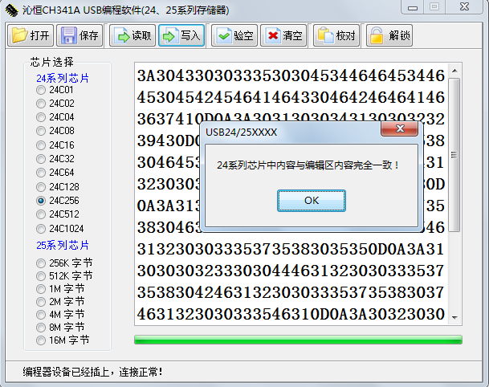
（3）SPI测试：首先把CH341A模块USB头左边的2个短路帽插到3V3处，然后MISO、MOSI、SCK、CS0、GND、VCC分别接W25Q40B模块的DO、DI、CLK、CS、GND、VCC，打开“工具软件”里的“USB(24-25)系列编程器”软件，打开“CH341A_TEST.hex”，选择芯片型号，点“写入”，若弹出以下对话框说明编程成功，SPI功能正常：
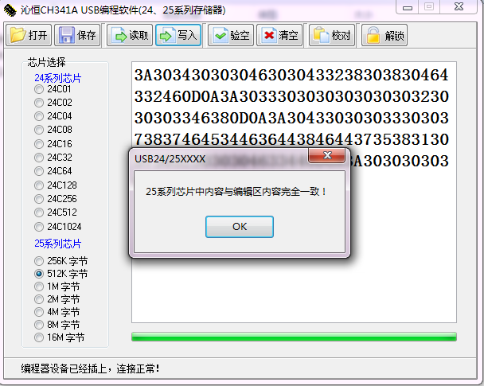
3. Introduced the hardware and instructions
The board size: 45*27mm
The board function description:

1, Interface description:
VCC, RXD, TXD, GND: UART interface;
VCC, SDA, SCL, GND: I2C interface;
MISO,MOSI,SCK,CS2,CS1,CS0,GND,VCC: SPI interface;
The 10P_2.54mm pin is print port and EPP/MEM port, pin’s definition can refer to manual.

2, Work mode ( jumper cap on the right of USB):

(1) UART model: the jumper cap is inserted into the UART, the D2 indicator light (blue) on;
(2) I2C/SPI and EPP/MEM parallel mode: the jumper cap is inserted into the I2C/SPI, the D1 indicator light (red) on;
(3)The printer parallel port mode: the need to unplug the jumpers，and SDA and SCL connected together.
3, the output voltage of VCC and signal level selection (2 jumper cap on the left of USB):
When the 2 jumper cap is inserted into the 3V3 side is 3.3V; when the 2 jumper cap also plug to the other side is 5V.

