Kuali Test Framework
Rob Tucker – University of Arizona 07/05/2014
Table of Contents
Overview 2
Configuration and Storage 2
Security 3
Application Architecture 3
Logical Test Model 3
Getting Started 4
Kuali Test Framework Configuration XML 4
Test Creator Command Line 5
Test Runner Command Line 6
Test Creator User Interface 6
Test Creator Tool Bar and Main Menu 6
Initial Setup 8
Application Email 8
JDBC Database Connection 9
JMX Connection Setup 9
Web Service Connection Setup 10
Platform Setup 10
Additional Database Information 11
Creating a New Test 12
Creating a File Test 14
Completing Checkpoint Dialog 15
Creating a Web Service Test 15
Creating a Database Test 18
Selecting Columns for Database Query 19
Database associated with test platform 19
Database Table 20
Table Column 20
Primary Key Table Column 20
Building SQL Select and Order By Clause 21
Building SQL Where Clause 23
Displaying Generated SQL and Verifying Validity 24
Creating SQL Checkpoint 25
Creating a Web Application Test 27
Web Application Test Framework Overview 27
Test Creator 27
Test Runner 28
Starting a Web Application Test 28
Creating a Web Checkpoint 30
Default text input tag handler 32
Capital Asset Tab System Selection tag handler 33
Creating Web Checkpoint Properties 35
Creating Web Test Execution Parameters 36
Test Management Panel 39
Repository 40
Platform Popup Menu 41
Test Suite Popup Menu 41
Test Popup Menu 41
Databases 41
Web Services 42
JMX Connections 42
Test Scheduling 43
Tag Handler Configuration Detail 45

Overview
The Kuali Test Framework provides a simple interface for creating, saving and running application tests that closely replicate real-world application usage scenarios. Once created, a test runner provides functionality to run tests on a scheduled basis. The test runner supports multi-threaded, parallel test execution to replicate multi-user environments or drive load test scenarios. Test results are delivered via email with excel spreadsheet attachments.

The twat framework is primarily designed to support web application testing. “Kuali Test Framework” is a bit of a misnomer as the application is designed as a configurable test environment that can support any web application. While primarily designed for web application testing, the framework supports several test methods to provide a full suite of test capabilities – supported test types include:

- HTTP/HTML based web application tests
- SQL query database tests
- File based tests
- SOAP based web service tests
- JMX memory tests

The primary goals of the Kuali Test Framework are as follows:

- Provide a simple interface that allow non-technical users to create tests during normal application user testing and evaluation.
- Support test scenarios that closely replicate real-world application usage.
- Support multi-user and load test scenarios.
- Provide an easily configured environment for test creation, scheduling and results delivery.
- Provide an application that can be configured to support complex web-based HTML interfaces while still presenting a standard, simple user interface for test creation.

General Description

Configuration and Storage
XML documents are used throughout the application for configuration and storage. Excel files are used for test results.

Security
The application as it currently exists has no user authentication/authorization built in. Data security is handled via encryption using Jasypt (http://www.jasypt.org). Database, JMX and Web Service tests may requires passwords, if so, the passwords will be stored in an encrypted form in the XML configuration. Web tests may store sensitive information in XML test files that will later be passed as parameters during test execution. The application provides the capability to define parameter names requiring encryption and the values associated with these parameters will be encrypted prior to saving in the XML test documents.

Application Architecture
The Kuali Test Framework consist of 2 Java applications:
- Swing based GUI front end for test environment management, test creation and test scheduling.
- Java command line application designed to run as service for test execution and test results delivery.

Logical Test Model
The diagram below displays the logical model of the test application:
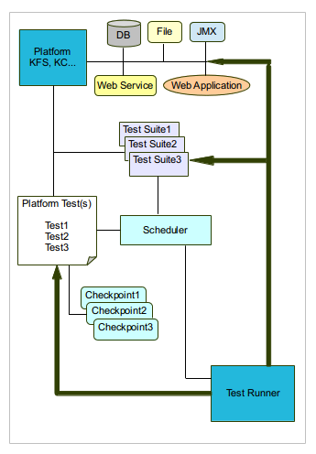

Diagram symbols are described below:

- Platform – defines the basic test foundation. A platform consists of an application of a specified version in a specified environment. For example DEV KFS 3.0, TST KC 5.0 etc. Tests, Test Suites, DB connections, JMX connections, Web Service URLs and Web Application URLs are associated with a specific platform.
- Platform Test – Tests are created for a specified platform, a test can be one of the following types – web, database, file or web service.
- Checkpoint – A checkpoint is composed of 1 or more checkpoint properties that are used to evaluate expected vs. actual test values for comparison purposes. During test creation check points are created and saved with expected (good) values. When tests are run via the scheduler the runtime values are evaluated against expected values to determine test status. Database, File and Web Service tests only support check points of the same type. A Web Application test supports check points of all types.
- Test Suite – Platform tests can be grouped together as a Test Suite which will execute in a single test execution context.
- DB – A platform can have an associated JDBC database connection which can then be used to create SQL tests and check points.
- File – The framework supports file tests and check points.
- JMX – A platform can have an associated JMX (Java management extension) connection to support server-side jvm memory check points.
- Web Service – A platform can have an associated web service connection (URL to WSDL) to support web service tests and checkpoints.
- Web Application– A platform can have an associated web application URL to support web application test creation.

Getting Started
Below you will find the preliminary configuration required to use the Kuali Test Framework.

Kuali Test Framework Configuration XML
Kuali Test Framework configuration is defined in an XML document whose path is passed to the application as an input parameter. An example test configuration file is shown below:

<?xml version="1.0" encoding="UTF-8"?>
<kuali-test-configuration xmlns="test.kuali.org">
<repository-location>
my-test-repository-root-directory
</repository-location>
<test-result-location>
my-test-results-root-dir
</test-result-location>
<tag-handlers-location>
my-html-tag-handler-definition-file-dir
</tag-handlers-location>
<default-test-wait-interval>2</default-test-wait-interval>
<additional-db-info-location>
my-additional-db-definition-file-dir
</additional-db-info-location>
<database-connections>
<!-- database connections created through the user
interface will go here -->
</database-connections>
<web-services>
<!-- web service URLs setup through the user interface
will go here -->
</web-services>
<jmx-connections>
<!-- JMX URLs setup through the user interface
will go here -->
</jmx-connections>
<modified>false</modified>
<email-setup>
<mail-host>mail-host</mail-host>
<subject>default-mail-subject</subject>
<from-address>default-from-address</from-address>
<to-addresses>default-to-address</to-addresses>
</email-setup>
<platforms>
<!-- platforms defined through the user interface
will go here -->
</platforms>
<test-execution-parameter-names>
<!-- test execution parameter names defined through
the user interface will go here -->
</test-execution-parameter-names>
<parameters-requiring-encryption>
<!-- test parameter names requiring encryption
defined through the user interface will go here -->
</parameters-requiring-encryption>
<encryption-password-file>
path-to-file-containing-password-to-facilitate-encryption
</encryption-password-file>
<auto-replace-parameters>
<!-- auto replace parameter names defined through
the user interface will go here -->
</auto-replace-parameters>
</kuali-test-configuration>

The XML above is the base configuration required to run the Kuali Test Framework. Please replace any file path entries with the the desired path. Tags that include comments with “defined through the user interface” will be populated using the test creator GUI.

Test Creator Command Line
Below is an example of the command line to start and run the test creator GUI application. It is expected that the kualitest-1.0.jar can be found on the classpath.

javaw -Dhttp.proxyHost=localhost -Dhttp.proxyPort=8888
org.kuali.test.creator.TestCreator “path-to-configuration-file”

The proxy settings are required to create web application tests. The test creator starts up an internal proxy server that intercepts all HTTP requests and saves selected requests as part of the test. If this is a windows installation you must set the proxy server in the control panel to the same value as the proxy arguments above.
The “path-to-configuration-file” argument is the full path to the Kuali test configuration file discussed in the previous section.

Test Runner Command Line
Below is an example of the command line to start and run the test runner. It is expected that the kualitest-1.0.jar can be found on the classpath.
Java -Xms512m -Xmx2g org.kuali.test.runner.TestRunner
“path-to-configuration-file”

The “path-to-configuration-file” argument is the full path to the kuali test configuration file discussed in the previous section.

Test Creator User Interface
The Test Creator user interface is shown below. It constants of 2 main panels – a management panel and a test creation panel. The management panel provides functionality to manage the platform/test suite/test hierarchy, JDBC database connections, JMX URLs and Web Service URLs. The test creation panel provides the interface for creating web, SQL, web service and File tests.

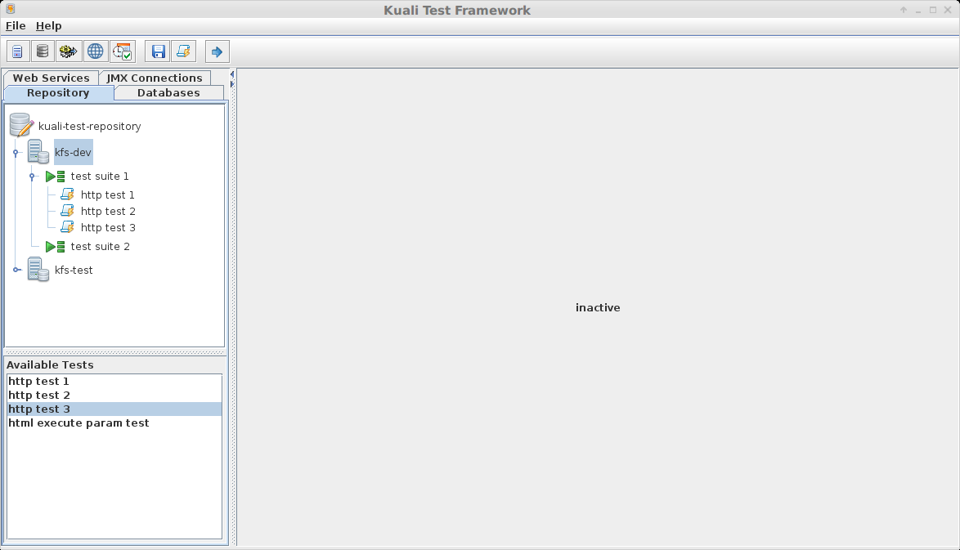
Test Creation Panel
Management Panel

Test Creator Tool Bar and Main Menu
The test creator tool bar button descriptions are shown below:
Save Configuration Changes

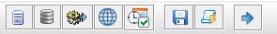
Add Platform
Exit Application
Add Database Connection
Add JMX URL
Schedule Test Suites & Tests
Create New Test
New Web Service URL

Several main menu items parallel the tool bar button functionality described above, the other menu items are described below:

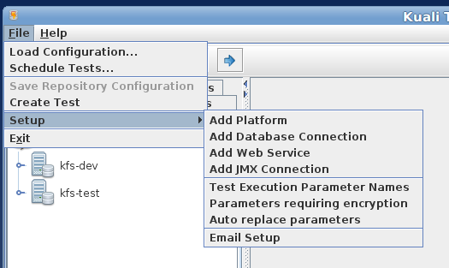

- Test Execution Parameter Names – provides a means of creating test execution replacement parameter names. A test execution parameter is an HTTP request parameter with the current test execution context value. For example, say I am creating a new web test that creates a requisition then pulls up several other screens referencing that new requisition. The HTTP requests saved with the test will contain the document number for the requisition. When the test is executed we do not want to reference the original requisition document number but the requisition created during the latest test run. For this scenario we can create an HTTP test execution parameter for the HTTP request parameter documentNumber and setup the test to populate the runtime HTTP requests by the requisition document number generated in the current test execution context.
- Parameters requiring encryption – provides a means of specifying HTTP request parameters that require encryption. During test creation selected HTTP requests are saved in the test XML document. Since the XML is stored as plain text any sensitive data in the request will be also be stored as plain text. Parameters that are specified as requiring encryption will stored in encrypted form in the test XML. For example, e request that contains the parameter “password=mypassword” would be stored in the XML test document as something similar to “password=ElXikoD3RTVn36VP3CdBuZGrWyKmlTh+”
- Auto replace parameters – provides a means of specifying auto replacement parameters for web tests. In some test scenarios certain HTTP request parameters should always use the value from the current test execution context. Often these are hidden input fields related to authentication such as ticket values from an authentication service. HTTP request parameter names specified as auto replace will always be replaced by the current execution context values during test execution.
- Email Setup – provides a setup dialog for base application email parameters such as mail host, return address, default subject etc.

Initial Setup
After creating the kuali test configuration XML document and getting the test creator GUI up and running and before creating tests and test suites some initial setup is required:
- default application email parameters
- JDBC database connections
- JMX URLs
- Web Service URLs
- Platforms

Application Email
From the application main menu click on the File->Setup->Email Setup menu item to display the email setup dialog:

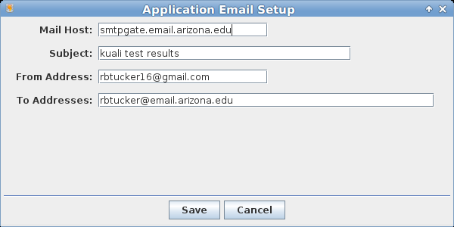

The dialog above sets the default email parameters for test result emails. The entries are for the most part self-explanatory with a couple of exceptions. The Subject is treated as a prefix for the test results emails – test specific information will be added to the end of this subjects line – an example is shown below:

kuali test results - Platform: kfs-dev, Test: http test 1

The To Addresses entry contains the default destination addresses for all tests. This field can be left empty. If not empty it can contain 1 or more addresses separated by commas that will receive test result emails for all test run.

JDBC Database Connection
From the application main menu click on the File->Setup->Add Database Connection menu item or the Add Database tool bar button to display the database connection setup dialog:

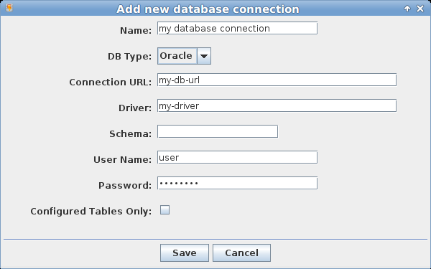

Enter a desired name and the JDBC parameters required to connect to the selected database. The schema field can be left blank. By default a SQL test will pull in all tables and views accessible to the database user configured for the database connection. These tables and views and their associated columns will then be presented to the user to allow for SQL query creation. The application provides a mechanism to support specifying user-friendly table and columns names to the user creating a SQL test. If the Configured Tables Only check box is checked only tables configured via this mechanism will display to the user. A detailed description of this functionality is found later in this section under Additional Database Information.

JMX Connection Setup
From the application main menu click on the File->Setup->Add JMX Connection menu item or the Add JMX Connection tool bar button to display the JMX connection setup dialog:
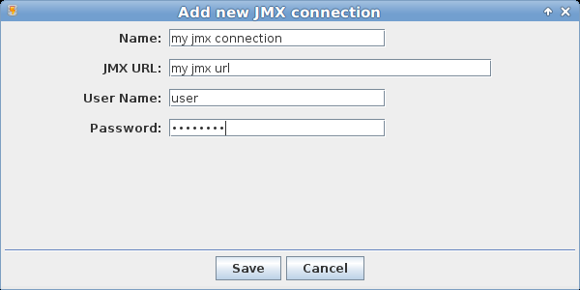

Web Service Connection Setup
From the application main menu click on the File->Setup->Add Web Service Connection menu item or the Add Web Service Connection tool bar button to display the web service connection setup dialog:

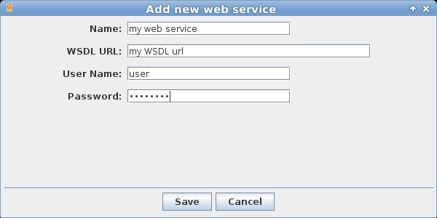

Platform Setup
From the application main menu click on the File->Setup->Add Platform menu item or the Add Platform tool bar button to display the platform setup dialog:
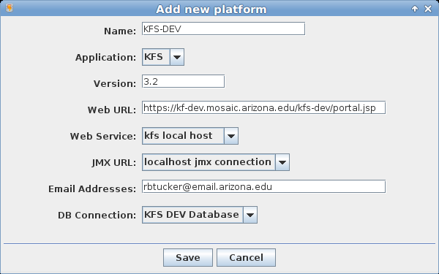

A platform represents an application of a specific version running on a defined server. The Web URL entry is the web application URL. The Web Service, JMX URL and DB Connection entries are selected via drop down and are setup as defined in the previous sections. Once a platform is created tests and test suites can be created for the platform.

Additional Database Information
For SQL test creation the test application provides a mechanism to present user-friendly table/view and column names to the end user. In addition, pseudo foreign key relationships can be defined. For example, in Kuali many KC and KFS tables reference document numbers that also reside in RICE tables but there are no foreign key constraints in the database. Since the SQL query creation panel of the test creator uses foreign keys to logically display table relationships the associated KFS/KC/RICE table relationships are not displayed; however, by configuring pseudo foreign keys the UI can display these relationships.
To define additional database information create an XML file in the directory specified in the Kuali test framework configuration under the tag shown below:
<additional-db-info-location>path-to-db-info</additional-db-info-location>
The file naming convention must be as follows:
[application-name]-additional-db-info.xml
for example kfs-additional-db-info.xml.

Example XML is shown below:

<additional-database-info xmlns="test.kuali.org">
<application>
<application-name>KFS</application-name>
<tables>
<table>
<table-name>FP_DV_EXT_T</table-name>
<display-name>
DisbursementVoucherDocumentExtension
</display-name>
<columns>
<column>
<column-name>FDOC_NBR</column-name>
<display-name>documentNumber</display-name>
</column>
<column>
<column-name>VER_NBR</column-name>
<display-name>versionNumber</display-name>
</column>
<column>
<column-name>OBJ_ID</column-name>
<display-name>objectId</display-name>
</column>
<column>
<column-name>BATCH_ID</column-name>
<display-name>batchId</display-name>
</column>
</columns>
<custom-foreign-keys>
<custom-foreign-key>
<name>customfk1</name>
<primary-table-name>
KREW_DOC_HDR_T
</primary-table-name>
<foreign-key-column-pair>
<primary-column>
DOC_HDR_ID
</primary-column>
<primary-column-type>
number
</primary-column-type>
<foreign-column>
FDOC_NBR
</foreign-column>
<foreign-column-type>
string
</foreign-column-type>
</foreign-key-column-pair>
</custom-foreign-key>
</custom-foreign-keys>
</table>

Creating a New Test
To create a new test, select File->Create Test from the main application menu,

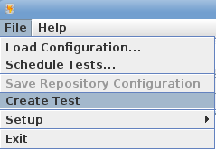

or right click on the desired platform on the repository tab,

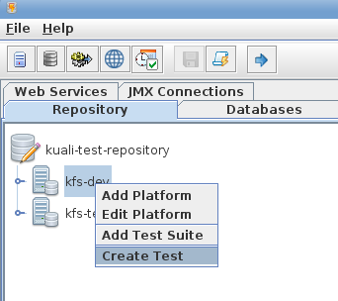

or click the create new test button on the application tool bar,

to display the Initialize New Test dialog:

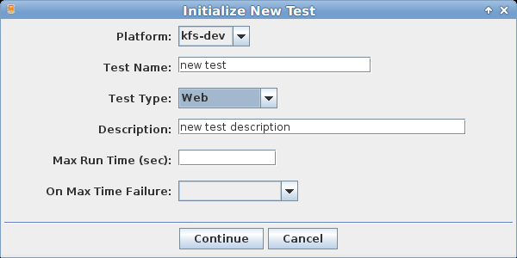

Below are the descriptions of the dialog entry fields:

- Platform – the platform that this test will be associated with.
- Test Name – desired test name – this must be unique for the platform.
- Test Type – test type from drop down selection – one of 4 choices: database, file web or web service.
- Description – test description
- Max Run Time (sec) – the maximum time in seconds to allow this test to run before flagging an error. The field is not required.
- On Max Time Failure – if the max run time is set, select a failure status from drop down selection to associate with the error – one of 4 choices: ignore, warning, error – continue or error – halt test.

Creating a File Test
Pull up the Initialize New Test dialog as described above and complete the entries as desired. Ensure that the Test Type of File is selected from the drop down. Click Continue to load the file test setup panel.

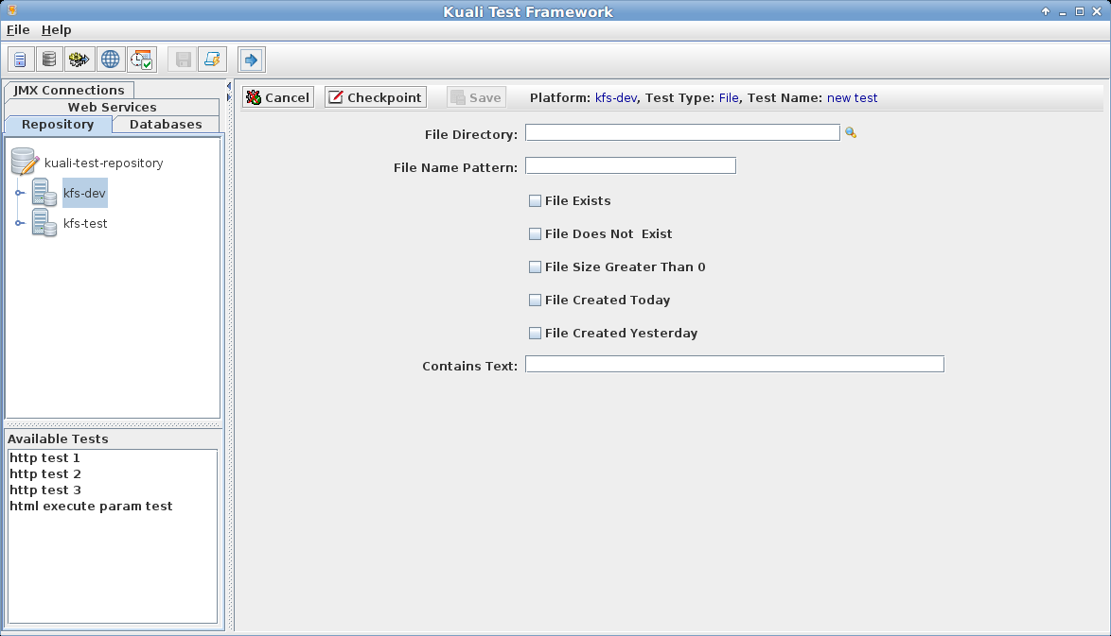
Complete the entry fields on the file test panel and click the checkpoint button

to display the Add new checkpoint dialog and save the checkpoint. Click the save button

to save the test.

The File test panel entry fields are described below:
- File Directory – the directory where the files of interest reside.
- File Name Pattern – the name pattern of file to look for. An asterisk (*) can be used as a wild card character.
- File Exists - check box to indicate test that file exists
- File Does Not Exist – check box to indicate test that file does not exist
- File Size Greater Than 0 – check box to indicate a test that files exists with size greater than zero.
- File Created Today – check box to indicate a test that file was created today
- File Created Yesterday – check box to indicate a test that file was created yesterday
- Contains Text – File will be tested to see if the entered text is found in the file.

Various combinations of these test properties are allowed.

Completing Checkpoint Dialog
When the checkpoint button is clicked the Add new checkpoint dialog will display:

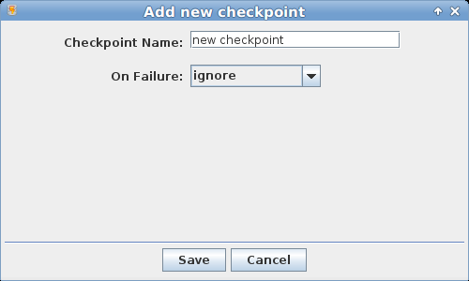

Enter a valid check point name and select a failure status to associate with a file test failure.

Creating a Web Service Test
Pull up the Initialize New Test dialog as described in the Creating a New Test section and complete the entries as desired. Ensure that the Test Type of Web Service is selected from the drop down. Click Continue to load the initial web service setup panel.

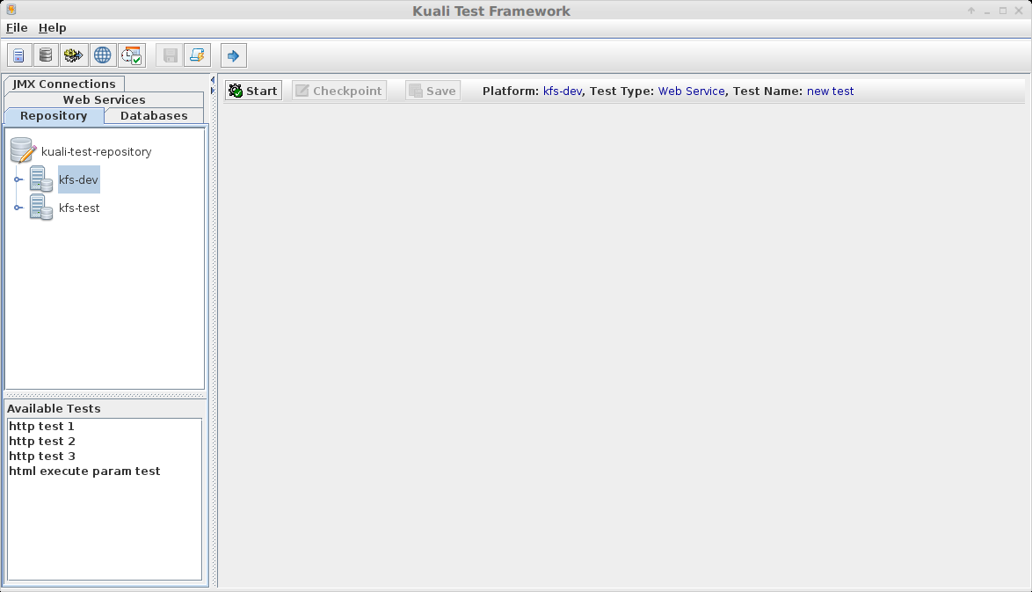

Click the Start button to connect to the web service setup for the platform.

If the connection succeeds the full web service test setup panel will display.

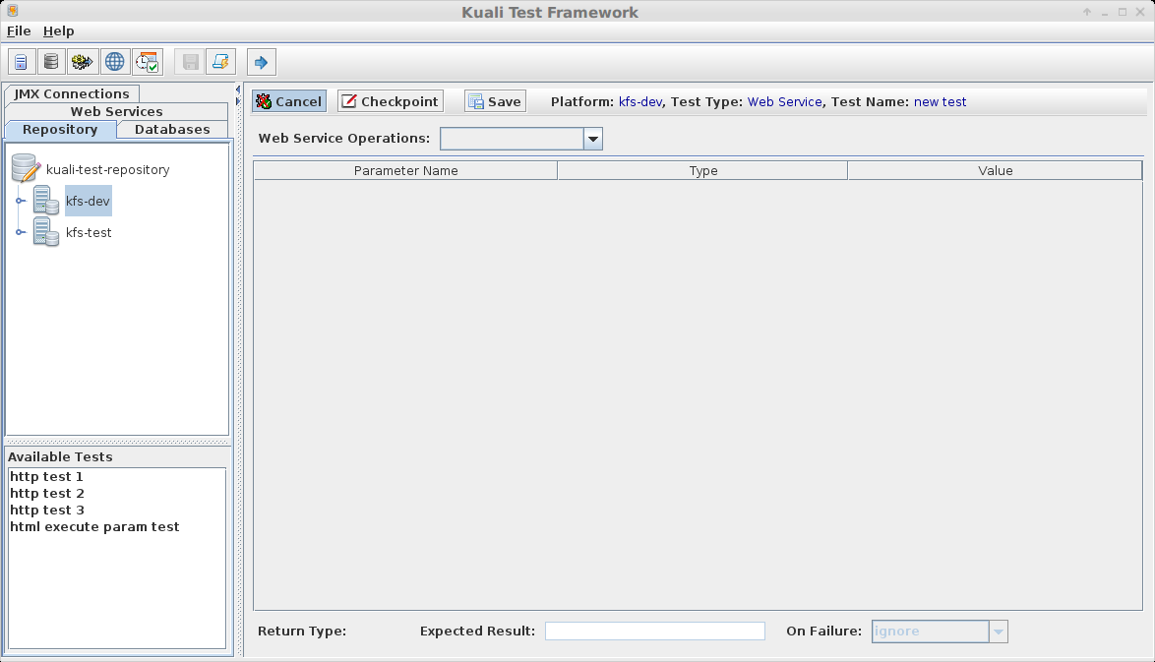

From the Web Service Operations drop down select a desired operation for a checkpoint.

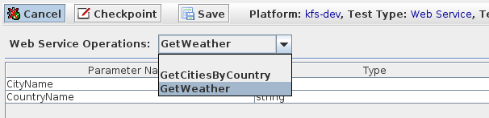

Complete the input parameter entries:

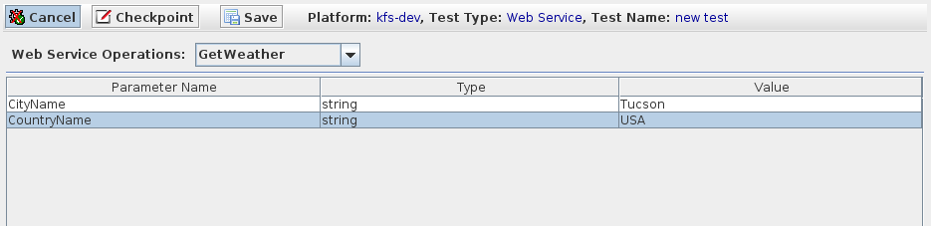
And the expected result field:

Select the failure status to set if expected result is not retrieved and click the checkpoint button to display the Add new checkpoint dialog.

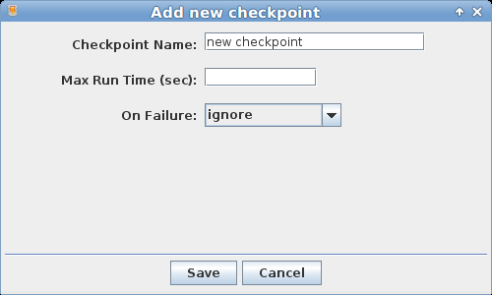

Enter Checkpoint Name, a Max Run Time and a max runtime failure status if desired. Click the Save button to save the check point.

to save the test.

Creating a Database Test
Pull up the Initialize New Test dialog as described in the Creating a New Test section and complete the entries as desired. Ensure that the Test Type of Database is selected from the drop down. Click Continue to load the initial database test setup panel.

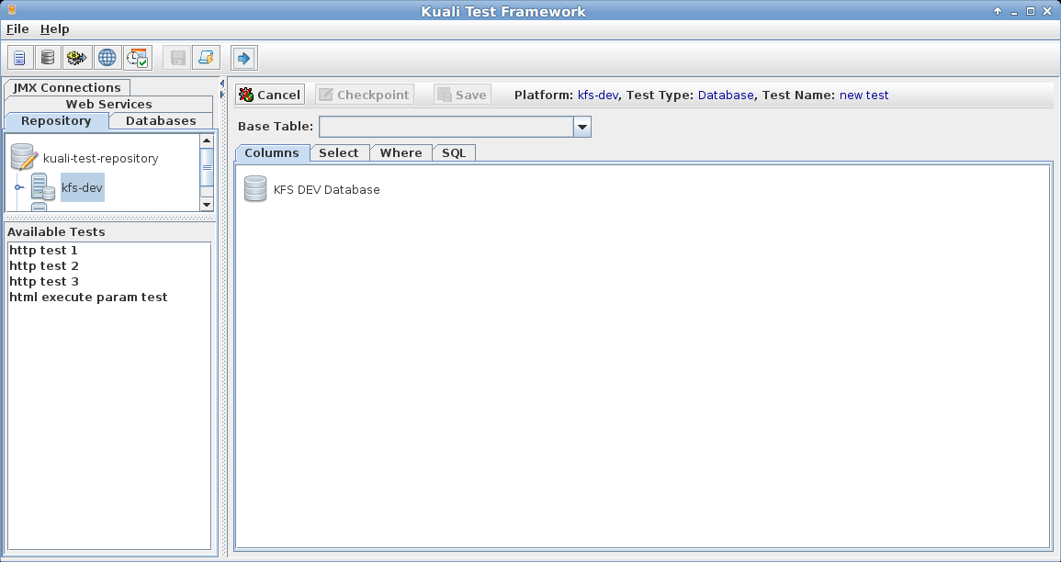

To begin the process of creating a SQL query for the database test, select a base table from the Base Table drop down.

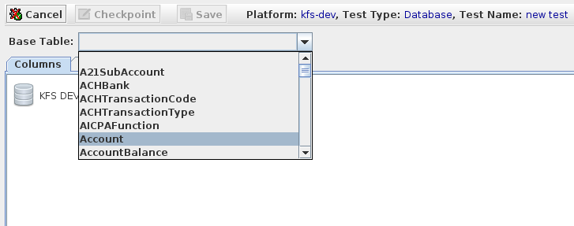
Once selected the SQL query creation tabs will display.

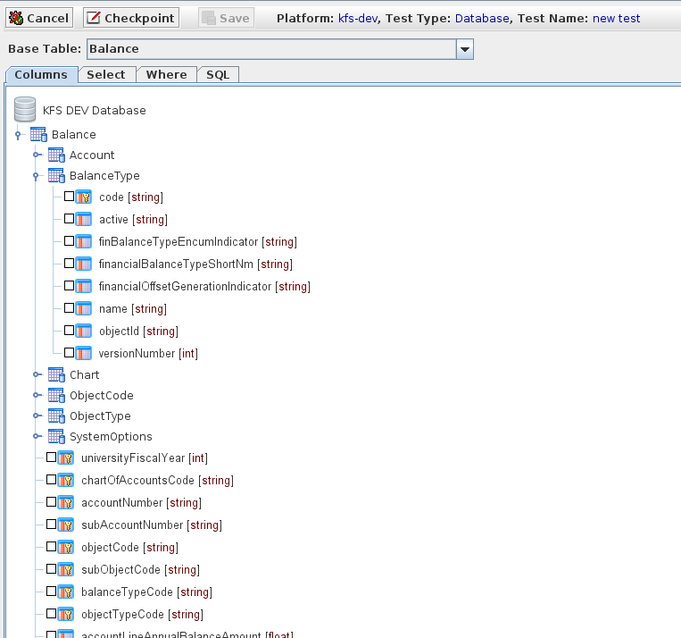

Selecting Columns for Database Query
The first step in creating a SQL query is to select the desired tables/columns you want to work with. The Columns tab of the SQL query panel provides a tree display of related tables with the Base Table selection as the root. Table relationships are displayed based on database foreign key constraints. You can also create pseudo foreign key relationships as described in section Additional Database Information. Description of the various column selection tree elements are described below:

Database associated with test platform
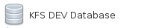

Database Table

Table Column

Primary Key Table Column

Column data type is displayed in square brackets:

As mentioned earlier, the table hierarchy is based on foreign key constraints with the selected base table as root. To display the foreign key information hover the cursor over the table of interest:

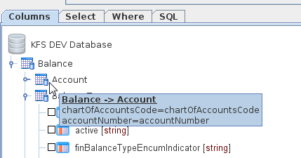

By default multi-table column selections will create an inner-join query. If an outer join is desired, right click on the table desired and select the outer join option:

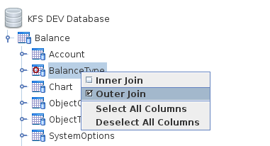

The table will display with a red “O” to indicate that this relationship will generate an outer join.

Click the check box next to all columns that you wish to include in the SQL query. The selected columns will be the only columns that can be used in the select, where and order by clauses of the generated query.

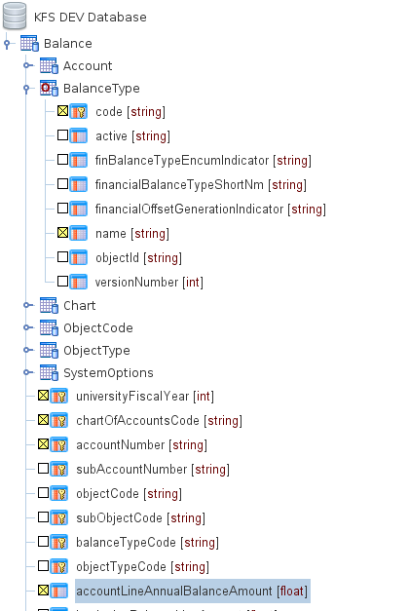

Building SQL Select and Order By Clause
Click the Select tab on the SQL query creation panel to build the select clause:

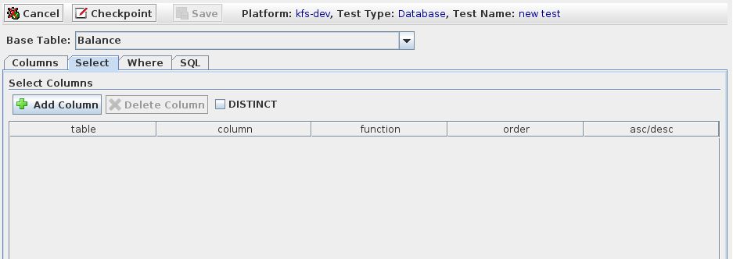
To add a new select column click the Add Column button:

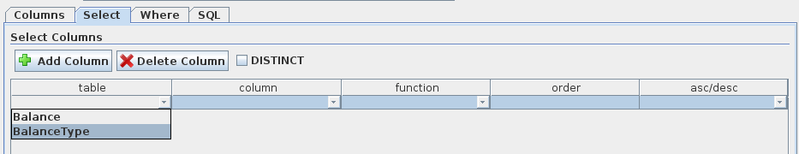

Choose the desired table and column from the drop down selections. To apply an aggregate function to a column choose the desired function from the function drop down.

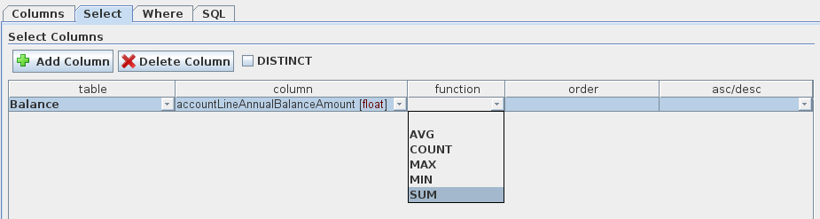

The application will handle generating the correct group by cause if aggregate functions are selected.

Enter an integer order position in the order column if desired to generate an order by clause. If an order position is specified asc/desc can be selected via drop down. If neither ascending or descending is specified the generated order by clause will default to ascending for the column.

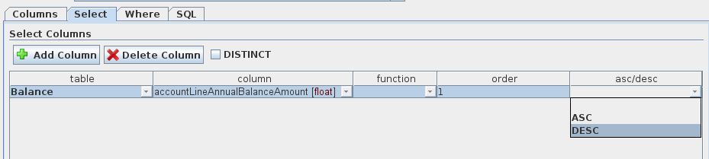

To generate a distinct SQL query check the DISTINCT check box.

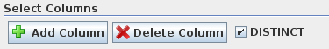

Building SQL Where Clause
Click the Where tab on the SQL query creation panel to build the where clause:

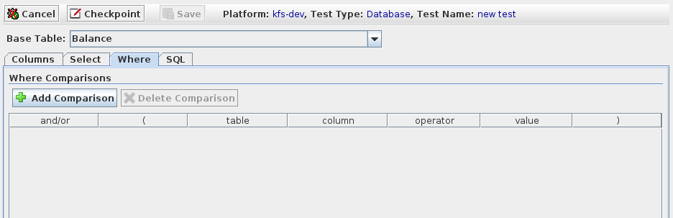
To add a new where comparison click the Add Comparison button

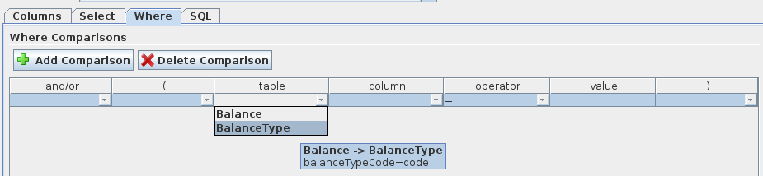

Select the desired table, column and operator then enter an appropriate comparison value.

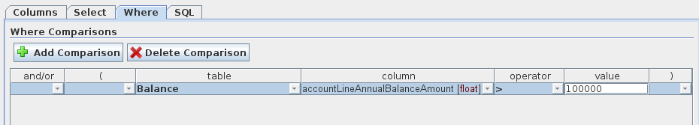

If more than 1 comparison is entered the and/or values and parenthesis values - ( ) - can be selected to further define the where clause.

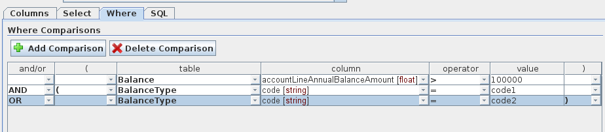

Displaying Generated SQL and Verifying Validity
To view and validate the SQL statement that will be generated, click the SQL tab.

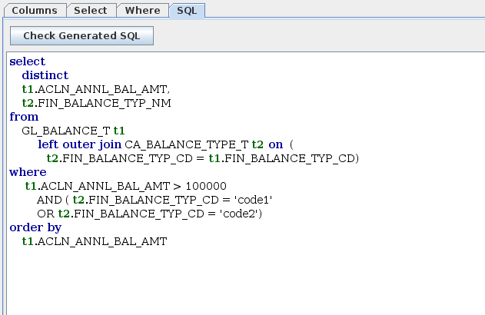
Click the Check Generated SQL button to verify the SQL.

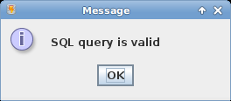

Right click on the SQL display screen and click the Copy SQL popup menu item to copy the generated SQL to the clipboard.

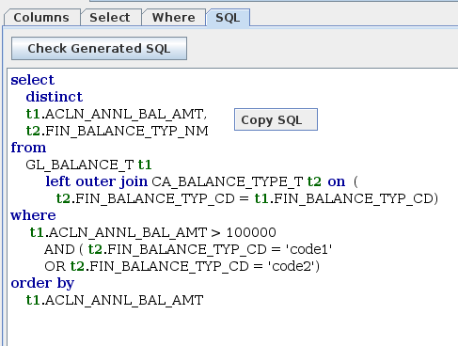

Creating SQL Checkpoint
Once the SQL query is created checkpoints can be applied. Click the Checkpoint button

to display the Add new checkpoint dialog:

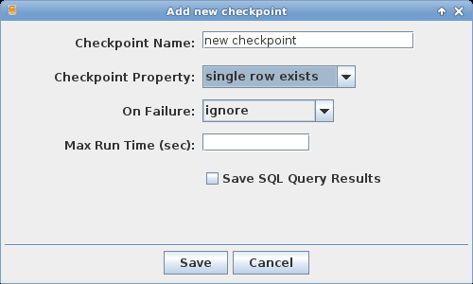

Assign an appropriate name to this check point and select the desired Checkpoint Property for test evaluation purposes.

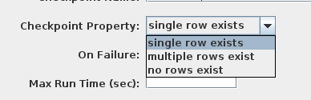

Select the appropriate On Failure status to set in the event of check point failure.

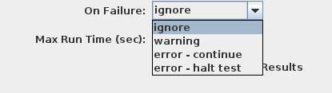

If desired a maximum query run time can be entered. If the query execution exceeds this time then the check point fails.

To save query results generated from a SQL check point query check the Save SQL Query Results check box. The query results will be saved as a comma-delimited file and delivered as an email attachment with the test results email.

Click the save button to close the dialog and save the check point.

To save the SQL test click the test Save button:

Creating a Web Application Test
Pull up the Initialize New Test dialog as described in the Creating a New Test section and complete the entries as desired. Ensure that the Test Type of Web is selected from the drop down. Click Continue to load the initial database test setup panel.

Web Application Test Framework Overview
The web application test framework is relatively complex and requires a bit of an overview.

Test Creator
The test creator is a Java Swing application used to manage the test framework and create tests. For web application tests the test creator uses an embedded native browser instance and an internal proxy server to facilitate test creation as shown in the diagram below:

Test Creator

Embedded Native Browser
DJ Project NativeSwing library for integration of native components into Swing applications

Internal Proxy Server
LittleProxy open source HTTP proxy
Target Web Application
Selected HTTP Requests
(HTTP requests saved to test XML file)

The proxy server allows the application to act as a “man-in-the-middle” and grab non encrypted HTTPS requests before they are sent to the target web application. To use the proxy server the test creator must be started with the appropriate input parameters as described in section Test Creator Command Line.

Test Runner
The test runner is a multi-threaded Java application that executes scheduled tests. For web application testing the test runner executes HTTP requests from a test file using the Apache Http Client libraries as shown in the diagram below:
Test Runner
Test Scheduler
Picks up test files, creates a test execution context thread and starts test execution.
Test Execution Context
Pulls HTTP test requests from input test XML file submits the requests to the internal Apache HTTP Client, evaluates the returned response and generates test results email.

Apache HTTP Client

Target Web Application
Test Results Email

Starting a Web Application Test
After clicking the Continue button on the Initialize New Test dialog the web test panel should display.

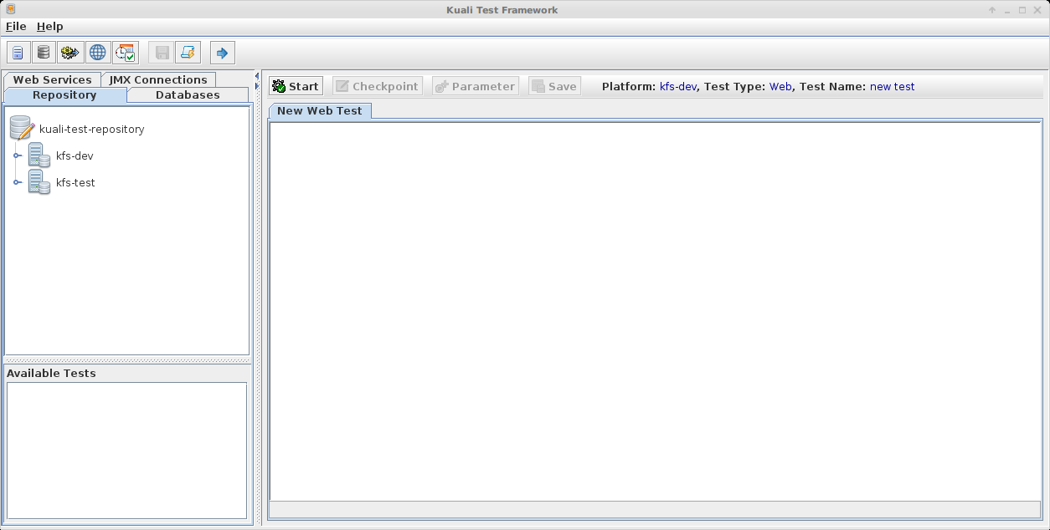
Click the Start button to begin the test.

Once the web test is initialized the default native browser should display in the web test panel:

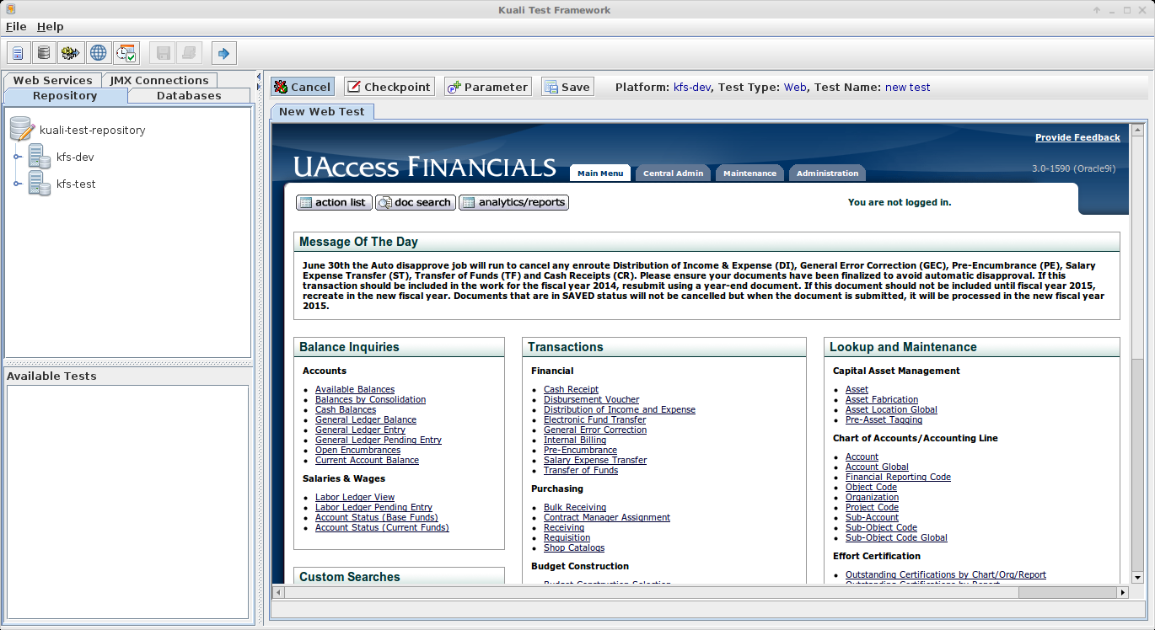

Now you can navigate through the target web application as normal. At any point you can click the Checkpoint button

to create a check point that will be used as evaluation criteria during test runs. To better see the full web page click the split pane icon shown below – this will close the management pane:

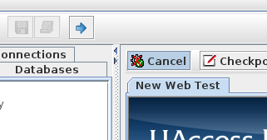

Close and Open
Split Pane

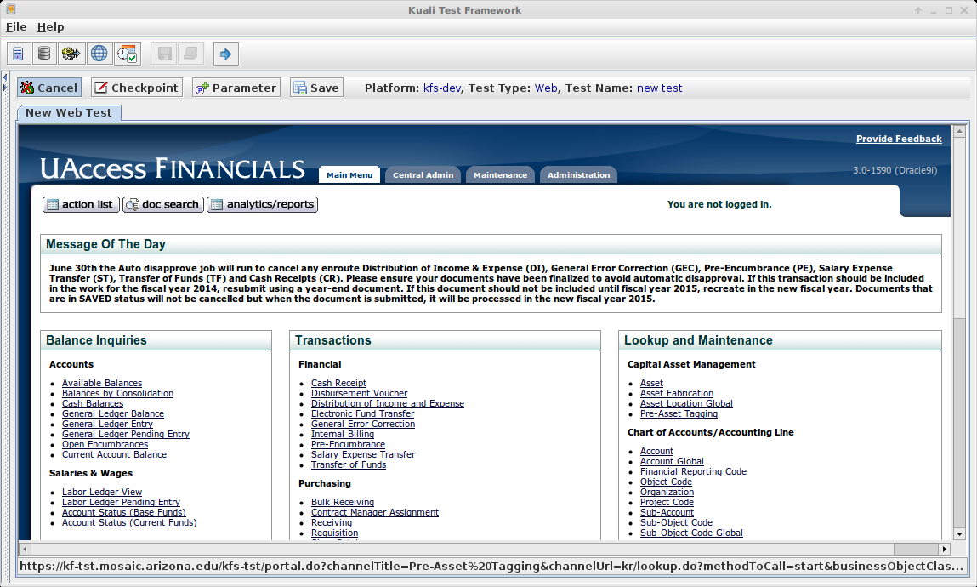

Creating a Web Checkpoint
To create a web check point click the Checkpoint button while on a web page of interest. In the example below the user is displaying a requisition document:

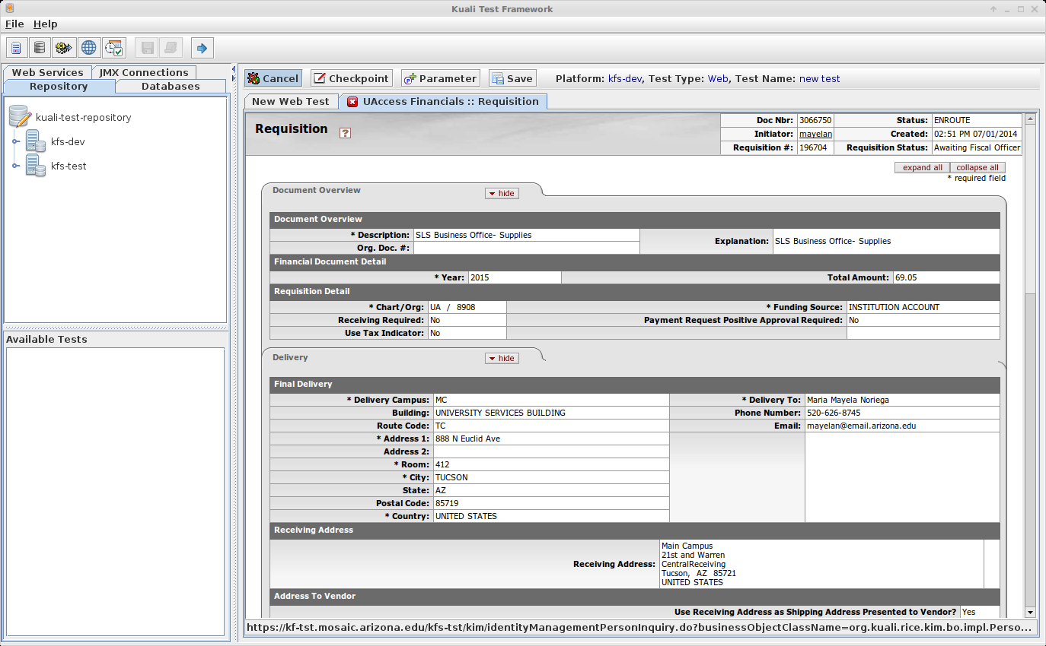
When the checkpoint button is clicked the Select Check Point Type dialog will display:

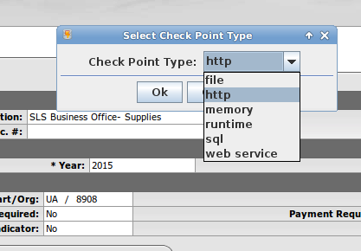

Web tests support multiple check point types. The check point types file, sql and web service are quite similar to the file, database and web service tests discussed previously. The memory check point provides the ability to run JVM memory tests on the JMX connection associated with the test platform.

To create an HTTP checkpoint choose http from the drop down and click Ok – this will display the Add new checkpoint dialog.

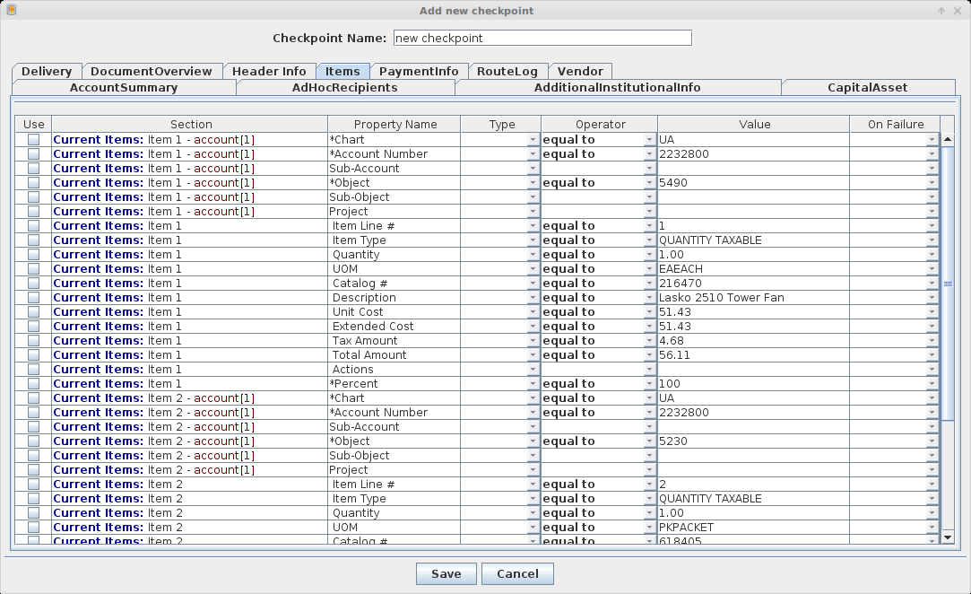

The layout of the HTTP check point dialog will vary depending on the source HTML page. Layout configuration (the way the HTML tags are displayed on the check point screen) is determined by a set of configurable tag handler objects that use XML tag handler definitions as input. This design allows the kuali test application to handle complex web pages in a flexible, generic manner. In the example above, there are tag handlers configured to support the KFS tab-based document display. Tag handler configuration will be discussed in detail later in this document but a couple of example XML snippets are shown below:

Default text input tag handler
<handler>
<tag-name>input</tag-name>
<handler-class-name>
org.kuali.test.handlers.TextInputTagHandler
</handler-class-name>
<tag-matchers>
<tag-matcher>
<match-type>current</match-type>
<tag-name>input</tag-name>
<match-attributes>
<match-attribute>
<name>type</name>
<value>text</value>
</match-attribute>
</match-attributes>
</tag-matcher>
</tag-matchers>
</handler>

Capital Asset Tab System Selection tag handler
<handler>
<application>KFS</application>
<tag-name>td</tag-name>
<handler-class-name>
org.kuali.test.handlers.TdTagHandler
</handler-class-name>
<tag-matchers>
<tag-matcher>
<match-type>current</match-type>
<tag-name>td</tag-name>
<match-attributes></match-attributes>
</tag-matcher>
<tag-matcher>
<match-type>parent</match-type>
<tag-name>table</tag-name>
<match-attributes>
<match-attribute>
<name>class</name>
<value>datatable</value>
</match-attribute>
<match-attribute>
<name>summary</name>
<value>System Selection</value>
</match-attribute>
</match-attributes>
</tag-matcher>
<tag-matcher>
<match-type>sibling</match-type>
<tag-name>th</tag-name>
<search-definition>-1</search-definition>
<match-attributes></match-attributes>
</tag-matcher>
</tag-matchers>
<label-matcher>
<tag-matcher>
<match-type>sibling</match-type>
<tag-name>th</tag-name>
<search-definition>-1</search-definition>
<match-attributes></match-attributes>
</tag-matcher>
</label-matcher>
<handler-name>kfs2</handler-name>
</handler>

In the current example the check point dialog is displaying requisition document data. The tag handlers have been configured to display this data as follows:
- Kuali KFS Tabs such as those shown below
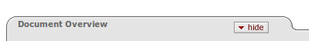

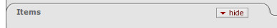

will show as Tabs in the checkpoint dialog

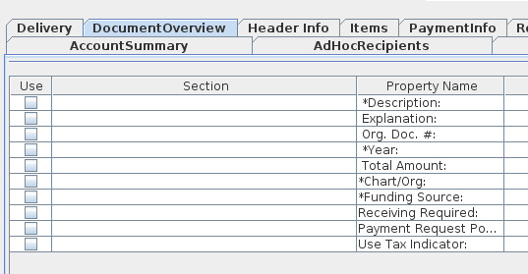

- Header values on the KFS document tabs such as those shown below

will show under the Section column in the checkpoint dialog

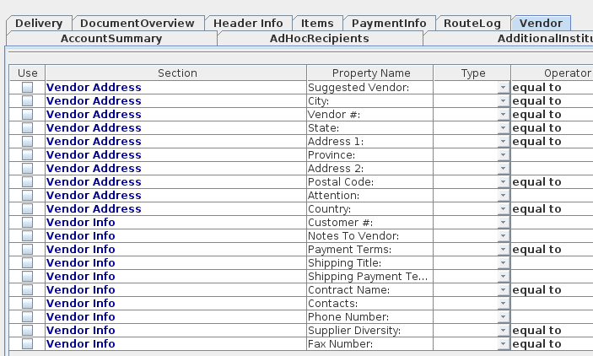

- Data labels such as the ones shown below

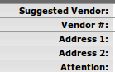

will show under the Property Name column in the checkpoint dialog

Creating Web Checkpoint Properties
A web check point can contain multiple check point properties. The check point properties will be evaluated in future test runs to determine test pass/fail status. To select check point properties pull up the web check point dialog and check the Use check box for the desired properties then select valid entries for the Type, Operator, Value and On Failure columns.

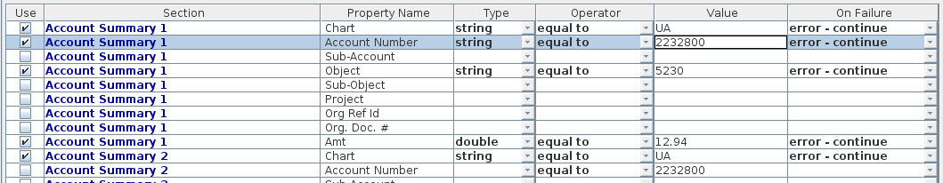
Enter a check point name and click the Save button to save the check point.
A web test can contain multiple check points of varying types. When the test is run the check points will be evaluated against the current test execution values.

Creating Web Test Execution Parameters
During a web application test there are times when we must use a value from the current test execution context in web operations later in the test. Consider the example scenario below:

- Pull up the KFS application and login
- Create a new requisition and save
- Perform other KFS web operations that would impact the new requisition
- Pull up the requisition and create a check point to test tax amount and other account information.

In the scenario above when the original test is created the document number of the requisition would be saved in the test file. When the test is run we would not want to use the original document number but the new document number created during the current test run. A test execution parameter can be used to solve this problem.

Again consider the example outlined above. Assume we are sitting in the test application at the create requisition screen as shown below:

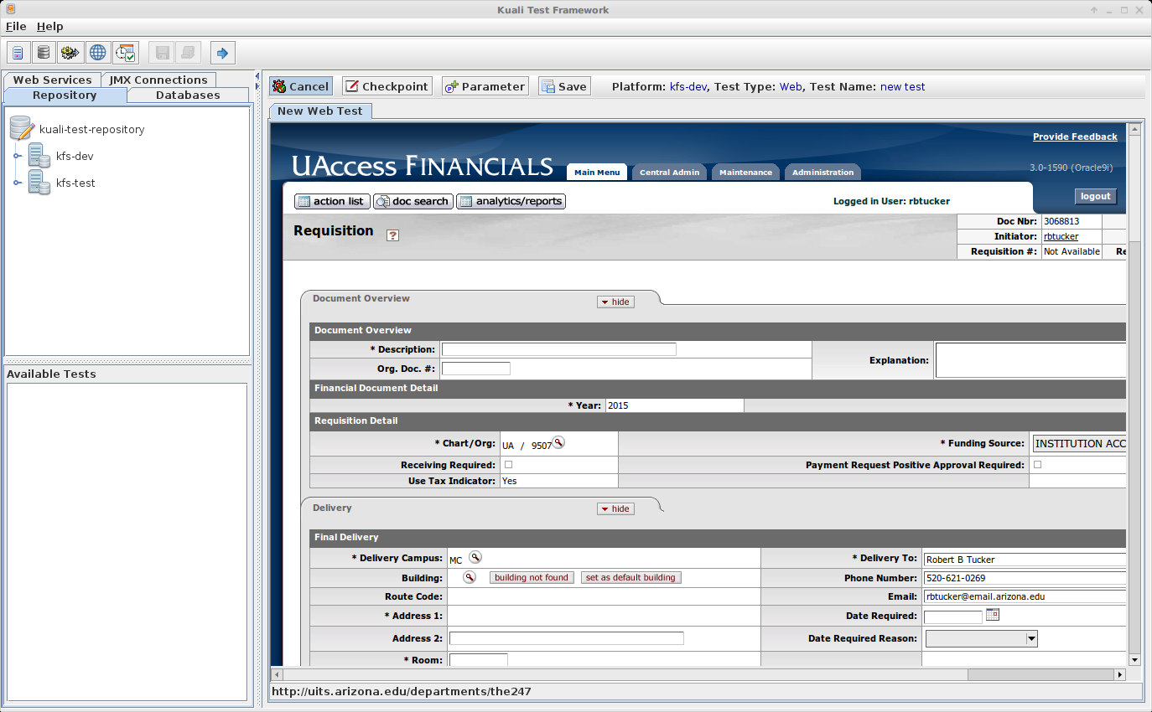
As you can see the generated document number for the new requisition is shown in the upper right corner:

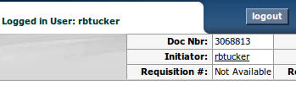

This is the number we would like to grab and pass along during the test. To do this click the Parameter button

To display the Add new test execution parameter dialog.

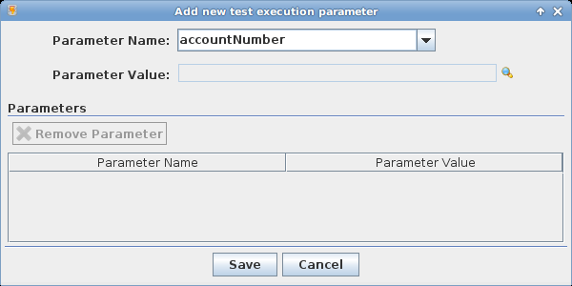

Select the appropriate Parameter Name from the drop down list. The parameter name setup is discussed in the Test Creator Tool Bar and Main Menu under the Getting Started section of this document.

For this scenario we would choose the parameter name documentNumber.
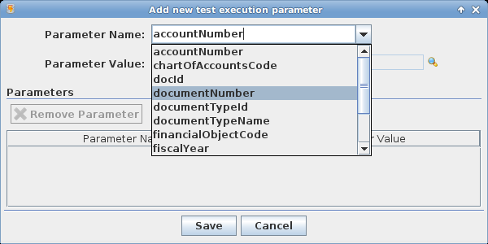

Now click the lookup icon on the Parameter Value field to display the Test Execution Parameter Select dialog, choose the row with Doc Nbr: under the Name column and click Ok to close the dialog.

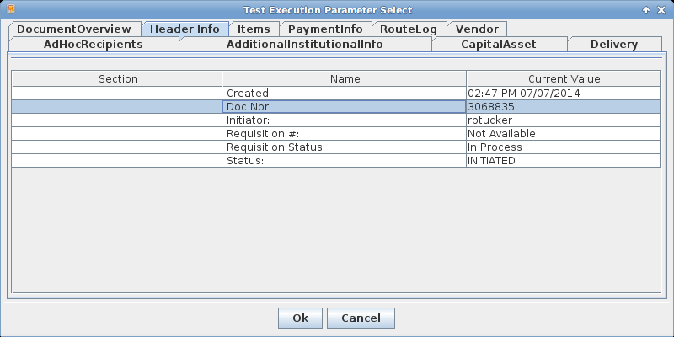

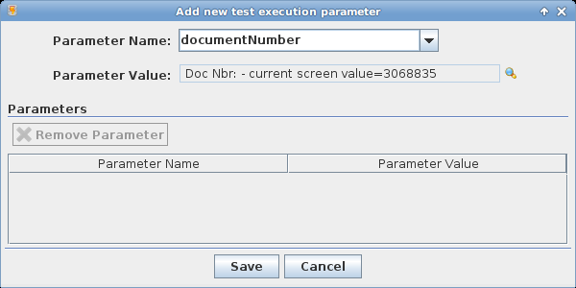

Any existing parameters will display in the Parameters table. Once set, all HTTP requests containing the parameter documentNumber will have the value set to the number associated with the screen value as described in the scenario above. To clear a test execution parameter, click the Parameter button

select the parameter you wish to remove from the Parameters table, click the Remove Parameter button then click Save.
In cases where a parameter name is not standardized and may have several names, for example – documentNumber, docId, docNbr – just repeat the process described above for each name.

Test Management Panel
The test management panel provides the user interface to manage the various test entities created by the application and consists of 4 tabs – Repository, Databases, Web Services and JMX Connections:

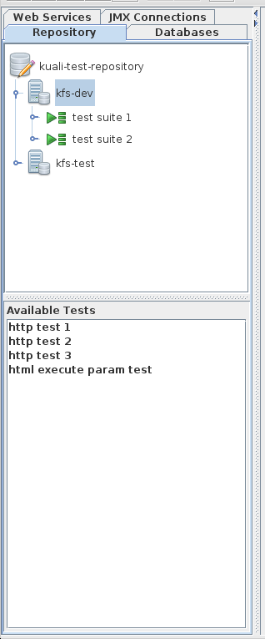

Repository
The repository tab is a logical representation of the test repository. The upper pane contains a tree view of the test repository. The lower pane lists available platform tests for a selected platform. Most functionality is driven by a popup menu. Several of which are shown below. When a test is created for a platform it will appear in the Available Tests list. Test can be run individually or added to a Test Suite. To add available tests to a test suite, create the test suite and drag the tests from the available tests list to the desired test suite in the repository tree.

Platform Popup Menu
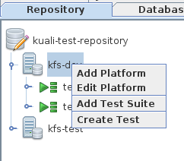

Test Suite Popup Menu
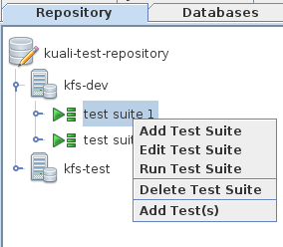

Test Popup Menu
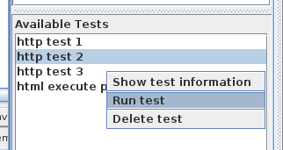

Databases
The databases tab displays a tree view of all JDBC connections setup in the application. Functionality is driven by a popup menu.

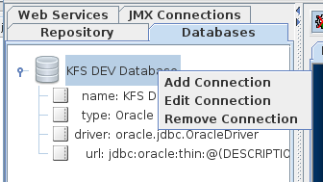

Web Services
The web services tab displays a tree view of all web service URLs setup in the application. Functionality is driven by a popup menu.

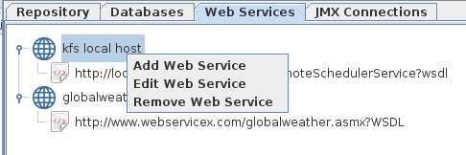

JMX Connections
The JMX connections tab displays a tree view of all JMX URLs setup in the application. Functionality is driven by a popup menu.

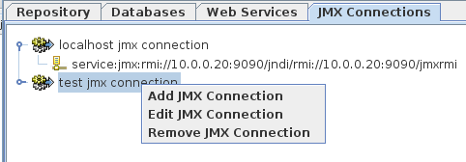

Test Scheduling
To schedule the running of tests and test suites click File->Schedule Tests... menu item on the application main menu or the schedule tests tool bar button
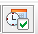

to display the Schedule Tests dialog.

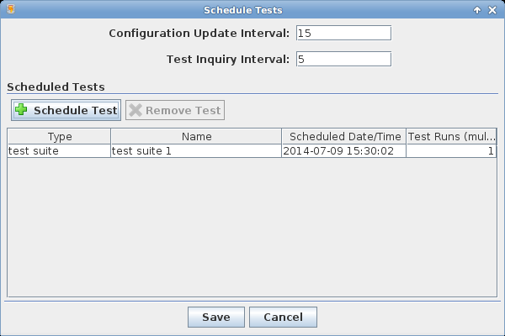
Currently scheduled tests will display in the Scheduled Tests table. To remove a currently scheduled test select the desired row in the table and click the Remove Test button.

The Configuration Update Interval entry defines how often in minutes that the test runner will update the schedule from the schedule file. When the schedule is modified and saved it is written as an XML file. The test runner will pick up this file at the defined interval.

The Test Inquiry Interval defines how often in minutes that the test runner will look for tests that are ready to run. At the defined interval any scheduled tests with a run time less than or equal to the current time will run. Once a test is run it is removed from the schedule.

To schedule a test or test suite click the Schedule Test button

to display the Schedule Test dialog.
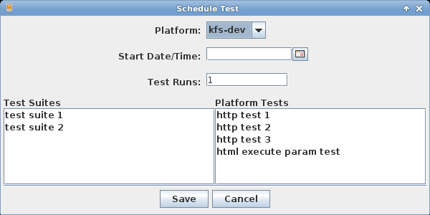

Choose the desired platform from the Platform drop down and select a Start Date/Time by clicking on the calendar icon.

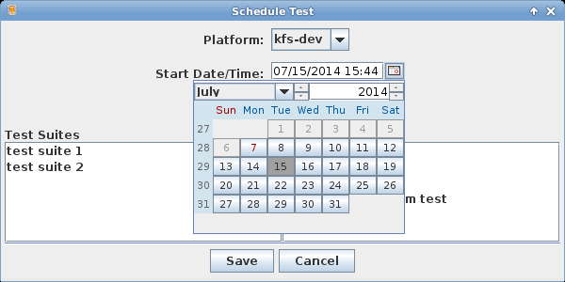

The start date and time must be in the future. The Test Runs entry defaults to 1. You can enter a number greater than 1 and the test runner will spawn off multiple threads to asynchronously run the entered number of instances of the selected test/test suite.

Choose the desired platform test or test suite to run and click Save to schedule the test.
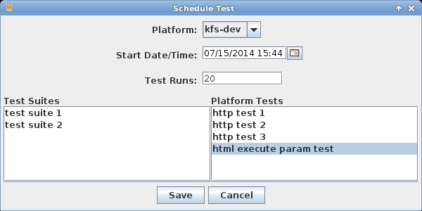

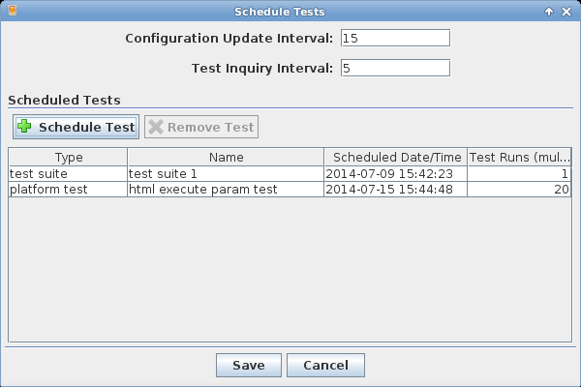

Tag Handler Configuration Detail
Full details of tag handler XML configuration will go here.

