Wyant College of Optical Sciences Remote Sensing Group (RSG) Blacklab Facility
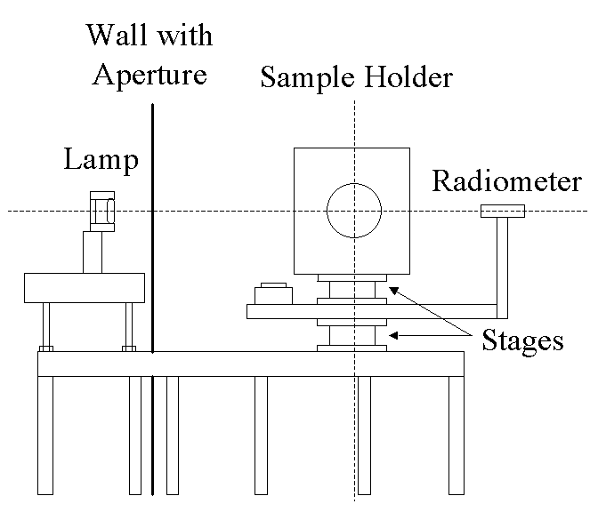
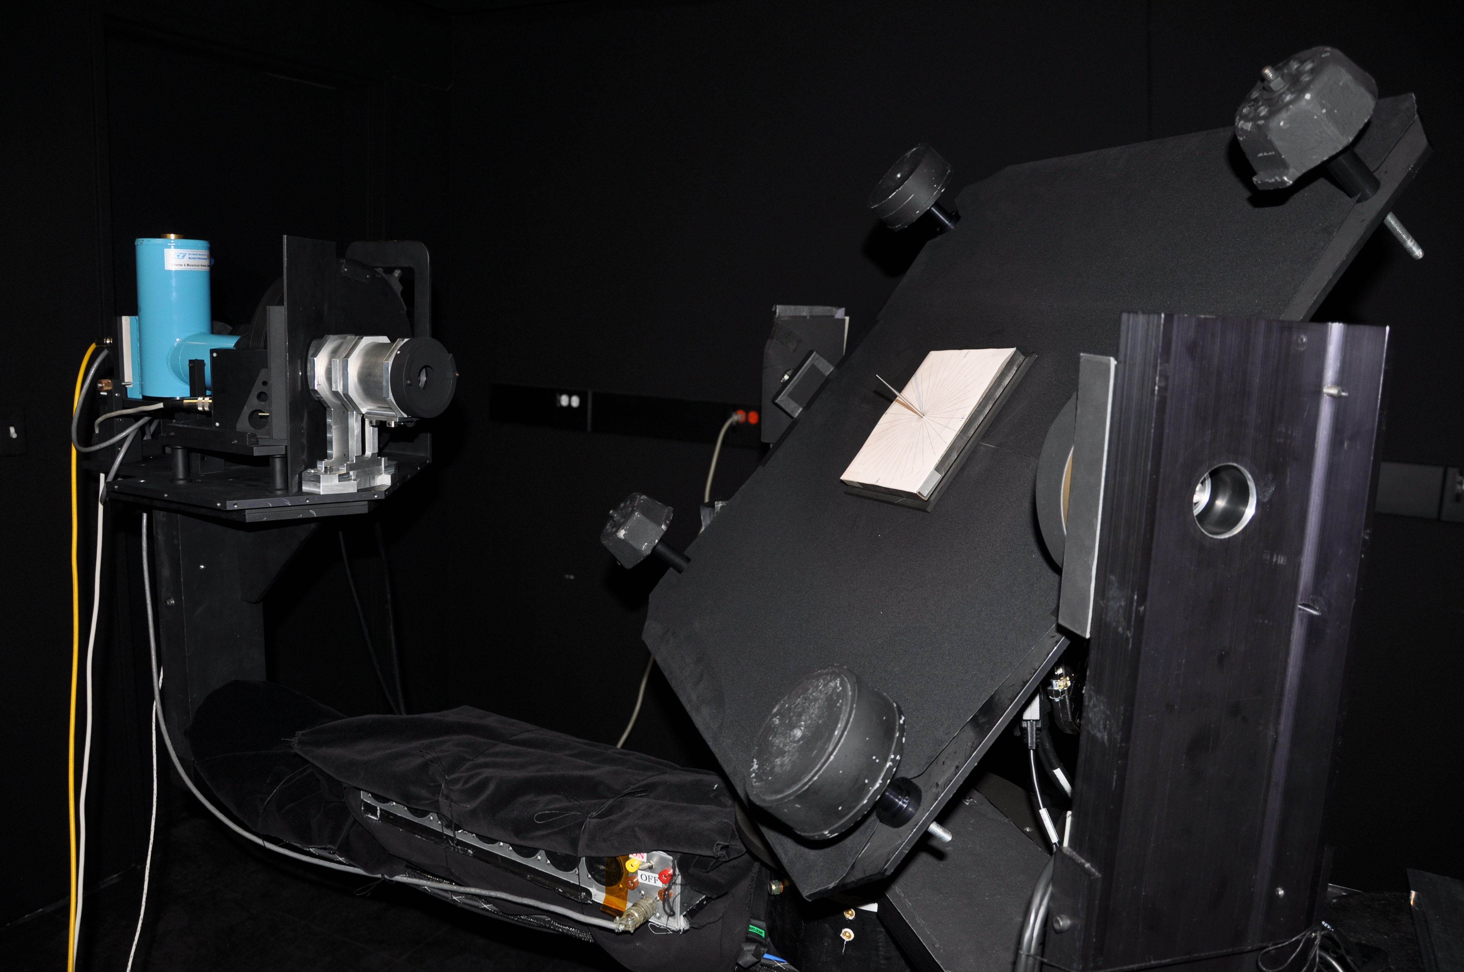
The bi-directional reflectance factor (BRF) for a sample is the unit-less ratio of the reflected radiant flux from a sample to the reflected radiant flux from a perfect Lambertian surface for a specified set of incident and reflected angles and wavelengths. Because a truly Lambertian surface does not exist, measurements in our facility are made using a relative method where the traceable standard is a Spectralon® panel calibrated at NIST (0°/45° RF data applicable for wavelength range of 350 nm and 2500 nm). The sample room consists of a goniometer with 4 servo motor-controlled rotary stages (controlling incident and reflected angles, tilt, and sample rotation) and two filter-based radiometers (silicon detector and InSb detector). Custom software automatically cycles through configurable sets of angle and filter measurements. The source room houses a quartz halogen 1 KW lamp operated at constant current. The default lamp distance is 2 m from the panel so the solid angle of the source approximates the size of the solar disk. Light source distance, wall aperture, and bandpass filter selections are customizable.
RSG Blacklab layout overview (not to scale)
Sample room stage, radiometer, and sample holder goniometric system with SWIR radiometer viewing shadow alignment test jig
Sample Sizes
The default configuration is for samples up to 500 mm with a maximum thickness of 26 mm. The minimum sample size is 10 mm (viewing at normal incidence) with an optional FOV limiter installed. Samples other than standard Spectralon® sizes may require fabrication of custom mounting hardware.

Expected Uncertainty in % RF at example wavelengths
Wavelength (nm) | 400 | 650 | 1650 | 2330
Lamp effects
Stray light | 0.21 | 0.22 | 0.24 | 0.25
Current uncertainty | 0.08 | 0.05 | 0.02 | 0.02
Current stability | 0.1 | 0.06 | 0.02 | 0.02
Current uncertainty | 0.08 | 0.05 | 0.02 | 0.02
Current stability | 0.1 | 0.06 | 0.02 | 0.02
Alignment | 0.4 | 0.4 | 0.4 | 0.4
Lamp senescence & drift | 0.5 | 0.2 | 0.1 | 0.1
Reference effects
RF spectral change | 0.1 | 0.1 | 0.1 | 0.9
NIST uncertainty | 0.285 | 0.225 | 0.22 | 0.24
Instrumentation
Spectral uncertainty | 0.5 | 0.16 | 0.1 | 0.1
Signal measurement unc. | 0.015 | 0.015 | 0.5 | 0.5
Detector/amp ‘SNR’ | 0.5 | 0.5 | 0.1 | 0.1
Detector/amp ‘SNR’ | 0.5 | 0.5 | 0.1 | 0.1
Stability | 0.2 | 0.2 | 0.2 | 0.2
Repeatability | 0.5 | 0.5 | 0.5 | 0.5
Transmittance | 0.1 | 0.1 | 0.1 | 0.1
RSS Total (k=1) | 1.3 | 1.1 | 0.9 | 1.3

On-Hand Radiometer Bandpass Filters
Center Wavelength (nm) | Bandpass (nm)
385 | 26
415 | 10
448 | 20
503 | 40
539 | 30
632 | 22
684 | 24
810 | 10
850 | 10
1061 | 10
1244 | 20
1646 | 30
2130 | 10
2134 | 50
2164 | 40
2208 | 40
2220 | 10
2262 | 50
2332 | 70
2403 | 70
940 (water vapor) | 10
1381 (water vapor) | 30

