**Sea Ice NOAA Indicators** Freeze-up Break-up Dates derived from NSIDC-0051

**Table 2:**

Comparison of sea-ice cycle phenologies for the Chukchi/Beaufort Seas, 1979—2007

|  |  |  |  |
| --- | --- | --- | --- |
|  | this study  chukchi-beaufort | paper chukchi/beaufort | this vs. paper chukchi/beaufort |
| freezeup_start | 10-16 | 10/16 | same |
| freezeup_end | 11-07 | 11/2 | 5 days later |
| breakup_start | 06-05 | 5/28 | 8 days later |
| breakup_end | 08-13 | 8/1 | 12 days later |

**Table 3:**

Climatological freeze-up and break-up dates with seasonal durations for the Chukchi and Beaufort Sea coastal regions, 1979–2013

|  |  |  |  |  |  |  |
| --- | --- | --- | --- | --- | --- | --- |
|  | this study beaufort | paper  beaufort | this vs. paper beaufort | this study chukchi | paper chukchi | this v paper chukchi |
| freezeup_start | 10-05 | 10/3 | 2 days later | 10-15 | 10/9 | 6 days later |
| freezeup_end | 11-16 | 11/14 | 2 days later | 12-08 | 12/1 | 7 days later |
| breakup_start | 05-10 | 4/24 | 16 days later | 05-04 | 5/2 | 2 days later |
| breakup_end | 08-13 | 8/10 | 3 days later | 07-28 | 8/1 | 4 days earlier |

**Table 4:**

Mean freeze-up and break-up dates and trends for the Chukchi and Beaufort Sea coastal regions, 1979–2013

|  |  |  |  |  |  |  |
| --- | --- | --- | --- | --- | --- | --- |
|  | this study beaufort | paper beaufort | this v paper beaufort | this study chukchi | paper chukchi | this v paper chukchi |
| freezeup_start | 10-16 | 10/16 | same | 10-24 | 10/21 | 3 days later |
| freezeup_end | 11-04 | 10/30 | 4 days later | 11-18 | 11/10 | 8 days later |
| breakup_start | 06-06 | 5/26 | 11 days later | 05-27 | 5/24 | 3 days later |
| breakup_end | 08-12 | 8/1 | 11 days later | 07-31 | 7/28 | 3 days later |

**Figure 4:**

Sea-ice concentration record of Barrow, Alaska.

1997-1998

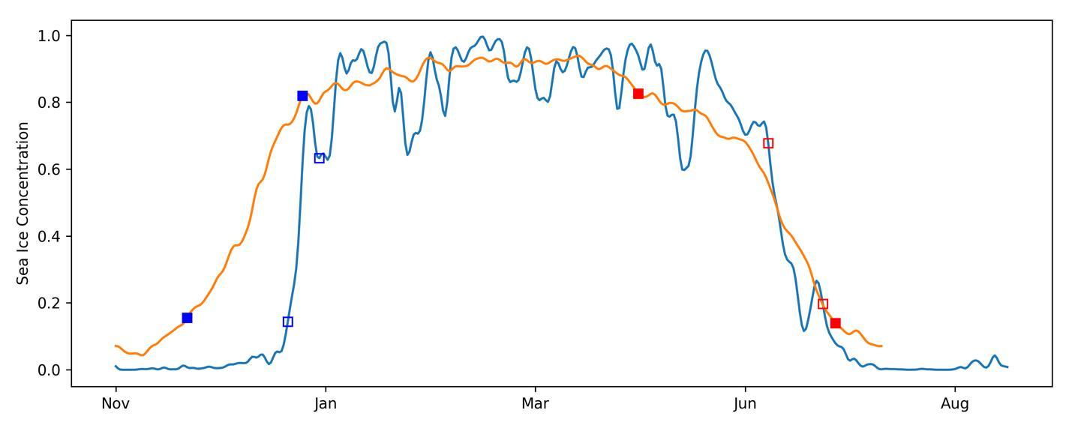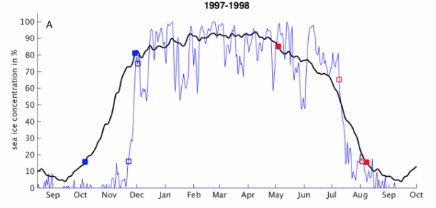

The daily ice concentration from this study (top) is visibly smoother than what is shown in the paper (bottom).

Where is the “summer” climatology sea ice? It is needed for computing the end of break up because the summer (Aug-Sep) is needed to calculate spring breakup.

2005-2006

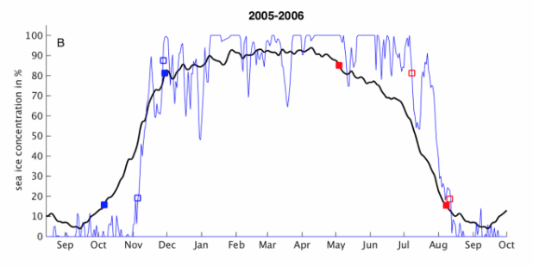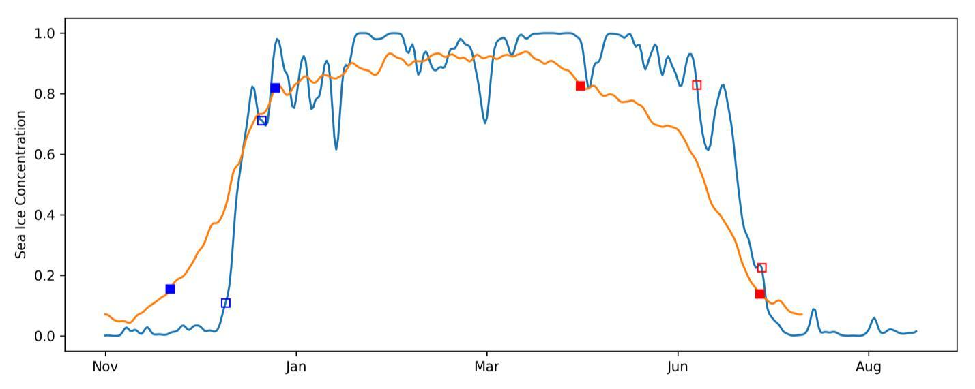

Same as above regarding smoothness, especially in Sep-Oct and winter at 100%

**Figure 5:**

Freeze-up and break-up with two summer ice events.

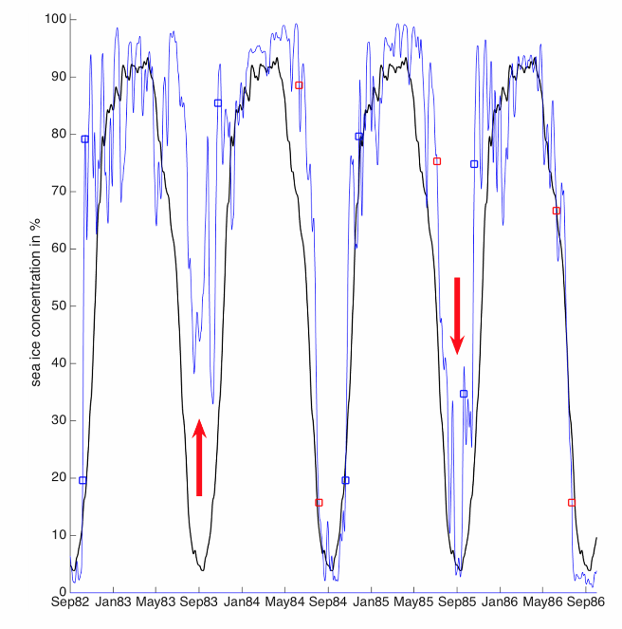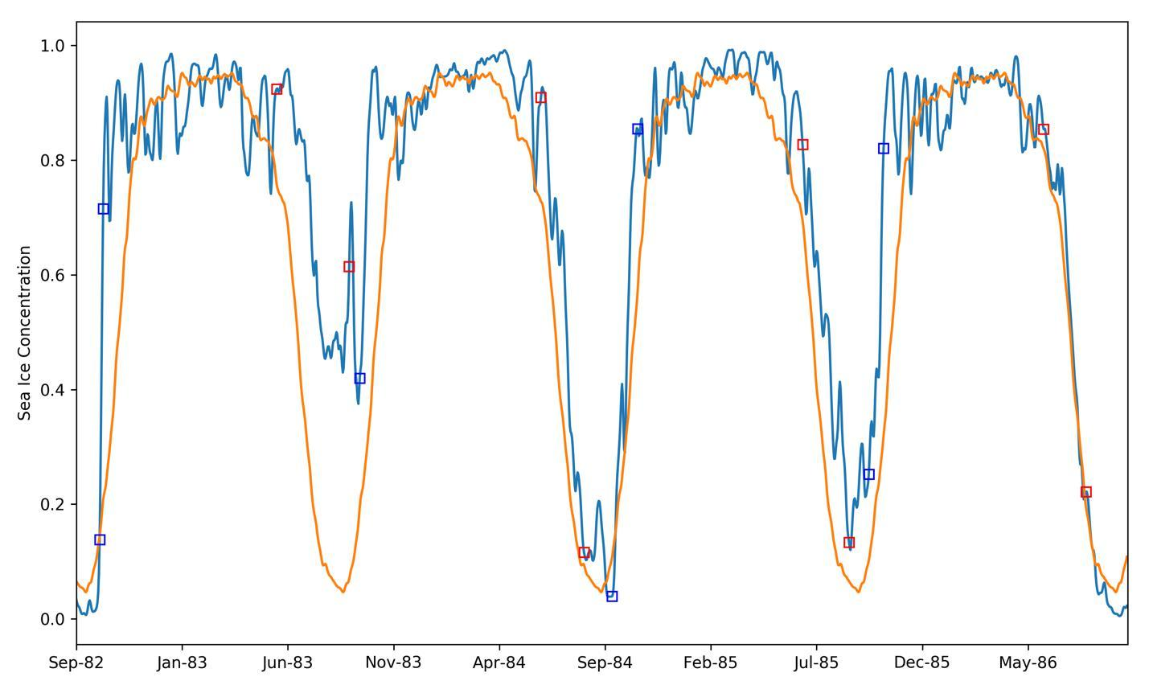

Summer of ‘83 are very different between two studie, as is the SIC in Fall of 1985. The **dates** for summer of ‘84 are visibly different.

**Figure 6:**

Freeze-up and break-up from 2007 to 2012.

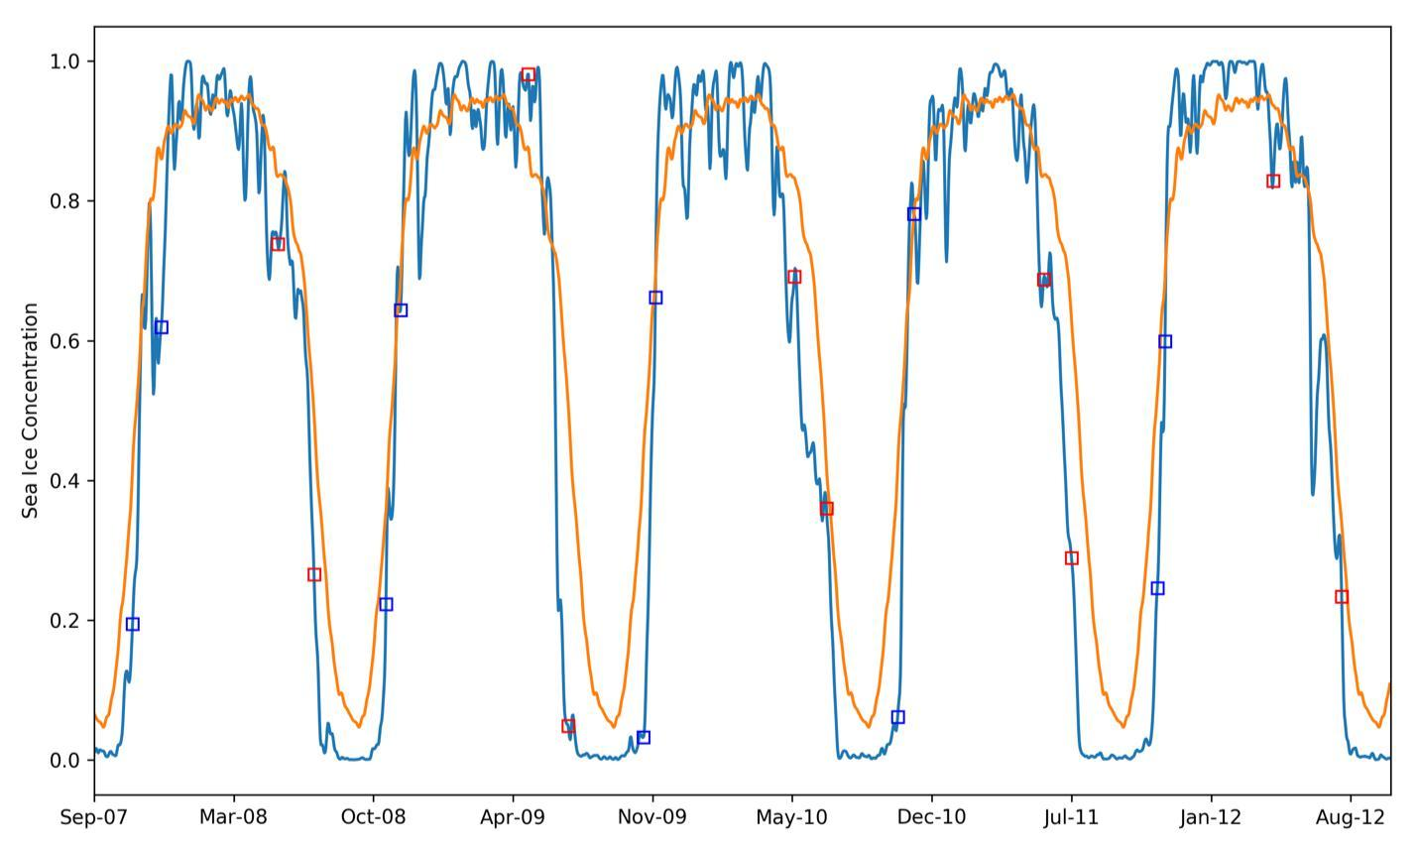

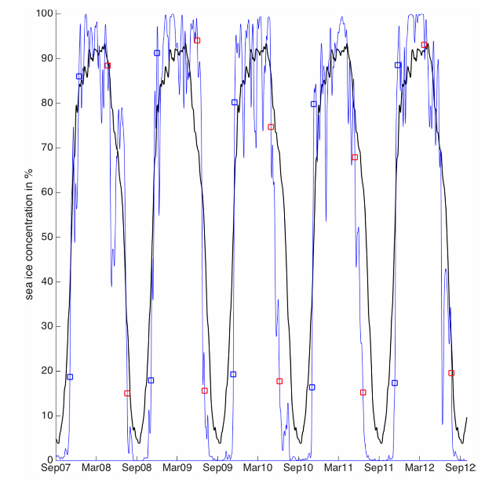

The daily SIC is different in spring of 2008, summers of 2009 and 2010.