**Sea Ice NOAA Indicators**

Freeze-up Break-up Dates derived from NSIDC-0051

January 26, 2019

Progress Update

**CODEBASE:**

Processing pipeline has been completed and is a simple way for us to run the freeze-up/break-up (FUBU) dates from the NSIDC-0051 daily Sea Ice Concentration time-series. This code base covers all bases from download, prep, smoothing, FUBU, and plotting to mimic what was done in the paper.

Repository: <https://github.com/ua-snap/seaice_noaa_indicators>

The processing steps are laid out in the readme.md file in the root folder and the script order is listed in the readme.md in the `pipeline` folder. More cleanup and documentation is in the works, for clarity and re-use in the future.

**OUTPUTS:**

**Study Area (with the points I attempted to lift from the paper):**

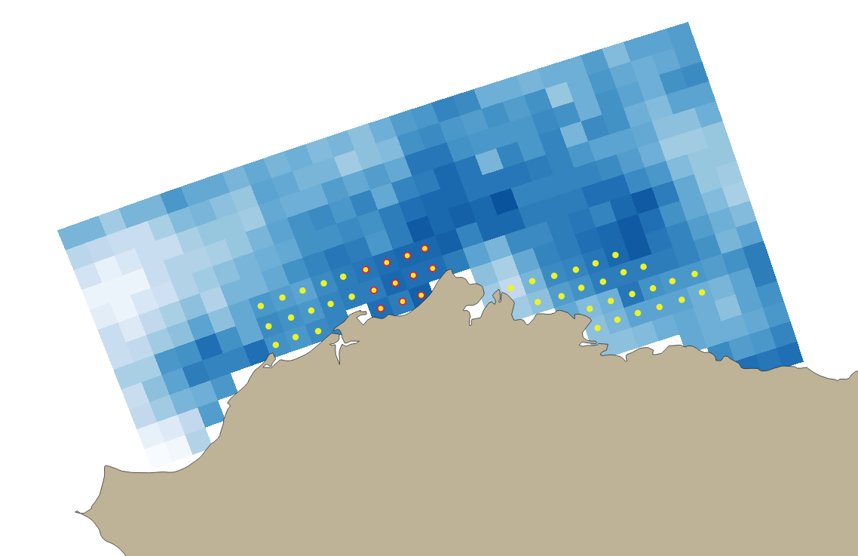

**Table 2:**

Comparison of sea-ice cycle phenologies for the Chukchi/Beaufort Seas, 1979—2007

|  |  |  |  |  |
| --- | --- | --- | --- | --- |
|  | barrow | beaufort | chuckchi | chuckchi-beaufort |
| freezeup_start | 10-18 | 10-14 | 10-20 | 10-16 |
| freezeup_end | 11-11 | 11-01 | 11-17 | 11-07 |
| breakup_start | 06-12 | 06-08 | 05-30 | 06-05 |
| breakup_end | 08-17 | 08-17 | 08-05 | 08-13 |

**Table 3:**

Climatological freeze-up and break-up dates with seasonal durations for the Chukchi and Beaufort Sea coastal regions, 1979–2013

|  |  |  |  |  |
| --- | --- | --- | --- | --- |
|  | barrow | beaufort | chuckchi | chuckchi-beaufort |
| freezeup_start | 10-07 | 10-05 | 10-15 | 10-08 |
| freezeup_end | 11-30 | 11-16 | 12-08 | 11-24 |
| breakup_start | 05-06 | 05-10 | 05-04 | 05-08 |
| breakup_end | 08-09 | 08-13 | 07-28 | 08-07 |

**Table 4:**

Mean freeze-up and break-up dates and trends for the Chukchi and Beaufort Sea coastal regions, 1979–2013

|  |  |  |  |  |
| --- | --- | --- | --- | --- |
|  | barrow | beaufort | chuckchi | chuckchi-beaufort |
| freezeup_start | 10-21 | 10-16 | 10-24 | 10-19 |
| freezeup_end | 11-12 | 11-04 | 11-18 | 11-09 |
| breakup_start | 06-07 | 06-06 | 05-27 | 06-03 |
| breakup_end | 08-12 | 08-12 | 07-31 | 08-07 |

* [Note]: Some of the above FUBU dates do not fit exactly (or in some cases, even closely) with the dates from the paper. I am still digging in to what might be causing these shifts in dates, but due to the fact that I am not able to fluidly test the old code, nor do I have the *exact* locations of the points used in extraction from the Chuckchi, Barrow, Beaufort regions, this is where it currently falls out.

**Figure 4:**

Sea-ice concentration record of Barrow, Alaska.

1997-1998:

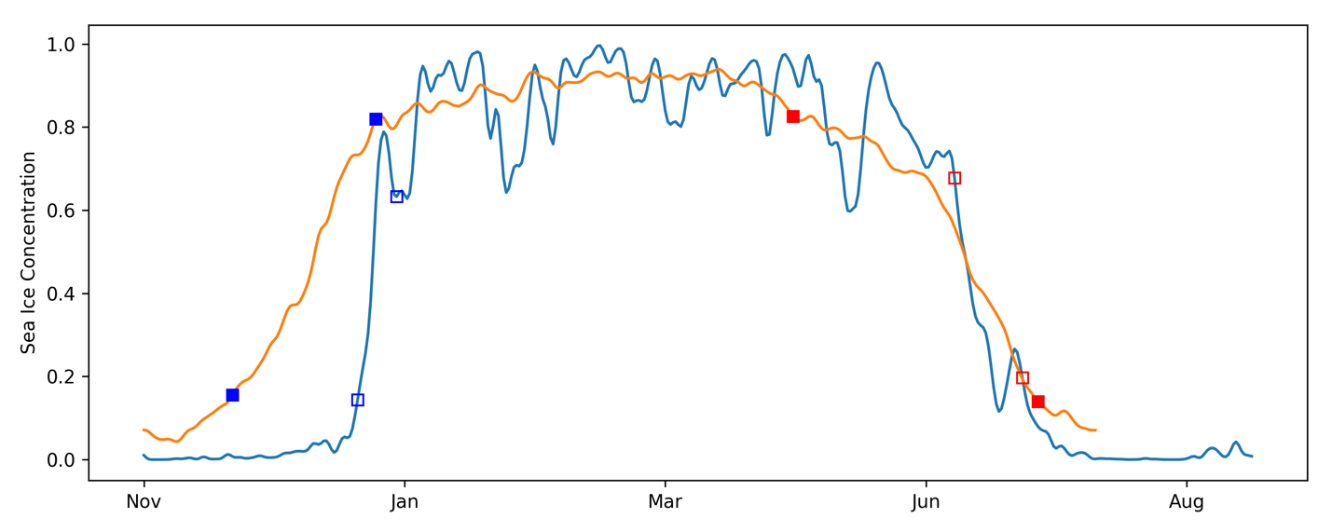

2005-2006:

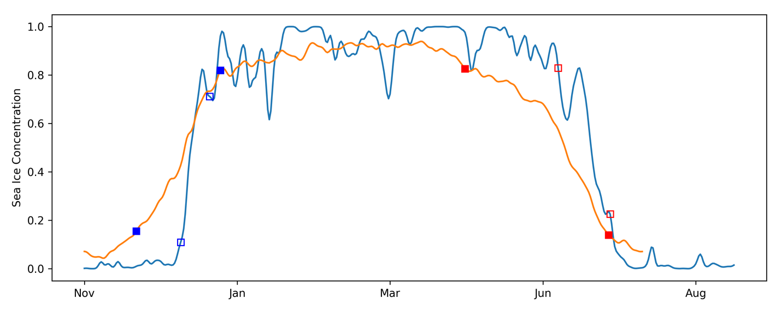

**Figure 5:**

Freeze-up and break-up with two summer ice events.

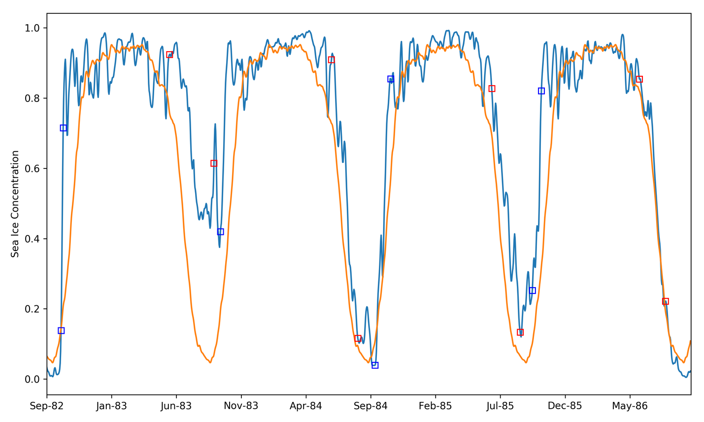

**Figure 6:**

Freeze-up and break-up from 2007 to 2012.

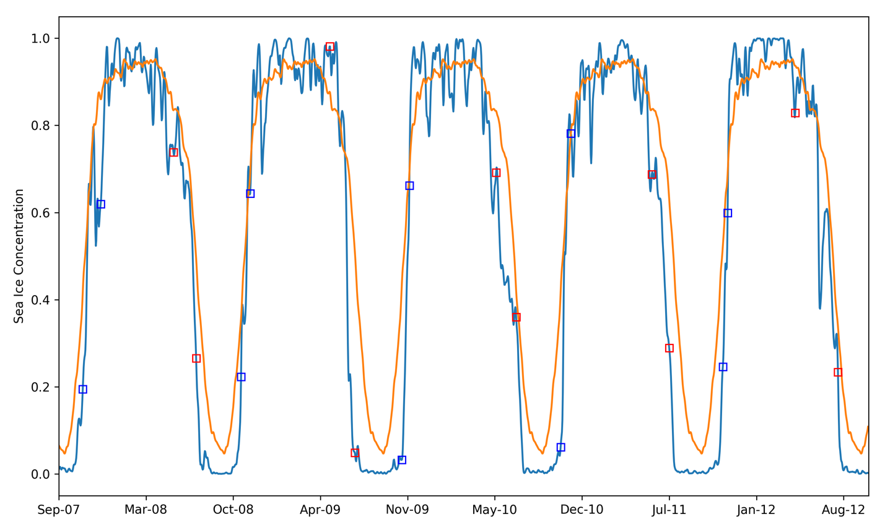

**Figure 7:**

Chukchi Sea break-up and freeze-up dates.

FREEZE-UP:

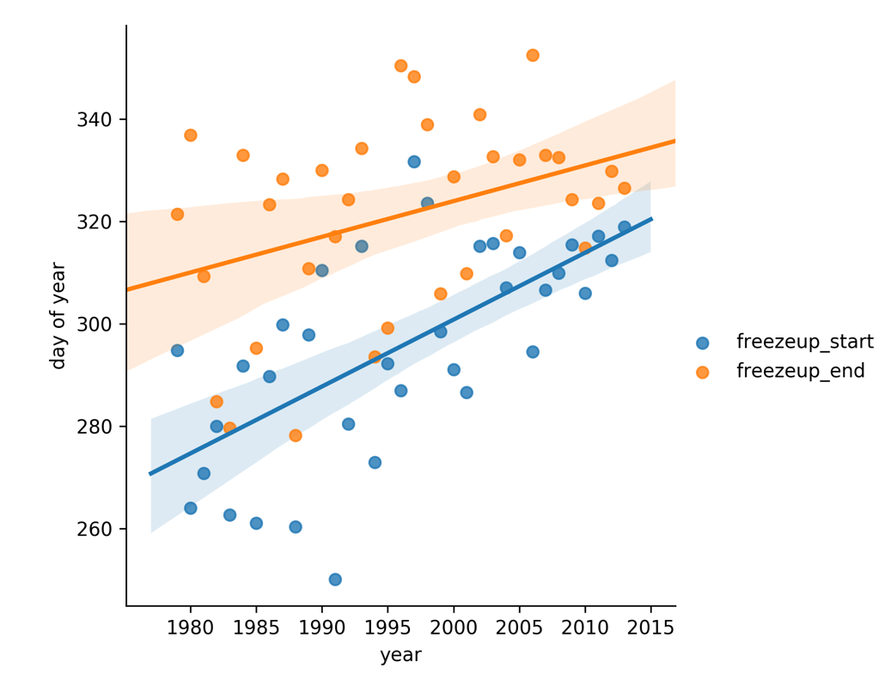

BREAK-UP:

