Okta Advanced Server Access (ASA) - End User Guide

1. Introduction
Okta Advanced Server Access (ASA) is a cloud-based solution that provides secure, passwordless, and role-based access to both on-premises and cloud servers. Instead of managing static SSH keys or RDP credentials, ASA uses short-lived certificates that are generated on-demand. This ensures that server access is more secure, easier to manage, and aligned with modern Zero Trust security principles.
Why this matters for you:
- Passwordless login → No need to remember SSH keys or RDP passwords.
- One-click access → Connect to your servers directly from your Okta dashboard.
- Secure by design → Every login is verified with Okta MFA and policy.
- Audit-ready → All access events are logged for compliance.

2. Working Flow (Simple for End Users)
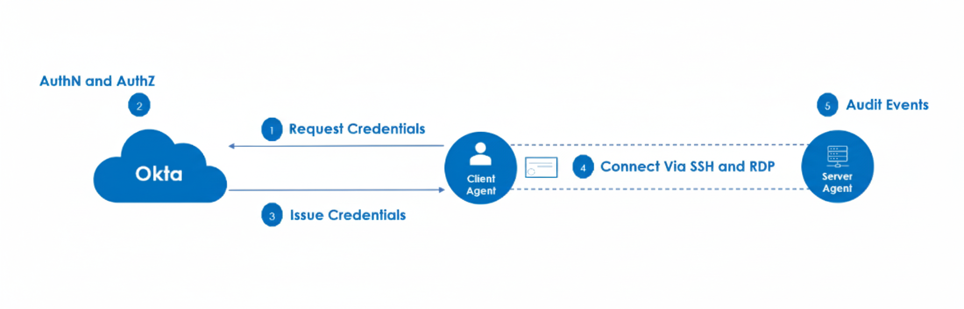Here’s how it works when you log in:
- Request Access – You (client) try to connect to a server using the ASA Client Agent.
- Authenticate with Okta – Okta checks your identity (username, password, MFA, etc.).
- Get Credentials – Okta issues a short-lived certificate just for this session.
- Connect to Server – Using that certificate, you connect directly to the server (SSH for Linux or RDP for Windows).
- Audit Logged – The Server Agent records the event (who logged in, when, from where).
👉 The key idea: No passwords or static keys. Every login is verified with Okta and gets a temporary certificate, which expires quickly.

3. Installing the Okta ASA Client (Windows)
1. Go to the download link provided by IT: [Link: Okta ASA Client for Windows]
2. Download the MSI installer (latest stable version).
3. Run the installer by double-clicking the .msi file.
4. Follow the installation wizard:
- Click Next → Accept license → Install → Finish.
5. Once installed, the ScaleFT Client Tool (Okta ASA client) is available on your machine.
3. Once installed, open Command Prompt and run:
sft --version
If you see a version number, installation was successful.

4. Enrolling Your Windows Client
After installing the client, you need to enroll your machine with Okta ASA.
- Open Command Prompt (cmd) as administrator.
- Run the following command:
- sft enroll
- A browser window will open automatically:
  - Enter your Team Name (provided by IT, e.g., okta-demo).
  - You’ll be redirected to the Okta login page.
[Screenshot: Okta login prompt]
- Enter your Okta credentials (username + password + MFA).
- Approve the consent window.
- Once complete, your client is now enrolled.
✅ You can verify enrollment in two ways:
- Check via command:
- sft list-servers
- Or log into ASA Dashboard → Clients → See your device listed.

5. Accessing Servers
Now that your client is enrolled, you can connect to assigned servers directly.

Option A: From Okta Dashboard (Web Portal)

5.1 Access Linux Servers (SSH)
- Open Okta Dashboard → Click Advanced Server Access App.
- Select the Linux server from the list → Click Connect.
- A consent window appears → Click Approve.
- A PowerShell window opens and you are logged into the Linux server securely via SSH.
[Screenshot: Linux server SSH session]

5.2 Access Windows Servers (RDP)
- Go to Okta Dashboard → Open Advanced Server Access App.
- Select the Windows server from the list → Click Connect.
- When prompted, click Open ScaleFT.
- Accept the certificate → An RDP window launches.
- You are now securely connected to the Windows server.
[Screenshot: RDP session to Windows server]

Option B: From Command Line
- List available servers:
- sft list servers
- Connect to Linux server (SSH):
- sft ssh <server-name>
- Connect to Windows server (RDP):
sft rdp <server-name> (Courier New)

6. Quick Commands Reference
Command | Purpose
sft --version | Checks ASA client version
sft enroll | Enrolls your client with Okta ASA
sft list servers | Shows servers you can access
sft ssh <server> | Connects to Linux server via SSH
sft rdp <server> | Connects to Windows server via RDP
sft unenroll | Unenrolls your client from ASA
sft login | Logs in and obtains fresh credentials
sft logout | Logs out your client and clears credentials
sft whoami | Displays the currently authenticated user and team
sft help | Shows a list of commands or help for a specific command
👉 If you want to know more about ASA commands, please refer to the official documentation:
Okta ASA CLI Reference

6. Troubleshooting
Issue | What it means & How to fix
sft enroll not working | Your ASA client may not be installed properly. Try reinstalling the ASA client. Also, verify you entered the correct Team Name during enrollment. Ensure your system has internet connectivity and that the ASA client service (sftd) is running.
Cannot see any servers | You may not be assigned to the correct group/project. Contact your IT admin to ensure your account has the right server assignments.
Session expired | ASA uses short-lived certificates for security. If your session expires, run sft enroll again or reconnect from the ASA dashboard.
Consent window not appearing | Check your browser settings and disable pop-up blockers for the Okta ASA page.
RDP connection fails | Ensure Remote Desktop is enabled on your Windows machine and on the target server. Verify your firewall and internet connection.
MFA issues | Ensure your Okta MFA device (phone, email, or authenticator app) is working correctly and follow the prompts during login.
System clock issue | Certificates are time-sensitive. Ensure your system clock is accurate.

7. Support
For any issues or questions regarding Okta ASA, please contact IAM Engineering team or raise a SNow ticket.

