Web Application Security Assessment
OWASP Juice Shop — Authentication Module d
Target: OWASP Juice Shop (localhost:3000, Docker: bkimminich/juice-shop)
Assessment Type: Manual black-box application security testing
Tester: Umer Ali
Date: August 17, 2026

1. Executive Summary
During a manual security assessment of the OWASP Juice Shop web application, a critical SQL Injection vulnerability was identified in the login authentication mechanism. The vulnerability allows an unauthenticated attacker to bypass the login process entirely and gain access to the administrator account without knowledge of valid credentials.
This finding represents a complete compromise of the authentication control and should be treated as the highest priority for remediation. The root cause is unsanitized user input being concatenated directly into a backend SQL query, and the fix is well established: parameterized queries combined with proper input validation.
Finding | Severity | Category | Status
SQL Injection – Authentication Bypass | Critical | Broken Authentication (OWASP A07:2021) | Confirmed

2. Methodology
The assessment followed a standard manual black-box testing approach:
- Reconnaissance of the application's login and authentication flow via browser DevTools.
- Manual input manipulation testing on authentication form fields (email/password).
- Verification of successful exploitation via observed application state (session/account change).
- Impact analysis and remediation research based on OWASP guidance.
Tools used: Web browser with Developer Tools, Docker (for hosting the test target).

3. Detailed Findings

3.1 SQL Injection — Authentication Bypass
Severity: Critical (CVSS 3.1 Base Score: 9.8 — Critical)
CVSS Vector: AV:N/AC:L/PR:N/UI:N/S:U/C:H/I:H/A:H
OWASP Category: A03:2021 – Injection / A07:2021 – Identification and Authentication Failures
Location: POST /rest/user/login — Email field
Status: Confirmed / Exploited

Description
The login endpoint fails to sanitize or parameterize user-supplied input before using it in a backend SQL query. This allows an attacker to inject SQL syntax into the email field that alters the logic of the query, causing it to bypass the password check entirely and authenticate as an arbitrary user.

Proof of Concept
Steps to reproduce:
- Navigate to the application login page.
- In the Email field, enter the payload: ' OR 1=1--
- Enter any arbitrary value in the Password field.
- Submit the form.
Result: the application authenticates the attacker without valid credentials and logs them in as the administrator account (admin@juice-sh.op), confirmed by the application's own success banner and the account panel.
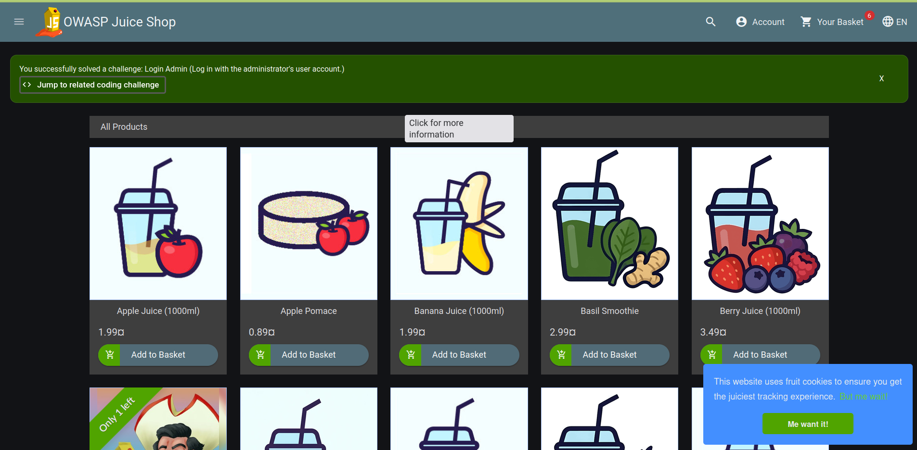
Figure 1 — Successful exploitation confirmed by the application's challenge banner after submitting the SQLi payload.
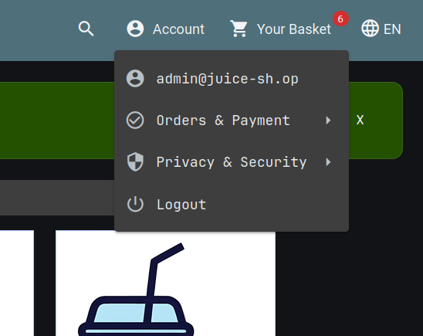
Figure 2 — Account menu confirms the attacker is now authenticated as admin@juice-sh.op.

Impact
Successful exploitation of this vulnerability allows an attacker to:
- Fully bypass authentication without valid credentials.
- Gain administrative access to the application.
- View, modify, or delete data belonging to any user.
- Potentially pivot to further attacks (e.g., data exfiltration, privilege abuse, stored XSS via admin-only functionality).
Because this affects the authentication layer itself, it undermines every access control built on top of it — the impact is effectively total compromise of user and administrative data confidentiality and integrity.

Root Cause
User input from the email field is concatenated directly into a SQL query string rather than being passed as a bound parameter. The injected payload ' OR 1=1-- closes the string literal early, adds a condition that is always true, and comments out the remainder of the original query (including the password check), causing the query to return the first matching user record regardless of credentials.

Remediation
- Use parameterized queries / prepared statements for all database access — never concatenate user input into SQL strings.
- Apply strict server-side input validation on all authentication fields.
- Use an ORM with built-in query parameterization where possible, and audit any raw query usage.
- Implement least-privilege database accounts so a compromised query cannot access unrelated tables.
- Add monitoring/alerting for anomalous authentication patterns (e.g., SQL metacharacters in login fields).
- Deploy a Web Application Firewall (WAF) as a defense-in-depth measure — not a substitute for fixing the root cause.

4. Conclusion
This assessment identified a critical authentication bypass vulnerability caused by improper handling of user input in a SQL query. The finding was reproduced reliably and results in complete compromise of the authentication mechanism. Remediation via parameterized queries is straightforward and should be prioritized immediately, followed by a broader review of all other input points in the application for similar injection weaknesses.

