Table of Contents

Document version history 2

Definitions 2

Added functionality 2

Use cases 2

Magento requirements 3

Third party libraries 3

Install procedure 3

Install procedure with „Magento Connect manager“ 3

Setting in up 3

DPD – esiunta.lt – “DPD Siuntų taškai” 4

“DPD Siuntų taškai” restriction 6

DPD – esiunta.lt – Courier service 6

Parcel data sending with DPD API 7

Printing packing slips for selected orders 8

Calling in DPD courier to pick up goods 10

Printing shipping manifest for selected orders 11

License 13

In case of problems 13

„Show order info“ button is not displayed in Sales Order Grid 13

List of “DPD Siuntų Taškų“ does not show on Internet Explorer 14

Customer is displayed gibberish/garbage when trying to pick „DPD Siuntų Taškai“ 14

Other problems 15

# Document version history

|  |  |  |  |
| --- | --- | --- | --- |
| **Version** | **Date** | **Comments** | **Changed by** |
| 1.4 | 2014-08-05 | Initial release | UAB “BaltiCode” |
| 1.5 | 2014-09-15 | Changes:   * Install procedure updated; * Section on errors was updated. | UAB “BaltiCode” |
| 1.6 | 2014-10-15 | Changes:   * Section ““DPD Siuntų taškai” restriction” changed | UAB “BaltiCode” |
| 1.7 | 2015-07-08 | Changed:   * Section “Calling in DPD courier to pick up goods” | UAB “BaltiCode” |

# Definitions

* DPD – Shipping service provider in Lithuania, link: http://www.dpd.lt/
* DPD API – Active programming interface, which allows Merchant to send parcel data, print packing slips from DPD and call courier to pick up parcels without leaving Magento admin panel.
* GPLv3 – Software license allowing distribution of free software. Link: <http://www.gnu.org/licenses/gpl-3.0.txt>
* DPD Siuntų taškai – Network of shops in, Lithuania, allowing customer to pick up purchased goods near comfortable location.

# Added functionality

* Clients can use “DPD Siuntų taškai” service in Lithuania by selecting preferred location from select menu, where they wish to pick up ordered goods.
* Clients can use DPD courier service in Lithuania.
* Auto updates list of “DPD Siuntų taškai” from DPD server assuming Magento cron has been properly configured.
* If Magento cron is not configured, the list of “DPD Siuntų taškai” can be updated from configuration panel.
* Meant for merchants, who operate mainly in Lithuania.
* When DPD API communication contract exists, then Merchants can send parcel data to DPD server and print out DPD PDF packing slips from Magento admin.
* When DPD API communication contract exists, then Merchants can send parcel data to DPD server and print out DPD PDF shipping manifests from Magento admin.
* When DPD API communication contract exists, Merchants can call for courier to pick up goods from Magento admin.
* When tracking code is supplied to the shipment, then customer can see tracking link when logging in to account, showing status of the shipment.

# Use cases

* Customer orders goods to “DPD Siuntų taškai” located in Lithuania.
* Customer located in Europe orders goods to be delivered to shipping address by courier.
* While merchant manages orders, he can send parcel data to DPD and print out DPD packing slips and shipping manifests without leaving Magento admin panel. When possible parcel data is sent automatically.
* Merchant prints out DPD packing slips without leaving Magento admin.
* Merchant calls courier to pick up goods to be delivered with DPD for one or many orders simultaneously by being able to specify date and time, when the goods are supposed to be picked up.

# Magento requirements

Current module works with following Magento versions:

* 1.4.x.x
* 1.5.x.x
* 1.6.x.x
* 1.7.x.x
* 1.8.x.x
* 1.9.x.x.

In order to auto-update list of “DPD Siuntų taškai” – Magento cron needs to be set up and configured.

# Third party libraries

Component uses LivePipe UI library: <http://livepipe.net/>

# Install procedure

From modules zip file you can find „install“ folder, which should be copied to Magento root folder.

Pay attention that „app“ folder in Magento’s root folder and „app“ folder from the modules „install“ folder should match. Contents of the folders should be merged, not replaced.

If you have installed other Balticode modules earlier such as Balticode_Livehandler or Balticode_Postoffice then it may happen that files from mentioned modules get overwritten. Such overwrite is allowed and should be performed. In such scenario you need to remove following folders (if exist) after copy operation:

* app/code/local/ Balticode/Livehandler
* app/code/local/ Balticode/Postoffice

After successful copy operation please proceed with following steps:

1. Log in to Magento admin panel.
2. If you are willing to use the “DPD Parcel Shop” shipping method, then enter your login data using the following steps:
   1. Go to System > Configuration > Sales > Shipping Methods;
   2. Choose the DPD parcel shop shipping method configuration tab;
   3. In the “Auto send data to DPD server” choose the “Yes” option;
   4. Fill in all necessary fields;
   5. Press “Save Config”.
3. Flush Magento cache storage and then log out from Magento admin and then log back in again.

# Install procedure with „Magento Connect manager“

At this time service is not available.

# Setting in up

Correctly installed module yields two DPD shipping methods under following locations:

System ->Configuration -> Shipping Methods -> „DPD Siuntų taškai”

System -> Configuration -> Shipping Methods -> DPD esiunta.lt – Kurjerių tarnyba

If you received error message during accessing of mentioned shipping methods then you probably have PHP 5.4. In such scenario ask updated shipping modules from developer.

|  |
| --- |
| **Notice!** |
| After first install please make sure that you update the parcel shops list. This can be achieved following these steps:   1. Connect to administration panel; 2. Go to System > Configuration > Sales > Shipping Methods; 3. Choose the "DPD - Dpd.lt - Siuntų taškas" tab; 4. Check if fields "DPD Self service username", "DPD Self-service password", "DPD Self service user ID" and "Api URL" have the correct information; 5. Click the "Rebuild postoffices for this carrier" button.   After the last action the list should appear on the web pages front end, to be more accurate on the checkout. |

## DPD – esiunta.lt – “DPD Siuntų taškai”

Enables you to set up DPD “DPD Siuntų taškai” availability to customers and if DPD API contract exists then details of parcel data sending and courier call methods can be configured.

* **Enabled** – “yes“ customers can use „DPD Siuntų taškai” service. “no“ customers cannot use „DPD Siuntų taškai” service
* **Title** – Title displayed to the customer for current shipping method. For example „DPD – Choose your pickup location“
* **Price** – Shipping price for customer with VAT. Price defined here will be applied if there is no separate shipping price declaration for the customer destination country, but this shipping method is available.
* **Price per country** – You can declare shipping price for each country. If one country is declared multiple times, then latest declaration overrides all previous declarations.
* **Country** – Country, to which the shipping price must be declared for
* **Base shipping price** – Flat shipping fee
* **Price per additional 10kg over base 10kg** – Additional shipping fee on top of base shipping price per additional 10 kilograms of the cart weight excluding base 10kg included in base shipping price. Weight is calculated from products weight field.
* **Free shipping from price** – Minimal cart subtotal cost without VAT, from which shipping cost to customer is free. Leaving this field empty disables free shipping for this country.
* **Show short office names** – “Yes“ – “DPD Siuntų taškai” list shows only names of delivery points. “No“ – “DPD Siuntų taškai” list shows names of delivery points, addresses, phone numbers.
* **Sort offices by priority** – “Yes“ – “DPD Siuntų taškai” points from more populated regions are dis-played first and rest will be sorted alphabetically. “No“ – Sorting is not applied. Changing this setting requires rebuild of delivery point list.
* **Disable this carrier if product's short description contains HTML comment <!-- no dpd_ee_module -->** - If this setting is allowed and such a product exists in cart, then this shipping method is unavailable to customer.
* **Maximum allowed package weight for this carrier** – Default 31.5 – If such a product exists in cart, which weighs more than 31.5kg (from products weight attribute) then this shipping method is unavailable to customer. If this field is left empty, then weight limitation is not applied.
* **Handling action** –
  + **Per order** – Shipping price equals configured shipping price + extra price by weight.
  + **Per package** –Shipping price equals configured base shipping price multiplied by number of products in cart + extra price by weight.
* **Enable free shipping** – When enabled and Free shipping subtotal is less or equal than carts subtotal excluding VAT then shipping is free for the customer.
* **Free shipping subtotal** – If carts subtotal excluding VAT is equal or greater than amount specified here, then customer receives free shipping for this carrier. If amount here is less than free shipping amount specified in the customers shipping address country then free shipping amount for the country is ignored and this configuration is used instead.
* **Auto send data to DPD server** – If you have DPD API contract, then you can configure it by enabling this setting. Enables you to auto send parcel data to DPD, print DPD packing slips and call courier to pick up parcels.
* **Allow courier pickup** – When enabled, you can order DPD courier to pick up parcels from Magento Sales Order Grid
* **DPD Self-service username** – Enter DPD API username here
* **DPD Self-service password** – Enter DPD API password here
* **When to send parcel data** – Defines when module attempts to send Parcel data to DPD server. If parcel data sending does not succeed then it is possible to re-send it by clicking on “Send shipping data to server“ button.
* **After successful checkout** – Parcel data is sent at the moment, when customer is displayed „order-was-successful“ screen and at that moment order is fully paid or payment method is cash on delivery.
* **After successful shipment creation** – Parcel data is sent at the moment when shipment is created for the order and order is fully paid or payment method is cash on delivery
* **I will send data myself by clicking on the button** – Parcel data is not sent automatically. Only way to send parcel data is by opening up order info in Magento Sales order grid and clicking on the “Send shipping data to server“ button.
* **Pickup address name** – First name and last name on pickup address when shipping to customer fails.
* **Pickup address company** – Company name on pickup address when shipping to customer fails.
* **Pickup address e-mail** – E-mail address on pickup address when shipping to customer fails.
* **Pickup address phone** –Phone number on pickup address when shipping to customer fails.
* **Pickup address street** – Street, house, apartment on pickup address when shipping to customer fails.
* **Pickup address city, county** – City, county, region on pickup address when shipping to customer fails.
* **Pickup address zip code** – Zip code on pickup address when shipping to customer fails.
* **Pickup address country** – Country on pickup address when shipping to customer fails. This field is also used with zip code to query available courier pickup times from DPD API.
* **API URL** – Destination URL for DPD API. Default:
  + Live - https://weblabel.dpd.lt/parcel_interface/
* You can decide whether to show customer error message when this shipping method is unavailable or simply not to show anything at all when this shipping method is unavailable.
* You can define the availability of this shipping method by country. By default this shipping method is enabled in Estonia, Latvia, Lithuania and correspondingly customer can only see “DPD Siuntų taškai” points from selected country only if they apply.
* **Width in pixels for city select menu** – If you have set up this shipping method up in a way that customer has to choose region first and then “DPD Siuntų taškai” from the region, then with of this region select menu can be regulated here.
* **Width in pixels for office select menu** – If “DPD Siuntų taškai” select menu width is not acceptable then you can regulate it here.
* **Show customer one dropdown instead of two** – When enabled, then customer is displayed with a select menu of all available delivery points. When disabled customer must pick region first and then is presented with list of available “DPD Siuntų taškai” points from previously selected region.
* **Disable populating list of last selected “DPD Siuntų taškai” points** – When disabled and customer leaves checkout after choosing “DPD Siuntų taškai”, then after returning to checkout customer is presented with radio button of last selected “DPD Siuntų taškai” in addition to select menus. If customer performs that multiple times and each time changes “DPD Siuntų taškai”, then this list grows longer. When this setting is enabled, then this list is never longer than one item. After customer has performed successful checkout, this list is cleared.
* **Enable cash on delivery**– Currently DPD does not support this feature.
* **Rebuild Postoffice List** – Clicking on this button synchronizes “DPD Siuntų taškai” list with DPD server. When setting up this module for the first time it is advised to rebuild it right away. Otherwise customer sees empty list and is unable to use this carrier. After initial rebuild new synchronizations will be performed every 24 hours assuming Magento cron is properly set up.
* **Sort order** – Available shipping methods to the customer are sorted by sort order ascending.

## “DPD Siuntų taškai” restriction

After installing DPD shipping module clients can select parcel shops (“DPD Siuntų taškai”) in Lithuania. However system administrators should be aware, that it is not possible to have parcel shop combined with cash on delivery payment option. This is because DPD is not able to assure that payments in the parcel shop will be transferred to the e-shop owner. That is why they must do additional system configuration or install a plugin (e. g. “Ship and pay combo[1]“), which will resolve this issue.

## DPD – esiunta.lt – Courier service

Enables to set up availability of DPD courier service.

DPD courier takes parcel right to customers preferred address, which can be more comfortable alternative to “DPD Siuntų taškai” pickups in some situations.

* **Enabled** – „yes“ customers can use DPD courier service. „no“ customers cannot use DPD courier
* **Title** – Title displayed to the customer for current shipping method. For example „Courier brings the goods to my address“
* **Price** – Shipping price for customer with VAT. Price defined here will be applied if there is no separate shipping price declaration for the customer destination country but this shipping method is available.
* **Price per country** – You can declare shipping price for each country. If one country is declared multiple times, then latest declaration overrides all previous declarations.
* **Country** – Country, to which the shipping price must be declared for.
* **Base shipping price** – Flat shipping fee.
* **Price per additional 10kg over base 10kg** – Additional shipping fee on top of base shipping price per additional 10 kilograms of the cart weight excluding base 10kg included in base shipping price. Weight is calculated from products weight field.
* **Free shipping from price** – Minimal cart subtotal cost without VAT, from which shipping cost to customer is free. Leaving this field empty disables free shipping for this country.
* **Disable this carrier if product's short description contains HTML comment <!-- no dpd_ee_module -->** - If this setting is allowed and such a product exists in cart, then this shipping method is unavailable to customer.
* **Maximum allowed package weight for this carrier** – Default 31.5 – If such a product exists in cart, which weighs more than 31.5kg (from products weight attribute) then this shipping method is unavailable to customer. If this field is left empty then weight limitation is not applied.
* **Handling action** –
  + **Per order** – Shipping price equals configured shipping price + extra price by weight.
  + **Per package** –Shipping price equals configured base shipping price multiplied by number of products in cart + extra price by weight.
* **Enable free shipping** – When enabled and Free shipping subtotal is less or equal than carts subtotal excluding VAT then shipping is free for the customer.
* **Free shipping subtotal** – If carts subtotal excluding VAT is equal or greater than amount specified here, then customer receives free shipping for this carrier. If amount here is less than free shipping amount specified in the customers shipping address country then free shipping amount for the country is ignored and this configuration is used instead.
* You can decide, whether to show customer error message when this shipping method is unavailable or simply not to show anything at all when this shipping method is unavailable.
* You can define the availability of this shipping method by country. By default this shipping method is enabled in Estonia, Latvia, Lithuania.
* **Enable cash on delivery**– if this option is enabled the customers can choose to pay for their goods on delivery.
* **Sort order** – Available shipping methods to the customer are sorted by sort order ascending.

# Parcel data sending with DPD API

If you have set up automatic parcel data sending with DPD, then you can send parcel data as following:

* In Magento admin navigate Sales -> Orders
* Open up order information by clicking on „Show order info“ or „View“
* If the order uses DPD carrier, then it is possible to send parcel data by clicking on the button „Send shipping data to server“

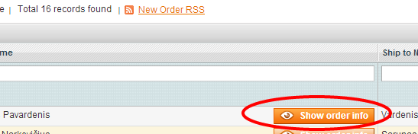

Clicking on the „Show order info“ button (you can navigate between orders using directional keys on keyboard): 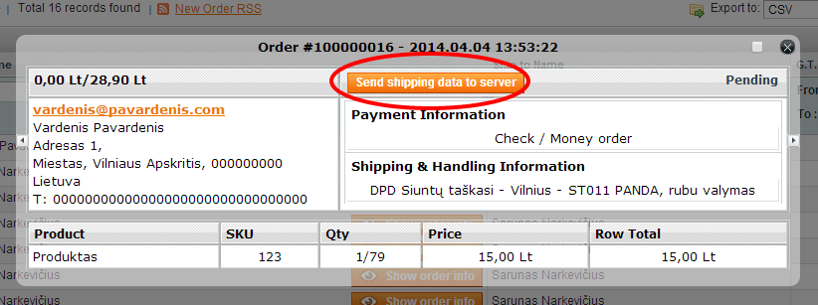

If current order allows parcel data sending then „Send shipping data to server“ button is displayed. Clicking on the button sends „labels-only“ request to DPD API which generates DPD packing slip.

Parcel data is sent only when order is fully paid or payment method is cash on delivery. If sending was successful, then „Send shipping data to server“ is not displayed any more.

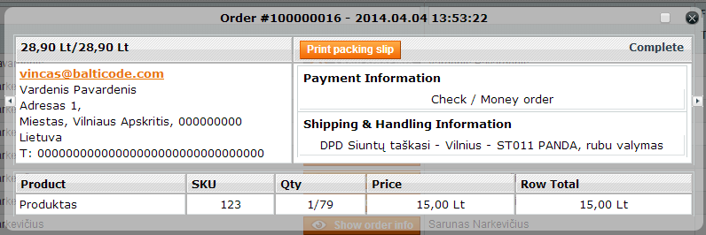

* On shipping data sending success you are presented with options to „Print packing slip“ and/or „Order courier to pick up goods“

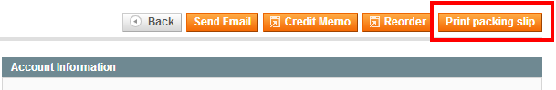

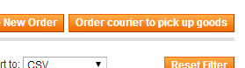

You can also „Send shipping data to server“ and „Print packing slip“ by opening up Magento Order by clicking on the order action buttons on top right.

Information about parcel data send status is held in order comments, which is not visible in frontend.

## Printing packing slips for selected orders

If an data sending with DPD API has been set up correctly then shop owners can print several packing slips on one or few A4 format PDF pages.

In order to do this they must follow the instructions below:

* In Magento admin navigate Sales -> Orders
* In the orders list, select the necessary orders by using check boxes from the first column

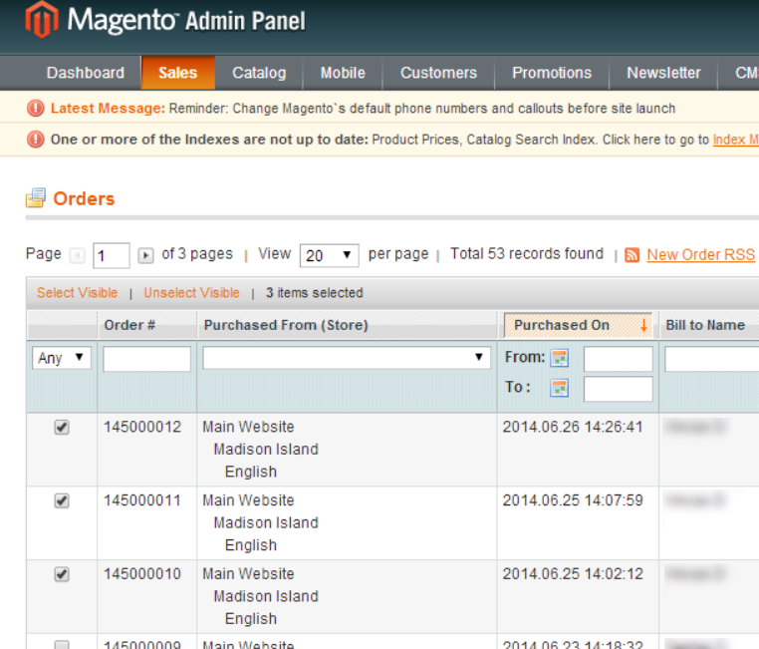

* After selection has been made an action called “Print DPD Labels” has to be submitted

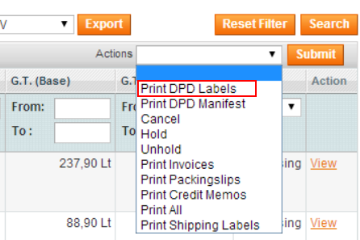

After the button “Submit” is pressed a new PDF file would be downloaded with all selected packing slips

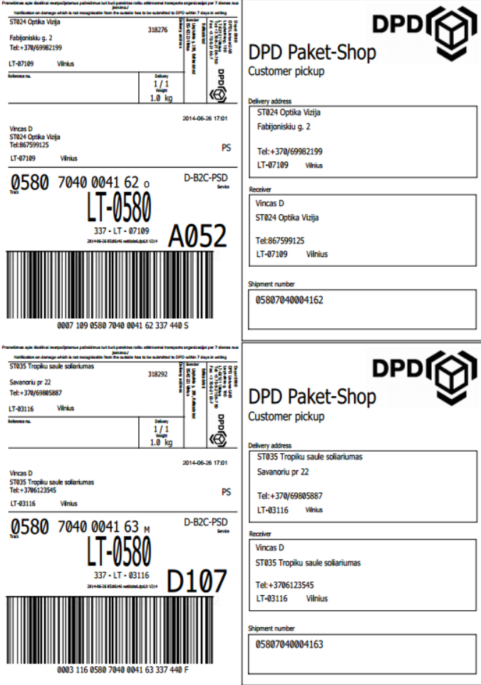

# Calling in DPD courier to pick up goods

If an automatic data sending with DPD API has been set up and courier calls are allowed, then you can call DPD courier as follows:

* In Magento admin navigate Sales -> Orders
* Locate „Order courier to pick up goods“ button from top right



Clicking on it will open up Order DPD courier menu.

* You can declare how many envelopes, parcels, pallets courier should pick up, make sure you enter correct amounts.
* You can also enter remark to courier by entering text in text area.

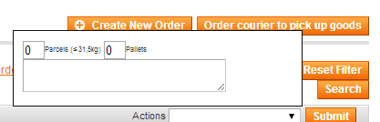

* After all required information has been provided, click the “Order courier to pick up goods“ button again to send a query to the DPD server.

If the data has been sent successfully a message with feedback is being provided, that DPD courier has been successfully called.

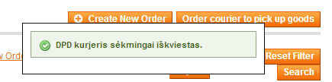

On success you are notified with message indicating when courier is coming to pick up the goods. Do not forget to print out packing slips and pasting them to parcels. If you have not done that, then you can print out packing slips by clicking on „Print packing slip“ button on the order.

If you have ordered DPD courier to pick up goods, then next time you can create another pickup order, when current pickup order has been processed.

**IMPORTANT!** In order to send a request to DPD server for calling a courier your e-shop’s IP address must be accepted by its firewall, so please contact your DPD manager and give him/her you e-shop IP address.

# Printing shipping manifest for selected orders

DPD shipping module provides an opportunity to print out shipping manifest only for selected orders. The difference from the main manifest printing is that the connection with DPD API is not necessary, the orders does not have to be paid and the printing date has no influence.

In order to print this you should perform these actions:

* In the Magento admin panel open Sales -> Orders
* In the orders list, select the necessary orders by using check boxes from the first column



* After the selection has been made an action called “Print DPD Manifest” must be submitted

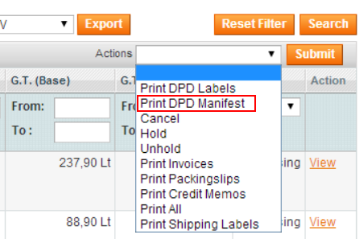

* After the button “Submit” is pressed a new PDF file would be downloaded with all selected packages on one shipping manifest

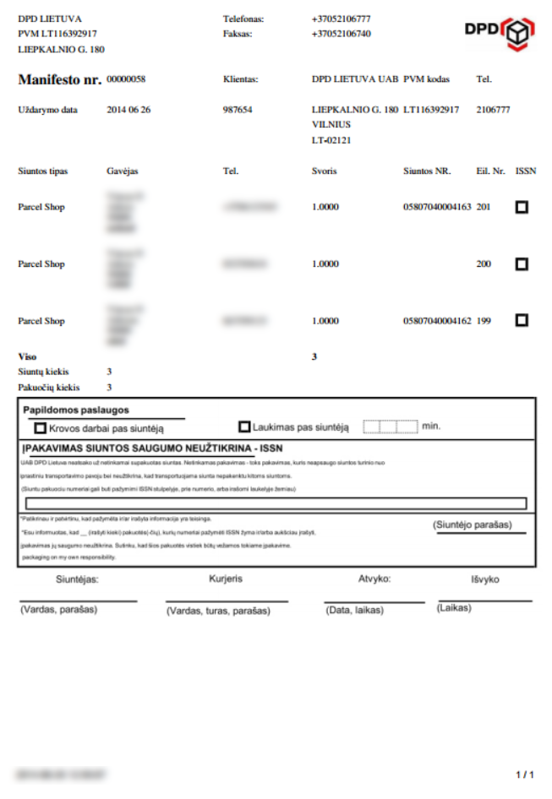

# License

Module is licensed under GPLv3 license.

# In case of problems

## „Show order info“ button is not displayed in Sales Order Grid

In Magento admin navigate:

System -> Configuration -> BaltiCode Livehandler -> Global Livehandler settings

Make sure it is enabled.

Also navigate:

System -> Configuration -> BaltiCode Livehandler -> Admin Order Grid Helper

Make sure it is enabled.

If after reviewing settings and flushing Magento cache problem does not resolve, contact the developer.

## List of “DPD Siuntų Taškų“ does not show on Internet Explorer

It is caused by JS prototype not being 100% compatible with all versions of Internet Explorer.

To fix this, please add following meta-tag to documents head:

Default location:

~/app/design/frontend/base/default/template/page/html/head.php

Meta tag:

|  |
| --- |
| <meta http-equiv="X-UA-Compatible" content="IE=8" /> |
| <meta http-equiv="X-UA-Compatible" content="IE=7" /> |

More information:

<http://alanstorm.com/ie9_fix_for_magento>

## Customer is displayed gibberish/garbage when trying to pick „DPD Siuntų Taškai“

This problem can occur when custom checkout module is in use:

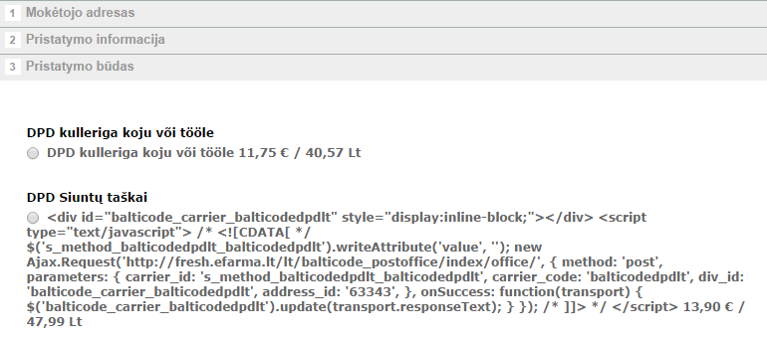

To resolve this open up following file:

~/app/design/frontend/base/default/template/checkout/onepage/shipping_method/available.phtml

and preform following replacement:

|  |
| --- |
| before: |
| <label for="s_method_<?php echo $_rate->getCode() ?>"><?php echo $this->escapeHtml($_rate->getMethodTitle()) ?> |
| after: |
| <label for="s_method_<?php echo $_rate->getCode() ?>"><?php echo ($_rate->getMethodTitle()) ?> |

Perform same replacement in your active Magento theme when necessary.

If it does not help, then locate templates which are used by your custom checkout module to render available shipping method and remove htmlEscape statements from there.

## Other problems

If you are experiencing problems with this module, then please contact developer by contact-us [support@balticode.com](mailto:support@balticode.com?subject=DPD%20module%20(LT)) .

1. <http://www.magentocommerce.com/magento-connect/ship-and-pay-combo.html> (checked on 2014-10-15)