Table of Contents

Document version history 2

Definitions 2

Added functionality 2

Use cases 2

OpenCart requirements 2

Third party libraries 3

Install procedure 3

Setting in up 4

Balticode DPD Livehandler 4

Geo Zones 4

BaltiCode DPD Siuntų taškai 4

BaltiCode DPD Courier service 5

Parcel data sending with DPD API 6

Manual way 6

Printing packing slips for selected orders 7

Calling in DPD courier to pick up goods 8

Printing shipping manifest for selected orders 9

License 10

In case of problems 10

# Document version history

|  |  |  |  |
| --- | --- | --- | --- |
| **Version** | **Date** | **Comments** | **Changed by** |
| 0.1 | 2014-10-27 | Initial release | UAB “BaltiCode” |
| 0.1.1 | 2014-11-18 | Minor changes | UAB “BaltiCode” |

# Definitions

* DPD – Shipping service provider in Lithuania, link: http://www.dpd.lt/
* DPD API – Active programming interface, which allows Merchant to send parcel data, print packing slips from DPD and call courier to pick up parcels without leaving OpenCart admin panel.
* GPLv3 – Software license allowing distribution of free software. Link: <http://www.gnu.org/licenses/gpl-3.0.txt>
* DPD Siuntų taškai – Network of shops in, Lithuania, allowing customer to pick up purchased goods near comfortable location.

# Added functionality

* Clients can use “DPD Siuntų taškai” service in Lithuania by selecting preferred location from select menu, where they wish to pick up ordered goods.
* Clients can use DPD courier service in Lithuania.
* Auto updates list of “DPD Siuntų taškai” from DPD server each time a customer enters shipping method selection step in the ckeckout.
* Meant for merchants, who operate mainly in Lithuania.
* When DPD API communication contract exists, then Merchants can send parcel data to DPD server and print out DPD PDF packing slips from OpenCart admin.
* When DPD API communication contract exists, then Merchants can send parcel data to DPD server and print out DPD PDF shipping manifests from OpenCart admin.
* When DPD API communication contract exists, Merchants can call for courier to pick up goods from OpenCart admin.
* When tracking code is supplied to the shipment, then customer can see tracking link when logging in to account, showing status of the shipment.

# Use cases

* Customer orders goods to “DPD Siuntų taškai” located in Lithuania.
* Customer located in Europe orders goods to be delivered to shipping address by courier.
* While merchant manages orders, he can send parcel data to DPD and print out DPD packing slips and shipping manifests without leaving OpenCart admin panel. When possible parcel data is sent automatically.
* Merchant prints out DPD packing slips without leaving OpenCart admin.
* Merchant calls courier to pick up goods to be delivered with DPD for one or many orders simultaneously by being able to specify date and time, when the goods are supposed to be picked up.

# OpenCart requirements

Current module works with following OpenCart versions:

* 1.5.4
* 1.5.4.1
* 1.5.5.1
* 1.5.6.1
* 1.5.6.2
* 1.5.6.3
* 1.5.6.4
* 1.5.6

In order to auto-update list of “DPD Siuntų taškai” – OpenCart cron needs to be set up and configured.

# Third party libraries

Module uses vQmod third party library: <https://github.com/vqmod/vqmod/releases>

# Install procedure

Before installing the DPD module please make sure that you have all DPD API connection information (user name, password and user ID). These can be received from corporate web page [1]<http://www.dpd.lt/lt/main/dpd-siuntu-taskas/verslo-klientams>[[2]](http://www.dpd.lt/lt/main/dpd-siuntu-taskas/verslo-klientams).

You also should inform DPD, that they would allow your web page IP (not your internet provider IP) to send queries to their server. This is necessary if you want to order couriers through your e-shop administration panel.

The module uses third party tool called vQmod. It can be downloaded from its github repository <https://github.com/vqmod/vqmod/releases>. You need a zip file witch has a word “opencart” in its name. After downloading please do the following steps:

* 1. Copy the vqmod folder to your web page’s root folder
  2. Make sure that vqmod and vqcashe folders are writable (either 755 or 777)
  3. After the following step go to your browser and enter the installation script by entering a URL address: [www.yoursite.com/vqmode/install](http://www.yoursite.com/vqmode/install)
  4. If the install went fine you should receive a message success message. If not, then the permissions above and try again.
  5. Go to your store and verify if it works.
  6. Using FTP, verify that there are new "vq" files in the "vqmod/vqcache" folder.

After the vQmod has been installed please extract all DPD module’s package content to the root folder:  
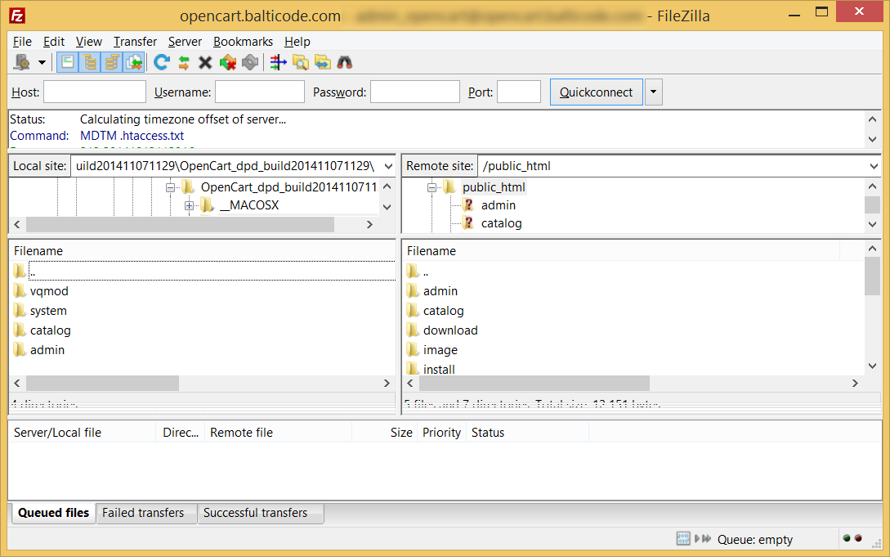

# Setting in up

Correctly installed module yields two DPD shipping methods under following locations:

* **Extensions -> Shipping Methods -> BaltiCode DPD Courier service**
* **Extensions -> Shipping Methods -> BaltiCode DPD Siuntų taškai**

In the **Extension -> Modules -> Balticode DPD Livehandler** location you will find main configuration features.

To finish the setup process please go through the following Balticode DPD Livehandler, Geo Zones, BaltiCode DPD Courier service and BaltiCode DPD Siuntų taškai sections.

## Balticode DPD Livehandler

On this configuration panel you will find some basic settings for both courier and parcel shop shipping methods.

* **Enable Global Livehandler** – enables/disables all DPD modules buttons in the order list (Sales -> Orders).
* **DPD Login Username** – Enter DPD API username here.
* **DPD Login UserPassword** – Enter DPD API password here.
* **DPD Login UserID** – Enter DPD API user ID here.
* **API URL** – Destination URL for DPD API. Default < <https://weblabel.dpd.lt/parcel_interface/>> .
* **Http request timeout** – the time in seconds for how long your system be waiting for an answer from DPD server.

Username, userpassword and UserID fields should be provided by you DPD manager.

## Geo Zones

Before you go on with setup you should create a Geo Zone for the new shipping method. Geo Zones are created to define specific geographical areas to be used for shipping and taxation. So if you do not have a Lithuanian Geo Zone already created please do the following steps:

1. Log in to OpenCart admin panel.
2. The module requires Lithuania as a shipping geo zone. If you already have it please skip this step. Otherwise do the following steps:
   1. Goto System > Localisation > Geo Zones
   2. Click the “Insert” button
   3. Give your geozone a name and a short description
   4. Click the “Add Geo Zone” button and select “Lithuania”
   5. Click “Save”

## BaltiCode DPD Siuntų taškai

Enables you to set up DPD “BaltiCode DPD Siuntų taškai” availability to customers and if DPD API contract exists then details of parcel data sending and courier call methods can be configured.

General settings:

* **Tax Class** – here a user can select a pre-configured tax class. Tax classes are available at System -> Localisation -> Taxes -> Tax Classes.
* **Status** – “Enabled“ customers can use „DPD Siuntų taškai” service. “Disabled“ customers cannot use „DPD Siuntų taškai” service.
* **Price** – Shipping price for customer with VAT. Price defined here will be applied if there is no separate shipping price declaration for the customer destination country, but this shipping method is available.
* **Show short office names** – “Yes“ – “DPD Siuntų taškai” list shows only names of delivery points. “No“ – “DPD Siuntų taškai” list shows names of delivery points, addresses, phone numbers.
* **Sort offices by priority** – “Yes“ – “DPD Siuntų taškai” points from more populated regions are dis-played first and rest will be sorted alphabetically. “No“ – Sorting is not applied. Changing this setting requires rebuild of delivery point list.
* **Disable this carrier if product's description contains HTML comment <!-- no dpd_ee_module -->** - If this setting is allowed and such a product exists in cart, then this shipping method is unavailable to customer.
* **Maximum allowed package weight for this carrier** – Default 31.5 – If such a product exists in cart, which weighs more than 31.5kg (from products weight attribute) then this shipping method is unavailable to customer. If this field is left empty, then weight limitation is not applied.
* **Handling action** –
  + **Per order** – Shipping price equals configured shipping price + extra price by weight.
  + **Per package** –Shipping price equals configured base shipping price multiplied by number of products in cart + extra price by weight.
* **Enable free shipping** – When enabled and Free shipping subtotal is less or equal than carts subtotal excluding VAT then shipping is free for the customer.
* **Free shipping subtotal** – If carts subtotal excluding VAT is equal or greater than amount specified here, then customer receives free shipping for this carrier. If amount here is less than free shipping amount specified in the customers shipping address country then free shipping amount for the country is ignored and this configuration is used instead.
* **Auto send data to DPD server** – If you have DPD API contract, then you can configure it by enabling this setting. Enables you to auto send parcel data to DPD, print DPD packing slips and call courier to pick up parcels. This setting also shows the pickup information fields.
* **Allow courier pickup** – When enabled, you can order DPD courier to pick up parcels from OpenCart Sales Order Grid
* **Which order status to use for auto send** – here the administrator can select the order status which defines that it is paid. If “auto send data to DPD server” is enabled then orders data with this status, would be sent automatically.
* **Pickup address name** – First name and last name on pickup address when shipping to customer fails.
* **Pickup address company** – Company name on pickup address when shipping to customer fails.
* **Pickup address e-mail** – E-mail address on pickup address when shipping to customer fails.
* **Pickup address phone** –Phone number on pickup address when shipping to customer fails.
* **Pickup address street** – Street, house, apartment on pickup address when shipping to customer fails.
* **Pickup address city, county** – City, county, region on pickup address when shipping to customer fails.
* **Pickup address zip code** – Zip code on pickup address when shipping to customer fails.
* **Pickup address country** – Country on pickup address when shipping to customer fails. This field is also used with zip code to query available courier pickup times from DPD API.
* **Update interval for the postoffice list in minutes** – here a number of minutes can be defined for postoffice list to be updated from DPD API.
* **Enable cash on delivery**– if “Enabled” then this payment method is allowed with parcel shop shipping method. Although currently DPD is not providing this sort of service.
* **Sort order** – a numerical field which is defining in which position this shipping method should be displayed.

Geo Zone specific setting:

* **Base shipping price** – You can declare shipping price for each country. If one country is declared multiple times, then latest declaration overrides all previous declarations.
* **Price per additional 10kg over base 10kg** – Additional shipping fee on top of base shipping price per additional 10 kilograms of the cart weight excluding base 10kg included in base shipping price. Weight is calculated from products weight field.
* **Free shipping from price** – Minimal cart subtotal cost without VAT, from which shipping cost to customer is free. Leaving this field empty disables free shipping for this country.
* **Status** – if “Enalbled” then this shipping method can be used for selected geo zone. If “Disabled” then this shipping method cannot be used on this geo zone.

## BaltiCode DPD Courier service

Enables to set up availability of DPD courier service. DPD courier takes parcel right to customers preferred address, which can be more comfortable alternative to “DPD Siuntų taškai” pickups in some situations.

General settings:

* **Tax Class** – here a user can select a pre-configured tax class. Tax classes are available at System -> Localisation -> Taxes -> Tax Classes.
* **Status** – “Enabled“ customers can use „DPD Siuntų taškai” service. “Disabled“ customers cannot use „DPD Siuntų taškai” service.
* **Price** – Shipping price for customer with VAT. Price defined here will be applied if there is no separate shipping price declaration for the customer destination country, but this shipping method is available.
* **Show short office names** – “Yes“ – “DPD Siuntų taškai” list shows only names of delivery points. “No“ – “DPD Siuntų taškai” list shows names of delivery points, addresses, phone numbers, opening hours.
* **Sort offices by priority** – “Yes“ – “DPD Siuntų taškai” points from more populated regions are dis-played first and rest will be sorted alphabetically. “No“ – Sorting is not applied. Changing this setting requires rebuild of delivery point list.
* **Disable this carrier if product's description contains HTML comment <!-- no dpd_ee_module -->** - If this setting is allowed and such a product exists in cart, then this shipping method is unavailable to customer.
* **Maximum allowed package weight for this carrier** – Default 31.5 – If such a product exists in cart, which weighs more than 31.5kg (from products weight attribute) then this shipping method is unavailable to customer. If this field is left empty, then weight limitation is not applied.
* **Handling action** –
  + **Per order** – Shipping price equals configured shipping price + extra price by weight.
  + **Per package** –Shipping price equals configured base shipping price multiplied by number of products in cart + extra price by weight.
* **Enable free shipping** – When enabled and Free shipping subtotal is less or equal than carts subtotal excluding VAT then shipping is free for the customer.
* **Free shipping subtotal** – If carts subtotal excluding VAT is equal or greater than amount specified here, then customer receives free shipping for this carrier. If amount here is less than free shipping amount specified in the customers shipping address country then free shipping amount for the country is ignored and this configuration is used instead.
* **Enable cash on delivery**– if “Enabled” then this payment method is allowed with parcel shop shipping method. Although currently DPD is not providing this sort of service.
* **Sort order** – a numerical field which is defining in which position this shipping method should be displayed.

Geo Zone specific setting:

* **Base shipping price** – You can declare shipping price for each country. If one country is declared multiple times, then latest declaration overrides all previous declarations.
* **Price per additional 10kg over base 10kg** – Additional shipping fee on top of base shipping price per additional 10 kilograms of the cart weight excluding base 10kg included in base shipping price. Weight is calculated from products weight field.
* **Free shipping from price** – Minimal cart subtotal cost without VAT, from which shipping cost to customer is free. Leaving this field empty disables free shipping for this country.
* **Status** – if “Enalbled” then this shipping method can be used for selected geo zone. If “Disabled” then this shipping method cannot be used on this geo zone.

# Parcel data sending with DPD API

## Manual way

If you have set up automatic parcel data sending with DPD, then you can send parcel data as following:

* In OpenCart admin navigate Sales -> Orders
* In the list of orders, select the orders you would like to send to DPD API  
  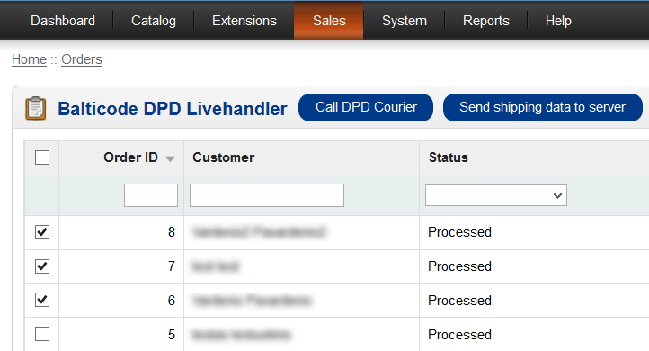
* If the order uses DPD carrier and its, then it is possible to send order data by clicking on the button „Send shipping data to server“.

# Printing packing slips for selected orders

If an data sending to DPD API has been set up correctly then shop owners can print packing slips on one or few A4 format PDF pages.

In order to do this they must follow the instructions below:

* In OpenCart admin navigate Sales -> Orders
* In the list of orders, select the orders you would like to get the packing slips
* After selection has been made click on “Print DPD Labels”

After the button “Print DPD Labels” is pressed a new PDF file would be downloaded with all selected packing slips.

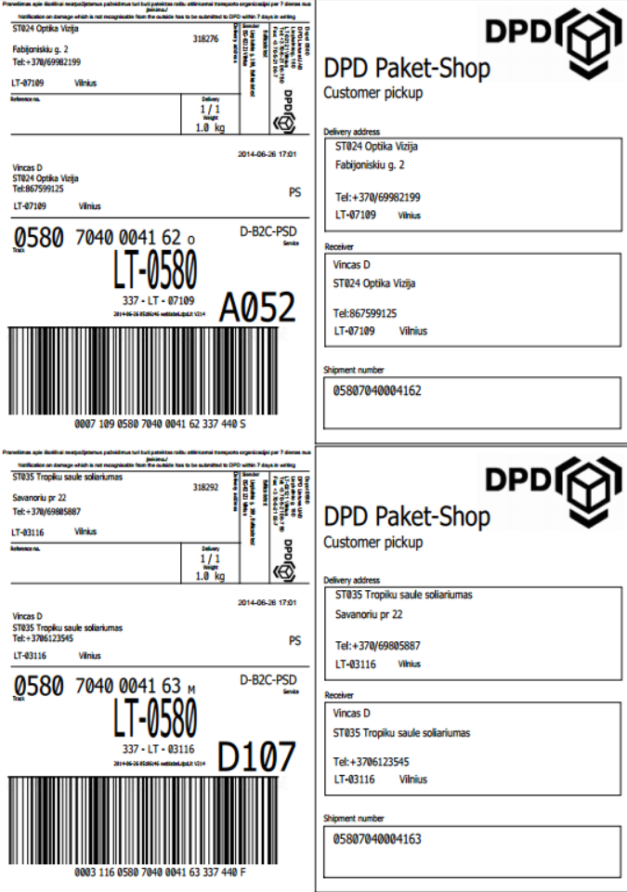

# Calling in DPD courier to pick up goods

If an automatic data sending with DPD API has been set up and courier calls are allowed.

**IMPORTANT!** In order to send a request to DPD server for calling a courier your e-shop’s IP address must be accepted by its firewall, so please contact your DPD manager and give him/her you e-shop IP address.

You can call DPD courier as follows:

* In OpenCart admin navigate Sales -> Orders
* Locate „Call DPD Courier“ button from left.



Clicking on it will open up Order DPD courier menu.

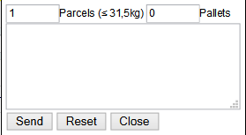

You can declare how many parcels, pallets courier should pick up, make sure you enter correct amounts. You can also enter remark to courier by entering text in text area.

* After all required information has been provided, click the “Send“ button to send a query to the DPD server.

If the data has been sent successfully a message with feedback is being provided, that DPD courier has been successfully called.

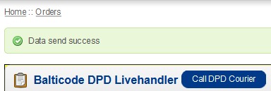

On success you are notified with message indicating when courier is coming to pick up the goods. Do not forget to print out packing slips and pasting them to parcels. If you have not done that, then you can print out packing slips by clicking on „Print packing slip“ button on the order.

If you have ordered DPD courier to pick up goods, then next time you can create another pickup order, when current pickup order has been processed.

# Printing shipping manifest for selected orders

DPD shipping module provides an opportunity to print out shipping manifest only for selected orders. Before printing the manifest for your orders, their data has to be sent to DPD API, that each order would receive a shipping number.

In order to print this you should perform these actions:

* In the OpenCart admin panel open Sales -> Orders
* In the orders list, select the necessary orders by using check boxes from the first column
* After the selection has been made a button “Print DPD Manifest” must clicked

After the button is pressed a new PDF file would be downloaded with all selected packages on one shipping manifest:

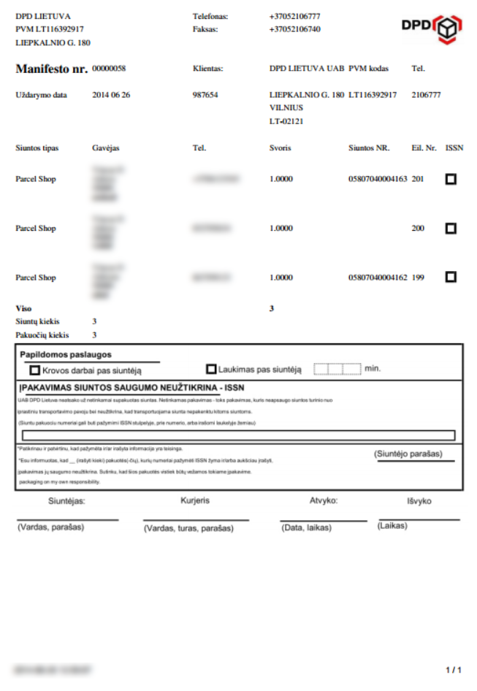

# License

Module is licensed under GPLv3 license.

# In case of problems

If you are experiencing problems with this module, then please contact developer by contact-us [support@balticode.com](mailto:support@balticode.com?subject=DPD%20module%20(LT)).

1. The link was checked on 2014-10-29.
2. The link was checked on 2014-10-29.