Table of Contents

Definitions 2

Added functionality 2

Use cases 2

PrestaShop requirements 2

Third party libraries 2

Install procedure 3

Setting in up 3

DPD – esiunta.lt – “DPD Siuntų taškai” 3

“DPD Siuntų taškai” restriction 4

DPD – esiunta.lt – Courier service 5

Parcel data sending with DPD API 5

Printing packing slips for selected orders 7

Calling in DPD courier to pick up goods 8

Printing shipping manifest for selected orders 9

License 11

In case of problems 11

Module is installed, but DPD carriers are not listed in the frontend 11

DPD Courier carrier displays empty select menu 11

Other problems 12

# Definitions

* DPD – Shipping service provider in Lithuania, link: http://www.dpd.lt/
* DPD API – Active programming interface, which allows Merchant to send parcel data, print packing slips from DPD and call courier to pick up parcels without leaving PrestaShop admin panel.
* GPLv3 – Software license allowing distribution of free software. Link: <http://www.gnu.org/licenses/gpl-3.0.txt>
* DPD Siuntų taškai – Network of shops in, Lithuania, allowing customer to pick up purchased goods near comfortable location.

# Added functionality

* Clients can use “DPD Siuntų taškai” service in Lithuania by selecting preferred location from select menu, where they wish to pick up ordered goods.
* Clients can use DPD courier service in Lithuania.
* Auto updates list of “DPD Siuntų taškai” from DPD server assuming PrestaShop cron has been properly configured.
* If PrestaShop cron is not configured, the list of “DPD Siuntų taškai” can be updated from configuration panel.
* Meant for merchants, who operate mainly in Lithuania.
* When DPD API communication contract exists, then Merchants can send parcel data to DPD server and print out DPD PDF packing slips from PrestaShop admin.
* When DPD API communication contract exists, then Merchants can send parcel data to DPD server and print out DPD PDF shipping manifests from PrestaShop admin.
* When DPD API communication contract exists, Merchants can call for courier to pick up goods from PrestaShop admin.
* When tracking code is supplied to the shipment, then customer can see tracking link when logging in to account, showing status of the shipment.

# Use cases

* Customer orders goods to “DPD Siuntų taškai” located in Lithuania.
* Customer located in Europe orders goods to be delivered to shipping address by courier.
* While merchant manages orders, they can send parcel data to DPD and print out DPD packing slips and shipping manifests without leaving PrestaShop admin panel. When possible parcel data is sent automatically.
* Merchant prints out DPD packing slips without leaving PrestaShop admin.
* Merchant calls courier to pick up goods to be delivered with DPD for one or many orders simultaneously by being able to specify date and time, when the goods are supposed to be picked up.

# PrestaShop requirements

Current module works with following PrestaShop versions:

* 1.5.x.x
* 1.6.x.x

# Third party libraries

Current modules uses jQuery loadTemplate plugin

https://github.com/codepb/jquery-template

# Install procedure

From modules zip file you can find “install“ folder, which contains uploadable tar file.

From PrestaShop admin panel navigate to:

Modules -> Modules

Pick “Add new module” and upload the contained tar file.

You can also unzip the .tar file and copy its contents to ~/modules folder in PrestaShop root folder

# Setting in up

Correctly installed module yields three new modules located under “Shipping and Logistics” tab:

• BaltiCode (balticode_postoffice) – General helper plugin, which helps with select menu

Generations.

• DPD Siuntų taškai (balticode_dpd_parcelstore) – Adds carrier DPD delivery points.

• DPD kurjeriai į Jūsų namus ar darbą (balticode_dpd_courier) – Adds carrier DPD Courier service.

Install listed modules in the following order

1. balticode_postoffice;
2. balticode_dpd_parcelstore;
3. balticode_dpd_courier.

If you do not wish to use either of the carriers, then do not uninstall the module, mark it as disabled instead.

|  |
| --- |
| **Notice!** |
| After first install please make sure that you update the parcel shops list. This can be achieved following these steps:   1. Connect to administration panel; 2. Go to Modules > Modules > Shipping and Logistics; 3. Click on Configure button by "DPD Parcekshop" module; 4. Check if fields "DPD Self service username", "DPD Self-service password", "DPD Self service user ID" and "Api URL" have the correct information; 5. Click the "Update settings" button.   After the last action the list should appear on the web pages front end, to be more accurate on the checkout. |

## DPD – esiunta.lt – “DPD Siuntų taškai”

Enables you to set up DPD “DPD Siuntų taškai” availability to customers and if DPD API contract exists then details of parcel data sending and courier call methods can be configured.

* **Title** – Title displayed to the customer for current shipping method. For example „DPD – Choose your pickup location“
* **Price** – Shipping price for customer with VAT. Price defined here will be applied if there is no separate shipping price declaration for the customer destination country, but this shipping method is available.
* **Tax Id -** Tax rate applied for this carrier.
* **Price per country** – You can declare shipping price for each country. If one country is declared multiple times, then latest declaration overrides all previous declarations.
* **Country** – Country, to which the shipping price must be declared for
* **Base shipping price** – Flat shipping fee
* **Price per additional 10kg over base 10kg** – Additional shipping fee on top of base shipping price per additional 10 kilograms of the cart weight excluding base 10kg included in base shipping price. Weight is calculated from products weight field.
* **Free shipping from price** – Minimal cart subtotal cost without VAT, from which shipping cost to customer is free. Leaving this field empty disables free shipping for this country.
* **Show short office names** – “Yes“ – “DPD Siuntų taškai” list shows only names of delivery points. “No“ – “DPD Siuntų taškai” list shows names of delivery points, addresses, phone numbers, opening hours.
* **Sort offices by priority** – “Yes“ – “DPD Siuntų taškai” points from more populated regions are dis-played first and rest will be sorted alphabetically. “No“ – Sorting is not applied. Changing this setting requires rebuild of delivery point list.
* **Disable this carrier if product's short description contains HTML comment <!-- no dpd_ee_module -->** - If this setting is allowed and such a product exists in cart, then this shipping method is unavailable to customer.
* **Maximum allowed package weight for this carrier** – Default 31.5 – If such a product exists in cart, which weighs more than 31.5kg (from products weight attribute) then this shipping method is unavailable to customer. If this field is left empty, then weight limitation is not applied.
* **Handling action** –
  + **Per order** – Shipping price equals configured shipping price + extra price by weight.
  + **Per package** –Shipping price equals configured base shipping price multiplied by number of products in cart + extra price by weight.
* **Enable free shipping** – When enabled and Free shipping subtotal is less or equal than carts subtotal excluding VAT then shipping is free for the customer.
* **Free shipping subtotal** – If carts subtotal excluding VAT is equal or greater than amount specified here, then customer receives free shipping for this carrier. If amount here is less than free shipping amount specified in the customers shipping address country then free shipping amount for the country is ignored and this configuration is used instead.
* **Auto send data to DPD server** – If you have DPD API contract, then you can configure it by enabling this setting. Enables you to auto send parcel data to DPD, print DPD packing slips and call courier to pick up parcels.
* **Allow courier pickup** – When enabled, you can order DPD courier to pick up parcels from PrestaShop Sales Order Grid
* **DPD Self-service username** – Enter DPD API username here
* **DPD Self-service password** – Enter DPD API password here
* **Pickup address name** – First name and last name on pickup address when shipping to customer fails.
* **Pickup address company** – Company name on pickup address when shipping to customer fails.
* **Pickup address e-mail** – E-mail address on pickup address when shipping to customer fails.
* **Pickup address phone** –Phone number on pickup address when shipping to customer fails.
* **Pickup address street** – Street, house, apartment on pickup address when shipping to customer fails.
* **Pickup address city, county** – City, county, region on pickup address when shipping to customer fails.
* **Pickup address zip code** – Zip code on pickup address when shipping to customer fails.
* **Pickup address country** – Country on pickup address when shipping to customer fails. This field is also used with zip code to query available courier pickup times from DPD API.
* **Show pickup address on packing label** – Decides if customer can read the pickup address from packing slip or not.
* **Labels position on packing slip** – Labels position on packing slip.
* **API URL** – Destination URL for DPD API. Default:
  + Live - https://weblabel.dpd.lt/parcel_interface/
* You can define the availability of this shipping method by country. By default this shipping method is enabled in Lithuania and correspondingly customer can only see “DPD Siuntų taškai” points from selected country only if they apply.
* **Width in pixels for city select menu** – If you have set up this shipping method up in a way that customer has to choose region first and then “DPD Siuntų taškai” from the region, then with of this region select menu can be regulated here.
* **Width in pixels for office select menu** – If “DPD Siuntų taškai” select menu width is not acceptable then you can regulate it here.
* **Show customer one dropdown instead of two** – When enabled, then customer is displayed with a select menu of all available delivery points. When disabled customer must pick region first and then is presented with list of available “DPD Siuntų taškai” points from previously selected region.

## “DPD Siuntų taškai” restriction

After installing DPD shipping module clients can select parcel shops (“DPD Siuntų taškai”) in Lithuania. However system administrators should be aware, that it is not possible to have parcel shop combined with cash on delivery payment option. This is why they must do additional system configuration or install a plugin (e. g. “Payment Restriction by Carrier[1]“), which will resolve this issue.

## DPD – esiunta.lt – Courier service

Enables to set up availability of DPD courier service.

DPD courier takes parcel right to customers preferred address, which can be more comfortable alternative to “DPD Siuntų taškai” pickups in some situations.

* **Title** – Title displayed to the customer for current shipping method. For example „Courier brings the goods to my address“
* **Price** – Shipping price for customer with VAT. Price defined here will be applied if there is no separate shipping price declaration for the customer destination country but this shipping method is available.
* **Price per country** – You can declare shipping price for each country. If one country is declared multiple times, then latest declaration overrides all previous declarations.
* **Country** – Country, to which the shipping price must be declared for.
* **Base shipping price** – Flat shipping fee.
* **Price per additional 10kg over base 10kg** – Additional shipping fee on top of base shipping price per additional 10 kilograms of the cart weight excluding base 10kg included in base shipping price. Weight is calculated from products weight field.
* **Free shipping from price** – Minimal cart subtotal cost without VAT, from which shipping cost to customer is free. Leaving this field empty disables free shipping for this country.
* **Disable this carrier if product's short description contains HTML comment <!-- no dpd_ee_module -->** - If this setting is allowed and such a product exists in cart, then this shipping method is unavailable to customer.
* **Maximum allowed package weight for this carrier** – Default 31.5 – If such a product exists in cart, which weighs more than 31.5kg (from products weight attribute) then this shipping method is unavailable to customer. If this field is left empty then weight limitation is not applied.
* **Handling action** –
  + **Per order** – Shipping price equals configured shipping price + extra price by weight.
  + **Per package** –Shipping price equals configured base shipping price multiplied by number of products in cart + extra price by weight.
* **Enable free shipping** – When enabled and Free shipping subtotal is less or equal than carts subtotal excluding VAT then shipping is free for the customer.
* **Free shipping subtotal** – If carts subtotal excluding VAT is equal or greater than amount specified here, then customer receives free shipping for this carrier. If amount here is less than free shipping amount specified in the customers shipping address country then free shipping amount for the country is ignored and this configuration is used instead.
* You can define the availability of this shipping method by country. By default this shipping method is enabled in Lithuania.

# Parcel data sending with DPD API

If you have set up automatic parcel data sending with DPD, then you can send parcel data as following:

* In PrestaShop admin navigate Orders -> Orders
* Open up order information by clicking on „View“
* If the order uses DPD carrier, then it is possible to send parcel data by marking the order as paid.

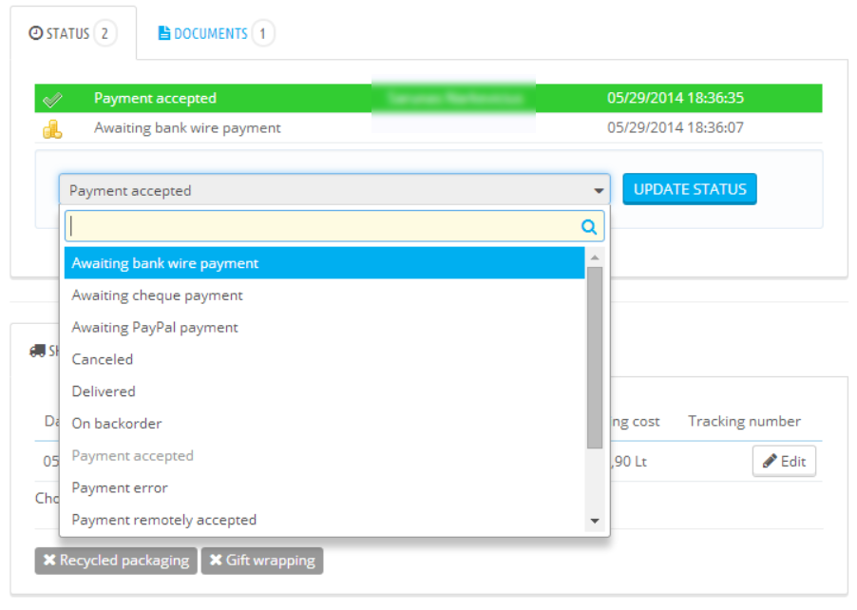

When payments gets accepted, data is send to DPD server and result is stored to order comments.

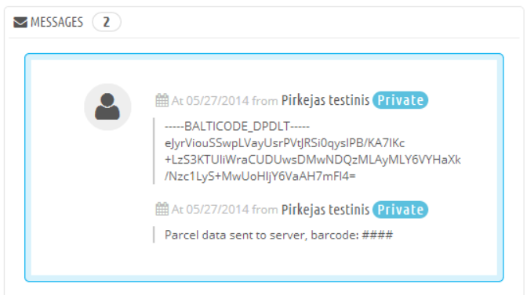

You can retry sending data to DPD server by marking order as Awaiting payment and thereafter marking order as Awaiting payment and thereafter marking it as paid again. This will allow to re-send carrier data to DPD server.

Packing slip is sent to merchants e-mail address.

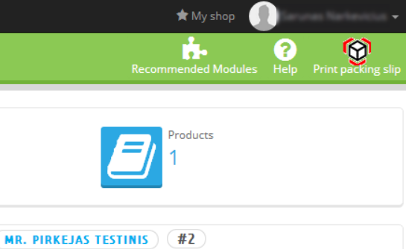

## Printing packing slips for selected orders

If an data sending with DPD API has been set up correctly then shop owners can print several packing slips on one or few A4 format PDF pages.

In order to do this they must follow the instructions below:

* In PrestaShop admin navigate Orders -> Orders
* In the orders list, select the necessary orders by using check boxes from the first column

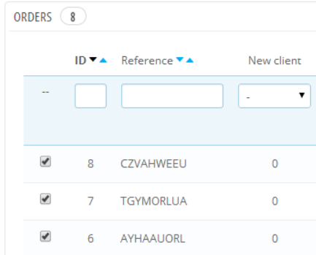

* After selection has been made bulk action called “Print DPD Labels” has to be submitted

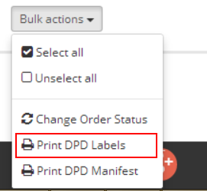

After a bulk action has been selected a new PDF file would be downloaded with all selected packing slips.

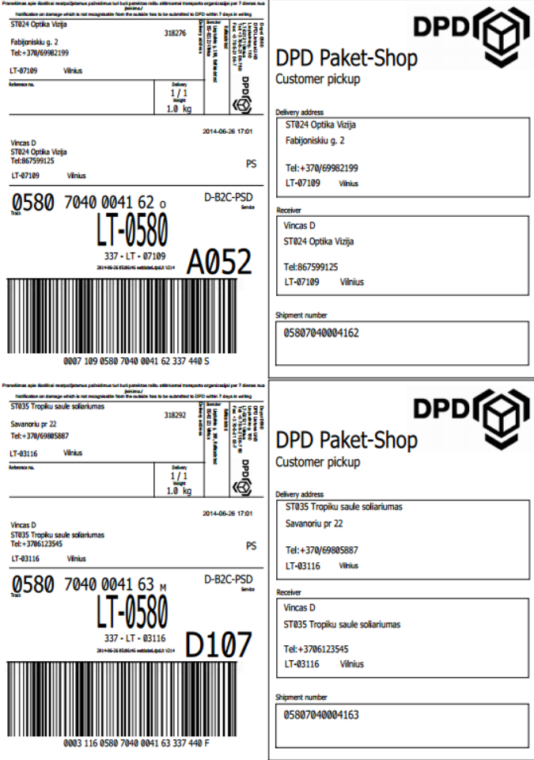

# Calling in DPD courier to pick up goods

If automatic data sending with DPD API has been set up and courier calls are allowed, then you can call DPD courier as follows:

* In PrestaShop admin navigate Orders-> Orders
* Locate „Order courier to pick up goods“ button from top right

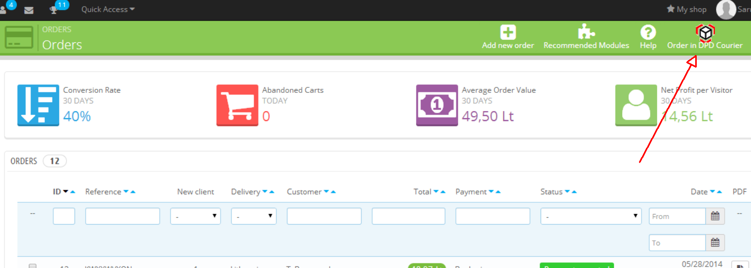

Clicking on it will open up Order DPD courier menu.

* You can declare how many envelopes, parcels, pallets courier should pick up, make sure you enter correct amounts.
* You can also enter remark to courier by entering text in text area.

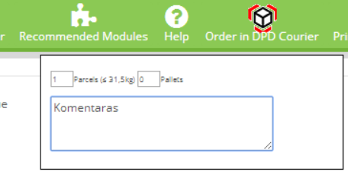

* The information will be sent out after second click on the “Order in DPD Courier” button.

If the data has been sent successfully a message with feedback is being provided, that DPD courier has been successfully called.

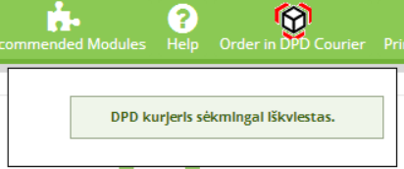

Do not forget to print out packing slips and pasting them to parcels. If you have not done that, then you can print out packing slips by clicking on „Print packing slip“ button on the order.

If you have ordered DPD courier to pick up goods, then next time you can create another pickup order, when current pickup order has been processed.

# Printing shipping manifest for selected orders

DPD shipping module provides an opportunity to print out shipping manifest only for selected orders. The difference from the main manifest printing is that the connection with DPD API is not necessary, the orders does not have to be paid and the printing date has no influence.

In order to print this you should perform these actions:

* In the PrestaShop admin panel open Orders -> Orders
* In the orders list, select the necessary orders by using check boxes from the first column



* After the selection has been made an action called “Print DPD Manifest” must be submitted

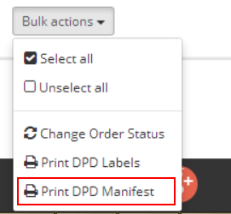

* After the Bulk action has been selected a new PDF file would be downloaded with all selected packages on one shipping manifest

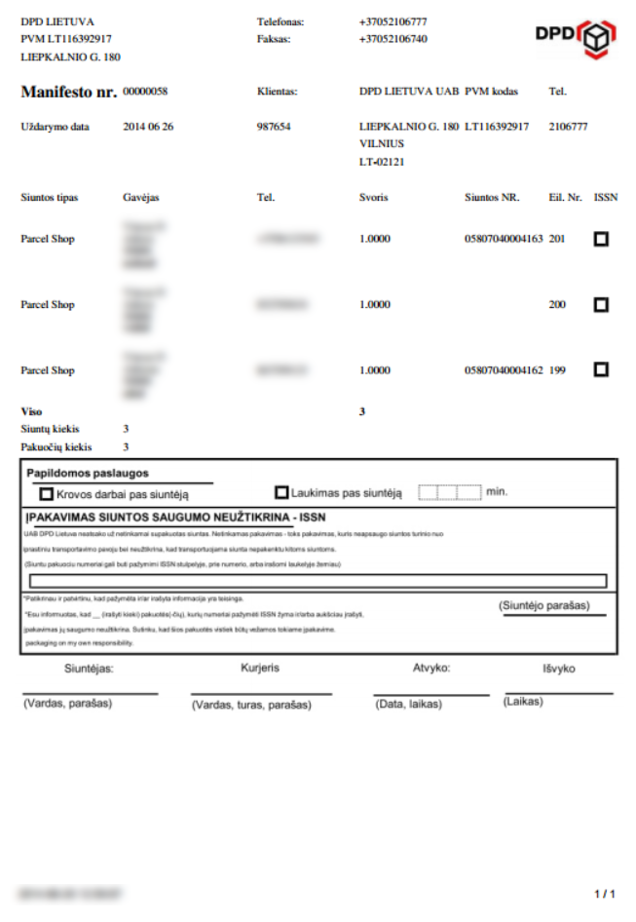

# License

Module is licensed under GPLv3 license.

# In case of problems

## Module is installed, but DPD carriers are not listed in the frontend

You may be using third party checkout module in your PrestaShop and may require few changes in the

code, which may result in minor extra expenses in order to make the module compatible.

If you are not using third party checkout module, then uninstall and re-install the module. If it does not

help, then contact developer.

## DPD Courier carrier displays empty select menu

When DPD Courier carrier displays empty select menu as on the picture, then navigate to DPD Courier

module settings panel in PrestaShop admin and save settings. This should fix this error.

## Other problems

If you are experiencing problems with this module, then please contact developer by contact-us [support@balticode.com](mailto:support@balticode.com?subject=DPD%20module%20(LT)) .

1. <http://addons.prestashop.com/en/checkout-modules/16851-payment-restriction-by-carrier.html> (checked on 2014-07-07)