Software Verification and Validation (Lab)

Lab Task

Submitted to:

Ma’am Jawaria Ramzan

Submitted by:

Abdul Rehman

Fa-23 / BSSE (Sec-A) / 008


Department: Software Engineering

Lahore Garrison University

Scenario: “Online Course Registration System – Real University Version”

Task A — Defect Hunt

- Inconsistencies

R2 vs R3
- R2: Registration not allowed after deadline
- R3: Late registration allowed for 3 days
Conflict: One says not allowed, other says allowed.

R4 vs R5 vs R16
- R4: Show available seats
- R5: Allow registration even if seats are full
- R16: Support waitlisting when seats are full
Conflict: If seats are full, should student register directly or waitlist?

R7 vs R8
- R7: Prevent registration if prerequisites not met
- R8: Prerequisites may be ignored with instructor approval
Conflict: System blocks vs system allows override.

R9 vs R10
- R9: Prevent schedule conflicts
- R10: Allow same-time registration if one is online
Conflict: One says prevent all conflicts, other allows exception.

R11 vs R12
- R11: Limit 18 credit hours
- R12: Allow 24 with advisor approval
Conflict: Limit unclear without defining exception rule.

R13 vs R15
- R13: Drop until Week 6
- R15: Not allow drops after deadline
Conflict: What is the drop deadline? Week 6 or some other date?

- Incompleteness Defects

R1 – Who can register?
Does it include undergraduate, postgraduate, probation students?

R6 – “Send confirmation”
How? Email? SMS? System notification?

R19 – Priority enrollment
How is priority implemented? Before others? Reserved seats?

R14 – Drop fee
What is the amount? Fixed or percentage?

R3 – Late registration
Is there extra fee? Approval required?

R16 – Waitlisting
Maximum waitlist size not defined.

R20 – “Register quickly”
No measurable value given.
- Ambiguities

R20 – “Quickly”
What does quickly mean? 2 seconds? 10 seconds?

R15 – “Deadline”
Which deadline? Registration deadline? Drop deadline?

R8 – “Instructor approval”
How is approval given? Email? System approval button?

- Unverifiable / Untestable

R20 – “Register quickly”
Cannot test without defined time.

R6 – “Send confirmation”
Cannot test unless delivery method defined.

Task A Summary
- 6 inconsistencies
- 7 incompleteness
- 3 ambiguities
- 2 unverifiable
Requirement satisfied

Task B — Defect Logging
Below are 10 sample logged defects.

Issue 1
Title: Conflict between deadline and late registration
Requirement ID: R2, R3
Defect Type: Inconsistency
Description: R2 blocks registration after deadline while R3 allows 3 days late registration.
Impact: System behavior unclear.
Suggested Fix: Define late registration as official extension with conditions.
Priority: High

Issue 2
Title: Seat full registration conflict
Requirement ID: R5, R16
Defect Type: Inconsistency
Description: System allows registration even if seats full but also supports waitlist.
Impact: Overbooking risk.
Suggested Fix: Clarify that full courses allow waitlist only.
Priority: High

Issue 3
Title: Prerequisite override unclear
Requirement ID: R7, R8
Defect Type: Inconsistency / Ambiguity
Description: Blocking rule conflicts with instructor approval rule.
Impact: Incorrect enrollment decisions.
Suggested Fix: Add formal override workflow.
Priority: High

Issue 4
Title: Credit hour limit unclear
Requirement ID: R11, R12
Defect Type: Inconsistency
Description: 18-hour limit conflicts with 24-hour approval rule.
Impact: Students may exceed limit incorrectly.
Suggested Fix: Define default 18, max 24 with approval.
Priority: Medium

Issue 5
Title: Schedule conflict exception not defined clearly
Requirement ID: R9, R10
Defect Type: Inconsistency
Description: Conflict prevention contradicts online exception.
Impact: Incorrect schedule validation.
Suggested Fix: Define exception rule explicitly.
Priority: High

Issue 6
Title: Confirmation method missing
Requirement ID: R6
Defect Type: Incompleteness
Description: Method of confirmation not specified.
Impact: Cannot test requirement.
Suggested Fix: Specify email + dashboard notification.
Priority: Medium

Issue 7
Title: Drop deadline unclear
Requirement ID: R13, R15
Defect Type: Ambiguity
Description: Deadline term not defined clearly.
Impact: Student confusion.
Suggested Fix: Define exact academic calendar date.
Priority: High

Issue 8
Title: Waitlist order handling
Requirement ID: R18, R19
Defect Type: Missing business rule
Description: Priority enrollment may conflict with FIFO waitlist rule.
Impact: Enrollment unfairness.
Suggested Fix: Define priority override mechanism.
Priority: Medium

Issue 9
Title: Drop fee amount missing
Requirement ID: R14
Defect Type: Incompleteness
Description: Fee amount not defined.
Impact: Billing errors.
Suggested Fix: Specify fixed amount or percentage.
Priority: Medium

Issue 10
Title: Performance requirement not measurable
Requirement ID: R20
Defect Type: Unverifiable
Description: “Register quickly” not measurable.
Impact: Cannot test performance.
Suggested Fix: Define response time ≤ 3 seconds.
Priority: Low

Task C — Rewritten Correct Requirements
Below I rewrite 10 requirements properly.

New R2 & R3
“The system shall allow course registration until the official registration deadline. Late registration shall be permitted for 3 calendar days after the deadline with an additional late fee of Rs. 2000.”

New R5 & R16
“If a course reaches maximum capacity, students shall not be enrolled directly. The system shall place students on a waitlist.”

New R6
“The system shall send a confirmation email and dashboard notification within 1 minute after successful registration.”

New R7 & R8
“The system shall prevent registration if prerequisites are not met. The instructor may approve an override through the system approval module.”

New R9 & R10
“The system shall prevent schedule conflicts except when one course is fully online and has no fixed meeting time.”

New R11 & R12
“The system shall limit students to 18 credit hours per semester. Students may register up to 24 credit hours only after advisor approval recorded in the system.”

New R13, R14, R15
“Students may drop courses until the end of Week 6. A drop fee of Rs. 1000 shall apply after Week 2. No course drops shall be permitted after Week 6.”

New R17 & R18
“When a seat becomes available, the system shall automatically enroll the first eligible student in the waitlist based on FIFO order, unless priority enrollment rules apply.”

New R20
“The system shall complete the course registration transaction within 3 seconds under normal load conditions.”

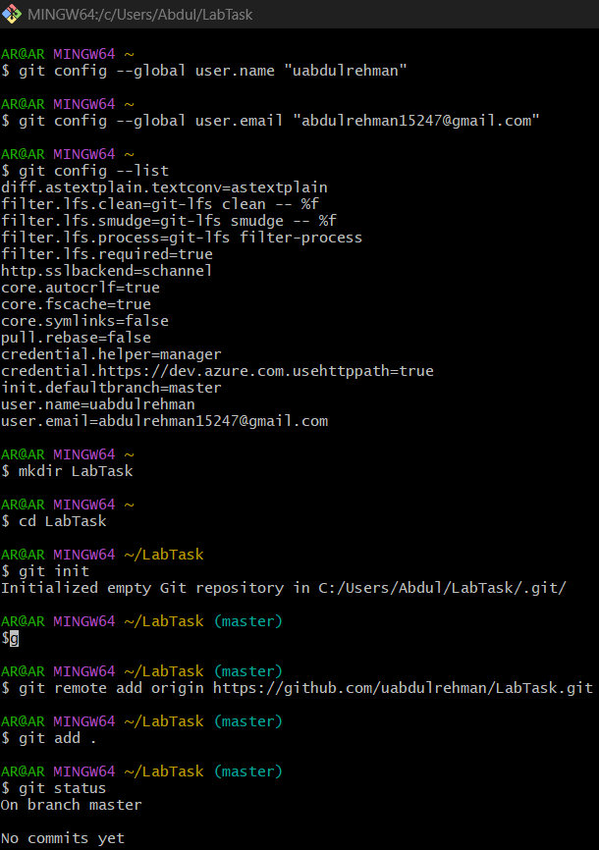
Git Bash:

