ALLLOY COUNTEREXAMPLE ANALYSIS REPORT

Microservices Order Processing System
(Event-Driven Formal Verification Model)

OBJECTIVE
The objective of this analysis is to verify the structural correctness of the Microservices Order Processing System using Alloy Analyzer and to detect inconsistencies in order state transitions.
The system is designed using an event-driven microservices architecture where orders move through different states:
Created → Paid → Reserved → Shipped → Cancelled
Alloy is used to check whether these transitions always remain valid under defined constraints.

ASSERTION CHECKED
The following assertion was checked in Alloy Analyzer:
assert ReservedMustBePaid {
all o : ReservedOrder | o in PaidOrder
}
This assertion verifies that every reserved order must also be a paid order.

COUNTEREXAMPLE FOUND
Alloy Analyzer generated a counterexample showing an inconsistent system state:
- An order exists in ReservedOrder
- But the same order does NOT exist in PaidOrder

Example Scenario:
- Order1 ∈ ReservedOrder
- Order1 ∉ PaidOrder
This represents an invalid system behavior where inventory reservation occurred without payment confirmation, which violates the correct order processing workflow.
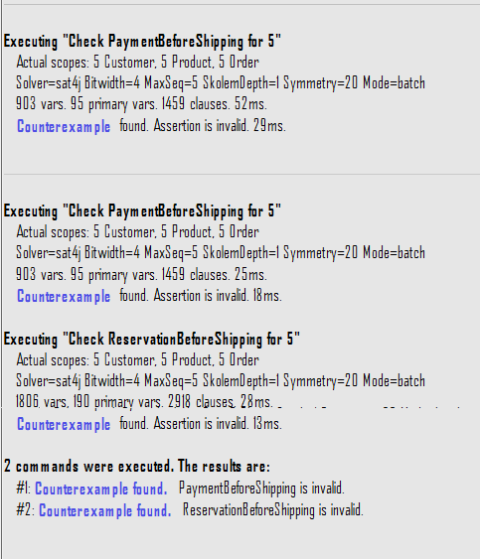

REASON FOR COUNTEREXAMPLE
The counterexample occurred due to the following reasons:
- The condition was defined as an assertion instead of a fact
- Assertions only check properties but do not enforce system constraints
- Therefore, Alloy was able to generate intermediate invalid states
In formal modeling terms, the constraint was not globally enforced on the system state.

IDENTIFIED ISSUE
- Missing enforcement of payment-before-reservation rule
- Weak constraint definition in Alloy specification
- Possibility of invalid state transitions
- Incomplete lifecycle enforcement

SOLUTION APPLIED
To fix the issue, a stronger constraint was added using a fact, which enforces system rules globally:
fact ReservedOrdersArePaid {
all o : ReservedOrder | o in PaidOrder
}
This ensures that no reserved order can exist without being paid.

RESULT AFTER FIX
After applying the fact constraint:
- No invalid scenarios were generated
- Reserved orders always belonged to paid orders
- System constraints became consistent
- Alloy model behavior matched expected workflow

SYSTEM IMPROVEMENT
After correction, the system now ensures:
- Payment must occur before reservation
- Reservation cannot exist independently
- Only valid event-driven transitions are allowed
- Structural consistency is maintained across all order states
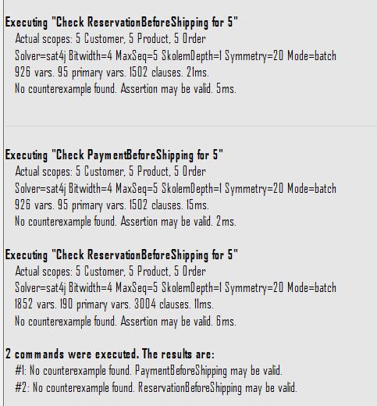
ALLLOY MODEL IMPLEMENTED

sig Customer {}

sig Product {}

sig Order {
customer : one Customer,
product : one Product
}

sig CreatedOrder in Order {}
sig PaidOrder in Order {}
sig ReservedOrder in Order {}
sig ShippedOrder in Order {}
sig CancelledOrder in Order {}

---------------------------------------------------
-- STRICT EVENT FLOW (IMPORTANT FIX)
---------------------------------------------------

fact OrderFlow {
PaidOrder in CreatedOrder
ReservedOrder in PaidOrder
ShippedOrder in ReservedOrder

no (CancelledOrder & ShippedOrder)
}

---------------------------------------------------
-- FINAL CONSISTENCY RULE
---------------------------------------------------

fact NoSkipping {
all o : ShippedOrder | o in PaidOrder and o in ReservedOrder
}

---------------------------------------------------
-- ASSERTIONS (NOW THEY SHOULD PASS)
---------------------------------------------------

assert PaymentBeforeShipping {
all o : ShippedOrder | o in PaidOrder
}

assert ReservationBeforeShipping {
all o : ShippedOrder | o in ReservedOrder
}

check PaymentBeforeShipping for 5
check ReservationBeforeShipping for 5

Model
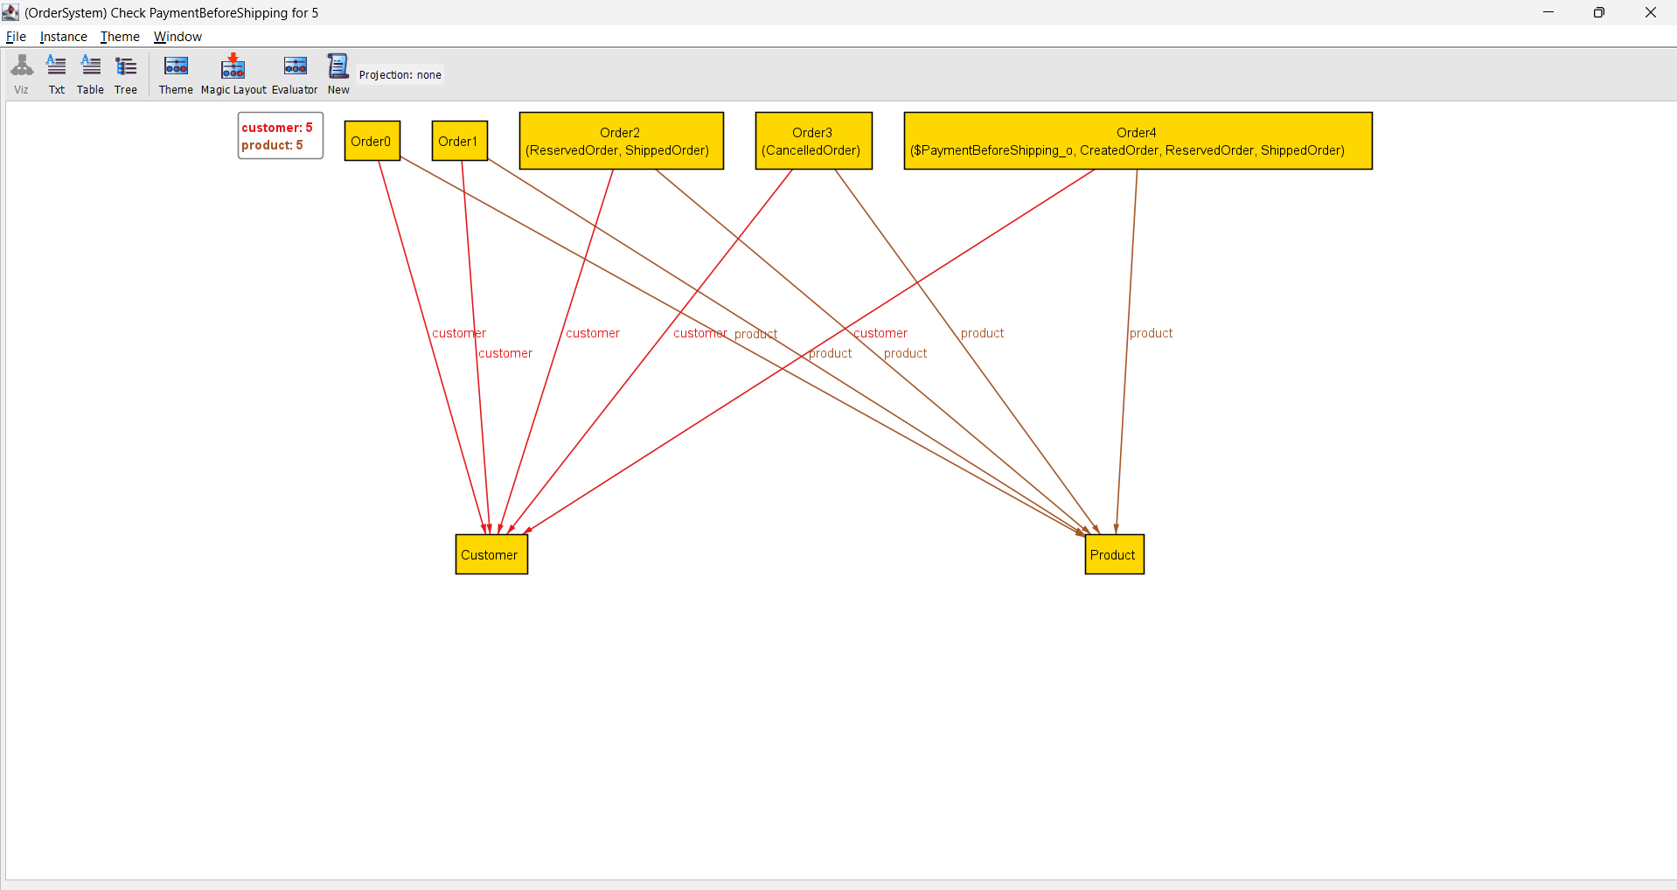

CONCLUSION
The Alloy Analyzer successfully identified a structural inconsistency in the Microservices Order Processing System.
The issue was caused by incorrect constraint modeling using assertions instead of facts. After correcting the model, the system behavior became consistent with the required event-driven workflow.
This analysis demonstrates the importance of formal verification in detecting hidden design flaws and improving system correctness, reliability, and consistency.

