GitHub Issues Tracking Log

Project Title
Microservices Order Processing System

PURPOSE
This document records the issues identified and managed during the development and formal verification of the Microservices Order Processing System.
The purpose of issue tracking is to ensure proper requirement management, traceability, and verification across all phases of the SVV pipeline including requirements, Z Notation, VDM, Alloy, and validation.

ISSUES LOG
Issue ID | Title | Description | Status
#1 | Create Project Repository Structure | Defined and created GitHub repository structure for SVV pipeline including requirements, Z model, VDM, Alloy, and validation folders | Closed
#2 | Add Software Requirements Specification (SRS) | Created complete SRS document for microservices order processing system with functional and non-functional requirements | Closed
#3 | Define System State Model (Z Notation) | Identified system states such as Created, Paid, Reserved, Shipped, Cancelled for formal modeling | Closed
#4 | Define System Invariants | Added invariants such as payment required before shipping and no cancellation after shipping | Closed
#5 | Define Payment Processing Constraints | Added rules ensuring payment must be completed before inventory reservation and shipping | Closed
#6 | Inventory Reservation Rules | Defined constraints for inventory availability before reservation and order processing continuation | Closed
#7 | Alloy Model Counterexample Detection | Identified invalid scenario where order could be shipped without payment; corrected using constraints | Closed
#8 | Add VDM Functional Specifications | Defined preconditions and postconditions for operations such as placeOrder, processPayment, and shipOrder | Closed
#9 | Configure CI Pipeline | Added GitHub Actions workflow for automated validation of project structure and consistency checks | Closed
#10 | Add OWASP ZAP Security Validation | Integrated security scanning process to evaluate system communication safety and basic vulnerability checks | Closed
#11 | Validate State Transition Rules | Ensured correct event-driven transitions between order states in formal models | Closed
#12 | Requirement Defect Fixes | Fixed ambiguous and inconsistent requirements identified in requirement analysis phase | Closed

Issues Created on GitHub

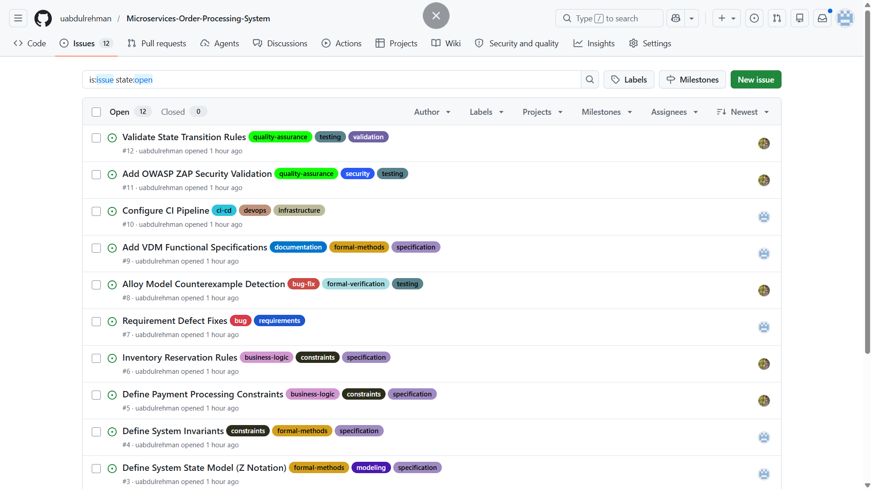

ISSUE RESOLUTION SUMMARY
All identified issues were resolved during different phases of the SVV lifecycle. Each issue contributed to improving the correctness, consistency, and formal structure of the system.
The issues helped refine:
- System requirements
- State modeling (Z Notation)
- Functional behavior (VDM)
- Structural consistency (Alloy)
- Validation and security checks

CONCLUSION
GitHub issue tracking played an important role in managing the development and verification process of the Microservices Order Processing System.
It improved traceability between requirements, formal models, and validation activities. It also ensured that all inconsistencies and modeling issues were identified and resolved before final submission.
Overall, issue tracking strengthened the correctness, reliability, and formal verification quality of the system.

