Requirement Defect Taxonomy Report

Project Title
Microservices Order Processing System

INTRODUCTION
This document identifies requirement defects found during the requirement analysis of the Microservices Order Processing System.
Requirement defects refer to problems in requirements such as ambiguity, inconsistency, missing constraints, and non-verifiable statements. These defects may lead to incorrect system behavior during formal modeling or verification.
The purpose of this report is to improve requirement quality before applying formal methods such as Z Notation, VDM Specification, and Alloy Modeling.

REQUIREMENT DEFECT TABLE
Requirement ID | Requirement Statement | Defect Type | Explanation | Corrected Requirement
R1 | System should process orders quickly | Ambiguity | “Quickly” is not measurable or defined | System shall process order events within 2–5 seconds
R2 | Orders may be shipped before payment | Inconsistency | Violates correct order lifecycle | Orders shall only be shipped after payment confirmation
R3 | System should rarely fail | Non-Verifiable | “Rarely” cannot be measured or tested | System shall ensure reliable order state transitions
R4 | Inventory might be reserved after shipping | Logical Inconsistency | Shipping must occur after inventory reservation | Inventory shall be reserved before order shipping
R5 | System may cancel shipped orders | Invalid Constraint | Shipped orders cannot be cancelled | Only orders in Created or Paid state may be cancelled
R6 | Customers can create unlimited active orders | Missing Constraint | No limit defined for active orders | System shall define and enforce constraints on active orders per customer
R7 | Payment can happen at any time | Ambiguity | No restriction on order state before payment | Payment shall only be processed for Created orders
R8 | Order status may change randomly | Non-Verifiable | No defined rule for state transitions | Order status shall follow defined event-driven transitions
R9 | Inventory is always available | Incorrect Assumption | Availability is not guaranteed | System shall verify inventory availability before reservation
R10 | Shipping happens immediately after order | Missing Constraint | Missing required processing steps | Shipping shall occur only after payment and inventory reservation

DEFECT CATEGORIES

1. Ambiguity
Ambiguity occurs when requirements are not clearly defined or contain vague terms.

Examples:
- quickly
- immediately
- efficiently
- at any time
In this project, ambiguity may lead to incorrect interpretation of order processing timing.

2. Inconsistency
Inconsistency occurs when requirements conflict with system logic or workflow.

Example:
- shipping before payment
- cancelling shipped orders
These violate the correct event-driven order lifecycle.

3. Non-Verifiable Requirements
Non-verifiable requirements cannot be tested or measured.

Examples:
- system rarely fails
- system is fast
- system performs efficiently
These must be converted into measurable conditions.

4. Missing Constraints
Missing constraints occur when important rules are not defined.

Examples:
- unlimited orders
- no restriction on cancellation
- no limit on active processes
These can lead to system misuse or undefined behavior.
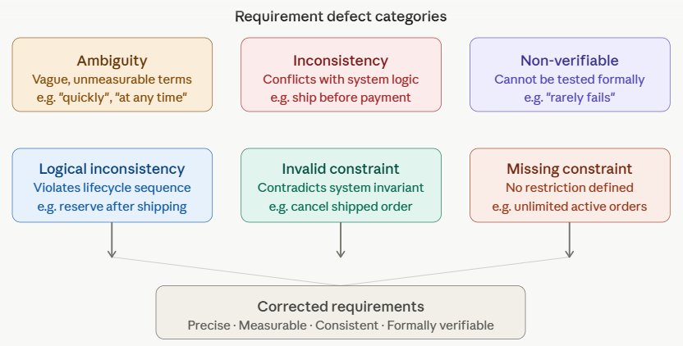

IMPACT ON SYSTEM DESIGN
If requirement defects are not corrected:
- Z Notation models may become inconsistent
- VDM contracts may fail verification
- Alloy may produce invalid counterexamples
- System may allow illegal state transitions

CONCLUSION
Requirement defect analysis is an important step in Software Verification and Validation. It helps to identify ambiguity, inconsistency, missing constraints, and non-verifiable requirements before formal modeling.
For the Microservices Order Processing System, this analysis ensures that all requirements are clear, consistent, and suitable for formal verification using Z Notation, VDM, and Alloy.
This improves system correctness, reliability, and prevents invalid state transitions during the order lifecycle.

