VDM SPECIFICATION

Microservices Order Processing System
(Event-Driven Formal Verification Model)

TYPE DEFINITIONS
types
ORDER = token;
Orders = set of ORDER;

SYSTEM STATE
state OrderSystem of
orders : Orders
paid : Orders
reserved : Orders
shipped : Orders
cancelled: Orders
inv mk_OrderSystem(o, p, r, s, c) ==
p subset o and
r subset o and
s subset o and
c subset o and
s subset p and
s subset r and
s inter c = {}
end

INITIAL STATE
init OrderSystem ==
mk_OrderSystem({}, {}, {}, {}, {});

OPERATION 1: CREATE ORDER
operations
CreateOrder : ORDER ==> ()
CreateOrder(order) ==
(
orders := orders union {order};
)
pre order not in set orders
post order in set orders;

OPERATION 2: CONFIRM PAYMENT
ConfirmPayment : ORDER ==> ()
ConfirmPayment(order) ==
(
paid := paid union {order};
)
pre order in set orders and order not in set paid
post order in set paid;

OPERATION 3: RESERVE INVENTORY
ReserveInventory : ORDER ==> ()
ReserveInventory(order) ==
(
reserved := reserved union {order};
)
pre order in set paid and order not in set reserved
post order in set reserved;

OPERATION 4: SHIP ORDER
ShipOrder : ORDER ==> ()
ShipOrder(order) ==
(
shipped := shipped union {order};
)
pre order in set reserved and order not in set shipped
post order in set shipped;

OPERATION 5: CANCEL ORDER
CancelOrder : ORDER ==> ()
CancelOrder(order) ==
(
cancelled := cancelled union {order};
)
pre order in set orders and order not in set shipped
post order in set cancelled;

IMPLEMENTATION ON VDM OVERTURE

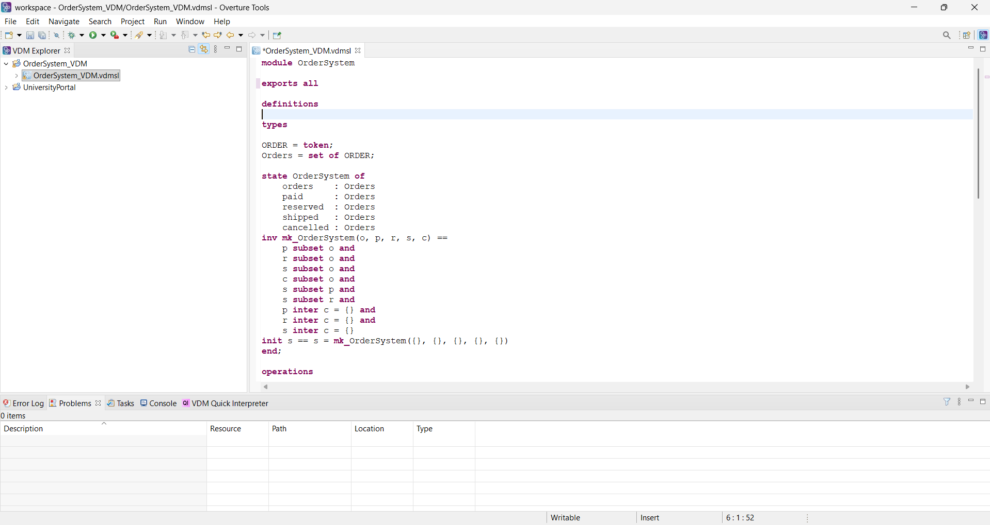

COMPLETE CODE FROM VDM EDITOR OVERTURE
module OrderSystem

exports all

definitions

types

ORDER = token;
Orders = set of ORDER;

state OrderSystem of
orders : Orders
paid : Orders
reserved : Orders
shipped : Orders
cancelled : Orders
inv mk_OrderSystem(o, p, r, s, c) ==
p subset o and
r subset o and
s subset o and
c subset o and
s subset p and
s subset r and
p inter c = {} and
r inter c = {} and
s inter c = {}
init s == s = mk_OrderSystem({}, {}, {}, {}, {})
end;

operations

CreateOrder : ORDER ==> ()
CreateOrder(order) ==
(
orders := orders union {order}
)
pre order not in set orders
post order in set orders;

ConfirmPayment : ORDER ==> ()
ConfirmPayment(order) ==
(
paid := paid union {order}
)
pre order in set orders and order not in set paid
post order in set paid;

ReserveInventory : ORDER ==> ()
ReserveInventory(order) ==
(
reserved := reserved union {order}
)
pre order in set paid and order not in set reserved
post order in set reserved;

ShipOrder : ORDER ==> ()
ShipOrder(order) ==
(
shipped := shipped union {order}
)
pre order in set reserved and order in set paid and order not in set shipped
post order in set shipped;

CancelOrder : ORDER ==> ()
CancelOrder(order) ==
(
cancelled := cancelled union {order}
)
pre order in set orders and order not in set shipped and order not in set paid
post order in set cancelled;

end OrderSystem

CONCLUSION
The VDM specification defines the functional behavior of the Microservices Order Processing System using state-based modeling and pre/post conditions.
It ensures that all operations follow correct constraints such as payment before shipping and inventory reservation before dispatch.
This model supports formal verification and consistency checking of system behavior.

