Z NOTATION SPECIFICATION

Microservices Order Processing System
(Event-Driven Formal Verification Model)

INTRODUCTION
This document presents the Z Notation specification for the Microservices Order Processing System. The specification formally defines system states, invariants, and operations involved in the order lifecycle.
The purpose of this model is to ensure correctness and consistency of order processing using formal verification techniques.

STEP 1: ABSTRACT TYPES
[ORDER, CUSTOMER, PRODUCT]
These abstract types represent the main entities used in the system.
Type | Description
ORDER | Represents customer orders
CUSTOMER | Represents registered customers
PRODUCT | Represents products available in inventory

STEP 2: STATE SCHEMA
OrderSystemState
-----------------------------
orders : ℙ ORDER
customers : ℙ CUSTOMER
products : ℙ PRODUCT
paid : ℙ ORDER
reserved : ℙ ORDER
shipped : ℙ ORDER
cancelled : ℙ ORDER

STATE VARIABLE MEANING
Variable | Meaning
orders | Set of all created orders
customers | Set of registered customers
products | Set of available products
paid | Orders with successful payment
reserved | Orders with reserved inventory
shipped | Orders that are shipped
cancelled | Cancelled orders

SYSTEM INVARIANTS
The following invariants define constraints that must always remain true in the system.

Invariant 1
A shipped order must always be paid.
∀ o : ORDER •
o ∈ shipped ⇒ o ∈ paid

Invariant 2
Reserved orders must exist in the system.
∀ o : ORDER •
o ∈ reserved ⇒ o ∈ orders

Invariant 3
Cancelled orders cannot be shipped.
∀ o : ORDER •
o ∈ cancelled ⇒ o ∉ shipped

Invariant 4
Shipped orders must have reserved inventory.
∀ o : ORDER •
o ∈ shipped ⇒ o ∈ reserved

Invariant 5
An order cannot be both shipped and cancelled.
∀ o : ORDER •
o ∈ shipped ⇒ o ∉ cancelled

STEP 3: OPERATIONS

Operation 1: CreateOrder
CreateOrder
-----------------------------
ΔOrderSystemState
o? : ORDER
o? ∉ orders
orders' = orders ∪ {o?}
paid' = paid
reserved' = reserved
shipped' = shipped
cancelled' = cancelled
customers' = customers
products' = products

Description
This operation creates a new order and initializes it in the system.

Operation 2: ConfirmPayment
ConfirmPayment
-----------------------------
ΔOrderSystemState
o? : ORDER
o? ∈ orders
o? ∉ paid
o? ∉ cancelled
paid' = paid ∪ {o?}
orders' = orders
reserved' = reserved
shipped' = shipped
cancelled' = cancelled
customers' = customers
products' = products

Description
This operation confirms payment for a valid order.

Operation 3: ReserveInventory
ReserveInventory
-----------------------------
ΔOrderSystemState
o? : ORDER
o? ∈ paid
o? ∉ reserved
o? ∉ cancelled
reserved' = reserved ∪ {o?}
orders' = orders
paid' = paid
shipped' = shipped
cancelled' = cancelled
customers' = customers
products' = products

Description
This operation reserves inventory for paid orders.

Operation 4: ShipOrder
ShipOrder
-----------------------------
ΔOrderSystemState
o? : ORDER
o? ∈ reserved
o? ∈ paid
o? ∉ shipped
o? ∉ cancelled
shipped' = shipped ∪ {o?}
orders' = orders
paid' = paid
reserved' = reserved
cancelled' = cancelled
customers' = customers
products' = products

Description
This operation ships an order after successful payment and inventory reservation.

Operation 5: CancelOrder
CancelOrder
-----------------------------
ΔOrderSystemState
o? : ORDER
o? ∈ orders
o? ∉ shipped
o? ∉ cancelled
cancelled' = cancelled ∪ {o?}
orders' = orders
paid' = paid
reserved' = reserved
shipped' = shipped
customers' = customers
products' = products

Description
This operation cancels a valid non-shipped order.

EVENT-DRIVEN STATE FLOW
Created → Paid → Reserved → Shipped
Created → Cancelled
Paid → Cancelled
Invalid transitions are not allowed in the system.

IMPLEMENTATION ON Z EDITOR

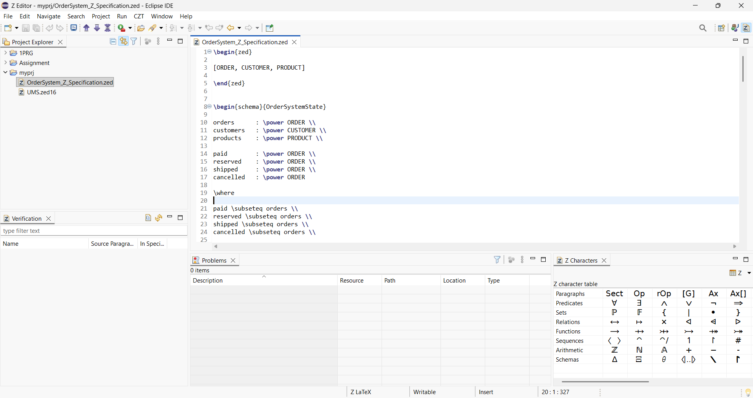

COMPLETE CODE FROM Z EDITOR CZT
\begin{zed}

[ORDER, CUSTOMER, PRODUCT]

\end{zed}

\begin{schema}{OrderSystemState}

orders : \power ORDER \\
customers : \power CUSTOMER \\
products : \power PRODUCT \\

paid : \power ORDER \\
reserved : \power ORDER \\
shipped : \power ORDER \\
cancelled : \power ORDER

\where

paid \subseteq orders \\
reserved \subseteq orders \\
shipped \subseteq orders \\
cancelled \subseteq orders \\

shipped \subseteq paid \\
shipped \subseteq reserved \\

shipped \cap cancelled = \emptyset

\end{schema}

\begin{schema}{InitOrderSystemState}

OrderSystemState

\where

orders = \emptyset \\
customers = \emptyset \\
products = \emptyset \\

paid = \emptyset \\
reserved = \emptyset \\
shipped = \emptyset \\
cancelled = \emptyset

\end{schema}

\begin{schema}{CreateOrder}

\Delta OrderSystemState \\

o? : ORDER

\where

o? \notin orders \\

orders' = orders \cup \{o?\} \\

customers' = customers \\
products' = products \\

paid' = paid \\
reserved' = reserved \\
shipped' = shipped \\
cancelled' = cancelled

\end{schema}

\begin{schema}{ConfirmPayment}

\Delta OrderSystemState \\

o? : ORDER

\where

o? \in orders \\
o? \notin paid \\
o? \notin cancelled \\

paid' = paid \cup \{o?\} \\

orders' = orders \\
customers' = customers \\
products' = products \\

reserved' = reserved \\
shipped' = shipped \\
cancelled' = cancelled

\end{schema}

\begin{schema}{ReserveInventory}

\Delta OrderSystemState \\

o? : ORDER

\where

o? \in paid \\
o? \notin reserved \\
o? \notin cancelled \\

reserved' = reserved \cup \{o?\} \\

orders' = orders \\
customers' = customers \\
products' = products \\

paid' = paid \\
shipped' = shipped \\
cancelled' = cancelled

\end{schema}

\begin{schema}{ShipOrder}

\Delta OrderSystemState \\

o? : ORDER

\where

o? \in paid \\
o? \in reserved \\
o? \notin shipped \\
o? \notin cancelled \\

shipped' = shipped \cup \{o?\} \\

orders' = orders \\
customers' = customers \\
products' = products \\

paid' = paid \\
reserved' = reserved \\
cancelled' = cancelled

\end{schema}

\begin{schema}{CancelOrder}

\Delta OrderSystemState \\

o? : ORDER

\where

o? \in orders \\
o? \notin shipped \\
o? \notin cancelled \\

cancelled' = cancelled \cup \{o?\} \\

orders' = orders \\
customers' = customers \\
products' = products \\

paid' = paid \\
reserved' = reserved \\
shipped' = shipped

\end{schema}

CONCLUSION
This Z specification formally models the Microservices Order Processing System using state schemas, invariants, and operations.
The specification ensures correctness of system behavior and prevents invalid order state transitions during the order lifecycle.
Formal verification through Z Notation improves system consistency, reliability, and structural correctness.

