

An event-driven system where order processing correctness is formally verified through state machines, ensuring reliable and consistent service behavior.

Microservices Order Processing System

Software Verification

& Validatiom

Lahore Garrison University

MICROSERVICE ORDER SYSTEM

Correctness. Consistency. Completeness.

Software Verification & Validation
SVV Semester Project

Submitted to:
Ma’am Jawaria Ramzan

Submitted by:
- Abdul Rehman
[FA23-BSSE-4A- 008]
- M. Saad Asad
[FA23-BSSE-4A- 017]


Department of Software Engineering
Lahore Garrison University

Table of Contents
ABSTRACT 1
1. INTRODUCTION 2
1.1 Purpose 2
1.2 Scope 2
1.3 Objectives 2
2. SYSTEM OVERVIEW 2
2.1 System Description 2
2.2 Main Services 3
2.3 Event Flow 3
3. FUNCTIONAL REQUIREMENTS (FRs) 4
4. NON-FUNCTIONAL REQUIREMENTS (NFRs) 5
5. SYSTEM STATES 7
6. SYSTEM CONSTRAINTS 7
7. ASSUMPTIONS 8
8. FORMAL VERIFICATION APPROACH 8
9. TOOLS USED 8
10. VALIDATION REQUIREMENTS 8
11. REQUIREMENT TRACEABILITY 9
12. CONCLUSION 9

ABSTRACT
This project presents a Microservices Order Processing System designed using an event-driven architecture. The system is developed for the Software Verification and Validation (SVV) Lab and focuses on formally verifying system behavior instead of implementing a real software application.
The system models the complete order lifecycle including order creation, payment processing, inventory reservation, shipping, and order cancellation. Each operation in the system is represented as a state transition triggered by events.
The main purpose of this project is to ensure that the system behaves correctly under all conditions and does not enter invalid or inconsistent states. Formal methods such as Z Notation, VDM Specification, and Alloy Modeling are used to define system states, invariants, and constraints.
Z Notation is used for state modeling and invariants, VDM is used for defining functional behavior with preconditions and postconditions, and Alloy is used to detect structural inconsistencies and counterexamples.
The system also includes validation techniques and security checking using CI pipelines and OWASP ZAP tools. The overall goal is to ensure correctness, reliability, and consistency of the system through formal verification methods.

- INTRODUCTION

1.1 Purpose
The purpose of this project is to design and formally verify a Microservices Order Processing System using Software Verification and Validation (SVV) techniques. The system models order processing activities including order creation, payment confirmation, inventory reservation, shipping, and order cancellation.

1.2 Scope
The system allows customers to place orders and process them through multiple microservices. The project focuses on formal correctness of system behavior using Z Notation, VDM Specification, and Alloy verification.
The system does not include UI or real deployment, only formal modeling and verification.

1.3 Objectives
- To model system states formally
- To define system invariants
- To verify structural consistency
- To validate order processing constraints
- To detect inconsistencies using Alloy Analyzer
- To ensure correct event-driven behavior

2. SYSTEM OVERVIEW

2.1 System Description
The Microservices Order Processing System is an event-driven system where multiple services cooperate to process customer orders. Each service performs a specific responsibility in the order lifecycle.

2.2 Main Services
Service | Responsibility
Order Service | Creates customer orders
Payment Service | Confirms payments
Inventory Service | Reserves products
Shipping Service | Ships orders

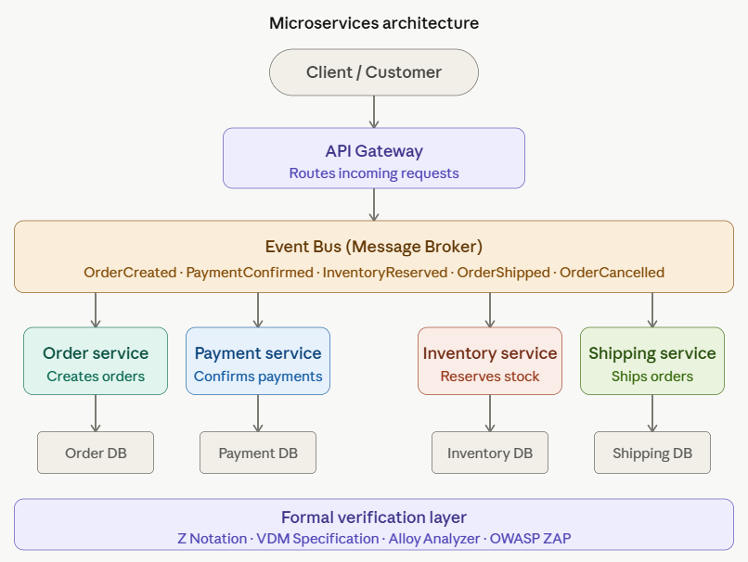

2.3 Event Flow
- OrderCreated
- PaymentConfirmed
- InventoryReserved
- OrderShipped
- OrderCancelled

3. FUNCTIONAL REQUIREMENTS (FRs)

FR-01 Order Creation
The system must allow customers to place orders, and each order must be assigned a unique Order ID. The order must be initialized in Created state within 2 seconds.

FR-02 Order Initialization
The system must ensure every order starts from Created state only and cannot directly enter any later state.

FR-03 Payment Processing
The system must process payment for valid orders, and payment must be confirmed before moving to the next state.

FR-04 Payment Validation
The system must ensure only successfully paid orders are allowed to proceed for further processing.

FR-05 Inventory Reservation
The system must reserve inventory after order creation, and reservation must be completed within 5 seconds.

FR-06 Stock Availability Check
The system must check inventory availability before reservation and reject orders if stock is unavailable.

FR-07 Order Shipping
The system must allow shipping only if payment is confirmed and inventory is reserved. Shipping must be processed within 5 seconds.

FR-08 Order Cancellation
The system must allow order cancellation only before shipping, and must block cancellation after shipping.

FR-09 Event Generation
The system must generate events for every state transition such as OrderCreated, PaymentConfirmed, InventoryReserved, OrderShipped, and OrderCancelled.

FR-10 State Update
The system must update order status immediately after each event, and updates must reflect within 2 seconds.

FR-11 Invalid Transition Prevention
The system must prevent invalid transitions such as shipping without payment or reservation.

FR-12 Order Tracking
The system must allow tracking of order status at any point in the lifecycle.

FR-13 Microservice Communication
The system must ensure communication between services through events only.

FR-14 Order Lifecycle Enforcement
The system must enforce strict lifecycle:
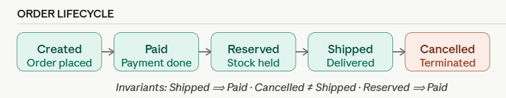

4. NON-FUNCTIONAL REQUIREMENTS (NFRs)

NFR-01 Consistency
The system must maintain consistent order states across all microservices.

NFR-02 Reliability
The system must ensure reliable processing of all order events without data loss.

NFR-03 Performance
The system must process events within 2–5 seconds.

NFR-04 Scalability
The system must support multiple concurrent orders without breaking event flow.

NFR-05 Security
The system must ensure secure communication between microservices.

NFR-06 Fault Tolerance
The system must handle service failure without breaking the order lifecycle.

NFR-07 Maintainability
The system must allow easy modification of services without affecting the entire system.

NFR-08 Traceability
The system must maintain full traceability of all order events.

NFR-09 Formal Verification Support
The system must support Z Notation, VDM, and Alloy modeling.

NFR-10 No Invalid State
The system must ensure no order exists in an undefined or invalid state.

NFR-11 Event Latency
All events must be processed and reflected within 2–3 seconds.

NFR-12 Data Integrity
The system must ensure data consistency across all microservices.

5. SYSTEM STATES
State | Description
Created | Order is created
Paid | Payment is completed
Reserved | Inventory is reserved
Shipped | Order is delivered
Cancelled | Order is cancelled

6. SYSTEM CONSTRAINTS
- Payment must be completed before shipping
- Inventory must be reserved before shipping
- Cancelled orders cannot be shipped
- Each order must follow full lifecycle
- No invalid transitions are allowed
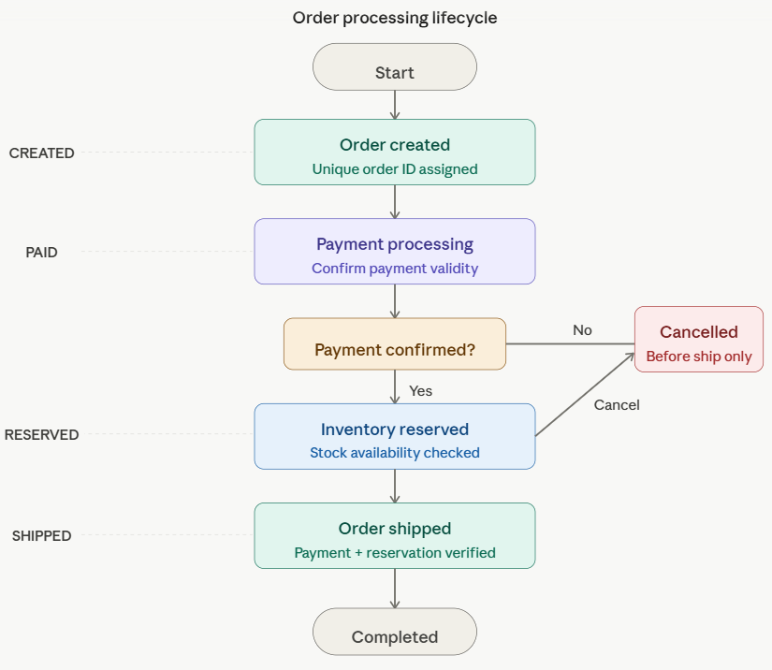

7. ASSUMPTIONS
- All customers are registered
- Products exist in inventory
- Payment service responds correctly
- System processes events sequentially
- Each order has a unique ID

8. FORMAL VERIFICATION APPROACH
Technique | Purpose
Z Notation | System state + invariants
VDM | Functional specification
Alloy | Structural verification + counterexamples
OWASP ZAP | Security validation

9. TOOLS USED
Tool | Purpose
GitHub | Version control
VS Code | Editing
CZT | Z Notation
Overture | VDM Specification
Alloy Analyzer | Constraint verification
OWASP ZAP | Security scanning

10. VALIDATION REQUIREMENTS
Validation Item | Expected Result
Create Order | Successful
Process Payment | Valid confirmation
Reserve Inventory | Stock reserved
Ship Order | Only after payment + reservation
Cancel Order | Prevent shipping

11. REQUIREMENT TRACEABILITY
Requirement | Method
FR1–FR4 | Z Notation
FR5–FR10 | VDM Specification
FR11–FR14 | Alloy Model
All NFRs | Validation + CI Pipeline

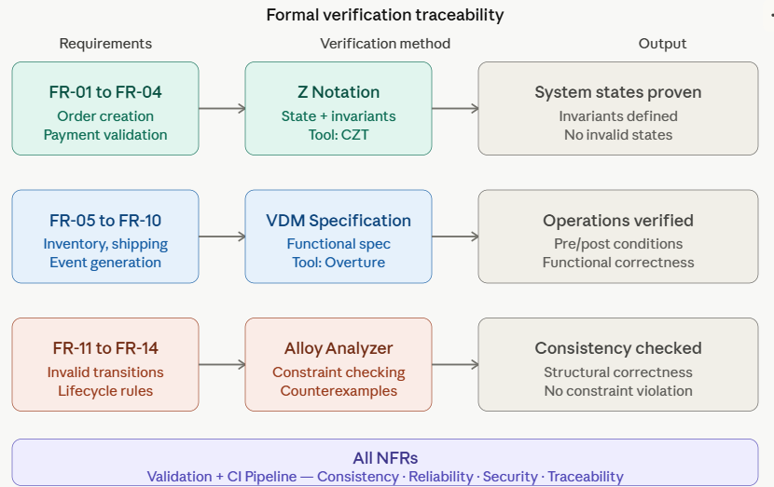

12. CONCLUSION
This project presents a Microservices Order Processing System based on an event-driven architecture and formal verification techniques. The system is designed to ensure correct and consistent behavior throughout the complete order lifecycle, including order creation, payment processing, inventory reservation, and order shipping.
The use of formal methods such as Z Notation, VDM Specification, and Alloy Modeling helps in defining precise system states, validating operations, and detecting inconsistencies in system behavior. These techniques ensure that the system does not enter invalid or undefined states.
Overall, the project improves system reliability, correctness, and structural consistency by applying Software Verification and Validation principles. It demonstrates how formal methods can be effectively used to model and verify a real-world distributed system in a structured and precise manner.

