# Create the processing mask.

## Description

The mask covers the land (glaciated and unglaciated) over the arctic and boreal biome of the northern hemisphere. It will be delineated using two sources: the global map of administrative boundaries (Fig 1a) and the global map of ecoregions and biomes (Fig 1b). The mask will be a geotif projected in WGS 84 / NSIDC EASE-Grid 2.0 North, EPSG 6931 (Fig 1c).

## Instructions

Two scripts are used to produce this mask: create_mask.sh and create_mask.py. The user only needs to edit the bash script by indicating the following parameters:

1. The resolution in meter the raster mask will be produced at (‘res’).
2. The path to the directory where the mask will be stores (‘maskdir’)

Once these two parameters are set in create_mask.sh, run the process with the following command:

$ create_mask.sh

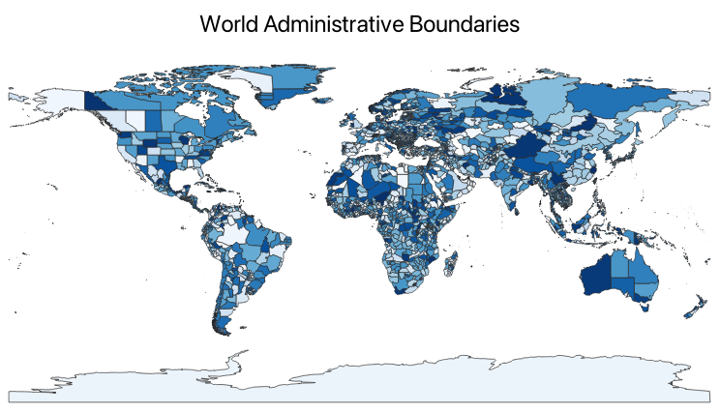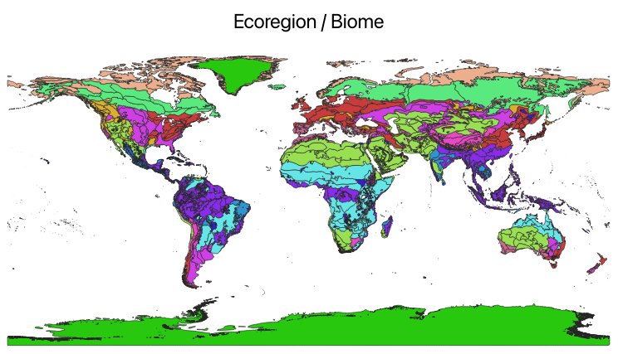

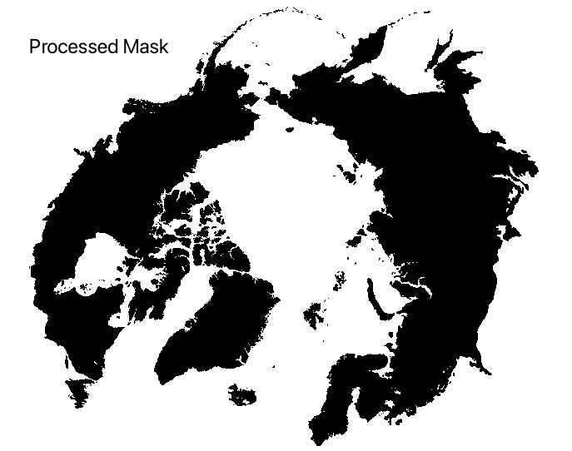

Figure 1: (a) global map of administrative boundaries. This map might be subject to change as a function of word conflicts (<https://github.com/wmgeolab/geoBoundaries/>), (b) global map of ecoregions and biomes from (Ecoregions 2017), and (c) produced mask raster.

# Downloading climate data

## Dataset description

### Downscaling reference: WorldClim 2.1

This is WorldClim version 2.1 climate data for 1970-2000. This version was released in January 2020. Data are distributed through the following website: <https://www.worldclim.org/>

There are monthly climate data for minimum, mean, and maximum temperature, precipitation, solar radiation, wind speed, water vapor pressure, and for total precipitation. The data is available at the four spatial resolutions, between 30 seconds (~1 km2) to 10 minutes (~340 km2). Each download is a “zip” file containing 12 GeoTiff (.tif) files, one for each month of the year (January is 1; December is 12).

Table 1: List of CRU-JRA variables

|  |  |  |
| --- | --- | --- |
| Variable | Units | Long name |
| tmin | Degrees Celsius | Minimum temperature |
| tmax | Degrees Celsius | Maximum temperature at 2m |
| tavg | Degrees Celsius | Average temperature |
| prec | mm | Total precipitation |
| srad | kJ/m2/day | Solar radiation |
| wind | m/s | Wind speed |
| vapr | kPa | Water vapor pressure |

### Historical dataset: CRU-JRA

he CRU JRA V2.5 dataset is a 6-hourly, land surface, gridded time series of ten meteorological variables produced by the Climatic Research Unit (CRU) at the University of East Anglia (UEA), and is intended to be used to drive models. The variables are provided on a 0.5 degree latitude x 0.5 degree longitude grid, the grid is near global but excludes Antarctica (this is the same as the CRU TS grid, though the set of variables is different). The data are available at a 6 hourly time-step from January 1901 to December 2023. Data are distribution by the Centre for Environmental Data Analysis. Visit the CEDA (Centre for Environmental Data Analysis) website. For information on the variables name and units, please see this link: <https://dap.ceda.ac.uk/badc/cru/data/cru_jra/cru_jra_1.1/data/CRUJRA_V1.1_Read_me.txt>

Table 2: List of CRU-JRA variables

|  |  |  |
| --- | --- | --- |
| Variable | Units | Long name |
| TMP | Degrees Kelvin | Temperature at 2m |
| TMAX | Degrees Kelvin | Maximum temperature at 2m |
| TMIN | Degrees Kelvin | Minimum temperature at 2m |
| PRE | mm/6h | Total precipitation |
| SPFH | kg/kg | Specific humidity |
| DSWRF | J/m^2 | Downward solar radiation flux |
| DLWRF | W/m^2 | Downward long wave radiation flux |
| PRES | Pa | Pressure |
| UGRD | m/s | Zonal component of wind speed |
| VGRD | m/s | Meridional component of wind speed |

### Future dataset: CMIP

## Instructions

In order to access the CRU-JRA data and the CMIP data, you’ll need to create accounts and use specific python packages. Following are instructions on how to do this.

### Historical dataset: CRU-JRA

1. If not already registered to CEDA, create an account to download the data. For more information, see <https://services.ceda.ac.uk/cedasite/register/info/>

### Future dataset: CMIP

The data are accessed from the Climate Data Store (CDS) or the Climate Change Service. The procedure to access the data is updated regularly, so please refer to this site for the latest information: <https://cds.climate.copernicus.eu/how-to-api>

Here, we summarize the two steps that you’ll have to follow PRIOR running the script “data_download.sh”.

1. Create an account on CDS at: <https://cds.climate.copernicus.eu/>
2. Login to your account
3. Once logged in, you need to create a file $HOME/.cdsapirc and copy the two following lines of code [THESE LINES CAN CHANGE OVER TIME!, check on the CDS website https://cds.climate.copernicus.eu/how-to-api for the latest verbose]

*url: https://cds.climate.copernicus.eu/api*

*key: 9d2f0ce9-67cd-4b01-8d49-aeb30f1c6d28*

The key number should correspond with the key number of your account on CDS.

# Cropping

# Tiling

# Resampling

# Downscaling

# Formating