# Create the processing mask [create_mask.sh].

## Description

The mask covers the land (glaciated and unglaciated) over the arctic and boreal biome of the northern hemisphere. It will be delineated using two sources: the global map of administrative boundaries (Fig 1a) and the global map of ecoregions and biomes (Fig 1b). The mask will be a geotif projected in WGS 84 / NSIDC EASE-Grid 2.0 North, EPSG 6931 (Fig 1c).

## Instructions

Two scripts are used to produce this mask: create_mask.sh and create_mask.py. The user only needs to edit the bash script by indicating the following parameters:

1. The resolution in meter the raster mask will be produced at (‘res’).
2. The path to the directory where the mask will be stores (‘maskdir’)

Once these two parameters are set in create_mask.sh, run the process with the following command:

$ create_mask.sh

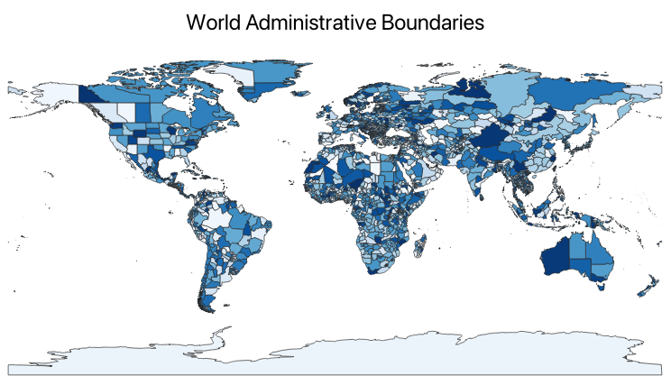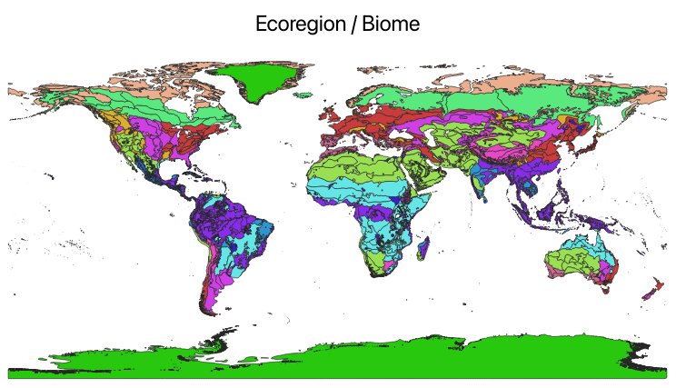

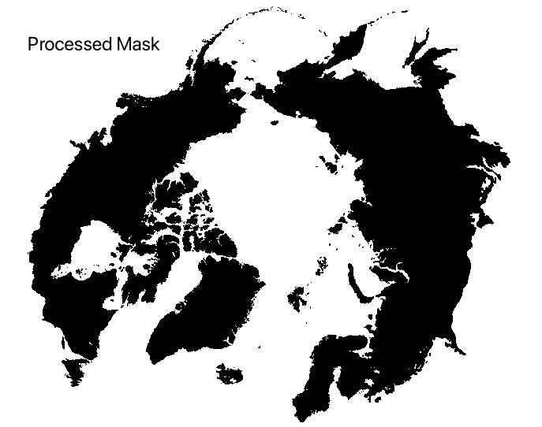

Figure 1: (a) global map of administrative boundaries. This map might be subject to change as a function of word conflicts (<https://github.com/wmgeolab/geoBoundaries/>), (b) global map of ecoregions and biomes from (Ecoregions 2017), and (c) produced mask raster.

# Downloading climate data [downscaling.sh].

## Dataset description

### Downscaling reference: WorldClim 2.1

This is WorldClim version 2.1 climate data for 1970-2000. This version was released in January 2020. Data are distributed through the following website: <https://www.worldclim.org/>

There are monthly climate data for minimum, mean, and maximum temperature, precipitation, solar radiation, wind speed, water vapor pressure, and for total precipitation. The data is available at the four spatial resolutions, between 30 seconds (~1 km2) to 10 minutes (~340 km2). Each download is a “zip” file containing 12 GeoTiff (.tif) files, one for each month of the year (January is 1; December is 12).

Table 1: List of World Clim variables

|  |  |  |
| --- | --- | --- |
| Variable | Units | Long name |
| tmin | Degrees Celsius | Minimum temperature |
| tmax | Degrees Celsius | Maximum temperature at 2m |
| tavg | Degrees Celsius | Average temperature |
| prec | mm | Total precipitation |
| srad | kJ/m2/day | Solar radiation |
| wind | m/s | Wind speed |
| vapr | kPa | Water vapor pressure |

### Historical dataset: CRU-JRA

CRU JRA V2.5 dataset is a 6-hourly, land surface, gridded time series of ten meteorological variables produced by the Climatic Research Unit (CRU) at the University of East Anglia (UEA), and is intended to be used to drive models. The variables are provided on a 0.5 degree latitude x 0.5 degree longitude grid, the grid is near global but excludes Antarctica (this is the same as the CRU TS grid, though the set of variables is different). The data are available at a 6 hourly time-step from January 1901 to December 2023. Data are distribution by the Centre for Environmental Data Analysis. Visit the CEDA (Centre for Environmental Data Analysis) website. For information on the variables name and units, please see this link: <https://dap.ceda.ac.uk/badc/cru/data/cru_jra/cru_jra_1.1/data/CRUJRA_V1.1_Read_me.txt>

Table 2: List of CRU-JRA variables

|  |  |  |
| --- | --- | --- |
| Variable | Units | Long name |
| TMP | Degrees Kelvin | Temperature at 2m |
| TMAX | Degrees Kelvin | Maximum temperature at 2m |
| TMIN | Degrees Kelvin | Minimum temperature at 2m |
| PRE | mm/6h | Total precipitation |
| SPFH | kg/kg | Specific humidity |
| DSWRF | J/m^2 | Downward solar radiation flux |
| DLWRF | W/m^2 | Downward long wave radiation flux |
| PRES | Pa | Pressure |
| UGRD | m/s | Zonal component of wind speed |
| VGRD | m/s | Meridional component of wind speed |

### Future dataset: CMIP

CMIP6 data underpins the Intergovernmental Panel on Climate Change (i.e. IPCC) 6th Assessment Report [latest current version]. The use of these data is mostly aimed at:

* addressing outstanding scientific questions that arose as part of the IPCC reporting process;
* improving the understanding of the climate system;
* providing estimates of future climate change and related uncertainties;
* providing input data for the adaptation to the climate change;
* examining climate predictability and exploring the ability of models to predict climate on decadal time scales;
* evaluating how realistic the different models are in simulating the recent past.

The term "experiments" refers to the three main categories of CMIP6 simulations:

* Historical experiments which cover the period where modern climate observations exist. These experiments show how the GCMs performs for the past climate and can be used as a reference period for comparison with scenario runs for the future. The period covered is typically 1850-2014.
* Climate projection experiments following the combined pathways of Shared Socioeconomic Pathway (SSP) and Representative Concentration Pathway (RCP). The SSP scenarios provide different pathways of the future climate forcing. The period covered is typically 2015-2100.

Table 3: List of CMIP climate variables

|  |  |  |
| --- | --- | --- |
| Name | Units | Description |
| Daily maximum near-surface air temperature | K | Daily maximum temperature of air at 2m above the surface of land, sea or inland waters. |
| Daily minimum near-surface air temperature | K | Daily minimum temperature of air at 2m above the surface of land, sea or inland waters. |
| Eastward near-surface wind | m s-1 | Magnitude of the eastward component of the two-dimensional horizontal air velocity 10m above the surface. |
| Near-Surface air temperature | K | Temperature of air at 2m above the surface of land, sea or inland waters. 2m temperature is calculated by interpolating between the lowest model level and the Earth's surface, taking account of the atmospheric conditions. |
| Near-surface specific humidity | Dimensionless | Amount of moisture in the air near the surface divided by amount of air plus moisture at that location. |
| Near-surface wind speed | m s-1 | Magnitude of the two-dimensional horizontal air velocity near the surface. |
| Precipitation | kg m-2 s-1 | The sum of liquid and frozen water, comprising rain and snow, that falls to the Earth's surface. It is the sum of large-scale precipitation and convective precipitation. This parameter does not include fog, dew or the precipitation that evaporates in the atmosphere before it lands at the surface of the Earth. This variable represents amount of water per unit area and time. |
| Surface air pressure | Pa | The pressure (force per unit area) of the air at the lower boundary of the atmosphere. It is a measure of the weight that all the air in a column vertically above a point on the Earth's surface. It is calculated over all surfaces - land, sea and inland water. |
| Surface downwelling shortwave radiation | W m-2 | Radiative shortwave flux of energy downward at the surface. |
| Surface temperature | K | Temperature at the interface (not the bulk temperature of the medium above or below) between air and sea for open-sea regions. |

## Instructions

In order to access the CRU-JRA data and the CMIP data, you’ll need to create accounts and use specific python packages. Following are instructions on how to do this.

### Historical dataset: CRU-JRA

1. If not already registered to CEDA, create an account to download the data. For more information, see <https://services.ceda.ac.uk/cedasite/register/info/>
2. Specify your username and password in the script ‘data_download.sh’ in your local directory
3. Specify the latest version of the CRU-JRA available, as well as the start and end years of the available data.

### Future dataset: CMIP

The data are accessed from the Climate Data Store (CDS) or the Climate Change Service. The procedure to access the data is updated regularly, so please refer to this site for the latest information: <https://cds.climate.copernicus.eu/how-to-api>

Here, we summarize the two steps that you’ll have to follow PRIOR running the script “data_download.sh”.

1. Create an account on CDS at: <https://cds.climate.copernicus.eu/>
2. Login to your account before you run the bash script that will download the data.
3. Check that the models you would like to downscale have available outputs for the scenarios and variables you are interested in at : <https://cds.climate.copernicus.eu/datasets/projections-cmip6?tab=download>
4. Specify the models and emission scenarios you are looking to download.
5. Once logged in, you need to create a file $HOME/.cdsapirc and copy the two following lines of code [THESE LINES CAN CHANGE OVER TIME!, check on the CDS website https://cds.climate.copernicus.eu/how-to-api for the latest verbose]

*url: https://cds.climate.copernicus.eu/api*

*key: 9d2f0ce9-67cd-4b01-8d49-aeb30f1c6d28*

The key number should correspond with the key number of your account on CDS.

Once these two parameters are set in create_mask.sh, run the process with the following command:

$ create_mask.sh

# Cropping

# Tiling

# Resampling

# Downscaling

# Formating