I. A brief Introduction to DVM-DOS-TEM

DVM-DOS-TEM, stands for Dynamical Vegetation Module & Dynamical Organic Soil module coupled Terrestrial Ecological Model. It coupled the DVM-TEM (Figure 1) and DOS-TEM (Figure 2). Please read referred literature, or programming guide (available soon).
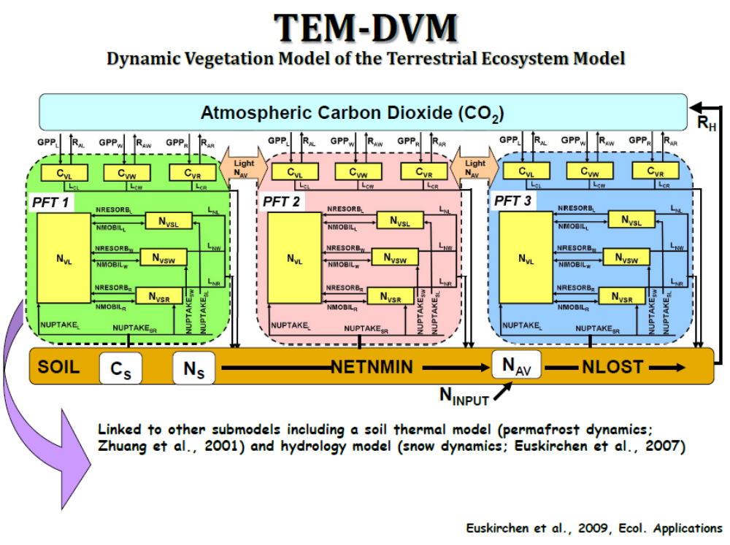

Figure 1. DVM-TEM scheme (Eushirchen et al., 2009)
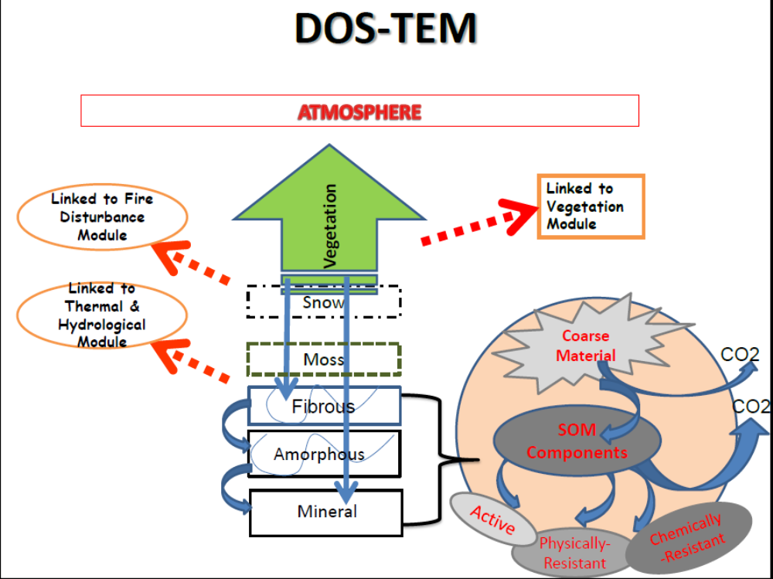

Figure 2. DOS-TEM (Yi et al., 2009, 2010; Yuan et al., 2012)

Here we briefly describe the concepts and model structure helpful for users to apply for the model, rather than theory and/or programming. So it focuses on model structure related to data preparation and output.

1. Base model structure (data and processes) unit: plant ecosystem (“cohort”)
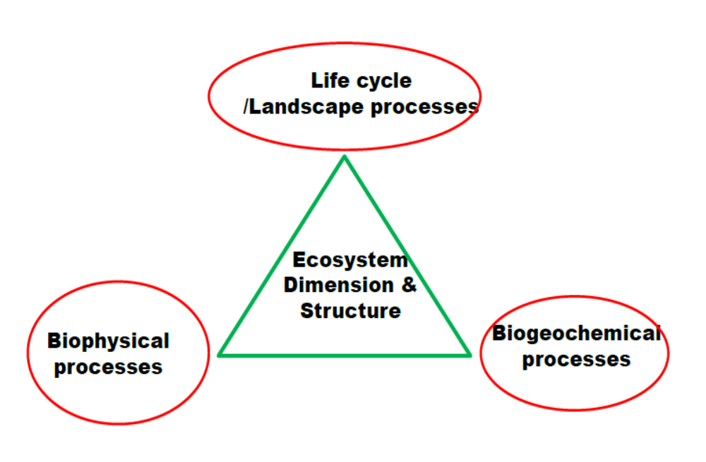
Figure. 1 Skeleton of Model Structure in DVM-DOS-TEM

In TEM, we first define the dimension and structure of an ecosystem. This ecosystem possesses a life cycle and/or interaction/events at landscape scale. This ecosystem is functioning in both (bio)physical and biogeochemical aspects (Figure 1).
So-called “ecosystem dimension & structure” (Figure 1) refers to the size, structure and spatial arrangement of the atmosphere-vegetation-ground/soil system. Simply to say, what components contained, what size (dimension) and age of each component are, and how they are organized in space. In TEM, for a unique/common ecosystem, it basically composes of air, a few (up to 10) plant function types (PFTs) stacked and covered on a ground/(snow-)soil column (horizonalized or layered).
The “Life cycle/Landscape processes” in Figure 1 mainly deals with the normal changes of ecosystem’s dimension (succession, development and growth, mature, and diminish), and event caused sudden changes of dimension (disturbances, invasion, …). Definitely those processes are directly connected with ecosystem dimension and structure.
The “biophysical processes” in Figure 1 mainly concerns physical processes, such as radiation, water, and heat relevant processes. These processes determine the physical states of an ecosystem and its components, thus providing direct impacts on life cycle and biogeochemical processes. In case of snow on ground, it also directly changes the system dimension and structure.
The “biogeochemical processes” in the model currently are those for soil-plant C and N cycling. The biomass C stocks are directly connected to plant and organic soil horizons’ structure and dimension. And of course it’s reflecting stages of a life cycle and impacts of disturbances and other landscape events. The corresponding changes in ecosystem dimension/structure and content will result in thermal/hydrological/radiation property change.
So, essentially the model codes are organized in a very similar way as those mechanisms involved in the model. Figure 2 gives more information how the model is organized.

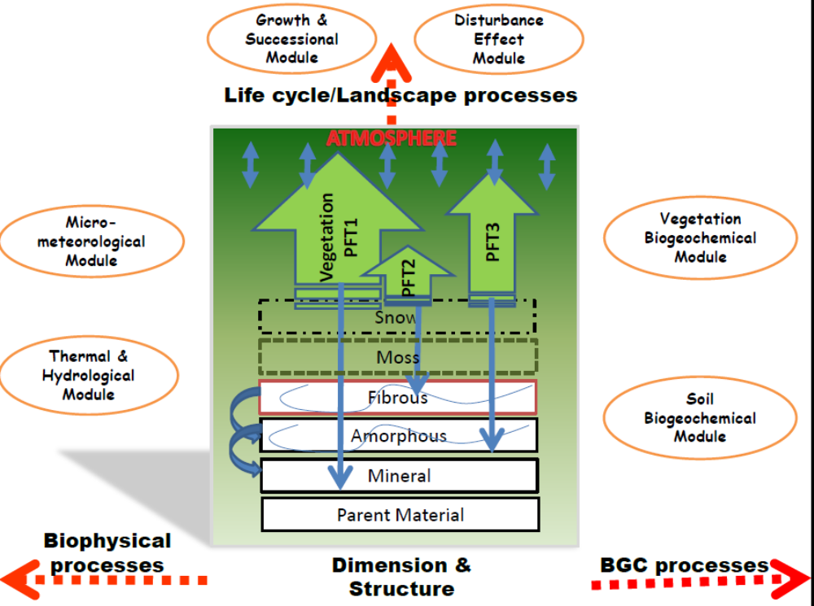
Figure 2. Some details on DVM-DOS-TEM

2. Spatial extension of base model unit
The base model unit (plant ecosystem), described above, has a spatial extension in a gridded geo-unit (“grid”). We define any one unique unit as “cohort”. And in such a grid, there may exist a few different “cohorts”, which are patched (horizontally arranged in space) in contrast to “stacked” structure in individual “cohort”. All these vegetated “cohorts” may not occupy the whole grid (e.g., bare soil, water bodies may co-exist in the grid).

So this version of TEM model is designed to contain such an idea that grid-level integration will be available internally (inside code) or externally by operating data (as currently do so). The internal approach right now is not yet carried out in the code, because basically we need to develop new cohort structure (like lake, bare soil, …) so that real landscape-level process may be included.
One of the reasons we describe this structure layout of the model is that it will be helpful to prepare input data sets for regional implementation of TEM.

3. Timestep
Basically TEM implements at monthly.
The (bio)physical processes are carried out at pseudo-daily timestep, because it uses Crank-Nicholson scheme to carry out the thermal and hydrological states and changes, rather than budget approaches. So the daily forcing data are interpolated linearly or non-linearly (for precipitation). The dimension and biogeochemical states remain constant when biophysical processes are in progress. And the biophysical states are integrated (averaged or accumulated) to monthly ones, which then drive the biogeochemical processes at monthly time step.
All state and state change variables at monthly are integrated (averaged or accumulated) to yearly for output purpose only. That is to say, yearly values are not used to drive any process in this version.

4. A few notes
- Currently in the code, the climate data length is 106, from 1901 – 2006; spin-up from 1001 – 1900; and scenario from 2007 – 2100. Very often users need to modify these settings, which are in “src/inc/timeconst.h”.
- Similarly for vegetations, we set at most 8 community types (though not used), 10 PFTs, and, 3 plant tissue/organs, and for landscape drainage classes of 2. For fire regimes, we set 5 fire severity categories, 4 fire seasons, and 5 fire sizes. Those are in “src/inc/cohortconst.h”, in case you need to modify it.
- For ground/soils, we set at most 6 layers for snow horizon, 2 layers of moss horizon, 3 layers for fibrous organic soil horizon, and 3 layers for amorphous organic soil horizon. We also set default 15 mineral layers with default depth of 4.2 m, and 5 parent material layers and default thick of 50 m. Those settings are in “src/inc/layerconst.h”.
(In the near future, we may consider some modification in code for those settings from input).

II. INPUTS for TEM

1) Control file
There are slightly different for Site-specific TEM run (we referred to ‘Siter’), and Regional (or, Multi-Site) TEM run (We referred to ‘Regner’).
If not specified, the model will search the following file, for Siter or Regner, respectively:
/config/control_site.txt
/config/control_regn.txt

Example of ‘control_site.txt’:

DVM-DOS-TEM-Test /* … */
config/ /* … */
C:/TEM/Simulations/Test_DVM/runchtlist.nc /* … */
C:/TEM/Simulations/Test_DVM/output/ /* … */
C:/TEM/Simulations/Test_DVM/dataregion/ /* … */
C:/TEM/Simulations/Test_DVM/datagrid/ /* … */
C:/TEM/Simulations/Test_DVM/datacht/ /* … */
Eq /* … */
Restart /* … */
C:/TEM/Simulations/Test_DVM/output/restart-eq.nc /* … */
1 /* … */
1 /* … */
1 /* … */
0 /* … */
-9999 /* … */
0 /* … */
0 /* … */
0 /* … */
0 /* … */
0 /* … */

*Notes: in the file, the line by line explanation is provided, as in /* … */. The following are a brief description on each line.

LINE 1 /* TEM running case */
- To give a name for the running case
LINE 2 /* directory of initial states and parameter files (9 files - cmt_calveg.txt, cmt_calsoil.txt, cmt_dimvegetation.txt, cmt_dimground.txt, cmt_envcanopy.txt, cmt_envground.txt, cmt_bgcvegetation.txt, cmt_begsoil.txt, cmt_firepar.txt)
- To give the directory in which “default” states and parameter files locate. The “default” states are used when setting the initial mode as “default” in LINE 9.

LINE 3 /* cohort list to be run
- To give a list of cohort to be run (in .nc format). This is mainly for ‘regner’, in which normally contains thousands cohort ids (that’s why a .nc format chosen). For ‘Siter’, it’s optional.

LINE 4 /* directory of outputs
- To give the output files directory. The files depend upon what setting up for output options in LINE 16 – 20.

LINE 5 /* directory of regional-level inputs
- The directory to hold ‘regional-level’ input dataset, i.e., those data is uniform through the whole targeted area. Currently it only contains CO2 data. Note: for transient period, the file is “co2.nc”, and for scenario run, the file is named as “co2_sc.nc”.

LINE 6 /* directory of gridded data inputs
- This directory holds data with geographically referenced data, BUT not time varied. Currently includes: grid.nc, drainage.nc, soiltexture.nc, and firestatistics.nc. See the following chapter for details.

LINE 7 /* directory of cohort inputs
- This directory holds data with both spatial and temporal variations. It includes: cohortid.nc, climate.nc, vegetation.nc, and fire.nc.

LINE 8 /* run stage (must be "eq", "sp", "tr", "sc", "eqsp", "sptr", "eqsptr", or "all")
- This is for how to run the model, either stage by stage or from the beginning to end. Currently only the stated keywords as listed here are allowed.

LINE 9 /* initial mode (must be "default", "restart", or, "sitein")
- This is for how to initialize the model. As mentioned above, “default” will take the initial states from the files in config/; “restart” will take the model generated file called restart point file, indicated in LINE 10. “sitein” provides site-specific initial conditions for running the model (currently not yet finished). The “sitein” data will not necessarily cover all needed initial conditions, implying that if not provided, the rest will take from “default” or “restart”.

LINE 10 /* restart/site-specific input file (if "restart"/"sitein" as in previous line)
- Explicitly give the file name and location for “restart” or “sitein” initialization mode.

LINE 11 /* using dynamical climate data (1) or not (-1) or default (0: upon run stage)
- This is useful if need to run baseline. So it’s optional for “eq” (equilibrium) run stage (in which, climate always averaged). For “sp” (spin-up) run stage, it’s taking the first 30 years data as it is (“dynamical”) or averaged (“static”). For “tr” (transient) or “sc” (scenario), it’s taking all time series as it is or averaged.

LINE 12 /* using varied co2 (1) or not (-1) or default (0: upon run stage)
- This is for similar purpose as in LINE 11. For “eq” and “sp” runs, it takes the first CO2 value in file “co2.nc” as pre-industry atmospheric CO2. If “co2.nc” does not cover the whole “tr” period, the rest will take the last CO2 in “co2.nc”. It is same for “co2_sc.nc” in “sc” run.

LINE 13 /* using dynamical LAI from veg. C in model (1), or otherwise from input (0)
- This is for model test first, but it’s reserved for use if input “LAI” is preferred in the model running. Basically if this sets to 0 (from input), the model will take the yearly LAI from variable “envlai[0]- [11]” in the “config/cmt_dimvegetation.txt”.

LINE 14 /* using fire severity as input (1), or otherwise derived
from fire size/fire season/drainage type (0)
- This is for options how to determine fire severity. This will determine how the fire occurrence data are needed. See next chapter for details.

LINE 15 /* output starting calendar year ('-9999' for starting model running)
- This is for controlling when to start output data. Note it’s in calendar year.

LINE 16 /* single-site output at daily (1) or not (0)
- This will output very detailed daily (bio)physical process results. It’s a big file, and normally for “siter” only.

LINE 17 /* single-site output at monthly (1) or not (0)
- This will output monthly simulation results for “siter” run. It produces 3 files: system domain or structure (dimension), (bio)physical simulation, and biogeochemical simulation. For state variables, it’s monthly mean value, and for fluxes, it’s cumulative value.

LINE 18 /* single-site output at yearly (1) or not (0)
- This will output yearly simulation results for “siter” run. It produces 3 files: system domain or structure (dimension), (bio)physical simulation, and biogeochemical simulation. For state variables, it’s monthly mean value, and for fluxes, it’s cumulative value.

LINE 19 /* summarized output (single/multiple sites) (1) or not (0)
- This will output monthly/yearly simulation results. It produces 1 file. It’s normally used for ‘regener’, although it’s workable for “siter”. The variables and time step options are controlled in file “config/outvarlist.txt”.

LINE 20 /* output soil climate dataset (1) or not (0) - not available
- This is for checking soil thermal/hydrological simulation. Currently it is not yet finished. The future usage of this option is for soil moisture/temperature inputs to drive the model.

2) regional data inputs
These inputs are for the whole region, i.e., no geographical variation.
One file:
co2.nc (co2_sc.nc) –
YEAR: Usually the first one is as the pre-industrial CO2.
CO2: atmospheric CO2 concentration in ppm.

3) gridded data inputs

Data for run TEM have geographic variations BUT static (no temporal variation). Basically “grid” means the geo-referred unit in a region.
Five files:
(a) grid.nc –
GRIDID: id for each grid
LAT: latitude for each grid
LON: longitude for each grid
DRAINAGEID: DRAINAGEID for each grid
SOILID: SOILID for each grid
GFIREID: GFIREID for each grid
Note that these IDs may be same or not, but have to consistent with each other

(b) drainage.nc –
DRAINAGEID: id for each drainage-type grid
DRAINAGETYPE: drainage type for each DRAINAGEID.
0: well-drained (dry), 1: poor-drained (wet).
(c) soiltexture.nc –
SOILID: id for each soil grid
TOPSOIL: top soil (0 – 25 cm) texture index for each SOILID. 12 classes are identified and ordered as following: sand (0), loamy sand (1), sandy loam (2), loam (3), silty loam (4), sandy clay loam (5), clay loam (6), silty clay loam (7), sandy clay (8), silty clay (9), clay (10) , gravel (11). The following are criteria of sand, silt and clay for determining the texture.
sand[] = {92, 82, 58, 43, 17, 58, 32, 10, 52, 6 , 22, 92};
silt[] = {5 , 12, 32, 39, 70, 15, 34, 56, 6 , 47, 20, 5};
clay[] = {3 , 6 , 10, 18, 13, 27, 34, 34, 42, 47, 58, 3};

BOTSOIL: bottom soil (25 cm - ) texture for each grid. Same classes are used as above.
(d) firestatistics.nc –
GFIREID: id for each fire statistical grid
FRI: fire return interval (years) for each GFIREID
PFSIZE: occurrence probability of 5 fire-size classes (0 – trace, 1 – small, 2 – large, 3 – very large, 4 – ultra-large) within a GIREID. In model, this parameter will generate fire size for model run at FRI
PFSEASON: occurrence probability of 4 fire-season classes (0 – pre-fire-season, 1 – early, 2 – late, 3 – after-fire-season) within a GFIREID. In model, this parameter will generate fire season for model run at FRI

NOTE: In one grid, there exists one or more cohort(s), which composes of varied factors to control the C cycling. The composite of these factors are determined by user’s questions. In TEM, there are 3 types of factors in consideration: climate change, vegetation dynamics, and fire regimes, as following.

4) cohort data inputs:
Data for running TEM with time-series, in addition to geographical variations, include 4 files as following:
(a) cohortid.nc –
CHTID: id for each cohort.
A cohort is one unique combination of geographical properties and time-series properties and driving forces. It includes the following IDs for those factors considered in the model.
INITCHTID: cohort id for initial model conditions, including input conditions (read-in) OR model-generated restart file.
GRIDID: grid id for each CHTID. This id is for lookup geographically-only distributed data sets, described in gridded data inputs above.
CLMID: climate data id for each CHTID, as described below.
VEGID: vegetation data id for each CHTID, as described below.
FIREID: fire occurrence data id for each CHTID, as described below.

(b) climate.nc –
CLMID: id for each climate coverage unit
YEAR: calendar year of climate data
TAIR: monthly air temperature for each CLMID, data arranged in year-month 2D matrix.
PREC: monthly precipitation for each CLMID, data arranged in year-month 2D matrix.
NIRR: monthly net irradiance radiation for CLMID, data arranged in year-month 2D matrix.
VAPO: monthly vapor content () for CLMID, data arranged in year-month 2D matrix.
(c) vegetation.nc –
VEGID: id for each vegetation coverage unit
VEGSETYR: the start-year of vegetation type datasets, maximal 15 changes (MAX_VEG_SET = 15 in ‘/inc/timeconst.h’). If there is only one data set, it is static vegetation type distribution (here, SETYR doesn’t matter in model-reading). Note each type has a number of pre-defined PFTs, coverage fractions of which are dynamical within TEM.
VEGTYPE: vegetation community type code for each VEGID at each SETYR.
0: non-vegetated, 1: spruce boreal forest, 2: deciduous boreal forest, 3: mixed boreal forest, 4: shrub tundra, 5: sedge tundra.
VEGFRAC: fraction of each VEGTYPE for each VEGID at each SETYR.
(d) fire.nc –
FIREID: id for each fire coverage unit
YEAR: the years of fire occurrences for each FIREID. The current setting of maximal fire occurrences, MAX_NUM_FIRE, is 30, so the data arrangement is FIREIDs*30 matrix. If no fire occurrence, let the value be 0. The maximal fire occurrences (now 30) can be reset in ‘timeconst.h’: MAX_FIR_OCRNUM=30;
SEASON: the seasons of fire occurrences for each FIREID. The data arrangement is same as fire YEAR, and codes are:
0 – month 2, 3, and 4 (pre-fire season);
1 – month 5, 6, and 7 (early season fire as defined in Turetsky et al. 2010)
2 – month 8, 9, and 10 (late season fire as defined in Turetsky et al. 2010)
3 – month 11, 12, and 1 (post-fire season);
SIZE: the fire size (fire burned area based) of fire occurrences for each FIREID. The data arrangement is same as fire YEAR, and codes are:
0 – trace fire;
1 – small fire (<=1% burned);
2 – large fire (1–2% burned);
3 – very large fire (2-3% burned);
4 – ultra-large fire (>3% burned).
Note: the above categories are from Eric’s concept for the whole interior ALASKA. So basically to say, this fire size is same for all FIREID.
FOR future runs, it may be better to use USFWS’s classification system, which bases on each individual fire burned area. So, here the fire size data in file is for each FIREID to contain this idea. And then FIREID represents an individual fire covering one or more cohorts

FROM above, fire burned vegetation and soil organic horizons can be defined in TEM. Otherwise, TEM will use the “fire severity” input as following for each FIREID, if setting ‘useseverity=1’ in ‘ModelData’.
SEVERITY: fire severity for each fire. Currently fire severity classes used in ALFRESCO are imported here.
// 0 - no burning; 1 - low; 2 - moderate; 3 - high + low surface; 4 - high + high surface
// so, 1, 2, and 3/4 correspond to TEM's low, moderate, and high, which are determined according fire size, season and landscape position.

5) Initial inputs

if initmode is “default”: no input needed, but rather read from /config/
if initial mode is “sitein”: not available yet
if initmode == “restart”:
This file is automatically generated when run TEM, so it’s the initial input for spin-up or transient run. The equilibrium run doesn’t use this initial mode. Currently this file is generated at the end of each run stage. In the near future, it will be used for spatially running TEM model – i.e., each time step run grid by grid and generate a “restart” file, which will serve the starting point for the next time step.
restart.nc – the following is the header information
netcdf restart {
dimensions:
CHTID = UNLIMITED ; // (1 currently)
PFT = 10 ;
PFTPART = 3 ;
ROOTLAYER = 10 ;
SNOWLAYER = 6 ;
SOILLAYER = 23 ;
ROCKLAYER = 5 ;
FRONTNUM = 10 ;
PRVYEAR = 10 ;
variables:
int CHTID(CHTID) ;
int ERRCODE(CHTID) ;
int DSR(CHTID) ;
int FIREA2SORGN(CHTID) ;
int NUMPFT(CHTID) ;
int YSF(CHTID) ;
int IFWOODY(CHTID, PFT) ;
int IFDECIWOODY(CHTID, PFT) ;
int IFPERENIAL(CHTID, PFT) ;
int NONVASCULAR(CHTID, PFT) ;
int VEGAGE(CHTID, PFT) ;
double VEGCOV(CHTID, PFT) ;
double LAI(CHTID, PFT) ;
double ROOTFRAC(CHTID, ROOTLAYER, PFT) ;
double VEGWATER(CHTID, PFT) ;
double VEGSNOW(CHTID, PFT) ;
double VEGC(CHTID, PFTPART, PFT) ;
double STRN(CHTID, PFTPART, PFT) ;
double LABN(CHTID, PFT) ;
double DEADC(CHTID, PFT) ;
double DEADN(CHTID, PFT) ;
double UNNORMLEAF(CHTID, PFT) ;
double TOPTA(CHTID, PRVYEAR, PFT) ;
double EETMXA(CHTID, PRVYEAR, PFT) ;
double PETMXA(CHTID, PRVYEAR, PFT) ;
double UNNORMLEAFMXA(CHTID, PRVYEAR, PFT) ;
double PRVFOLIAGEMX(CHTID, PFT) ;
int NUMSNWL(CHTID) ;
double SNWEXTRAMASS(CHTID) ;
double TSsnow(CHTID, SNOWLAYER) ;
double DZsnow(CHTID, SNOWLAYER) ;
double LIQsnow(CHTID, SNOWLAYER) ;
double ICEsnow(CHTID, SNOWLAYER) ;
double AGEsnow(CHTID, SNOWLAYER) ;
double RHOsnow(CHTID, SNOWLAYER) ;
int NUMSL(CHTID) ;
int MONTHSFROZEN(CHTID) ;
double WATERTAB(CHTID) ;
double DZsoil(CHTID, SOILLAYER) ;
int AGEsoil(CHTID, SOILLAYER) ;
int TYPEsoil(CHTID, SOILLAYER) ;
double TSsoil(CHTID, SOILLAYER) ;
double LIQsoil(CHTID, SOILLAYER) ;
double ICEsoil(CHTID, SOILLAYER) ;
double FROZENFRACsoil(CHTID, SOILLAYER) ;
int TEXTUREsoil(CHTID, SOILLAYER) ;
double TSrock(CHTID, ROCKLAYER) ;
double DZrock(CHTID, ROCKLAYER) ;
double frontZ(CHTID, FRONTNUM) ;
int frontFT(CHTID, FRONTNUM) ;
double WDEBRISC(CHTID) ;
double WDEBRISN(CHTID) ;
double RAWC(CHTID, SOILLAYER) ;
double SOMA(CHTID, SOILLAYER) ;
double SOMPR(CHTID, SOILLAYER) ;
double SOMCR(CHTID, SOILLAYER) ;
double SOLN(CHTID, SOILLAYER) ;
double AVLN(CHTID, SOILLAYER) ;
double PRVLTRFCN(CHTID, SOILLAYER) ;
}

*-- A VERY IMPORTANT NOTE for preparing input data sets
Unlike the previous TEM version, we design this one with flexible data structure. Each dataset has its own record ID (referring to either spatial unit or time series, or both). But they are related with each other by referring individual IDs. Then for each dataset, their grid mask may not have to be same, although they have to correspond uniquely (mapping) to the primary grid mask.
For an example, the primary grid mask is established. The other geographical data sets, like soil texture can have a different grid resolution. In the grid.nc, primary grid mask is represented as GRIDID, which then mapped to the SOILID in the soil texture database.

III. OUTPUTS for TEM
There are 3 types of outputs:

1) restart.nc – automatically generated when a run is finished. See the “inputs for TEM”.
2) sing-site output – optional; see the “control_site.txt”
Daily :
cmtenv_dly-(eq/sp/tr/sc).nc – this is from (bio)physical module (“env”) only, because this module is implemented at daily timestep.

Monthly:
cmtdim_mly-(eq/sp/tr/sc).nc - output of ecosystem domain/structure (dimension, “dim”)
cmtenv_mly-(eq/sp/tr/sc).nc – output of (bio)physical module (“env”)
cmtbgc_mly-(eq/sp/tr/sc).nc – output of biogeochemical module (“bgc”)

Yearly:
cmtdim_yly-(eq/sp/tr/sc).nc - output of ecosystem domain/structure (dimension, “dim”)
cmtenv_yly-(eq/sp/tr/sc).nc – output of (bio)physical module (“env”)
cmtbgc_yly-(eq/sp/tr/sc).nc – output of biogeochemical module (“bgc”)

3) single/multiple site summarized output – optional; see the “control_site.txt”
output(-eq/sp/tr/sc).nc – monthly/yearly chosen variables.

N.B., -eq: equilibrium run, -sp: spinup run; -tr: transient run; -sc: scenario run;
“dim”: ecosystem domain/structure’s sizes, horizons/layers, components, ….
“env”: (bio)physical properties, such as energy, heat (thermal), water (hydrological) states/variables
“bgc”: C and N relevant states/variables

1. site specific dimension output – monthly or yearly

netcdf cmtdim_mly/yly-eq {
dimensions:
tstep = UNLIMITED ; // (1212 currently) - monthly/yearly
pft = 10 ; - max. PFT numbers
rootlayer = 10 ; - max. root layer numbers (10 cm interval)
snwlayer = 6 ; - max. snow layer numbers
soilayer = 23 ; - max. soil layer numbers
variables:
int CHTID ;
int YEAR(tstep) ;
int MONTH(tstep) ;
int CMTTYPE(tstep) ; - community type (ecosystem type) code
int NUMPFT(tstep) ; - actual PFT numbers
double CMTFRAC(tstep) ; - fraction of community type
int VEGAGE(tstep, pft) ; - age of each PFTs (year)
int IFWOODY(tstep, pft) ; - woody PFT (1) or not (0)
int IFDECIWOODY(tstep, pft) ; - deciduous woody PFT (1) or not (0)
int IFPERENIAL(tstep, pft) ; - perennial PFT (1) or not (0)
int NONVASCULAR(tstep, pft) ; - non-vascular PFT code (0: vascular, 1: sphagnum, 2: feather moss; 3: lichen)
double VEGCOV(tstep, pft) ; - PFT’s ground coverage (0 – 1, it’s not same as FPC. VEGCOV is vegetated coverage, in contrast with bare soil, while FPC is the foliage coverage against non-shaded)
double LAI(tstep, pft) ; - PFT’s LAI (not VEGCOV adjusted)
double FPC(tstep, pft) ; - PFT’s foliage percent coverage (sum of all PFTs <=1.0)
double ROOTFRAC(tstep, rootlayer, pft) ; - PFT’s root distribution fraction with 10 layers of 10 cm thickness (sum of fraction must be 1.0).
double FLEAF(tstep, pft) ; - PFT’s (seasonal) leaf phenology (ET derived)
double FFOLIAGE(tstep, pft) ; - PFT’s leaf growing (allocation) factor (total biomass C based).
int SNWLNUM(tstep) ; - actual snow layer numbers
double SNWTHICK(tstep) ; - actual snow thickness (m)
double SNWDENSE(tstep) ; - actual snow density (kg/m3)
double SNWEXTRAMASS(tstep) ; - actual snow mass which cannot form a uniform layer (in this case, snow coverage less than 1.0)
double SNWDZ(tstep, snwlayer) ; - snow layer thickness (m, up to 6 layers), only valid for daily output
double SNWAGE(tstep, snwlayer) ; - snow layer formation time length (years), for daily
double SNWRHO(tstep, snwlayer) ; - snow layer density (kg/m3), for daily output
double SNWPOR(tstep, snwlayer) ; - snow layer porosity, for daily output
int SOILLAYERNO(tstep) ; - actual soil layer numbers of whole soil profile, which composes of 4 types of horizons: moss, fibrous organic soil, amorphous organic soil, and mineral soil. Each horizon can be divided into a few layers.
int MOSSLAYERNO(tstep) ; - actual layer numbers of moss horizon
int SHLWLAYERNO(tstep) ; - actual layer numbers of fibrous organic soil horizon
int DEEPLAYERNO(tstep) ; - actual layer numbers of amorphous organic soil horizon
int MINELAYERNO(tstep) ; - actual layer numbers of mineral soil horizon
double SOILTHICK(tstep) ; - total soil thickness (m)
double MOSSTHICK(tstep) ; - total moss horizon thickness (m)
double SHLWTHICK(tstep) ; - total fibrous horizon thickness (m)
double DEEPTHICK(tstep) ; - total amorphous horizon thickness (m)
double MINEATHICK(tstep) ; - upper mineral horizon thickness (m)
double MINEBTHICK(tstep) ; - middle mineral horizon thickness (m)
double MINECTHICK(tstep) ; - lower mineral horizon thickness (m)
double SOILZ(tstep, soilayer) ; - depth of each soil layer (m, at the top edge)
double SOILDZ(tstep, soilayer) ; - thickness of each soil layer (m)
int SOILTYPE(tstep, soilayer) ; - soil horizon type of each soil layer (0: moss, 1 – fibrous, 2 – amorphous, 3 – mineral)
double SOILPORO(tstep, soilayer) ; - porosity of each soil layer
int SOILTEXTURE(tstep, soilayer) ; - texture of each soil layer (only for mineral soil layer)
double SOILRTFRAC(tstep, soilayer, pft) ; - root fraction of each PFT in each soil layer (sum of all must be equal 1.0, this is different from ROOTFRAC as described above)
}

2. site specific (bio)physical output – daily/monthly/yearly

netcdf cmtenv_dly/mly/yly-eq {
dimensions:
tstep = UNLIMITED ; // (36865 currently) - daily/monthly/yearly
pft = 10 ; - max. PFT numbers
snwlayer = 6 ; - max. snow layer numbers
soilayer = 23 ; - max. soil layer numbers
frontnum = 10 ; - max. freezing/thawing front numbers
variables:
int CHTID ;
int ERRORID(tstep) ;
int YEAR(tstep) ;
int MONTH(tstep) ;
int DOY(tstep) ;
double CO2(tstep) ; - atmospheric CO2 concentration (ppm)
double TAIR(tstep) ; - atmospheric temperature (oC)
double NIRR(tstep) ; - canopy surface net irradiance (w/m2)
double PREC(tstep) ; - precipitation (mm H2O)
double VAPO(tstep) ; - vapor pressure (kPa or mbar)
double SVP(tstep) ; - saturated vapor pressure (Pa)
double VPD(tstep) ; - vapor pressure deficit (Pa)
double PAR(tstep) ; - incoming PAR (w/m2, cloudiness adjusted)
double RAINFALL(tstep) ; - rainfall (mm H2O)
double SNOWFALL(tstep) ; - snowfall (mm H2O)
double PARDOWN(tstep) ; - PAR after canopy reflection (used for canopy stomata conductance)
double PARABSORB(tstep) ; - PAR absorption by canopy (not used in the model)
double SWDOWN(tstep) ; - shortwave radiation (~NIRR) after reflection
double SWINTER(tstep) ; - shortwave interception by canopy/ground
double RAININTER(tstep) ; - rainfall interception by canopy
double SNOWINTER(tstep) ; - snow interception by canopy
double EETTOTAL(tstep) ; - total evapotranspiration (mm H2O)
double PETTOTAL(tstep) ; - total potential evapotranspiration (Penman-Monteith)
double CANOPYRAIN(tstep, pft) ; - canopy rain water storage for each PFT (NOTE, all those PFT’s variables, as following, are FPC adjusted)
double CANOPYSNOW(tstep, pft) ; - canopy snow water storage for each PFT
double CANOPYRC(tstep, pft) ; - canopy resistance (s/m)
double CANOPYCC(tstep, pft) ; - canopy conductance (m/s)
double CANOPYBTRAN(tstep, pft) ; - canopy stomata conductance factor by soil water content
double CANOPYM_PPFD(tstep, pft) ; - canopy stomata conductance factor by PAR
double CANOPYM_VPD(tstep, pft) ; - canopy stomata conductance factor by VPD
double CANOPYSWREFL(tstep, pft) ; - shortwave radiation reflected
double CANOPYSWTHFL(tstep, pft) ; - shortwave radiation throughfall into ground
double CANOPYEVAP(tstep, pft) ; - canopy evaporation
double CANOPYTRAN(tstep, pft) ; - canopy transpiration
double CANOPYPEVAP(tstep, pft) ; - canopy potential evaporation
double CANOPYPTRAN(tstep, pft) ; - canopy potential transpiration
double CANOPYSUBLIM(tstep, pft) ; - canopy snow sublimation
double CANOPYRDRIP(tstep, pft) ; - canopy intercepted rainfall drip into ground
double CANOPYRTHFL(tstep, pft) ; - canopy rainfall throughfall into ground
double CANOPYSDRIP(tstep, pft) ; - canopy intercepted snow drip into ground
double CANOPYSTHFL(tstep, pft) ; - canopy snow throughfall into ground
double SNWWE(tstep, snwlayer) ; - water equivalence of ground snow layers
double SNWT(tstep, snwlayer) ; - snow temperature of ground snow layers
double SNWWESUM(tstep) ; - total ground snow water equivalence
double SNWTAVE(tstep) ; - average snow temperature of ground snow
double SNWSWREFL(tstep) ; - snow shortwave radiation reflected
double SNWSUBLIM(tstep) ; - ground snow sublimation
double SOILICESUM(tstep) ; - total ice water content of whole soil column (kg/m3)
double SOILLIQSUM(tstep) ; - total liquid water content of whole soil column (kg/m3)
double SOILVWCSHLW(tstep) ; - averaged soil volume water content of fibrous horizon (fraction)
double SOILVWCDEEP(tstep) ; - averaged soil volume water content of amorphous horizon (fraction)
double SOILVWCMINEA(tstep) ; -averaged soil volume water content of upper mineral soil horizon
double SOILVWCMINEB(tstep) ; - averaged soil volume water content of middle mineral soil horizon
double SOILVWCMINEC(tstep) ; - averaged soil volume water content of lower mineral soil horizon
double SOILTAVE(tstep) ; - averaged soil temperature over whole soil column
double SOILTSHLW(tstep) ; - averaged soil temperature over fibrous soil horizon
double SOILTDEEP(tstep) ; - averaged soil temperature over amorphous soil horizon
double SOILTMINEA(tstep) ; - averaged soil temperature over upper mineral soil horizon
double SOILTMINEB(tstep) ; - averaged soil temperature over middle mineral soil horizon
double SOILTMINEC(tstep) ; - averaged soil temperature over lower mineral soil horizon
double SOILTEM(tstep, soilayer) ; - soil temperature of each soil layer (oC)
double SOILLIQ(tstep, soilayer) ; - soil liquid water content of each soil layer (kg/m3)
double SOILICE(tstep, soilayer) ; - soil ice water content of each soil layer (kg/m3)
double SOILVWC(tstep, soilayer) ; - soil volume water content of each soil layer (fraction)
double SOILLWC(tstep, soilayer) ; - soil liquid volume water content of each soil layer
double SOILIWC(tstep, soilayer) ; - soil ice volume water content of each soil layer
double FRONTZ(tstep, frontnum) ; - soil thawing/freezing front depth (m, from ground surface)
double FRONTTYPE(tstep, frontnum) ; soil front type (thawing: -1, freezing: 1)
double WATERTABLE(tstep) ; - water table (m)
double PERMAFROST(tstep) ; - permafrost or not (1: continuously frozen bottom soil for 24 months; otherwise, it’s 0)
double ALD(tstep) ; - if permafrost, active layer depth (m); for daily output, it’s also for the non-permafrost
double ALC(tstep) ; - if permafrost, the cap depth of active layer (m, i.e., the top unfrozen cap of an active layer); also for daily output, it’s for the non-permafrost
double RZGROWSTART(tstep) ; - starting DOY of growing season, based on top root zone soil temperature (thawing for longer than 5 days)
double RZGROWEND(tstep) ; - ending DOY of growing season, based on top root zone soil temperature (freezing for longer than 5 days)
double RZTEM(tstep) ; - top root zone soil temperature
double RZDEGDAY(tstep) ; - top root zone soil thermal time (degree-day), currently used for determining growing season and seasonal dynamics of litter-falling
double RZTHAWPCT(tstep) ; - fraction of thawing time of top root zone in a month, used in the monthly GPP function.
double SOILSWREFL(tstep) ; - soil surface shortwave radiation reflected
double SOILEVAP(tstep) ; - soil evaporation
double SOILPEVAP(tstep) ; - soil potential evaporation
double RUNOFF(tstep) ; - overland water runoff
double DRINAGE(tstep) ; - soil bottom water drainage
}

3. site specific biogeochemical process output – monthly/yearly
netcdf cmtbgc_mly-eq {
dimensions:
tstep = UNLIMITED ; // (1212 currently)
pft = 10 ;
vegpart = 3 ;
soilayer = 23 ;
variables:
int CHTID ;
int ERRORID(tstep) ;
int YEAR(tstep) ;
int MONTH(tstep) ;
double VEGCSUM(tstep, pft) ; // total veg. C for each PFT (kgC/m2)
double VEGCPART(tstep, pft, vegpart) ; // veg. C in leaf, stem and root for each PFT (kgC/m2)
double VEGNSUM(tstep, pft) ; // total veg. N for each PFT (kgN/m2)
double VEGNLAB(tstep) ; // veg. N in labile pool for each PFT (kgN/m2)
double VEGNSTRNSUM(tstep, pft) ; // sum of veg. N in leaf, stem and root for each PFT (kgN/m2)
double VEGNSTRNPART(tstep, pft, vegpart) ; // veg. N in leaf, stem and root for each PFT (kgN/m2)
double VEGCDEAD(tstep, pft) ; //dead (but standing) plant C for each PFT (kgC/m2)
double VEGNDEAD(tstep, pft) ; // dead (but standing) plant N for each PFT (kgN/m2)
double WDEBRISC(tstep) ; // woody debris C on ground (kgC/m2)
double WDEBRISN(tstep) ; // woody debris N on ground (kgN/m2)
double RAWC(tstep, soilayer) ; // raw material C content in each soil layer (kgC/m2)
double SOMA(tstep, soilayer) ; // active SOM C content in each soil layer (kgC/m2)
double SOMPR(tstep, soilayer) ; // physically-resistant SOM C content in each soil layer (kgC/m2)
double SOMCR(tstep, soilayer) ; // chemically-resistant SOM C content in each soil layer (kgC/m2)
double ORGN(tstep, soilayer) ; // organic N content in each soil layer (kgN/m2)
double AVLN(tstep, soilayer) ; // inorganic N content in each soil layer (kgN/m2)
double SOMCSHLW(tstep) ; // sum of SOM C content in fibrous horizon (kgC/m2)
double SOMCDEEP(tstep) ; // sum of SOM C content in amorphous horizon (kgC/m2)
double SOMCMINEA(tstep) ; // sum of SOM C content in upper mineral horizon (kgC/m2)
double SOMCMINEB(tstep) ; // sum of SOM C content in middle mineral horizon (kgC/m2)
double SOMCMINEC(tstep) ; // sum of SOM C content in lower mineral horizon (kgC/m2)
double RAWCSUM(tstep) ; // sum of raw material SOM C content in whole soil column (kgC/m2)
double SOMASUM(tstep) ; // sum of active SOM C content in whole soil column (kgC/m2)
double SOMPRSUM(tstep) ; // sum of physically-resistant SOM C content in whole soil column (kgC/m2)
double SOMCRSUM(tstep) ; // sum of chemically-resistant SOM C content in whole soil column (kgC/m2)
double ORGNSUM(tstep) ; // sum of organic N content in whole soil column (kgN/m2)
double AVLNSUM(tstep) ; // sum of inorganic N content in whole soil column (kgN/m2)
double GPPFTEMP(tstep, pft) ; // temperature factor for GPP function for each PFT
double GPPGV(tstep, pft) ; // canopy conductance factor for GPP function for each PFT
double GPPFNA(tstep, pft) ; // canopy N factor for GPP function for each PFT (not used)
double GPPFCA(tstep, pft) ; // photosynthetic C limitation for N uptake (not used)
double RAQ10(tstep, pft) ; // temperature factor (Q10) for plant respiration (autotrophic)
double RMKR(tstep, pft) ; // parameters for maintenance respiration
double NMITKSOIL(tstep, soilayer) ; // soil parameters for N mineralization in each soil
double RHMOIST(tstep, soilayer) ; // soil moisture factor for soil heterotrophic respiration in each layer
double RHQ10(tstep, soilayer) ; //temperature factor (Q10) for soil heterotrophic respiration in each layer
double SOILLTRFCN(tstep, soilayer) ; // litterfalling (root death) C/N ratio in each soil layer, used for adjusting soil OM C decomposition rate
double NEP(tstep) ; // net ecosystem productivity
double INGPPALL(tstep, pft) ; // sum of GPP without N limitation for each PFT
double INGPP(tstep, pft, vegpart) ; // GPP without N limitation allocated to leaf, stem and root for each PFT
double INNPPALL(tstep, pft) ; // sum of NPP without N limitation for each PFT
double INNPP(tstep, pft, vegpart) ; // NPP without N limitation allocated to leaf, stem and root for each PFT
double GPPALL(tstep, pft) ; //sum of GPP for each PFT
double GPP(tstep, pft, vegpart) ; // GPP allocated to leaf, stem and root for each PFT
double NPPALL(tstep, pft) ; // sum of NPP for each PFT
double NPP(tstep, pft, vegpart) ; //NPP allocated to leaf, stem and root for each PFT
double RMALL(tstep, pft) ; //sum of maintenance respiration for each PFT
double RM(tstep, pft, vegpart) ; // maintenance respiration for leaf, stem and root for each PFT
double RGALL(tstep, pft) ; // sum of growth respiration for each PFT
double RG(tstep, pft, vegpart) ; // growth respiration for leaf, stem and root of each PFT
double LTRFALCALL(tstep, pft) ; // sum of litterfalling (root death) C for each PFT
double LTRFALC(tstep, pft, vegpart) ; //litterfalling (death) C from leaf, stem and root for each PFT
double LTRFALNALL(tstep, pft) ; // sum of litterfalling (root death) N for each PFT
double LTRFALN(tstep, pft, vegpart) ; // litterfalling (death) N from leaf, stem and root for each PFT
double INNUPTAKE(tstep, pft) ; // plant N uptake at full capacity without interaction with plant growth requirement
double NROOTEXTRACT(tstep, pft, soilayer) ; //root N extraction fraction by each PFT from each soil layer (total must be equal to 1.0)
double NUPTAKEL(tstep, pft) ; // N uptake into plant labile N pool for each PFT
double NUPTAKESALL(tstep, pft) ; // N uptake into plant structural N pool (leaf, stem and root) for each PFT
double NUPTAKES(tstep, pft, vegpart) ; // N uptake into leaf, stem and root structural N pool for each PFT
double NMOBILALL(tstep, pft) ; // sum of N mobilized from plant labile N pool to structural pools for each PFT
double NMOBIL(tstep, pft, vegpart) ; // N mobilized from labile N pool to leaf, stem and root N pool, respectively, for each PFT
double NRESOBALL(tstep, pft) ; // sum of N reabsorbed when litterfalling (death)
double NRESORB(tstep, pft, vegpart) ; // N reabsorbed from leaf, stem and root litterfalling (death) for each PFT
double DOCLOST(tstep) ; // soil DOC loss (not used)
double AVLNLOST(tstep) ; // soil inorganic N leaching/runoff loss
double ORGNLOST(tstep) ; // soil organic N loss with DOC loss (not used)
}

4. Summarized single/multiple site output
See the outvarlist.txt in /config/

IV. Use of NCGEN.exe and NCDUMP.exe to simply generate and read NetCdf data

1. NCGEN.exe and NCDUMP.exe are two DOS type of commands to generate netcdf file (.nc) and its ascii format file (.cdl).

2. From your PC, enter the ‘Command Prompt’, and switch to the directory you’re operating the data

3. NCDUMP.exe to convert .nc file to ascii file
(for detail, refer to: http://www.unidata.ucar.edu/software/netcdf/docs/ncdump-man-1.html)
ncdump test.nc > test.cdl
‘test.nc’, indicates the netcdf filename to be converted; and
‘>test.cdl’, means the output going to a file named ‘test.cdl’.

4. NCGEN.exe to convert ascii file to .nc file
(for detail, refer to: http://www.unidata.ucar.edu/software/netcdf/docs/ncgen-man-1.html)
ncgen –o test.nc calirestart.cdl
‘-o test.nc’, indicates the output filename; and
‘calirestart.cdl’, the standard ascii file in CDL format.

V. Parameters for TEM

There are 8 parameter txt files in /config/ for TEM:
(1) dimension: cmt_dimvegetation.txt, and, cmt_dimground.txt, are for establishing community (‘cmt’) structure (dimension, ‘dim’) and their dynamics to be modeled. Note: term “vegetation” refers to the whole plant community consisting of a few coexisted PFTs, covering the “ground”, which includes the ground surface, snow, and soil (and parent materials) as a column.
(2) (bio)physical properties and parameters: cmt_envcanopy.txt, and, cmt_envground.txt, are for radiation, water, and heat (originally environmental process, ‘env’) parameters, including some initial states. Note: “canopy” only refers to plant canopy.
(3) biogeochemical properties and parameters: cmt_bgcvegetation.txt, and cmt_bgcsoil.txt, are for soil-plant C and N biogeochemical processes (‘bgc’), including some initial states. Note here “soil” means the ground debris-moss-organic soil-mineral soil column, excluding snow and parent material horizon, if any.
(4) fire disturbance parameters: cmt_firpar.txt, is for wild-fire parameters, including a typical fire occurrence sequence for site-run if needed.
(5) calibratable BGC parameters: cmt_calbgc.txt, are those parameters to be calibrated in terms of C and N states and fluxes at equilibrium condition.

See the files, in which a brief description provided for each parameter or variable. For those parameters not calibrated in the program, please refer to the theoretical portion of the model, for how to set up their values.
The parameters and initial default states are BLOCKLY written for EACH community type. So DON’T mess up the lines and variables/parameters ORDER!!!
Community type IS indexed as “CMT??”, in which “??” is 2-digit number (so totally 100 community types may be included). It’s suggested, for model integrity and/or file clearance, that let “CMT00” be model default (DEMO) community type. User-defined types can be appended into the files.

VI. Model Set-up

1. On Clusters

Compile DVMDOSTEM source codes in CLUSTERS (if needed)
PLEASE read this file carefully, before you modify and compile the source codes of DVMDOSTEM
(1) must have two folders with their files: src/, and netcdf/(/libs/, /includes/)
src/ - the C++ codes
netcdf/libs/ - must contain the following library for netcdf I/O for Linux OS: libnetcdf.a, libnetcdf_c++.a. (Already provided there, but if needed, you may find them in UCAR's relevant website)
netcdf/includes/ - the headers for netcdf I/O in Linux OS: ncvalues.h, netcdf.h, netcdf.hh, netcdfcpp.h, netcdf.inc

(2) Makefile
- the Makefile was generated automatically by qt 'qmake', as following

$/usr/lib64/qt-3.3/bin/qmake -project
This command will produce a file called *.pro, which basically contains all source files info and netcdf info. You only need to do once, if no directory/file name modification.

$/usr/lib64/qt-3.3/bin/qmake
This command will generate the Makefile

$ vi Makefile
This will open/edit Makefile, as following -
(a) check the INCPATH=, to see if "-Inetcdf/includes" exists. if not, append that.
tip: I found it already there on ashena.
(b) check the LIBS=, to see if "-Lnetcdf/libs -lnetcdf_c++ -lnetcdf" exists. if not, append those command.
tip: in both tuxedo and ashena, you have to do this by yourself.
(c) you may want to change the target make name. e.g., “TARGET = DVMDOSTEM”. It’s because the qt “qmake” default take the folder name as the project name.

(3) compilation
$make
It will compile the DVMDOSTEM, according to Makefile (and DVMDOSTEM.pro) generated above

$make clean
It will clean the obj files, and recompile and link all source codes to get executable DOSTEM

(4) Basically, if you didn't modify the header files in /src, you're always free to do step (3); otherwise, you may repeat step (2) and (3).

2. Cygwin with GNU package
- Go to http://www.cygwin.org/cygwin
- Download the setup.exe.
- Run “setup.exe”, will install the cygwin on PC (windows OS).
- When installation, beside base package, the package chosen must include the following:
(1) archive tools: netcdf 3.5 and above
(2) development tools: gcc, g++, gdb, gnu make
If asking some packages have been included, after you chose the above, please let it checked and do the installation.
It is recommended that java package installed as well. And include the “swig” package, which is useful for java/c++ mixed programming (we used to develop the calibration version of the model).
It is suggested that gcc/g++ package include both 3.4 and 4.x version. Occasionally we may need to use 3.4 version to compile the .dll for mixed programming (there seems some unknown bugs in TEM codes, which has some issues relevant to IEEE nan). In this case we can switch back to 3.4 version. For pure c++ code, it is working very well.

- After installation of cygwin, be sure of adding the path of cygwin/bin to the OS system directory.
(right click “my computer”, click “properties”, click tab “Advanced”, click button “Environmental Variables”, edit the “path” by appending “;c:\cygwin\bin” (NOTE don’t delete the other system paths, otherwise you’ll get troubles for your OS ).

- IF you’re familiar with cygwin or unix/linux environment for compiling (GNU complier), you can do the TEM compiling very easily.

3. Eclipse IDE – c/c++ development toolkit (CDT)
Eclipse CDT is helpful for debugging and compiling, although it is based on GNU make and compliers.
So basically this IDE needs GNU package installed first (such as Cygwin installation with GNU package briefed above).

- Go to http://www.eclipse.org, downloading CDT package.
- Uncompress the Eclipse CDT package directly into a folder.
- Run “Eclipse.exe” in the installed folder. Then you will prompt to enter your default workspace. Click go to benchmark to start your project. (Or, you may want to read the manual to get started)
- In the “Help” tab, click “check for update” try to update your software package, or add more IDE like Java development toolkit (JDT) by click “Install new software”.
- Then, the Eclipse CDT is ready for use.
- DVM-DOS-TEM project setup
(1) In File tab, click New c++ project, given a project name “DVMDOSTEM” (or any name you’d like it);
(2) copy the codes /src/ into the project folder. (by clicking Edit-refresh, you will see the codes in Eclipse project explorer window)
(3) By clicking “Project”->properties (or right click on the project name), you will open a setting-up window.
(4) in that window, there are many setting you need to establish, of which most you may keep them default. But you must check two settings under “c/c++ Build” -> Settings and ->Tool Chain Editor.
(5) -> Settings: Click the “GCC C++ Linker”, under Libraries, add “netcdf_c++” and “netcdf” (must be in this order).
NOTE: for this setting you may need to add the library path of netcdf package, if not default setting up in “cygwin/usr/include/”. Search the Eclipse or GNU manual for how to do so. Or you may refer to how we do so on the clusters.
(6) -> Tool Chain Editor: We suggest you chose “Linux GCC” tool chain, and “Gnu Maker Builder”, if you use cygwin. It’s OK if you chose others, but seems it will give you some annoying warning when you do the compiling.
(7) click OK to quit the setting-up. Try to compile the project or to debug the project. When you do the compiling, it will automatically generate a Makefile, which can be used to build the project in “cygwin”.

BY Fengming Yuan, March 01, 2012 @ORNL

