Java/C++ DVMDOSTEM
Calibrator Version
2012-05-16

1. Model Package
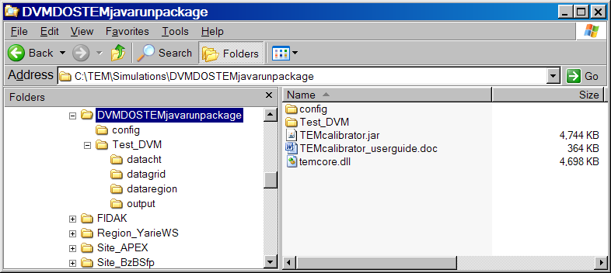

(1) temrun.dll – the C++ core modules of DVMDOSTEM;

(2) TEMcalibrator.jar -- the simplified java i/o and interface modules of DVMDOSTEM, specifically tailored for calibrating the model; This is java executable. By clicking it the model will start-up; or in any dos command or cygwin line command, by running ‘java –jar TEMcalibrator.jar’, it will startup.

(3) config/ - 8 txt files containing parameters and default initial conditions (exactly same as full version of DVMDOSTEM), and 3 calibration related files.
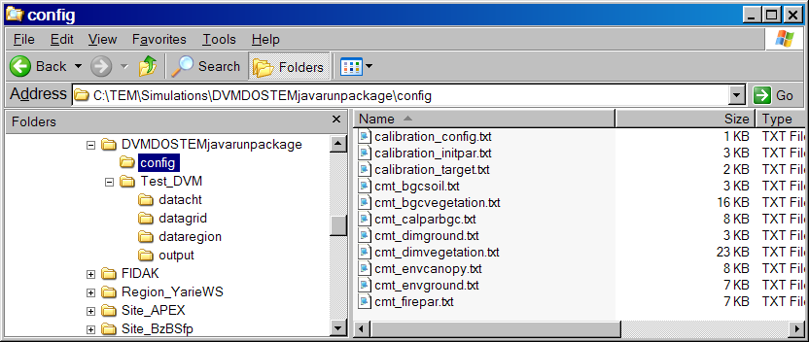

8 txt files are:
There are 8 parameter txt files in /config/ for running DVMDOSTEM:
- dimension: cmt_dimvegetation.txt, and, cmt_dimground.txt,
These two files are for establishing community (‘cmt’) structure (dimension, ‘dim’) and their dynamics to be modeled. Note: term “vegetation” refers to the whole plant community consisting of a few coexisted PFTs, covering the “ground”, which includes the ground surface, snow, and soil (and parent materials) as a column.
- (bio)physical properties and parameters: cmt_envcanopy.txt, and, cmt_envground.txt,
There two are for radiation, water, and heat (originally called environmental process, ‘env’) parameters, including some initial states. Note: “canopy” only refers to plant canopy.
- biogeochemical properties and parameters: cmt_bgcvegetation.txt, and cmt_bgcsoil.txt,
These two files are for soil-plant C and N biogeochemical processes (‘bgc’), including some initial states. Note here “soil” means the ground debris-moss-organic soil-mineral soil column, excluding snow and parent material horizon, if any.
- fire disturbance parameters: cmt_firpar.txt,
It is for wild-fire parameters.
- calibratible BGC parameters: cmt_calbgc.txt,
This file of parameters is already calibrated in terms of C and N states and fluxes at equilibrium condition. Note that the community (or cohort) is indexed as “CMT??” with “??” standing for 2 digits of numbers, which are representing index of community types.

See the files, in which a brief description provided for each parameter or variable.

3 configuration files for calibration are:
There are 3 parameter txt files in config/ for Calibrating DVMDOSTEM. Note these 3 files can put other directories (i.e. NOT necessary to be under config/)

- control file: calibration_config.txt
This is the simplified model control file, equivalent to control_site.txt for running DVMDOSTEM, but setting model run at ‘eq’ stage, ‘default’ initial mode, static climate driver, pre-industrial CO2, and no output.

- initial parameter file: calibration_initpar.txt.
Basically this is the calibration BGC parameters for ONE type of community, which needs calibration. So it’s exactly in same format as in ‘cmt_calbgc.txt’.

- targeted states and fluxes variable value file: calibration_target.txt.
This file contains variables and their values to be reached at equilibrium state.

(4) Test_DVM/ – demo data for DVMDOSTEM calibration.
This is a typical data directory demo for running DVMDOSTEM. Basically users are required to prepare own data like this demo dataset. The data directories must be consistently indicated in control file ‘calibration_config.txt’.
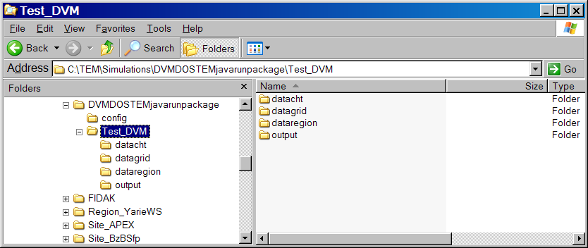

2. Java GUI for calibrating DVMDOSTEM

When clicking or starting ‘TEMcalibrator.jar’, there are THREE (3) separated windows:
(1) TEM Run Info window
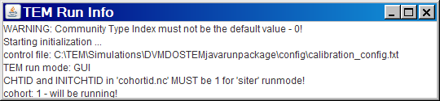
Figure 2-1. DVMDOSTEM running information window screen

(2) TEM calibration control panels
This is a 3-tabed panel window for model configuring, data showing/editing, parameter changing and performance.
- Configurer – for setting control file (running data directories/files), and module switches;
- Datalogger – for loading/editing parameters and initial states and targeted values;
- Calibrator – for choosing PFT index, changing parameters, and running model (start/pause/resetup/setup…).

TEM Configurer Panel
It contains TWO portions – (1) TEM control file, for I/O information; and (2) TEM module switches.
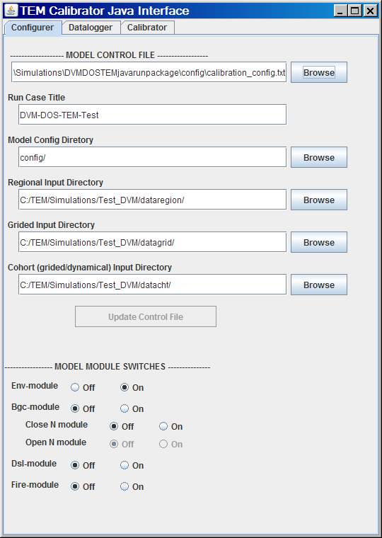
Figure 2-2. DVMDOSTEM ‘Configurer’ panel
- Instructions on ‘Configurer’ panel –

MODEL CONTROL INFORMATION

- Click ‘Browse’ button next to the text box below ‘MODEL CONTROL FILE’, to chose the control file ‘calibration_config.txt’;
- The information in ‘calibration_config.txt’ will immediately read into the following 5 text boxes.
- The model will be initialized as well – information will display on ‘TEM Run Info’ window. If things are going wrong, model error information will display – Please check your control file and related run case dataset.
- The 5 information text boxes are designed to be either editable or to be chosen by clicking ‘browse’ button, so that you may dynamically change those information. BUT this feature is NOT YET finished!!

MODEL MODULE SWITCHES

- DVMDOSTM can be running with/without coupled processes.
- ‘Env-module’ is the (bio)physical process module, with default plant-ground/soil dimensions. This switch is ON all the time, if turned off the model will do nothing.
- ‘Bgc-module’ is the C-N module of the model, in which N processes can be turned off to decouple the C-N (‘Close N module’). So-called ‘close N module’ refers to N cycle within soil-plant system; while ‘open N module’ refers to air-soil/plant-water N cycle. ‘close N module’ switch formerly was called ‘Nfeed’(N limitation feedback to C cycle) in DOSTEM. ‘Open N cycle’ implies N inputs and outputs are explicitly connected to N fertilization, deposition, exporsion to water bodies and emission to air. With this switch off (currently default option), the N in the model system will be mass conservative. This is for model future development.
- ‘Dsl-module’ switch is for using model’s Dynamical Soil Layer module or not (i.e. DOS-TEM);
- ‘Fire—module’ switch if for turning on/off TEM’s wild fire disturbance module.
TEM Datalogger Panel
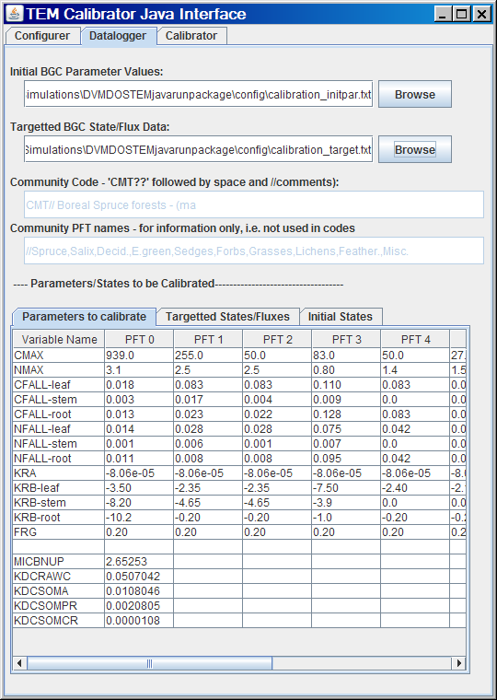
Figure 2-3. DVMDOSTEM ‘Configurer’ panel
- Instructions on ‘Datalogger’ panel –
Initial BGC Parameter file
- By clicking ‘Browse’ button to choose the ‘calibration_initpar.txt’ file in your file system.
- Read-in information on community type and its PFT names will input into two information display text boxes below.
- The initial parameters from the file will replace the default parameters in the ‘Parameters to calibrate’ table of 3-tabbed tables of bottom part in the panel. Note this default parameters and ‘initial states’ values are from the ‘CMT00’ in those files under ‘config/’, when the model was initialized.

Targeted BGC State/Flux file
- By clicking ‘Browse’ button to choose the ‘calibration_target.txt’ file in your file system.
- Read-in data will input into the ‘Targeted States/Fluxes’ table of the 3-tabbed tables.

NOTES
- Values for PFTs with greater than zero vegetation coverage will display into the tables.
- Values in those tables are editable, and will read into the model when running, except for the parameters on chosen PFT in ‘Calibrator’ panel, for which the model will read from the parameter changers.
- The default PFT parameter in ‘Calibrator’ panel will be set to the FIRST non-zero vegetation coverage PFT. Each time when changing PFT index in ‘Calibrator’ panel, the values on those changers will copy back to the parameter table.
- Editing values in ‘Initial States’ will change the model behavior.
- Normally when the values in those tables are edited, it will de-active the ‘start/pause’ button on ‘Calibrator’ panel (and mostly the ‘Setup’ button). In this case, it implies that you must click ‘Re-Setup’ (or ‘Setup’) button on ‘Calibrator’ panel to let model read those data and/or re-initialize the model.
- TEM Calibrator Panel
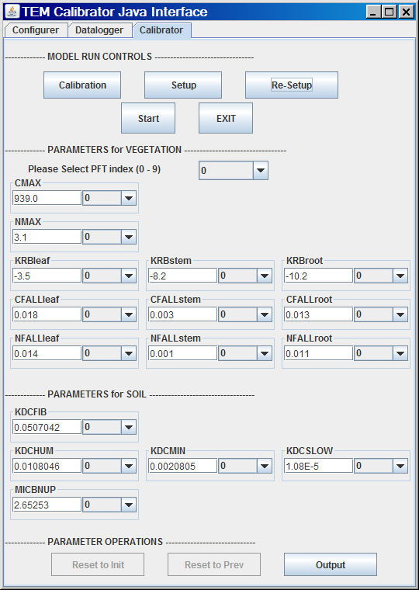
Figure 2-4. DVMDOSTEM ‘Calibrator’ panel
- Instructions on ‘Calibrator’ panel –
Model Run Controls:
‘Calibration/new driver’ – if need to only run ‘env’ module, may be switch this button
‘Setup’ button – it will force the model read control/module switches/parameters from current setting, and continue running.
‘Re-Setup’ button – it will force all setting clear-up and re-startup TEM model.
‘Start/Pause’ button – click it will start/resume model run; or pause the run.

PFT Selector:
Draw-down selector. If select certain PFT with vegetation coverage of zero, it will not do anything and show error message.

Parameter Changers:
The parameter changing is carrying out by modifying the ‘Calibrator’ panel’s individual parameters.
The changing is done either by directly input values in the text box, or by up/down arrows in the keyboard with decimal/digits controlling power index in draw-down box.

Parameter operations:
‘reset to int’ – reset the changers’ parameter values to the initial ones, as in ‘calibration_initpar.txt’;

‘reset to prv’ – reset the changers’ parameter values to the previously stored values.

‘output’ – by clicking it, it will write a parameter file, namely ‘calibration_outpar.txt’. It’s in exactly same format as ‘calibration_intpar.txt’, but the values are those already calibrated. Basically after the calibration is done, copy the content of this file to append/replace the community type parameters in ‘config/cmt_calbgc.txt’. Note you must be indexing the community type as ‘CMT??’, in which ‘??’ is a 2-digit index. And this 2-digit index IS the code for that community type when preparing the input file ‘datacht/vegetation.nc’.

(3) TEM run monitoring
- (bio)physical properties monitor

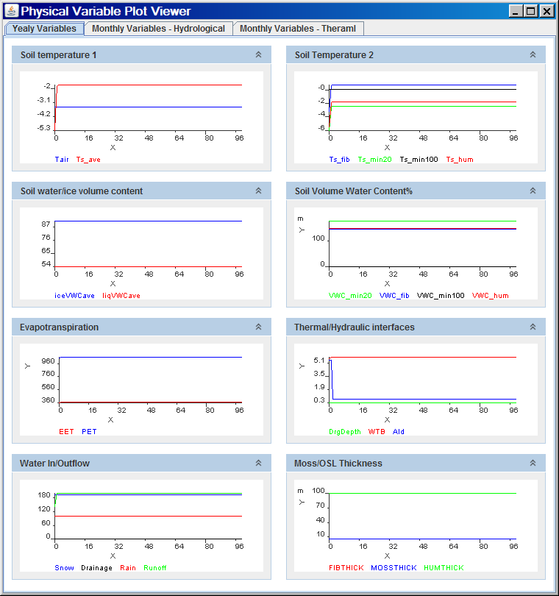
Figure 2-5. DVMDOSTEM (bio)physical properties monitor (3-tabbed multiple graphs)

- Biological/Biogeochemical monitor
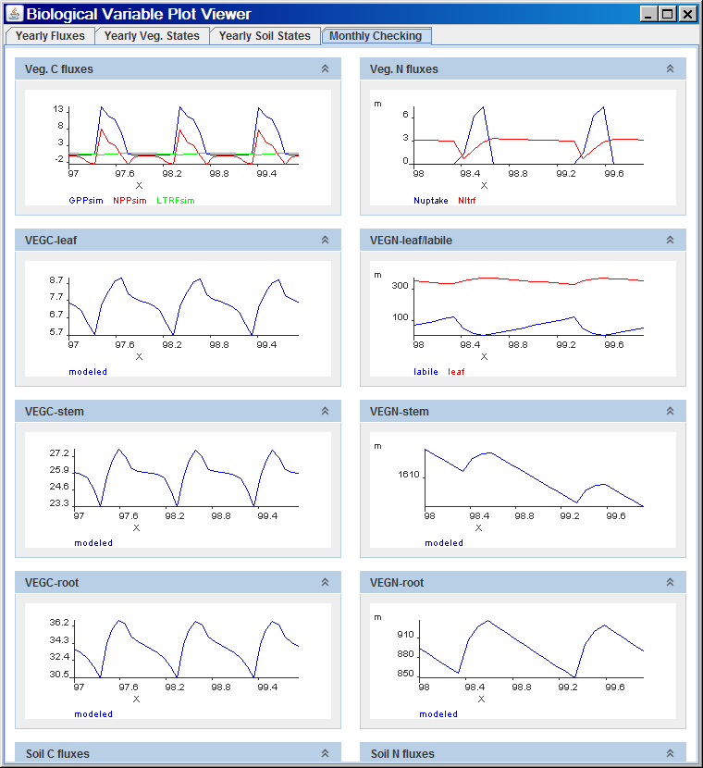
Figure 2-6. DVMDOSTEM biological/biogeochemical properties monitor (4-tabbed multiple graphs)

The biological/biogeochemical properties monitor IS the primary monitor to watch for calibration.
The first 3 yearly (fluxes, veg. states, and soil states) are targeted graphs for checking if calibration parameters are good or bad.

3. Calibration procedure

Important: THIS is from DOSTEM calibration, SO not tested at all on DVMDOSTEM. FOR INFORMATION ONLY!!!
I. Prepare the input file for TEM: Calibration_initpar.txt, Calibration_target.txt
The initial parameters you put in the file ‘calibration_initpar.txt’ are reasonably guessed. After you get the first set of calibrated parameters from the Calibrator (see below), you put them in this file. Then if you run the Calibrator again, it will save you time.

II. Run the Calibration Mode of TEM initially to get the driving variables
The purpose is to get an initial guess of driving variables for calibration.

After you start the Calibrator, toggling the NewDrivers/Calibration button on the calibration tab to show ‘NewDrivers’, click setup button, then hit the start. The calibrator will run initially to get the first set of driving variables. The running is based on the parameters in the Calibration_initpar.txt.

The Calibrator will show the Physical Variables for your monitoring.

Each time you run the Calibrator as below, then you run this process here again, the driving variables produced will be based on the new parameters showing in the adjusting boxes.

This process should be repeated until you get a set of parameters not varied too much.
The following steps will describe how to calibrate the model for your case.

III. Calibrate C Cycle First (set NFEED= OFF and AVLN= Off, and with BASELINE=ON)
1) Adjust CMAX until GPP & NPP are closed to desired values. Increase CMAX, increase GPP and NPP. Note: GPP will be the first priority to match here.

2) Adjust KRB until GPP & NPP are desired values. Decrease KRB, increase GPP and NPP. Note: NPP will be the variable you should match up with data here.

3a) Adjust CFALL until VEGC is at desired value;
3b) Adjust KDCFIB until FIBRIC is at desired value; then KDCHUM for HUMIC to be the target value; and finally KDCMIN for MINERALC to be the target value (at this moment, KDCMINSLOW doesn’t work)

NOTE: whenever you’re feeling the calibrated parameters not reasonable, Click the re-setup button to redo the calibration. Otherwise, each time you change the parameters, click the setup button, and then click start.

Up to here, if you don’t need to consider N cycles, you’re done with calibration. And by clicking output button to save the parameters in the file ‘Jcalinput.txt’.

4) Adjust CMAX until YRNPP gets to target NPPSAT (INNPP). Keep it at this high value through the N Cycle calibration described below.

IV. Calibration of the N cycle - Set NFEED = ON and AVLN = ON

- Adjust NUP until AVAILN is at target values.
* Increase NUP (negative, for microbial control of available soil N to plant uptake), decrease AVAILN (and almost everything else as described in step 2) below);
* Usually this AVAILN is related to KDCMIN more than other KDC. Pay attention to the MINERALC, when it gets to the steady, AVAILN should be steady as well.

- Adjust NMAX (and NUP, NFALL) until NPP, AVAILN, and NUPTAKE are at target values.
- Adjusting NMAX & NUP to get NPP close to target NPP and NUPTAKE close to targets.
* Increase NMAX, increase NPP and NUPTAKE and decrease AVLN but only slightly and vice versa;
* Increase NUP (negative, for microbial control of available soil N to plant uptake), AVLN will decrease (as described above), and then will decrease NPP and NUPTAKE;
* NMAX and NUP are highly associated. NUP has to be getting to some points, NMAX adjusting starts working. Basically to say, NUP controls the AVLN actual supply to satisfy NUPTAKE;
* If you can’t get both variables to the targets, try to get they are changing in opposite direction. Then you tune NFALL as below.
- Fine-tuning with NFALL, usually only if NPP and NUPTAKE are opposite meaning if NPP is higher than the desired value and NUPTAKE is lower than the desired value or vice versa.

- Adjust CFALL until VEGC is at desired value.

- Adjust KDCFIB until FIBRIC is at desired value; then KDCHUM for HUMIC to be the target value; and finally KDCMIN for MINERALC to be the target value (at this moment, KDCMINSLOW doesn’t work).

NOTE: you may need to click re-setup button to restart a new tuning of parameters, which will save your time and tide-up the monitoring graph.

- When step 2)-3) done the first time, it normally will change the results from step 1). So you need to repeat 1), and then step 2) -3), until both C/N fluxes and C/N stocks are close to target values.

6) As already mentioned before, you need to redo the NewDrivers process when you tuning the parameters from time to time.

V. Calibration of soil C and organic layer thickness with multiple-module ON

- Adjust NUP until AVAILN is at target values.
* Increase NUP (negative, for microbial control of available soil N to plant uptake), decrease AVAILN (and almost everything else as described in step 2) below);

VI. Tips

1) Practically, if in step III.3) the tuning of KD are toward unrealized values, and the C & N fluxes are in the way of out of ranges, then stop and redo the III.1). So generally you need to coordinate steps III.1) and III. 2-3).

2) When tuning parameter(s), put more weight on the target values which are less uncertain. It’s a real challenge to tune every variables matching up with the target values (almost not possible).

3) When back-forth tuning between III.1) and III.2-3), GRADUALLY get to the target values all together as much as possible. DON’T try to get one at the exact range while others far away.

4) Preferably, when tuning C&N fluxes, veg. C & N stocks, Fibrous C & N, it’s better to get them with 1000yrs or shorter. Especially pay attention to the plant biomass growth curve and NPP curve. The best is to let the initial VEGC to nearly zero (by modifying it in the Table of fixed states).

5) As said in 4), the Humic and mineral C & N may be up to thousands years to get equilibrium status. But this really is upon the soil conditions.

