# Introduction

## Purpose

The **purpose** of this document is...

## Content

The *content* of this ***document*** is...

# Applicable Documents

AD1 EID-A: Solar Orbiter Experiment Interface Document, Part A. SOL-EST-RCD-0050 issue 5 rev 0

# Reference Documents

RD1 CCSDS Packet Telemetry. CCSDS 102.0-B-5. Blue Book. SO-EPD-PO-IF-0001. 11/2000

# Terms, Definitions & Abbreviations

EPD Energetic Particle Detector

# General Description

## Product Perspective

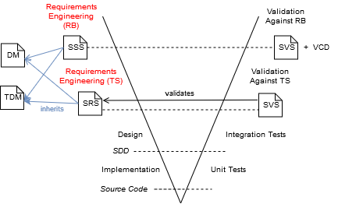

Figure 1: V-Model

## General Capabilities

As noted in EID-A and shown in previous image

## General Constraints

1. Enum item 1
   1. Enum item 1.1
2. Enum item 2

## Operational Environment

* Bullet item 1
* Bullet item 2

## Assumptions & Dependencies

| Cell 1.1 | Cell 1.2 | Cell 1.3 |
| Cell 2.1 | Cell 2.2 | Cell 2.3 |

Table 1: Simple Table

|  |  |  |  |  |  |  |  |
| --- | --- | --- | --- | --- | --- | --- | --- |
| 1-2; 1 | 1; 2-3 | | 1-2; 4-5 | | 1; 6 | 1; 7 | 1; 8 |
| 2; 2 | 2; 3 | 2-3; 6-7 | | 2; 8 |
| 3; 1 | 3; 2 | 3; 3 | 3; 4 | 3; 5 | 3; 8 |

Table 2: Hard Table

# Specific Requirements

## General Requirements

|  |  |
| --- | --- |
| **Name** | **SampleItem-001** |
| **Description** | Item description |
| **Validation Method** | Analysis |

Item extended description

## System, Software and Observability Requirements

# Verification, Validation and Integration Requirements

## Verification and Validation Process Requirements

## Verification Requirements