
DESIGN AND IMPLEMENTATION OF A MACHINE LEARNING BASED STUDENT
SEGMENTATION AND ACADEMIC MONITORING SYSTEM (A CASE STUDY OF KASHIM IBRAHIM UNIVERSITY, KIU)

BY

ABUBAKAR ALHAJI MODU
(22/03/03/027)

A PROJECT SUBMITTED TO THE DEPARTMENT OF MATHREMATICS AND
COMPUTER SCIENCE, FACULTY OF SCIENCE, KASHIM IBRAHIM UNIVERSITY
IN PARTIAL FULFILMENT OF THE REQUIREMENTS FOR THE AWARD OF BACHELOR OF SCIENCE (B.Sc. Hons.) COMPUTER SCIENCE

AUGUST 2026

CHAPTER ONE

INTRODUCTION
1.1 Background of the Study
Higher education institutions globally generate enormous volumes of student academic data in every academic cycle. These data include results of continuous assessments, semester examinations, attendance records, assignment scores and cumulative grade point averages (CGPAs). Despite the richness of information embedded in these records, much of it is stored and referenced only for administrative purposes such as grading, transcript generation and statutory reporting to regulatory bodies (Romero & Ventura, 2010). The potential of this data to support early identification of students struggling academically or to reveal systemic patterns in student performance, remains largely untapped in many developing country universities.
The scale of student enrolment in Nigerian universities underscores the urgency of this challenge. According to the National Universities Commission (NUC), Nigeria had over 170 accredited universities as of 2022, with a total student enrolment exceeding 1.9 million across undergraduate programmes (NUC, 2022). Managing the academic progress of such a large student population through manual review of records is inherently impractical and susceptible to error. Lecturers and academic advisors may be responsible for hundreds of students simultaneously, making it nearly impossible to detect early warning signs of academic decline through unaided observation alone.
Academic monitoring which involves the systematic tracking and analysis of student academic progress over time, is a critical institutional responsibility. Effective academic monitoring enables universities to identify students at risk of academic failure, implement targeted interventions and improve graduation rates. Traditional academic monitoring in Nigerian universities is largely reactive intervention occurs only after a student has failed a course or been placed on probation, rather than being proactive and predictive (Adeyemi & Adeyemi, 2014). This reactive posture results in missed opportunities to support students before their situations become irreversible.
The emergence of data science and machine learning has opened new frontiers in educational research and institutional management. Machine learning refers to a branch of artificial intelligence that enables systems to learn patterns from data and make inferences or classifications without being explicitly programmed for each scenario (Mitchell, 1997; Bishop, 2006). In the domain of education, machine learning techniques have been applied to problems ranging from dropout prediction and course recommendation to performance classification and early warning system design (Baker & Yacef, 2009; Kotsiantis et al., 2010).
One of the most widely studied machine learning techniques in educational data analysis is clustering. Clustering is an unsupervised learning technique that identifies natural groupings within a dataset without relying on pre labelled categories (Han, Kamber & Pei, 2012). Among the various clustering algorithms available, K means clustering is one of the most commonly used due to its computational efficiency, conceptual simplicity and scalability to large datasets (Jain, 2010). K means operates by iteratively assigning data points to a predefined number of clusters (K) based on minimizing the distance between each data point and its nearest cluster centroid (MacQueen, 1967; Lloyd, 1982).
When applied to student academic data, K means clustering can partition the student population into meaningful performance groups, for example, high performing students, moderately performing students and academically at risk students. These clusters can provide actionable intelligence for university administrators, enabling them to design differentiated academic support programs, allocate resources more effectively and monitor trends in academic performance across student cohorts (Dutt, Aghabozrgi & Maizatul, 2015).
Educational Data Mining (EDM) is the interdisciplinary field dedicated to developing and applying analytical methods for exploring data originating from educational environments (Baker & Yacef, 2009). EDM encompasses a wide range of techniques including classification, regression, clustering, association rule mining and sequential pattern analysis. The application of EDM has demonstrated measurable improvements in academic outcomes in several international universities that have integrated data driven monitoring systems into their administration (Romero & Ventura, 2010; Pena,Ayala, 2014).
In the Nigerian higher education context, however, the integration of machine learning and data mining techniques in academic monitoring systems remains limited. Most universities, including Kashim Ibrahim University, KIU, currently rely on conventional manual processes for academic record keeping and student performance review. While some institutions have adopted student information systems (SIS) for data storage, these systems typically serve as passive repositories rather than active analytical platforms. The lack of intelligent analytics capabilities means that large volumes of valuable academic data go unanalyzed and critical intervention opportunities are frequently missed.
This study therefore proposes the design and implementation of a machine learning based student segmentation and academic monitoring system as a case study of Kashim Ibrahim University, KIU. The system will apply K means clustering to student academic data including CGPA, attendance rate and assessment scores to segment students into performance groups and provide a dashboard based interface for administrators and academic staff to monitor student progress and identify those who may require academic support. This initiative represents a practical step towards data driven academic governance within the Nigerian university environment.
1.2 Statement of the Problem
The monitoring of student academic performance is a fundamental obligation of higher education institutions. Sustained academic monitoring enables institutions to measure student progress, detect signs of academic difficulty early and implement corrective interventions before performance deteriorates irreversibly. However, in many Nigerian universities, academic monitoring systems remain largely manual, fragmented and reactive (Adeyemi & Adeyemi, 2014; Nworie, 2012).
At Kashim Ibrahim University, KIU, as in many comparable institutions, student academic data including examination scores, continuous assessment records and attendance figures are collected each semester. However, these data are typically analysed in isolation for the purpose of calculating semester grades and cumulative grade point averages, rather than being subjected to deeper analytical scrutiny. The relationships between multiple performance indicators and their collective influence on academic st anding are seldom explored in a systematic or automated manner.
The volume of student data generated per semester makes manual analysis increasingly impractical. A department with several hundred students across multiple levels would require significant administrative effort to individually review each student's academic profile and identify those who may be struggling. This labour, intensive approach is not scalable, is prone to oversight and does not lend itself to the identification of patterns or trends across student cohorts (Han, Kamber & Pei, 2012; Witten, Frank & Hall, 2016).
Furthermore, the absence of an automated analytical framework means that academic administrators lack the tools to cluster or categorise students according to performance characteristics. Without such segmentation, it is difficult to design targeted academic interventions or to allocate tutorial and mentorship resources efficiently. Students who fall into high risk performance categories may go unidentified until they have already failed a course or accumulated a CGPA below the minimum required st andard at which point the scope for effective intervention is considerably diminished.
Existing literature has demonstrated that machine learning based systems, particularly those employing clustering techniques such as K means, can effectively segment student populations and provide early warning signals for academic underperformance (Dutt, Aghabozrgi & Maizatul,
2015; Kovacic, 2010; Bydžovská, 2016). However, few such systems have been designed and implemented within Nigerian university setting s and none are documented specifically for Kashim Ibrahim University.
Therefore there is an identifiable gap between the potential of machine learning analytics to support academic monitoring and its current application in many Nigerian universities. This study seeks to address that gap by developing a practical, functional and deployable student segmentation and academic monitoring system tailored to the operational realities of a Nigerian university environment.
1.3 Objectives of the Study
The main objective of this study is to design and implement a machine learning based student segmentation and academic monitoring system using K means clustering, with Kashim Ibrahim University, KIU, as the case study institution.
The specific objectives of the study are:
- To design and develop a web based system that enables authorized administrators to upload, manage and process student academic datasets.
- To implement the K means clustering algorithm to automatically segment students into performance groups based on academic indicators including CGPA, attendance rate and assessment scores.

- To provide an academic monitoring interface that enables institutional administrators and academic staff to identify students who may require academic support, intervention or mentorship.
1.4 Scope of the Study
This study is concerned with the design and implementation of a machine learning based student segmentation and academic monitoring system. The analytical scope of the study encompasses three principal academic performance indicators: cumulative grade point average (CGPA), attendance rate (expressed as a percentage) and assessment scores (comprising coursework and test marks). These indicators were selected on the basis of their availability within institutional records, their recognised influence on overall academic outcomes and their frequent use in comparable educational data mining studies (Romero & Ventura, 2010; Dutt, Aghabozrgi & Maizatul, 2015).
The system developed in this study employs the K means clustering algorithm for student segmentation. The study does not extend to predictive modelling of future academic performance, nor does it incorporate natural language processing, deep learningor other advanced machine learning paradigms. The clustering analysis is limited to unsupervised grouping of students based on the three stated performance variables and the results are communicated through an administrative dashboard.
Geographically, the study is conducted as a case study of Kashim Ibrahim University, KIU, Borno State, Nigeria. The dataset used in the study is sourced from or constructed to reflect the structure of student academic records at that institution. The system is designed primarily for use by academic administrators and departmental level staff. It is not intended as a student facing application.
The study does not address network security architecture, integration with existing university enterprise resource planning (ERP) systems or long term data governance frameworks, as these fall outside the defined scope of a final year undergraduate project. These areas are acknowledged as important considerations for future development and deployment.

1.5 Significance of the Study
This study holds significance at multiple levels institutional, academic and practical.
From an institutional st andpoint, the system developed in this study offers a practical tool for academic administrators at Kashim Ibrahim University and comparable institutions to improve the quality and efficiency of student academic monitoring. By automating the segmentation of students based on performance data, the system reduces the administrative burden associated with manual record review and enables faster, more consistent identification of students who require academic support. This can contribute directly to improved student retention and academic outcomes.
From an academic st andpoint, this study contributes to the growing body of literature on educational data mining and machine learning applications in Nigerian higher education. While international literature on clustering based academic monitoring systems is well developed (Romero & Ventura, 2010; Baker & Yacef, 2009; Pena,Ayala, 2014), indigenous studies contextualized to Nigerian universities remain relatively limited. This work therefore fills an identifiable gap in the local academic literature and may serve as a reference for subsequent researchers in this domain.
From a practical st andpoint, the dashboard and reporting features of the system provide decision support capabilities that enable data driven academic governance. Rather than relying on intuition or anecdotal assessments, academic staff can use evidence derived from quantitative cluster analysis to inform decisions regarding tutorial allocations, probation notifications and scholarship assessments.
More broadly, this study demonstrates that the application of machine learning techniques in academic management is both feasible and beneficial within the resource constraints typical of Nigerian universities. It provides a replicable model that other institutions in the country can adapt to their local data structures and operational contexts. In doing so, it supports the broader ambition of the National Universities Commission to improve the quality and data responsiveness of academic management across the Nigerian higher education system (NUC, 2022).

1.6 Operational Definition of Terms
Academic Monitoring
The systematic process of collecting, reviewing and analysing student academic performance data over time in order to track progress, detect signs of academic difficulty and facilitate timely institutional intervention (Adeyemi & Adeyemi, 2014).
Artificial Intelligence (AI)
A broad field of computer science concerned with the development of systems capable of performing tasks that would normally require human cognitive abilities, including reasoning, pattern recognition, learning and decision making (Russell & Norvig, 2016).
Cluster
A group of data points that share greater similarity with one another than with data points in other groups, as determined by a chosen distance or similarity metric within a clustering algorithm (Jain, 2010).
Clustering
An unsupervised machine learning technique that groups unlabeled data points into clusters based on inherent similarities in their feature values, without prior knowledge of class labels (Han, Kamber & Pei, 2012).
Cumulative Grade Point Average (CGPA)
A numerical measure of a student's cumulative academic achievement across all completed semesters, calculated as the weighted average of the grade points earned in all registered courses up to the point of calculation.
Dashboard
A graphical user interface that organises and presents key performance indicators and analytical results in a visual format, enabling users to monitor information at a glance and make informed decisions (Few, 2006).
Educational Data Mining (EDM)
An interdisciplinary field focused on the development and application of computational methods for exploring and analysing data generated within educational environments, with the aim of better underst anding students and the institutions in which they learn (Baker & Yacef, 2009).
K means Clustering
A partition clustering algorithm that divides a dataset into K pre specified clusters by iteratively assigning each data point to the nearest cluster centroid and updating centroids until convergence (MacQueen, 1967; Lloyd, 1982).
Machine Learning
A subfield of artificial intelligence that enables computer systems to automatically learn and improve from experience ,specifically, by detecting patterns in data ,without being explicitly programmed for each task (Mitchell, 1997).
Student Segmentation
The process of partitioning a student population into distinct subgroups based on similarities in academic performance characteristics, for the purpose of facilitating differentiated academic support or decision making (Dutt, Aghabozrgi & Maizatul, 2015).
Unsupervised Learning
A category of machine learning in which algorithms identify structure and patterns within data that has not been pre labelled or categorised relying instead on inherent statistical relationships among the input features (Bishop, 2006).

CHAPTER TWO

LITERATURE REVIEW

2.1 Introduction
This chapter presents a structured review of literature relevant to the design and implementation of a machine learning based student segmentation and academic monitoring system. The review is organised to establish a strong conceptual and empirical foundation for the study, beginning with the theoretical basis of machine learning and educational data mining before narrowing progressively to clustering methodologies, student performance analysis and related system implementations. The chapter concludes by synthesizing findings from related studies, identifying critical gaps in the existing literature and establishing how the present study addresses those gaps through a context aware, machine learning driven monitoring framework.
Literature reviewed in this chapter is drawn from peer reviewed journal articles, conference proceedings, authoritative text books and technical reports published between 1967 and 2026. Selected works include both foundational studies defining the theoretical basis of the techniques employed and contemporary studies reflecting current advances in educational data mining and intelligent academic analytics.

2.2 Machine Learning: Concepts and Theoretical Foundations
Machine learning is a branch of artificial intelligence concerned with the development of computational systems that improve their performance on a defined task through experience, without being explicitly programmed for each scenario. The widely cited definition by Mitchell (1997, p. 2) captures this principle precisely: a computer program learns from experience E with respect to a class of tasks T and performance measure P if its performance at T improves with E. This formulation distinguishes machine learning from conventional rule based software, which operates strictly on hardcoded logic regardless of data patterns.
Machine learning is categorised into three principal paradigms. Supervised learning trains a model on labelled datasets,where inputs are paired with known outputs ,enabling predictive mappings for unseen data. Representative algorithms include decision trees, support vector machines and neural networks. Unsupervised learning, by contrast, operates on unlabelled data and seeks to uncover hidden structures through techniques such as clustering and dimensionality reduction. Reinforcement learning involves an agent that learns optimal behaviour through environmental interaction and reward,based feedback (Bishop, 2006; Russell & Norvig, 2016). The rapid acceleration of machine learning since the early 2000s has been driven by exponential growth in data availability, reductions in computational cost and innovations in algorithm design (LeCun, Bengio & Hinton, 2015).
Within education, machine learning has been applied to student dropout prediction, intelligent tutoring, adaptive course recommendation, automated grading and academic performance classification (Kotsiantis, Pierrakeas & Pintelas, 2010; Kemper, Vorhies & Martens, 2020). The growing digitalisation of academic administration through student information systems and learning management platforms has further exp anded the availability of structured data that these techniques require.
2.2.1 Supervised vs. Unsupervised Learning in Educational Contexts
In educational data analysis, the distinction between supervised and unsupervised learning has significant methodological implications. Supervised techniques require datasets pre labelled with outcome categories such as 'pass/fail' or 'at risk/not at risk' ,which presupposes the availability of reliable historical classifications. Many institutions, particularly in developing country contexts, lack such consistently labelled records (Bydžovská, 2016). Unsupervised learning eliminates this dependency by discovering natural groupings within data based solely on statistical similarity. This characteristic makes clustering especially valuable for exploratory academic analytics and institutions at early stages of data maturity (Dutt, Aghabozrgi & Maizatul, 2015). The present study adopts the unsupervised learning approach precisely because it aligns with the nature of available institutional data and supports pattern discovery without pre imposed classification assumptions.

2.3 Educational Data Mining
Educational Data Mining (EDM) is an interdisciplinary field that applies data mining, machine learning and statistical techniques to data generated within educational environments, with the objective of better underst anding students and improving learning outcomes (Baker & Yacef, 2009). The field integrates methodologies from computer science, education and psychology to analyses data sourced from student information systems, learning management platforms and institutional databases.
Romero and Ventura (2010), in a l andmark review of over 300 studies, categorised EDM applications into four domains: student modelling, domain knowledge modelling, pedagogical support and institutional improvement. The fourth domain institutional improvement through data driven administrative decision making is most directly relevant to the present study. Pena Ayala (2014) further surveyed 240 EDM studies and found classification to be the most commonly used technique, followed by clustering and regression. Crucially, the survey also documented growing interest in clustering based approaches for contexts where labelled data is unavailable, reinforcing the analytical direction of this research.
2.3.1 Data Sources and Feature Selection
EDM systems draw on diverse data types: demographic features (age, gender, geographic origin), academic features (grades, CGPA, attendance, assessment scores), engagement features (LMS login frequency, assignment submission timing) and socioeconomic attributes. Academic features consistently emerge as the most influential predictors of student outcomes across the literature (Huang & Fang, 2013; Marburger, 2001). Attendance is of particular significance: empirical studies have established a strong positive correlation between consistent class attendance and academic achievement and conversely, a pattern of regular absence frequently precedes academic decline even among students with comparable prior records (Gatherer & Manning, 1998; Marburger, 2001). In this study, three core features, CGPA, attendance rate and assessment score, are selected on the basis of theoretical validity, empirical precedent and practical availability within the Nigerian institutional context. Because CGPA is only meaningful for students with at least one completed semester, this study applies CGPA alongside attendance rate and assessment score for returning students, while relying on attendance rate and assessment score alone for newly admitted students, who have not yet accumulated a cumulative grade point average.

2.4 Overview of Clustering Techniques
Clustering is a fundamental unsupervised machine learning technique that organizes data into groups called clusters such that objects within the same cluster are more similar to each other than to objects in other clusters (Han, Kamber & Pei, 2012). Jain (2010) categorizes clustering algorithms into four primary families: partitional, hierarchical, density, based and model based methods. Table 2.1 provides a structured comparison of these families across key analytical dimensions.

Family | Key Algorithm(s) | Requires K in Advance? | H andles Outliers Well? | Suitability for Student Data
Partitional | K means, K,Medoids | Yes | Moderate (K,Medoids better) | High ,efficient, scalable, interpretable
Hierarchical | Ward's, Complete Linkage | No | Poor | Low ,O(n² log n) complexity limits scalability
Density Based | DBSCAN, HDBSCAN | No | High | Moderate ,sensitive to parameter tuning with variable, density data
Model Based | Gaussian Mixture Model (GMM) | Yes | Moderate | Low ,computationally intensive; distributional assumptions rarely hold

Table 2.1: Comparison of Major Clustering Algorithm Families

As Table 2.1 demonstrates, partitional clustering and K means in particular, offers the optimal balance of computational efficiency, interpretability and scalability for student segmentation. Hierarchical methods are computationally prohibitive for large cohorts. DBSCAN's sensitivity to parameter configuration produces inconsistent results on variable density academic data. Model based methods introduce unnecessary complexity and distributional assumptions that academic performance data rarely satisfies (Bishop, 2006; Han, Kamber & Pei, 2012). These comparative weaknesses justify the selection of K means as the algorithm of choice for the present system.

2.5 The K means Clustering Algorithm
K means is one of the most widely studied and deployed algorithms in data mining, with over five decades of application across diverse domains since its original formulation by MacQueen (1967) and algorithmic refinement by Lloyd (1982). The algorithm partitions a dataset into K clusters by minimizing the Within Cluster Sum of Squares (WCSS) ,a measure of intra cluster compactness defined as:
J = Σ(k=1 to K) Σ(xᵢ Cₖ) ||xᵢ − μₖ||²
where μₖ is the centroid (mean vector) of cluster Cₖ and ||xᵢ − μₖ||² is the squared Euclidean distance. The algorithm operates through four iterative steps: (1) Initialize K centroids; (2) Assign each data point to its nearest centroid; (3) Re compute centroids as the mean of assigned points;
(4) Repeat until cluster assignments converge. Figure 2.1 illustrates this process conceptually.

STEP 1 STEP 2 STEP 3 CONVERGENCE
Initialize → Assign to nearest → Update → No further
K centroids centroid centroids assignment
changes

Data Points Cluster Assignment Updated Final
o o o o [High] o o Centroids Clusters
o o o o → [Avg] o o → µ₁ µ₂ µ₃ → C₁ C₂ C₃
o o o o [Risk] o o
Figure 2.1: K means Iterative Clustering Process

2.5.1 K means++ Initialization
Standard random centroid initialization is prone to suboptimal placement, leading to slow convergence or poor final clusters. Arthur and Vassil vitskii (2007) addressed this with K means++, which selects centroids probabilistically in proportion to their squared distance from already selected centroids. This ensures wider initial spacing across the feature space, consistently improving both cluster quality and convergence speed. K means++ is now the default initialization strategy in scikit, learn and most modern ML libraries (Pedregosa et al., 2011).
2.5.2 Determining the Optimal Number of Clusters
Three established techniques are applied in this study to determine the appropriate value of K. The Elbow Method plots WCSS against increasing K values; the optimal K appears at the 'elbow' ,where the marginal reduction in WCSS begins to diminish significantly (Ketchen & Shook, 1996). The Silhouette Method measures, for each data point, how similar it is to its own cluster relative to the nearest alternative; an average silhouette score approaching 1 indicates well separated clusters (Rousseeuw, 1987). The Gap Statistic compares observed WCSS to an expected baseline under a reference null distribution, with the optimal K maximising the gap (Tibshirani, Walther & Hastie, 2001). Across the EDM literature, K=3, grouping students into high, average and at risk categories, is the most commonly adopted and institutionally actionable solution (Pal & Pal, 2013; Bakar, Rosbi & Hamid, 2015).
2.5.3 Strengths and Limitations
K means offers computational efficiency with time complexity of O(nKd) per iteration ,highly scalable for large student populations ,alongside interpretable centroid based cluster summaries that can be communicated directly to nontechnical academic stakeholders (Jain, 2010). Its limitations are equally well documented: sensitivity to outliers, an assumption of spherical equally sized clusters and the requirement to pre specify K. In the present study, these limitations are mitigated through feature normalization, IQR based outlier detection during preprocessing and systematic Elbow and Silhouette analysis for K selection.

2.6 Student Academic Performance Monitoring in Higher Education
Academic performance monitoring has evolved from simple record keeping into a data driven institutional function that integrates analytics, predictive modelling and decision support. York, Gibson and Rankin (2015) identify four essential components of effective monitoring systems: timely data collection, systematic analysis, targeted intervention and institutional feedback, emphasizing that monitoring's value lies not in data accumulation alone but in transforming data into actionable insights. A critical development in this space is the early alert system, designed to identify students at risk before academic failure occurs. Stinebrickner and Stinebrickner (2014) demonstrated that early identification combined with targeted support significantly improves student retention, reducing dropout rates by up to 18% among at risk cohorts.
Despite these advances, adoption of data driven monitoring remains uneven globally. In the Nigerian context, Adeyemi and Adeyemi (2014) documented that most universities lack the coordinated digital infrastructure necessary for systematic performance monitoring, with fragmented data practices, limited technical capacity and absent analytical frameworks compounding the challenge. While Olaleye (2016) and Eze et al. (2018) note gradual progress in the adoption of digital academic systems, the integration of machine learning techniques into institutional monitoring remains largely absent. This positions the present study at a critical intersection between demonstrated international best practice and an underserved national context.

2.7 Review of Related Works
This section critically examines prior studies that have applied machine learning and data mining techniques to student performance analysis. Rather than merely summarizing existing approaches, the review evaluates each study's methodological contributions and limitations relative to the objectives of the present research.
Furthermore, Kovacic (2010) applied decision trees and logistic regression to enrolment data from the Open Polytechnic of New Zeal and, demonstrating that institutional administrative data could support meaningful student risk prediction. The study achieved classification accuracies between 62% and 68% and established the viability of using routinely collected administrative data, rather than bespoke assessments, as the basis for academic risk identification. However, its reliance on supervised learning required pre labelled outcome data and the absence of a deployable monitoring interface limited its institutional utility beyond the analytical phase.
Additionally, Pal and Pal (2013) applied K means clustering (K=3) to student examination scores, internal assessment marks and attendance at an Indian technical university. The resulting clusters mapped onto coherent academic performance categories, high, medium and low with the high performance cluster exhibiting significantly higher attendance rates alongside stronger examination results. This study is the closest direct precedent to the present work, validating both the feature selection and the algorithm. Its principal limitation is the absence of a system implementation: the study remains an offline analysis without the monitoring dashboard or downloadable reporting capabilities that translate cluster insights into institutional action.
Besides, Dutt et al. (2015) reviewed 33 clustering based EDM studies and found that K means accounted for 45% of applications attributed to its efficiency and interpretability while academic performance indicators appeared as the primary feature set in 78% of studies. The survey highlighted two important deficiencies: insufficient attention to usability for nontechnical stakeholders and a near complete absence of studies in sub Saharan African contexts. Both gaps are directly addressed by the present study.
Equally Important, Bakar et al. (2015) applied K means to student CGPA and semester GPA data at a Malaysian public university, determining K=4 as optimal through silhouette analysis and introducing the concept of longitudinal cluster tracking. Their findings showed that approximately 22% of at risk students migrated to higher performing clusters within three semesters, a finding that positions cluster, based monitoring as a tool for measuring intervention effectiveness over time, not merely for point in time classification. The study did not, however, implement a real time monitoring interface.
Similarly, Bydžovská (2016) compared K means, decision trees, naive Bayes and artificial neural networks on student data from Masaryk University. While neural networks achieved the highest predictive accuracy, clustering produced more interpretable and actionable insights for academic administrators. This study crystallizes a key design principle for the present work: in institutional contexts where nontechnical stakeholders must act on analytical outputs, interpretability is not a compromise, it is a requirement. The study does not, however, advance beyond comparative analysis to system implementation.
Likewise, Within the Nigerian context, Afolabi et al. (2019) demonstrated the effectiveness of classification trees using CGPA and attendance as predictors, validating the feature selection of the present study but without exploring clustering or implementing a monitoring interface.
Olawale, Alabi and Ayo (2021) developed a threshold based early warning system at a Nigerian polytechnic ,demonstrating clear institutional demand for automated monitoring ,but their rule based architecture lacks the adaptive, data driven pattern discovery that machine learning clustering provides. Together, these studies confirm both the relevance of performance monitoring in Nigeria and the absence of ML based clustering solutions designed specifically for that context.

2.8 Comparative Analysis of Related Works
Table 2.2 presents a structured comparison of the reviewed studies across five analytical dimensions. The final row positions the present study relative to the identified body of work.

Author(s) & Year | Technique | Key Features | Dashboard? | Context | Gap Relative to Present Study
Kovacic (2010) | Decision Tree, LR | Demographics, prior qualifications | No | New Zeal and | Supervised only; no clustering or dashboard
Pal & Pal (2013) | K means (K=3) | Exam scores, CA, attendance | No | India | No deployment framework or monitoring interface
Dutt et al. (2015) | Survey (K means dominant) | Varied | N/A | International | No African studies; no implementation
Bakar et al. (2015) | K means (K=4) | CGPA, Semester GPA | Partial | Malaysia | No real time monitoring or actionable report output
Bydžovská (2016) | K means, ANN, DT, NB | Grades, course history | No | Czech  Republic | Comparative study only; no system deployment
Afolabi et al. (2019) | Classification Tree, LR | Attendance, CGPA | No | Nigeria | No clustering; no dashboard; supervised only
Olawale et al. (2021) | Rule Based Thresholds | CGPA,  Attendance | Partial | Nigeria | No ML; static rules lack adaptive pattern discovery
Present Study (2026) | K means++ Clustering | CGPA,  Attendance,  Assessment (returning students); Attendance,  Assessment (new students) | Yes ,Full | Nigeria  (KIU, KIU) | Addresses all gaps: Nigerian context, full dashboard, ML clustering, downloadable reports
Table 2.2: Comparative Summary of Related Studies

The comparative analysis in Table 2.2 reveals three consistent patterns across the reviewed literature: K means dominates student segmentation research for its interpretability and efficiency; the translation of clustering outputs into deployable monitoring systems remains largely unaddressed; and sub Saharan African institutional contexts with their specific operational challenges are systematically underrepresented. The present study is uniquely positioned to address all three simultaneously.

2.9 Identified Gaps in the Literature

First, there is a pronounced geographical gap: the substantial majority of EDM studies have been conducted in North American, European and Asian institutions. The structural realities of Nigerian higher education ,including fragmented data management practices, limited technical infrastructure, large class sizes and constrained access to commercial analytics platforms ,are not addressed by systems designed for resource rich institutional environments (Adeyemi & Adeyemi, 2014; Dutt et al., 2015).
Second, there is a persistent implementation gap. While studies such as Pal and Pal (2013) and Bakar et al. (2015) validate the effectiveness of K means for student segmentation at the analytical level, none extend their work to a fully deployable, interactive monitoring system. Bydžovská (2016) explicitly identified the need for better visualization tools to support nontechnical decision makers, yet no study in the reviewed literature implements a comprehensive administrative dashboard that converts cluster outputs into actionable institutional intelligence.
Third and most specifically, there is a methodological gap in the Nigerian literature. Existing Nigerian studies, Afolabi et al. (2019) and Olawale et al. (2021), rely on supervised classification or static threshold rules, precluding the adaptive, exploratory pattern discovery that unsupervised clustering enables. The present study addresses all three gaps through the development of a machine learning based student segmentation system, implementing K means++ clustering within a web based administrative dash board and situated specifically within the Nigerian university context.
Fourth, none of the reviewed studies distinguish between returning and newly admitted students when selecting clustering features. Pal and Pal (2013), Bakar et al. (2015) and Bydžovská (2016) all rely on CGPA or semester GPA as a primary clustering variable without addressing how such systems would treat first semester students who have not yet accumulated any GPA history. This is not a minor oversight, since a student segmentation system intended for continuous, semester by semester institutional use must account for the reality that a portion of the student population will always be newly admitted. The present study addresses this gap directly by implementing two distinct clustering models, one for returning students incorporating CGPA, attendance rate and assessment score and one for newly admitted students relying on attendance rate and assessment score alone, ensuring that no student is excluded or misclassified for lack of an academic history that new students cannot yet possess.

2.10 Chapter Summary
This chapter has provided a comprehensive and critically engaged review of the literature underpinning the design of a machine learning based student segmentation and academic monitoring system. Beginning with the theoretical foundations of machine learning and the rationale for adopting an unsupervised learning approach, the chapter progressed through educational data mining, a comparative evaluation of clustering technique families and a detailed examination of the K means algorithm ,including its mathematical formulation, K means++ initialization, cluster number determination methods and documented strengths and limitations.
A critical review of seven related studies, summarized in Table 2.2, established the consensus on K means as the preferred segmentation technique while exposing consistent deficiencies in system implementation, visualization provision and geographic contextualization. The three gaps identified in Section 2.9 provide the precise justification for the present study. Chapter Three presents the research methodology employed to design and implement the proposed system, addressing these gaps in a structured and academically rigorous manner.

CHAPTER THREE

RESEARCH METHODOLOGY
3.1 Introduction
This chapter presents the methodology adopted for the design and implementation of the machine learning based student segmentation and academic monitoring system. It covers the research design and conceptual framework, data collection and preprocessing strategy, analysis of the existing system and its shortcomings, full system architecture, use case and data flow descriptions, database design, K Means algorithm implementation, tools and technologies and the testing strategy. Every methodological decision is grounded in the objectives established in Chapter One and the evidence reviewed in Chapter Two. The development process is governed by the Waterfall Software Development Life Cycle model, which organizes work into sequential phases of requirements analysis, design, implementation, testing and evaluation, consistent with established software engineering practice for projects with stable and well defined requirements (Pressman and Maxim, 2015; Sommerville, 2016).
3.2 Research Design
The research adopts a design and implementation methodology, the standard approach for applied computer science projects whose primary deliverable is a functional software system (Oates, 2006). This methodology combines applied research with experimental evaluation: the analytical core is quantitative, operating on numerical student academic performance data and evaluated through objective metrics including Within Cluster Sum of Squares and average silhouette scores. The case study institution is Kashim Ibrahim University (KIU), selected on the basis of the researcher's institutional affiliation and the practical availability of relevant student academic data structures, consistent with established educational data mining research practice (Yin, 2018).
3.2.1 Conceptual Framework
The study is guided by an Input Process Output (IPO) conceptual framework, which organizes the research activities into three logically sequential stages. In the input stage, student academic records comprising CGPA, attendance rate and assessment scores are collected and uploaded into the system. The processing stage applies data cleaning, outlier detection, normalization and K Means clustering to the input data. The output stage produces student performance segments categorized as High Performing, Average Performing and At Risk, accompanied by dashboard visualizations and downloadable intervention reports. Figure 3.1 illustrates the framework.
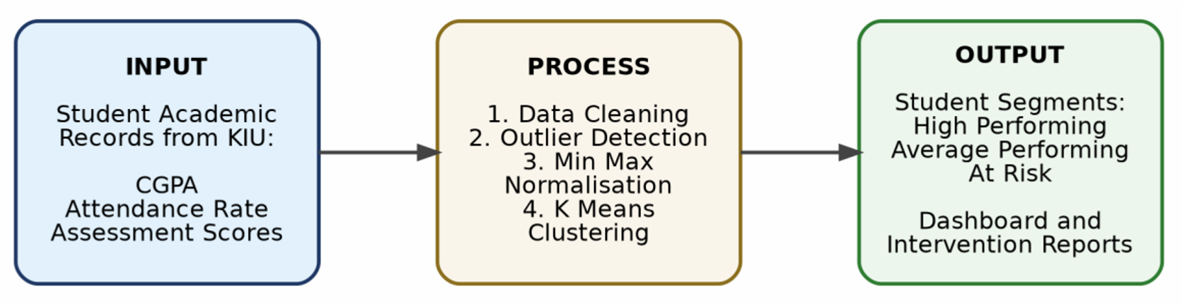
Figure 3.1: Input Process Output (IPO) Conceptual Framework
3.3 Data Collection, Variables and Preprocessing
The system accepts student academic data from two sources. Primary data consists of structured records from the Department of Computer Science at KIU, including semester examination scores, continuous assessment results and attendance registers maintained by course lecturers. A synthetic dataset constructed to reflect realistic Nigerian university performance distributions supplements primary data during prototype development, following accepted practice when institutional data access is subject to privacy constraints (Aggarwal, 2015). Three academic performance variables serve as clustering features, selected because they are readily available within institutional records and collectively capture long term academic achievement, classroom engagement and short term academic effort (Dutt, Aghabozrgi and Maizatul, 2015).

Variable | Scale | Source | Justification | Role in Model
Cumulative GPA (CGPA) | 0.00 to 5.00 | Academic records | Long term summative indicator of academic achievement | Clustering feature
Attendance Rate | 0.00 to 100.00% | Attendance registers | Classroom engagement and early predictor of academic difficulty (Marburger, 2001) | Clustering feature
Assessment Score | 0.00 to 100.00 | Course CA records | Short term academic effort independent of final examinations | Clustering feature
Student ID, Name, Level | String / Integer | Institutional records | Administrative identification only | Excluded from clustering
Table 3.1: Clustering Feature Variables
Raw institutional data requires preprocessing before clustering can be applied reliably. The system implements a four step pipeline. Step 1 (Data Cleaning) detects missing values across all three feature columns and flags duplicate Student ID entries, excluding incomplete records. Step 2 (Outlier Detection) applies the Interquartile Range method, flagging values below Q1 minus 1.5 times IQR or above Q3 plus 1.5 times IQR, since K Means is sensitive to extreme values that distort centroid positions (Jain, 2010). Step 3 (Min Max Normalization) rescales all features to the range zero to one using the formula: x normalized equals x minus x minimum divided by x maximum minus x minimum, preventing wider range variables from dominating Euclidean distance calculations (Witten, Frank and Hall, 2016). Step 4 (Size Validation) confirms the dataset contains at least thirty records before clustering is permitted to proceed.
3.3.1 Segmentation by Student Category: Returning and New Students
A closer look at the three clustering variables in Table 3.1 reveals a practical problem that only becomes apparent once real institutional data is considered. Cumulative GPA, as its name implies, is a measure that accumulates across multiple semesters of registered coursework. A student who has just been admitted into the university has no such history to draw on. Treating a new student's CGPA as zero, or substituting some arbitrary placeholder value, would not simply be a harmless gap in the data. It would actively mislead the clustering algorithm, since K Means has no way of knowing that a zero in this context means “not yet applicable” rather than “extremely poor academic performance.” New students would either be forced into the same low performing cluster as genuinely struggling returning students, or would distort the cluster boundaries for everyone else depending on how the placeholder value happened to fall relative to the rest of the distribution.
For this reason, the system implemented in this study does not apply a single clustering model uniformly across the entire student population. Instead, two separate K Means models are trained, each operating on the feature set that is actually available and meaningful for the category of student concerned.
The first model, referred to throughout this dissertation as the Returning Students model, is applied to students who have completed at least one prior semester and therefore possess an established CGPA. This model uses all three variables described in Table 3.1, namely CGPA, Attendance Rate and Assessment Score, consistent with the feature justification already given in that section.
The second model, referred to as the New Students model, is applied to students in their first semester at the institution. Since these students have no CGPA to contribute, this model is restricted to the two variables that are available from day one of enrolment, Attendance Rate and Assessment Score. Table 3.1(b) summarizes this distinction.

Model | Applies To | Clustering Features | Rationale
Returning Students  Model | Students with at least one completed semester | CGPA, Attendance  Rate, Assessment  Score | CGPA, Attendance  Rate, Assessment  Score
New Students  Model | Students in their first semester of enrolment | Attendance Rate,  Assessment Score | Classroom engagement and early predictor of academic difficulty (Marburger, 2001)
Table 3.1(b): Clustering Feature Sets by Student Category
Both models are otherwise identical in structure. Each passes through the same four step preprocessing pipeline described above, is fitted using K Means with K Means plus plus initialization and K set to three, and produces the same three performance categories of High Performing, Average Performing and At Risk. The two models are trained and evaluated entirely independently of one another, since pooling students with fundamentally different feature sets into a single clustering exercise would violate the basic requirement that all observations in a K Means run be described by the same variables. The administrator distinguishes between the two categories at the point of data upload, with each student record tagged according to whether the student is returning or newly admitted, a distinction stored in the Students table described in Section 3.7.

3.4 Analysis of the Existing System and Proposed System Responses
Academic performance monitoring at KIU is entirely manual. Lecturers submit paper score sheets each semester; departmental staff enter data into spreadsheets to compute GPA and CGPA; attendance registers are maintained separately and never cross referenced with performance data. Review by the Head of Department occurs only after results are finalized, meaning intervention consistently arrives after failure rather than before it. Table 3.2 maps each identified shortcoming to its institutional impact and the specific response provided by the proposed system.

Shortcoming | Impact | Proposed System Response
Attendance and academic data are never integrated | Relationships between variables remain unexamined | Single pipeline combines CGPA, attendance and assessment score for joint analysis
Monitoring is reactive; action occurs only after failure | Critical intervention window is consistently missed | Cluster based early warning identifies at risk students each semester before failure occurs
Manual data entry introduces transcription errors | CGPA miscalculations affect official transcripts | Automated CSV upload and programmatic computation eliminate manual entry errors
Process cannot scale with growing enrolment | Administrative burden increases with cohort size | System processes hundreds of records in seconds regardless of cohort size
No visual reporting of performance distributions | Administrators interpret raw tables with no trend visibility | Interactive dashboard with scatter, bar and radar chart visualizations
No automated segmentation for intervention planning | Grouping for support is subjective and inconsistent | K Means produces objective, reproducible cluster assignments with action flags
Table 3.2: Existing System Shortcomings and Proposed System Responses
3.5 System Architecture
The proposed system follows a three tier client server architecture comprising a Presentation Layer, an Application Logic Layer and a Data Layer. This architectural pattern is widely adopted in web based information systems for its modularity, maintainability and clear separation of concerns (Sommerville, 2016). Figure 3.2 presents the complete architecture showing all interface modules, backend components and data storage elements.
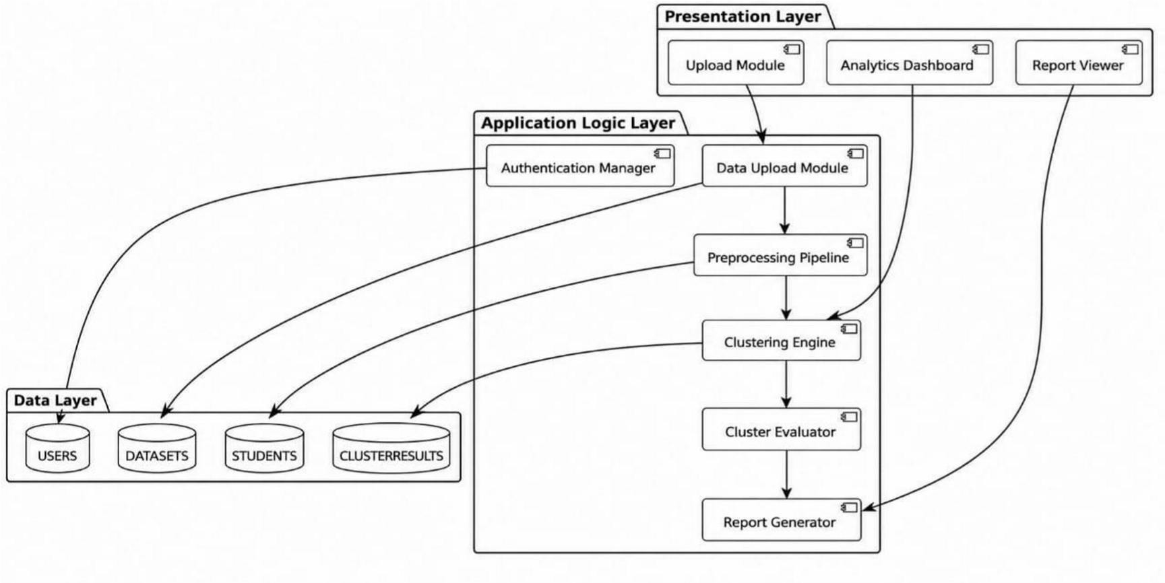
Figure 3.2: Three Tier System Architecture
The Presentation Layer is a browser based interface communicating with the backend exclusively through REST API calls. Three interface modules handle dataset upload, analytics dashboard visualization and report viewing respectively. The Application Logic Layer is implemented in Python using Flask and contains six modules: the Data Upload Module validates and ingests CSV files; the Preprocessing Pipeline applies the four step procedure described in Section 3.3; the Clustering Engine runs K Means using scikit learn with K Means plus initialization; the Cluster
Evaluator assigns performance labels based on centroid ranking; the Report Generator produces downloadable CSV output with action flags; and the Auth Manager implements bcrypt password hashing and role based access control (Grinberg, 2018; Pedregosa et al., 2011). The Data Layer uses SQLite during development for zero configuration setup, with a migration path to MySQL for production deployment, both managed through the SQL Alchemy Object Relational Mapper (Bayer, 2012).
3.6 Use Case Diagram, Data Flow Diagram and Entity Relationship Diagram
Figure 3.3 presents the UML use case diagram showing the Administrator actor and the seven use cases supported by the system.
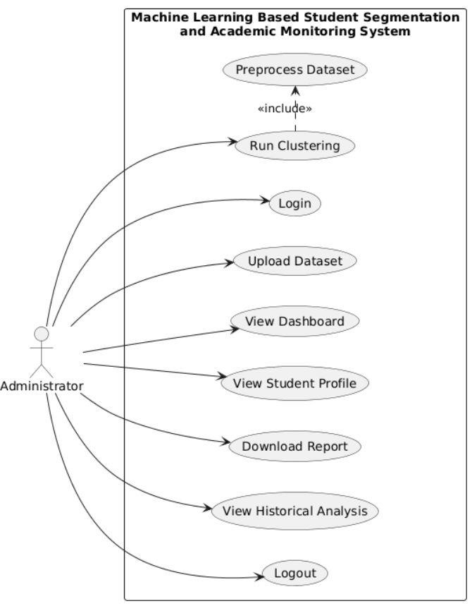
Figure 3.3: UML Use Case Diagram
Figure 3.4 presents the standard Level 1 Data Flow Diagram drawn using Gane and Sarson notation, illustrating how data moves through the system's four primary processes and two data stores.
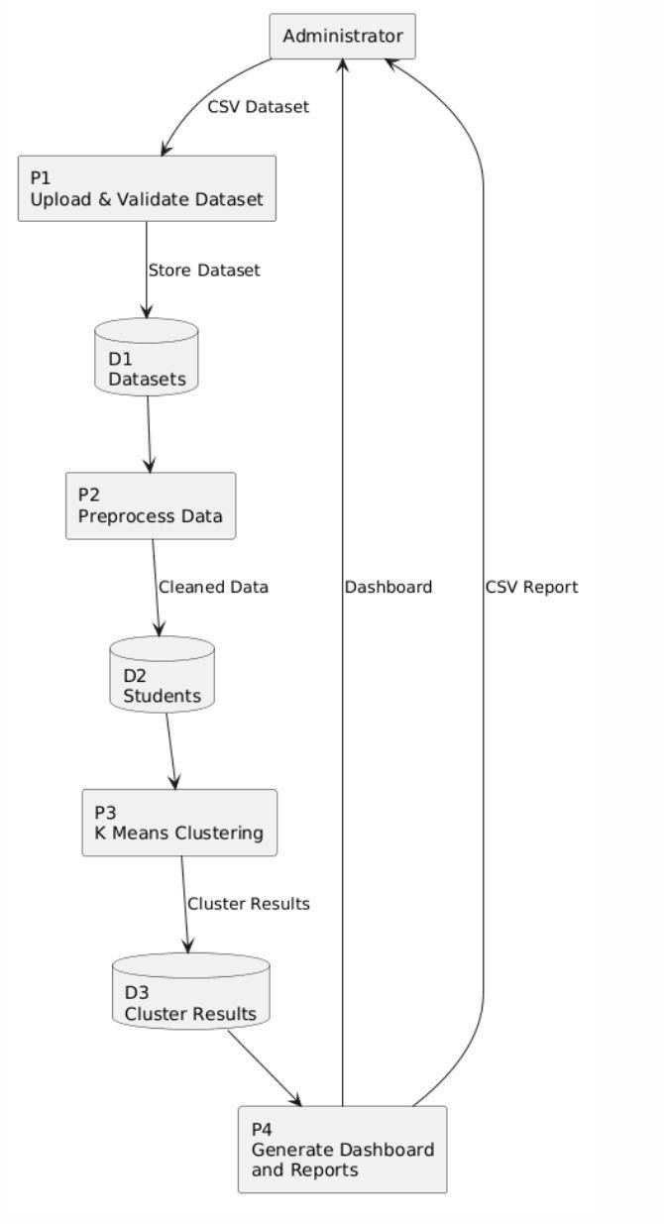
Figure 3.4: Level 1 Data Flow Diagram
Figure 3.5 presents the Entity Relationship Diagram showing the four database tables and their cardinality relationships.
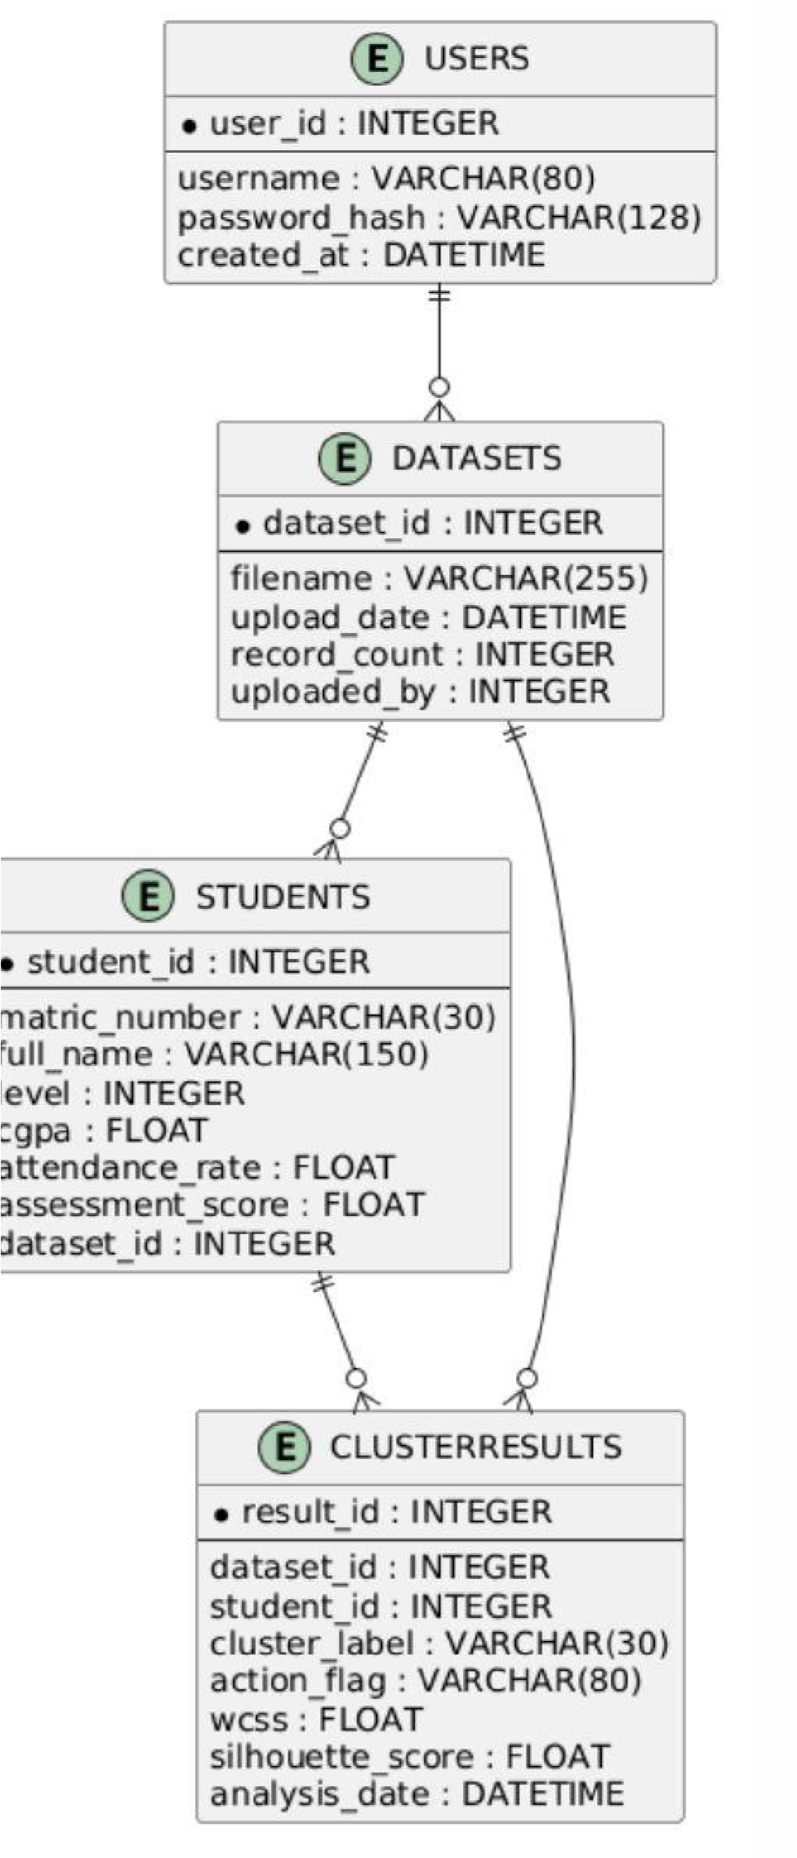
Figure 3.5: Entity Relationship Diagram

UC | Name | Precondition | Description
UC01 | Upload Dataset | Admin logged in; CSV file prepared | Admin selects a CSV file conforming to the expected schema. System validates structure, runs the preprocessing pipeline, displays a summary report and stores the dataset.
UC02 | Run Clustering | Validated dataset is available | Admin selects a stored dataset and initiates K Means clustering with K set to 3. System assigns cluster labels, computes WCSS and silhouette score and redirects to the dashboard.
UC03 | View Dashboard | Clustering analysis completed | Admin views scatter plots, bar charts, radar charts, Elbow and  Silhouette diagnostic plots  and cluster summary statistics. All chart elements are interactive.
UC04 | View Student Profile | Clustering analysis completed | Admin searches for a student by name or matric number to view individual feature values, cluster label and recommended action flag.
UC05 | Download Report | Clustering analysis completed | Admin downloads a CSV report containing all student cluster assignments and action flags for use in advisory meetings and departmental records.
Table 3.3: Primary Use Case Descriptions
3.7 Database Design
The relational database comprises four tables. A one to many relationship links Users to Datasets, Datasets to Students and Datasets to Cluster Results, enabling one dataset to be clustered multiple times and supporting longitudinal performance tracking across semesters, as shown in Figure 3.5. Table 3.4 presents the complete schema.

Table and Field | Data Type | Constraint | Description
USERS |  |  | Stores administrator account credentials
User_id | INTEGER | PK AUTO | Auto incremented primary key
Username | VARCHAR(80) | UNIQUE NN | Unique administrator login identifier
Passwordhash | VARCHAR(128) | NN | bcrypt hashed password; plain text is never stored
created | DATETIME | NN | Timestamp of account creation
DATASETS |  |  | Records each uploaded CSV file and metadata
dataset,id | INTEGER | PK AUTO | Auto incremented primary key
Filename | VARCHAR(255) | NN | Original uploaded filename
Upload_date | DATETIME | NN | Timestamp of the upload
Record_count | INTEGER | NN | Number of student records in the dataset
Uploaded_by | INTEGER | FK to Users | Administrator account that performed the upload
STUDENTS |  |  | Stores individual student academic records per dataset
Student_id | INTEGER | PK AUTO | Auto incremented primary key
Student_type | VARCHAR(20) | NN | Indicates whether the student is "Returning" or "New", determining which clustering model the record is routed to
Matric_number | VARCHAR(30) | NN | KIU institutional student identifier
Full_name | VARCHAR(150) | NN | Student full name
Level | INTEGER | NN | Academic level: 100, 200, 300or 400
Cgpa | FLOAT | 0.00 to 5.00 | Cumulative Grade Point Average
Attendance_rate | FLOAT | 0.00 to 100.00 | Semester attendance as a percentage
Assessment_score | FLOAT | 0.00 to 100.00 | Average continuous assessment score
Dataset_id | INTEGER | FK to Datasets | Dataset this student record belongs to
CLUSTERRESULTS |  |  | Stores clustering output per student per analysis run
result,id | INTEGER | PK AUTO | Auto incremented primary key
Dataset_id | INTEGER | FK to Datasets | Dataset analyzed in this run
Student_id | INTEGER | FK to Students | Student this result belongs to
Cluster_label | VARCHAR(30) | NN | High Performing,  Average Performing or At  Risk
Action_flag | VARCHAR(80) | NN | Recommended  institutional response for this student
Wcss | FLOAT |  | Within Cluster Sum of Squares for this run
Silhouette_score | FLOAT |  | Average silhouette score for this run
Analysis_date | DATETIME | NN | Timestamp of the clustering run
Table 3.4: Database Schema
One addition to the STUDENTS table deserves separate mention. Because the system trains two distinct clustering models depending on whether a student is returning or newly admitted, as described in Section 3.3.1, the database needs a way of recording which category each student falls into at the point of data entry. A student_type field is therefore included in the STUDENTS table, storing either "Returning" or "New" for each record. This field is populated automatically during the CSV upload and validation stage, drawing on whichever column the administrator's dataset provides for level or admission status, and is used downstream by the Clustering Engine to route each record to the correct model before any preprocessing begins. Without this field, the system would have no principled way of deciding which of the two models should process a given student, and the safeguard against feeding an incomplete CGPA value into the Returning Students model, discussed in Section 3.3.1, would not be enforceable at the data layer.

3.8 K Means Algorithm Implementation
The Clustering Engine implements K Means using scikit learn's KMeans class configured with K Means plus initialization, n init set to 10 independent runs and max iter set to 300, retaining the solution with the lowest WCSS across all runs (Pedregosa et al., 2011; Aggarwal, 2015). The algorithm receives the Min Max normalized feature matrix and minimizes the objective function: J equals the sum over K clusters of the sum over all points xi in cluster Ck of the squared Euclidean distance between xi and the cluster centroid mu sub k. Figure 3.6 presents the complete algorithm flowchart.
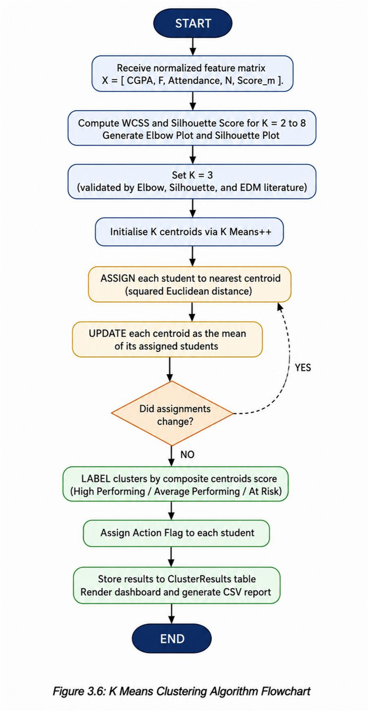
3.8.1 Model Evaluation Strategy: Train Test Validation
A recurring question in unsupervised learning is how a clustering model can be evaluated at all, since there are no preexisting labels against which predictions can be checked for accuracy in the way a supervised classifier would be tested. This does not mean the model escapes evaluation altogether. What can and should be tested is whether the clusters a model discovers on one portion of the data continue to hold up when the model is confronted with records it has never seen. If the structure the algorithm finds is genuine and not simply an artefact of the particular sample it was trained on, then new records should fall into similarly well formed clusters when assigned using the same centroids.
To test this, both the Returning Students model and the New Students model in this study follow a train test split, with eighty percent of each cleaned dataset used for training and the remaining twenty percent held back entirely during training. The split is performed after outlier removal but before normalization, and the Min Max scaler itself is fitted only on the training portion, since allowing information from the test set to influence the scaling would quietly leak knowledge of unseen data back into the model and overstate how well it generalizes (Witten, Frank and Hall, 2016).
K Means is then trained on the eighty percent training set in the usual way described in Section 3.8, using K Means plus initialization with K set to three. The resulting centroids are treated as fixed. Each record in the twenty percent test set is then assigned to whichever of these three centroids it lies closest to, without any retraining or adjustment of the centroids themselves. Two diagnostics are computed for both the training set and the test set separately, the Within Cluster Sum of Squares and the average Silhouette Score. If these two figures remain close between the training and test sets, this is taken as evidence that the clustering structure is stable and not merely memorized noise specific to the training sample. A sharp deterioration in test set performance, by contrast, would indicate that the model had over fit to the training data and could not be trusted to classify new students reliably each semester.
This evaluation is carried out independently for each of the two models, since the Returning Students model and the New Students model operate on different feature sets and populations and therefore need to be validated on their own terms rather than pooled together.

3.9 Tools, Technologies and System Requirements

Category | Technology |  | Version | Justification and Role
SOFTWARE
Backend Language | Python | 3.11+ |  | Dominant language in data science with an extensive machine  learning library ecosystem (Pedregosa et al., 2011)
Web Framework | Flask | 3.0+ |  | Lightweight Python framework suited to REST API development with machine learning

 |  |  | backends (Grinberg, 2018)
ML Library | scikit learn | 1.4+ | Industry st andard library providing optimised K Means plus plus implementation with silhouette scoring
Data Processing | Pandas and NumPy | 2.0 and 1.26 | St andard Python libraries for CSV parsing, tabular manipulation and numerical computation  (McKinney, 2010)
Database | SQLite and MySQL | 3.x and 8.x | SQLite for development; MySQL for production; both managed via SQL Alchemy ORM (Bayer,  2012)
Frontend | Bootstrap 5 and Chart.js | 5.3 and 4.4 | Bootstrap for responsive layout; Chart.js for interactive scatter, bar and radar charts
Version Control | Git and GitHub | 2.40+ | Source code management, change tracking and cloud backup
HARDWARE | Minimum |  | Recommended
Processor | Intel Core i3 at 2.0 GHz |  | Intel Core i5 or AMD  Ryzen 5 at 2.4 GHz or better
RAM | 4 GB |  | 8 GB or more
Storage | 50 GB HDD |  | 100 GB SSD
Browser | Any modern browser |  | Google Chrome 110 or Mozilla Firefox 110 or  later
Table 3.5: Tools, Technologies and System Requirements

3.10 System Testing Strategy
System testing will be conducted across four levels to verify that the implemented system satisfies its functional and nonfunctional requirements (Sommerville, 2016). Table 3.6 summarizes the planned testing approach, scope and acceptance criteria at each level.

Level | Scope | Method and Tool | Acceptance Criterion
Unit Testing | Individual backend modules: Upload, Preprocessing Pipeline,  Clustering Engine,  Cluster Evaluator, Report  Generator | Python unittest framework applied to normal inputs and edge cases | All modules pass expected output tests; WCSS decreases monotonically as K increases
Integration Testing | End to end pipeline from CSV upload through preprocessing, clustering and dashboard rendering | Flask test client for programmatic API endpoint calls without a live server | Correct data transmission across all modules; charts render accurate cluster data
System Testing | All use cases in Table 3.3 and performance benchmarks for datasets of 50, 100, 250 and 500 records | Manual functional testing  and automated performance timing  scripts | All use cases execute without error; clustering of 500 records will complete in under ten  seconds
User Acceptance Testing | System will be evaluated by academic administrators at KIU performing realistic operational tasks | System Usability Scale questionnaire (Brooke, 1996) administered after task completion | An average SUS score of  70 or above, the  established threshold for Good usability, will constitute acceptance
Table 3.6: System Testing Strategy
3.11 Ethical Considerations
The research involves student academic data, which constitutes personally identifiable information requiring appropriate safeguards. Four ethical principles govern the study. First, data anonymisation: all real student records used in prototype development are anonymised by replacing names with pseudonyms and matriculation numbers with synthetic identifiers and no real student data appears in any figure, table or report in this dissertation. Second, data confidentiality: student data is used solely for the purposes of this research and is not shared with or disclosed to any third party. Third, data security: the system implements bcrypt password hashing, session based authentication and role based access control, ensuring that database records are accessible only to authorized administrators. Fourth, nondiscriminatory application: cluster labels are analytical tools intended to guide the allocation of academic support resources and are not permanent judgments of student ability; system documentation explicitly advises administrators that cluster membership must be interpreted alongside contextual information and must not be communicated to students as definitive academic assessments. These principles are consistent with the Nigerian Data Protection Act (NDPA, 2023) and the ethical standards recommended by the Association for Educational Communications and Technology (AECT, 2016).
3.12 Chapter Summary
This chapter has presented the full methodology underpinning the design and implementation of the machine learning based student segmentation and academic monitoring system at KIU. The Waterfall SDLC model governs the development process and the IPO conceptual framework organizes the study's analytical activities into clearly defined input, process and output stages. A systematic analysis of the existing manual monitoring system identified six specific shortcomings, each directly addressed by the proposed system. The three tier architecture, six backend modules, UML use case diagram, standard Level 1 DFD, ER diagram and complete database schema were all documented with supporting figures and tables. The K Means implementation was described with its objective function formula and a detailed algorithmic flowchart. Technology selections were justified, system requirements were specified, a four level testing strategy with future tense acceptance criteria was defined and ethical safeguards consistent with the NDPA (2023) were articulated. Chapter Four will present the results of the system implementation, including cluster analysis outputs, dashboard visualizations, evaluation metrics and user acceptance testing findings.

REFERENCES
Adeyemi, T. O., & Adeyemi, O. S. (2014). Information and communication technology and administration of universities in Nigeria. International Journal of Educational Administration and Policy Studies, 6(3), 34–45. https://doi.org/10.5897/IJEAPS2013.0333
Aggarwal, C. C. (2015). Data mining: The textbook. Springer. https://doi.org/10.1007/978,3,319,14142,8
Baker, R. S., & Yacef, K. (2009). The state of educational data mining in 2009: A review and future visions.
Journal of Educational Data Mining, 1(1), 3–17.
Bishop, C. M. (2006). Pattern recognition and machine learning. Springer.
Bydžovská, H. (2016). A comparative analysis of techniques for predicting student performance. In
Proceedings of the 9th International Conference on Educational Data Mining (EDM 2016) (pp. 306–311). International Educational Data Mining Society.
Dutt, A., Aghabozrgi, S., & Maizatul, A. B. I. (2015). Clustering algorithms applied in educational data mining. International Journal of Information and Electronics Engineering, 5(2), 112–116.
https://doi.org/10.7763/IJIEE.2015.V5.513
Few, S. (2006). Information dashboard design: The effective visual communication of data. O'Reilly Media. Han, J., Kamber, M., & Pei, J. (2012). Data mining: Concepts and techniques (3rd ed.). Morgan Kaufmann.
Jain, A. K. (2010). Data clustering: 50 years beyond K means. Pattern Recognition Letters, 31(8), 651– 666. https://doi.org/10.1016/j.patrec.2009.09.011
Kotsiantis, S. B., Pierrakeas, C. J., & Pintelas, P. E. (2010). Predicting students' performance in distance learning using machine learning techniques. Applied Artificial Intelligence, 18(5), 411–426. https://doi.org/10.1080/08839510490442058
Kovacic, Z. J. (2010). Early prediction of student success: Mining students' enrolment data. In Proceedings of the Informing Science and IT Education Conference (InSITE 2010) (pp. 647–665). Informing Science Institute.
Lloyd, S. P. (1982). Least squares quantization in PCM. IEEE Transactions on Information Theory, 28(2), 129–137. https://doi.org/10.1109/TIT.1982.1056489
MacQueen, J. B. (1967). Some methods for classification and analysis of multivariate observations. In L. M. Le Cam & J. Neyman (Eds.), Proceedings of the 5th Berkeley Symposium on Mathematical Statistics and Probability (Vol. 1, pp. 281–297). University of California Press.
Mitchell, T. M. (1997). Machine learning. McGraw,Hill.
National Universities Commission (NUC). (2022). NUC annual statistical digest. Federal Republic of Nigeria. https://www.nuc.edu.ng
Nworie, J. (2012). Using the Delphi technique in educational technology research. TechTrends, 55(5), 24–
30.
Pena,Ayala, A. (2014). Educational data mining: A survey and a data mining based analysis of recent works. Expert Systems with Applications, 41(4), 1432–1462. https://doi.org/10.1016/j.eswa.2013.08.042
Romero, C., & Ventura, S. (2010). Educational data mining: A review of the state of the art. IEEE Transactions on Systems, Man and Cybernetics Part C: Applications and Reviews, 40(6), 601–618.
https://doi.org/10.1109/TSMCC.2010.2053532
Russell, S., & Norvig, P. (2016). Artificial intelligence: A modern approach (3rd ed.). Pearson Education.
Witten, I. H., Frank, E., & Hall, M. A. (2016). Data mining: Practical machine learning tools and techniques (4th ed.). Morgan Kaufmann.
Adeyemi, T. O., & Adeyemi, O. S. (2014). Information and communication technology and administration of universities in Nigeria. International Journal of Educational Administration and Policy Studies, 6(3), 34–45.
Afolabi, I. T., Gbadamosi, B., Oyelaran, O. A., Arowolo, M. O., & Arowolo, T. E. (2019). Predicting students' academic performance using decision tree. International Journal of Scientific and Engineering Research, 10(2), 149–153.
Arthur, D., & Vassilvitskii, S. (2007). K means++: The advantages of careful seeding. In Proceedings of the 18th Annual ACM SIAM Symposium on Discrete Algorithms (pp. 1027–1035). SIAM.
Bakar, Z. A., Rosbi, S., & Hamid, H. A. (2015). Segmentation of student academic performance using K means clustering for higher educational institutions. Journal of Advanced Research in Dynamical and Control Systems, 7(4), 1–14.
Baker, R. S., & Yacef, K. (2009). The state of educational data mining in 2009: A review and future visions. Journal of Educational Data Mining, 1(1), 3–17.
Bishop, C. M. (2006). Pattern recognition and machine learning. Springer.
Bydžovská, H. (2016). A comparative analysis of techniques for predicting student performance. In Proceedings of the 9th International Conference on Educational Data Mining (pp. 306–311).
International Educational Data Mining Society.
Dutt, A., Aghabozrgi, S., & Maizatul, A. B. I. (2015). Clustering algorithms applied in educational data mining. International Journal of Information and Electronics Engineering, 5(2), 112–116.
Ester, M., Kriegel, H.,P., S ander, J., & Xu, X. (1996). A density,based algorithm for discovering clusters in large spatial databases with noise. In Proceedings of the 2nd ACM SIGKDD International Conference on Knowledge Discovery and Data Mining (pp. 226–231). AAAI Press.
Eze, S. C., Chinedu,Eze, V. C., Bello, A. O., & Inegbedion, H. (2018). Exploratory evaluation of the challenges of e learning in Nigerian universities. Journal of Engineering and Applied Sciences, 13(1), 111–120.
Gatherer, D., & Manning, F. C. (1998). Correlation of examination performance with attendance: A study of a first,year life sciences course. Biochemical Education, 26(2), 121–123.
Han, J., Kamber, M., & Pei, J. (2012). Data mining: Concepts and techniques (3rd ed.). Morgan Kaufmann.
Huang, S., & Fang, N. (2013). Predicting student academic performance in an engineering dynamics course: A comparison of four types of predictive mathematical models. Computers and Education, 61, 133–145.
Jain, A. K. (2010). Data clustering: 50 years beyond K means. Pattern Recognition Letters, 31(8), 651– 666.
Kaufman, L., & Rousseeuw, P. J. (1987). Clustering by means of medoids. In Y. Dodge (Ed.), Statistical Data Analysis Based on the L1 Norm and Related Methods (pp. 405–416). North Holl and.
Kemper, L., Vorhies, G., & Martens, A. (2020). Predicting student dropout: A machine learning approach. European Journal of Higher Education IT, 7(1), 1–17.
Ketchen, D. J., & Shook, C. L. (1996). The application of cluster analysis in strategic management research. Strategic Management Journal, 17(6), 441–458.
Kotsiantis, S. B., Pierrakeas, C. J., & Pintelas, P. E. (2010). Predicting students' performance in distance learning using machine learning techniques. Applied Artificial Intelligence, 18(5), 411–426.
Kovacic, Z. J. (2010). Early prediction of student success: Mining students' enrolment data. In Proceedings of the Informing Science and IT Education Conference (pp. 647–665). Informing Science Institute. LeCun, Y., Bengio, Y., & Hinton, G. (2015). Deep learning. Nature, 521(7553), 436–444.
Lloyd, S. P. (1982). Least squares quantization in PCM. IEEE Transactions on Information Theory, 28(2), 129–137.
MacQueen, J. B. (1967). Some methods for classification and analysis of multivariate observations. In Proceedings of the 5th Berkeley Symposium on Mathematical Statistics and Probability (Vol. 1, pp.
281–297). University of California Press.
Marburger, D. R. (2001). Absenteeism and undergraduate exam performance. Journal of Economic Education, 32(2), 99–109.
Mitchell, T. M. (1997). Machine learning. McGraw Hill.
Olaleye, F. O. (2016). Technology,enhanced academic records management in Nigerian universities. African Journal of Library, Archives and Information Science, 26(2), 113–122.
Olawale, B. E., Alabi, O., & Ayo, C. K. (2021). Development of an automated student academic performance monitoring system for Nigerian polytechnics. Journal of Information Technology and Digital World, 3(2), 89–102.
Pal, A. K., & Pal, S. (2013). Analysis and mining of educational data for predicting the performance of students. International Journal of Electronics Communication and Computer Engineering, 4(5), 1560–1565.
Pedregosa, F., Varoquaux, G., Gramfort, A., Michel, V., Thirion, B., Grisel, O., Blondel, M., Prettenhofer, P., Weiss, R., Dubourg, V., V anderplas, J., Passos, A., Cournapeau, D., Brucher, M., Perrot, M., & Duchesnay, E. (2011). Scikit,learn: Machine learning in Python. Journal of Machine Learning Research, 12, 2825–2830.
Pena,Ayala, A. (2014). Educational data mining: A survey and a data mining based analysis of recent works. Expert Systems with Applications, 41(4), 1432–1462.
Romero, C., & Ventura, S. (2010). Educational data mining: A review of the state of the art. IEEE Transactions on Systems, Man and Cybernetics,Part C, 40(6), 601–618.
Rousseeuw, P. J. (1987). Silhouettes: A graphical aid to the interpretation and validation of cluster analysis. Journal of Computational and Applied Mathematics, 20, 53–65.
Russell, S., & Norvig, P. (2016). Artificial intelligence: A modern approach (3rd ed.). Pearson Education.
Stinebrickner, R., & Stinebrickner, T. (2014). Academic performance and college dropout: Using longitudinal expectations data to estimate a learning model. Journal of Labor Economics, 32(3), 601–644.
Tibshirani, R., Walther, G., & Hastie, T. (2001). Estimating the number of clusters in a data set via the gap statistic. Journal of the Royal Statistical Society: Series B, 63(2), 411–423.
Witten, I. H., Frank, E., & Hall, M. A. (2016). Data mining: Practical machine learning tools and techniques (4th ed.). Morgan Kaufmann.
York, T. T., Gibson, C., & Rankin, S. (2015). Defining and measuring academic success. Practical Assessment, Research and Evaluation, 20(5), 1–20.
AECT. (2016). Code of ethics. Association for Educational Communications and Technology. https://aect.org/ethics.php
Aggarwal, C. C. (2015). Data mining: The textbook. Springer.
Arthur, D. and Vassilvitskii, S. (2007). K means++: The advantages of careful seeding. In Proceedings of the 18th Annual ACM SIAM Symposium on Discrete Algorithms (pp. 1027 to 1035). SIAM.
Bayer, M. (2012). SQLAlchemy. In A. Brown and G. Wilson (Eds.), The Architecture of Open Source Applications (Vol. 2). aosabook.org.
Brooke, J. (1996). SUS: A quick and dirty usability scale. In P. W. Jordan et al. (Eds.), Usability Evaluation in Industry (pp. 189 to 194). Taylor and Francis.
Chart.js. (2023). Chart.js documentation. https://www.chartjs.org/docs/latest/
Dutt, A., Aghabozrgi, S. and Maizatul, A. B. I. (2015). Clustering algorithms applied in educational data mining. International Journal of Information and Electronics Engineering, 5(2), 112 to 116.
Grinberg, M. (2018). Flask web development: Developing web applications with Python (2nd ed.). O'Reilly Media.
Han, J., Kamber, M. and Pei, J. (2012). Data mining: Concepts and techniques (3rd ed.). Morgan Kaufmann.
Jain, A. K. (2010). Data clustering: 50 years beyond K means. Pattern Recognition Letters, 31(8), 651 to 666.
Marburger, D. R. (2001). Absenteeism and undergraduate exam performance. Journal of Economic Education, 32(2), 99 to 109.
McKinney, W. (2010). Data structures for statistical computing in Python. In Proceedings of the 9th Python in Science Conference (pp. 56 to 61).
Nigerian Data Protection Act (NDPA). (2023). Federal Republic of Nigeria Official Gazette, 110(154).
https://ndpc.gov.ng
Oates, B. J. (2006). Researching information systems and computing. SAGE Publications.
Pedregosa, F., Varoquaux, G., Gramfort, A., Michel, V., Thirion, B., Grisel, O., Blondel, M., Prettenhofer, P., Weiss, R., Dubourg, V., V anderplas, J., Passos, A., Cournapeau, D., Brucher, M., Perrot, M. and Duchesnay, E. (2011). Scikit learn: Machine learning in Python. Journal of Machine Learning Research, 12, 2825 to 2830.
Pressman, R. S. and Maxim, B. R. (2015). Software engineering: A practitioner's approach (8th ed.). McGraw Hill Education.
Provos, N. and Mazieres, D. (1999). A future adaptable password scheme. In Proceedings of the USENIX Annual Technical Conference (pp. 81 to 91). USENIX Association.
Rousseeuw, P. J. (1987). Silhouettes: A graphical aid to the interpretation and validation of cluster analysis. Journal of Computational and Applied Mathematics, 20, 53 to 65.
Sommerville, I. (2016). Software engineering (10th ed.). Pearson Education.
Witten, I. H., Frank, E. and Hall, M. A. (2016). Data mining: Practical machine learning tools and techniques (4th ed.). Morgan Kaufmann.
Yin, R. K. (2018). Case study research and applications: Design and methods (6th ed.). SAGE Publications.

