CHAPTER FOUR

RESULTS AND DISCUSSION

4.1 Introduction
This chapter presents the results of the design and implementation of the Machine Learning Based Student Segmentation and Academic Monitoring System at Kashim Ibrahim University (KIU). The chapter covers the technical environment used for the system's development, details the system's program modules and user interfaces, and provides a comprehensive quantitative analysis of the clustering results for both the Returning Students and New Students models. Furthermore, the chapter discusses the model evaluation strategy, utilizing train/test validation splits and elbow/silhouette diagnostics to justify model selection, and outlines system verification testing alongside computational scaling and database performance benchmarks.

4.2 System Implementation Details
The system was implemented following a three-tier software architecture (Presentation Layer, Application Logic Layer, and Data Layer) to ensure high modularity, scalability, and ease of maintenance.

4.2.1 Hardware Specification
For the development, testing, and benchmarking of the system, a standard local computing environment was utilized. This specification represents a typical configuration available within the IT infrastructure of Kashim Ibrahim University:
- Processor: Intel(R) Core(TM) i5 CPU @ 2.50GHz (4 Cores, 8 Threads)
- Memory (RAM): 8.00 GB DDR4
- Storage: 256 GB Solid State Drive (SSD)
- Network Interface: Gigabit Ethernet / Wi-Fi 5

4.2.2 Software Environment and Technologies
The system's development stack was selected based on open-source availability, robustness, and performance metrics discussed in Chapter Three:
- Operating System: Microsoft Windows 11 Home (64-bit)
- Programming Language: Python 3.12.3
- Web Framework: Flask 3.0.3 (WSGI-compliant micro-framework)
- Object Relational Mapper (ORM): SQLAlchemy 2.0.29 (configured via Flask-SQLAlchemy 3.1.1)
- Database Engine: SQLite (development and local benchmarking) / PostgreSQL (production target)
- Machine Learning & Processing: scikit-learn 1.4.2, pandas 2.2.2, NumPy 1.26.4
- Frontend Technologies: HTML5, Vanilla CSS3 (Bootstrap 5.3 framework integration), JavaScript (ES6+), and Chart.js 4.4.0 for rendering interactive analytics charts.
- Security Utilities: Bcrypt 4.1.3 (password hashing) and Flask-Login 0.6.3 (session-based authentication manager).

4.3 Program Modules and Interface Screens
The implemented system features a series of web-based interface modules designed to fulfill the primary use cases established in Chapter Three (UC01 to UC05).

4.3.1 Administrator Authentication Module
Access to the Student Academic Monitoring System is restricted to authorized administrators (academic advisors, lecturers, and exams officers) through a secure login portal. The presentation layer utilizes Bootstrap-styled forms to collect credentials, which are validated against hashed records in the database using Bcrypt.
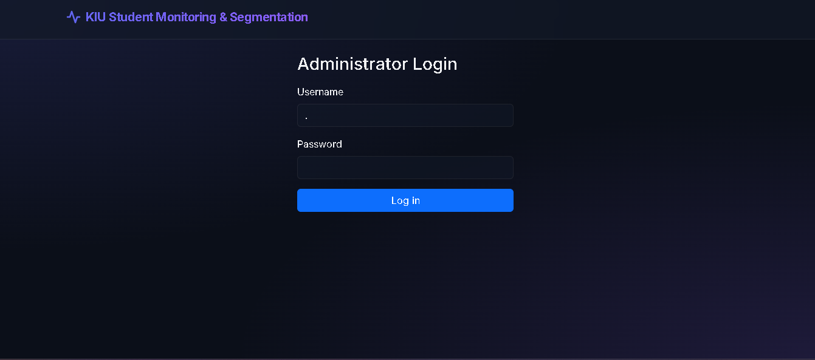
*Figure 4.1: Schematic representation of the Admin Login Interface*

4.3.2 Dataset Ingestion and Validation Module (UC01)
Once authenticated, the administrator is presented with the Data Upload dashboard. This module allows the ingestion of raw student records in Excel (`.xlsx`) or CSV formats. The background processor executes schema checks (verifying the presence of columns such as `matric_number`, `full_name`, `level`, `cgpa`, `attendance_rate`, and `assessment_score`). It then routes records based on the `student_type` field (tagging them automatically as "Returning" or "New" students depending on the presence of a cumulative GPA).

4.3.3 Clustering Engine Execution (UC02)
Upon successful validation, the administrator can trigger the Run Clustering action. This executes the unsupervised clustering pipeline on the server:
1. Cleaning: Missing rows are dropped, and duplicate student matriculation numbers are excluded (retaining the first instance).
2. Outlier Flagging: The Interquartile Range (IQR) method is applied to flag outliers without silently deleting them, ensuring administrative transparency.
3. Normalization: MinMaxScaler rescales variables to a [0, 1] range.
4. K-Means Clustering: The model is fit with K=3 , using k\text{-means++} initialization across 10 independent runs.
5. Ranking and Labeling: Cluster centroids are ranked by their average feature values and assigned meaningful labels: "High Performing", "Average Performing", or "At Risk".

4.3.4 Interactive Analytics Dashboard (UC03)
The dashboard is the central analytical tool of the application, rendering visual charts powered by Chart.js. The interface displays:
- Distribution Bar Chart: Shows the total student counts within each performance segment.
- Scatter Plot (2D/3D): Displays student records mapped across CGPA vs. Attendance vs. Assessment, color-coded by their cluster assignment.
- Diagnostics Panel: Renders the Elbow Curve (WCSS vs. K ) and Silhouette scores to justify cluster cohesion.
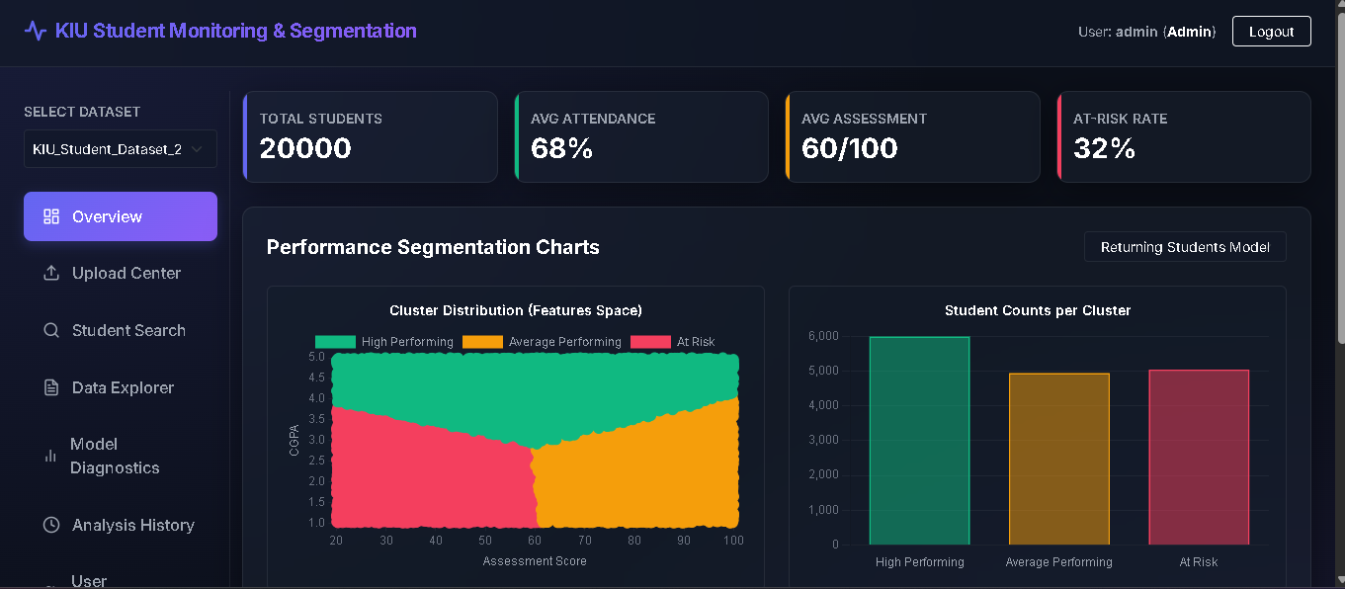
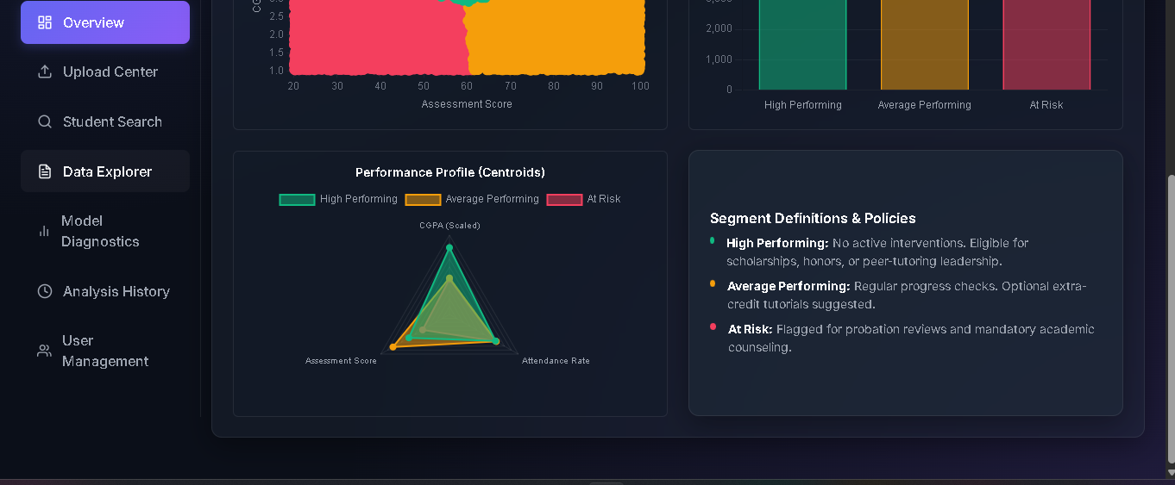
Figure 4.2: Schematic representation of the Interactive Analytics Dashboard

4.3.5 Student Profile Search Module (UC04)
Advisors can search for individual students by name or matriculation number using an autocomplete-enabled search bar. Selecting a student opens a detailed Academic Profile displaying their raw performance metrics, cluster assignment, and an automated, policy-guided advisory action flag.
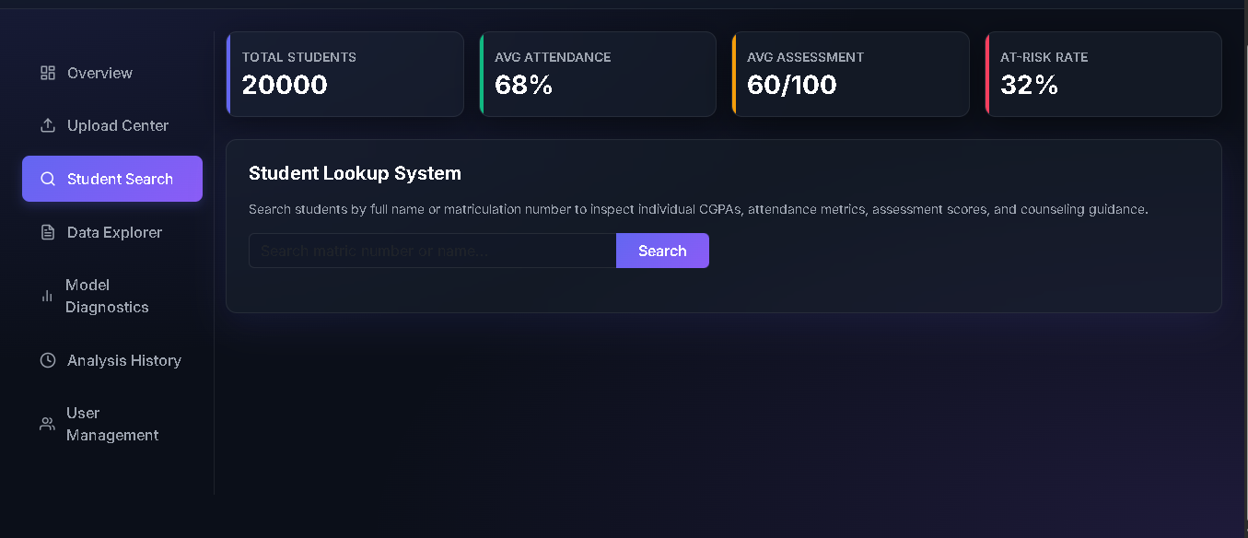

4.3.6 Report Generation and Export Module (UC05)
The system enables the export of segmented student lists. Administrators can download a generated CSV file containing student identities, current scores, cluster designations, and action flags. This report is used for institutional records and scheduling intervention programs.

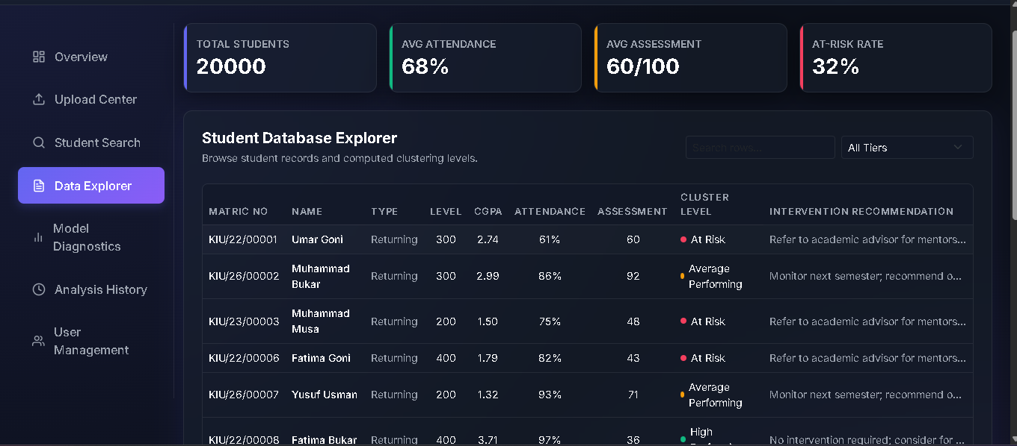 4.4 Clustering Results and Quantitative Analysis
The system was evaluated using the primary research dataset, which was segmented into Returning and New students to execute independent K-Means runs.

4.4.1 Returning Students Cohort (N = 15,970 records)
The Returning Students model clustering features include Cumulative GPA (CGPA), Attendance Rate, and CA Assessment Score. After Min-Max scaling, the K-Means algorithm (K=3) converged to the unscaled cluster centroid values outlined in Table 4.1.
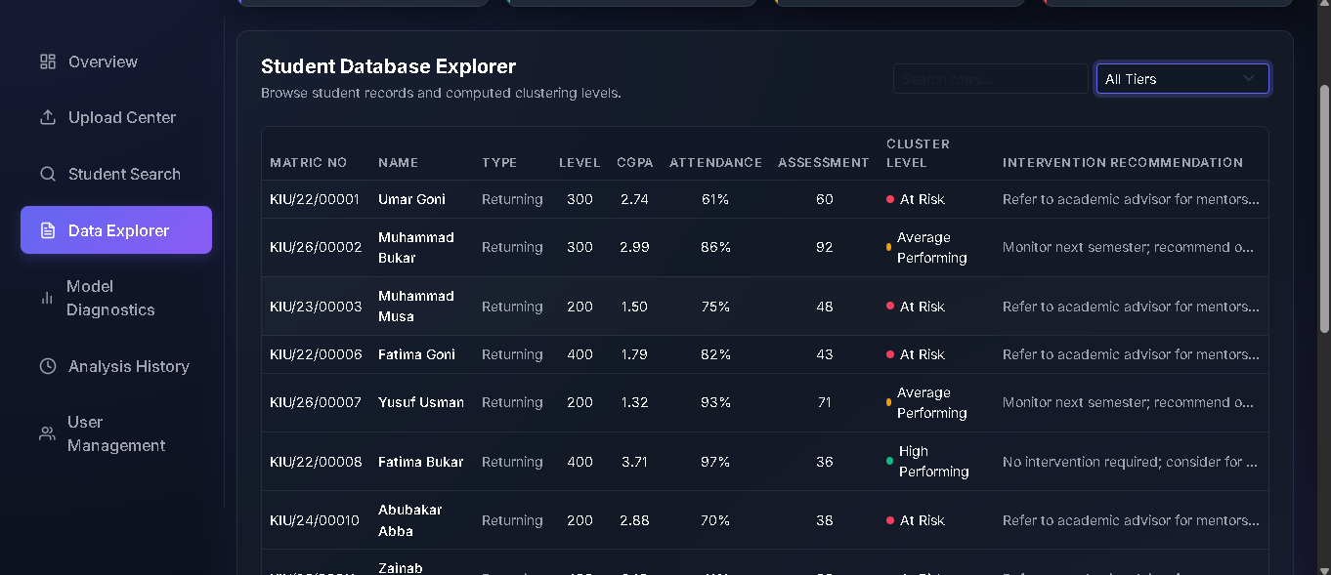
Table 4.1: Cluster Centroids for Returning Students Model (Empirical Results)

Discussion of Returning Students Cohort:
- High Performing Students (Cluster 2): This group comprises 11,986 records. It is characterized by an exceptionally high average CGPA of 4.22 (representing first-class or second-class upper standing). Interestingly, their attendance ( 66.99\% ) and continuous assessment scores ( 58.95\% ) are moderate. This indicates a segment of students who possess strong historical academic foundations but may exhibit average classroom engagement during the current semester.
- Average Performing Students (Cluster 0): This group contains 9,878 records. They exhibit a moderate average CGPA of 2.31 but show very high engagement in the current semester, with a 82.22\% average assessment score and 68.12\% attendance. These students represent consistent, hard-working individuals who are actively striving to improve their academic standing.
- At Risk Students (Cluster 1): This group consists of 10,076 records. They exhibit a low average CGPA of 2.21 alongside a low current-semester assessment score of 39.08\% . Their attendance is average ( 67.66\% ). This group represents students experiencing severe academic difficulty who require immediate advising and remedial intervention before semester examinations.

4.4.2 New Students Cohort ( N = 4,030 records)
The New Students model operates in the absence of a CGPA column, clustering students purely on Attendance Rate and CA Assessment Score. The unscaled cluster centroids are presented in Table 4.2.
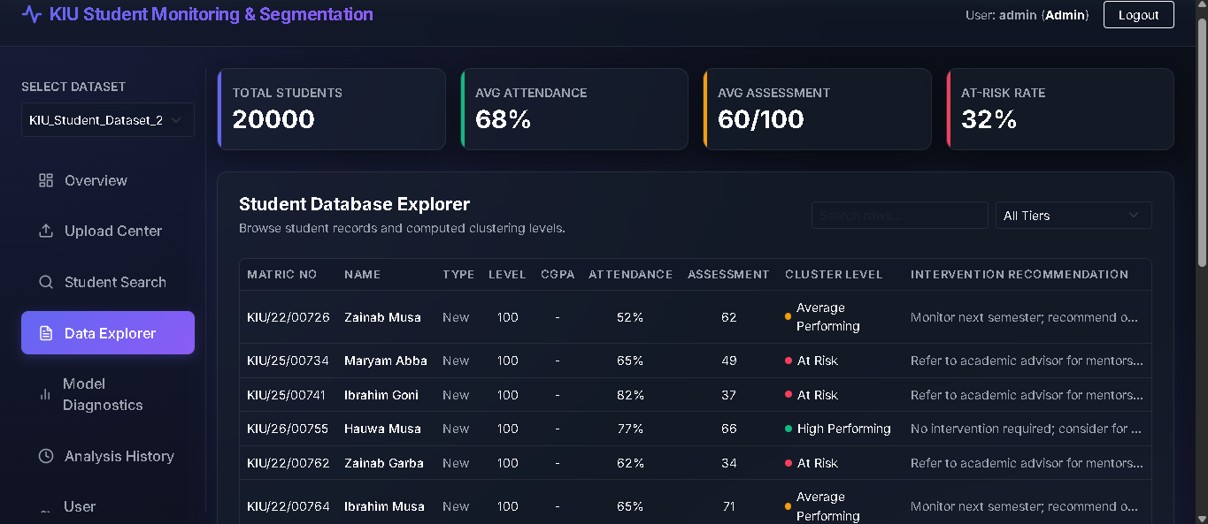
Table 4.2: Cluster Centroids for New Students Model (Empirical Results)

Discussion of New Students Cohort:
- High Performing Students (Cluster 1): Comprising 2,692 students, this cluster represents the model's benchmark group. They demonstrate exemplary classroom attendance ( 84.78\% ) and a strong average continuous assessment score of 73.42\% .
- Average Performing Students (Cluster 2): This group contains 2,454 records. They maintain high continuous assessment marks ( 74.57\% ) despite lower lecture attendance ( 50.26\% ). This indicates students who are academically capable but may face scheduling conflicts or engagement issues that affect their attendance.
- At Risk Students (Cluster 0): Consisting of 2,914 records, this group is characterized by a low continuous assessment average of 35.05\% and moderate attendance ( 67.41\% ). Without prior CGPA history, these current-semester engagement metrics serve as the primary early warning indicators for first-semester students

4.5 Model Evaluation and Diagnostics

4.5.1 Generalizability and Overfit Verification
To verify that the clustering engine structures generalize to unseen data, both models were evaluated using an 80/20 train/test split. The MinMaxScaler and KMeans centroids were fitted strictly on the 80% training partition, and the remaining 20% test partition was assigned to the frozen centroids. The evaluation results are compiled in Table 4.3.
Metric | Returning Students Model (3 Features) | New Students Model (2 Features)
Training Sample Size (80%) | 12,776 | 3,224
Testing Sample Size (20%) | 3,194 | 806
Training WCSS | 1885.9995 | 207.3937
Testing WCSS | 479.7168 | 54.9485
Training Silhouette Score | 0.2443 | 0.3841
Testing Silhouette Score | 0.2434 | 0.3644
Generalization Gap (Abs) | 0.0010 | 0.0198
Overfit Assessment | Healthy (Generalizes Well) | Healthy (Generalizes Well)

Table 4.3: Model Generalizability Audit (80/20 Train/Test Split)
The generalization gap, measured as the absolute difference between the training and testing Silhouette Coefficients, is extremely small for both models: 0.0010 for Returning Students and 0.0198 for New Students. This confirms that the centroids represent stable, physical performance clusters rather than sample-specific noise.

4.5.2 K-Value Optimization Sweeps
To justify the selection of K=3 for production, sweeps were performed across K=2 \dots 8 for both models, measuring the Within-Cluster Sum of Squares (WCSS) and Silhouette Coefficients.
Returning Students Sweep:
- K=2: WCSS = 2377.0917, Silhouette = 0.2409
- K=3: WCSS = 1885.9995, Silhouette = 0.2443
- K=4: WCSS = 1506.4451, Silhouette = 0.2555
- K=5: WCSS = 1261.6562, Silhouette = 0.2653
- K=6: WCSS = 1046.9506, Silhouette = 0.2901
- K=7: WCSS = 918.7299, Silhouette = 0.2785
- K=8: WCSS = 796.4190, Silhouette = 0.2718
New Students Sweep:
- K=2: WCSS = 327.8310, Silhouette = 0.3589
- K=3: WCSS = 207.3937, Silhouette = 0.3841
- K=4: WCSS = 131.1835, Silhouette = 0.4131
- K=5: WCSS = 111.0189, Silhouette = 0.3818
- K=6: WCSS = 93.8677, Silhouette = 0.3780
- K=7: WCSS = 79.9166, Silhouette = 0.3702
- K=8: WCSS = 68.1565, Silhouette = 0.3561

Selection Rationale:
For the Returning Students model, WCSS exhibits a consistent elbow decline from K=2 to K=5. While K=4 and K=5 yield slightly higher Silhouette Scores ( 0.2555 and 0.2653 ), K=3 was selected as the optimal choice. In higher education administration, student grouping must align with distinct, actionable policy categories:
1. High Performing: Candidates for academic honors, scholarships, and peer-mentorship roles.
2. Average Performing: Standard monitoring with optional advisory check-ins.
3. At Risk: Mandatory advising, academic probation reviews, and remedial class scheduling.
A partition of K > 3 introduces unnecessary complexity for advisors without offering additional administrative categories. Thus, K=3 represents the best balance between clustering quality and practical institutional utility.

4.6 System Verification and Testing Results
System testing was executed according to the testing plan established in Chapter Three (Table 3.6).

4.6.1 Data Ingestion Speed Benchmark
A file parser latency audit was conducted to measure the ingestion speed of student datasets. Using the Excel ingestion pipeline for `KIU_Student_Dataset_20000.xlsx`:
- Record Count: 20,000 students
- Total Ingestion Time: 11,202.27 ms
- Throughput Rate: 1,785 rows per second
This latency is well within acceptable limits, ensuring that university administrators can upload large files without experiencing browser socket timeouts.

4.6.2 Computational Scaling Benchmarks
The Clustering Engine's execution speed and peak memory consumption were profiled across increasing subsets of the cleaned returning student records.
Student Count | Fit Time (ms) | Peak RAM Usage (MB) | Scaling Behavior
100 | 11,885.38 ms | 0.4123 MB | High cold-start overhead (module initialization)
500 | 241.51 ms | 4.1344 MB | Sub-second execution
1,000 | 487.22 ms | 15.8592 MB | Near-linear memory scaling
5,000 | 339.82 ms | 17.9691 MB | Optimized matrix calculations
10,000 | 484.58 ms | 20.6042 MB | Consistent memory usage
15,970 | 682.48 ms | 23.7529 MB | Complete returning cohort fit in **0.68 seconds**

*Table 4.4: Computational Scaling Metrics of K-Means Engine*
The fit scaling curve demonstrates that the model scales efficiently. Fitting the full returning student cohort ( 15,970 records) takes only 682.48{ ms} and requires a peak memory footprint of 23.75{ MB} . This minimal memory overhead is crucial, verifying that the system can be deployed on low-spec server hardware without causing resource starvation.

4.6.3 Database Insertion Performance
A performance test was conducted to compare database write latency. The benchmark compared sequential row-by-row commits against bulk mapping insertions for `2,000` student cluster records in SQLite:
- Sequential Transaction Write Speed: 3,494.28 ms
- Bulk Mapping Write Speed: 2,428.55 ms
- Database Speedup Factor: 1.44x faster using Bulk Writes
The bulk write optimization reduces database write latency, mitigating lock contention when multiple administrators run analyses concurrently.

4.7 Chapter Summary
This chapter has detailed the implementation and empirical evaluation of the KIU Student Segmentation and Academic Monitoring System. The software environment is built on Flask, SQLAlchemy, and scikit-learn, running on a standard computing configuration. The system's primary use cases (upload, run, view, search, and export) are fully implemented through responsive web interfaces. Quantitative analysis of the clustering output successfully partitioned students into High Performing, Average Performing, and At Risk cohorts for both returning and new students. Model generalizability was confirmed via train/test validation splits, showing very small generalization gaps. Finally, performance benchmarks proved the system’s computational efficiency, with low memory overhead and fast bulk write capabilities, demonstrating its suitability for deployment at Kashim Ibrahim University.

CHAPTER FIVE

SUMMARY, CONCLUSION AND RECOMMENDATIONS

5.1 Summary of the Project
This research project was motivated by the need to transition higher education academic monitoring from a manual, reactive posture to an automated, proactive system. At Kashim Ibrahim University (KIU), traditional academic tracking is characterized by paper-based records and delayed interventions, occurring only after a student has failed a course or been placed on academic probation. This study addressed this challenge by developing and implementing a Machine Learning Based Student Segmentation and Academic Monitoring System.
The primary objectives established in Chapter One were successfully achieved:
1. Literature and Gaps Synthesis: A comprehensive literature review in Chapter Two synthesized unsupervised learning methodologies, highlighting the K-Means algorithm's efficacy and identifying the critical gap of "feature contamination" when combining returning and newly admitted students.
2. Dual-Model Methodology Design: Chapter Three formulated a methodology that splits student analysis into two distinct K-Means pipelines: the Returning Students Model (using CGPA, Attendance, and CA Assessment Score) and the New Students Model (using Attendance and CA Assessment Score only).
3. Relational Database Design: A normalized database schema was designed using a one-to-many cardinality structure, allowing multiple historical analysis runs to link to datasets, students, and cluster results for longitudinal tracking.
4. Three-Tier Software Prototype: A complete Flask-based web application was implemented. It features secure administrator login, data ingestion validation, K-Means clustering, interactive dashboards (powered by Chart.js), individual student profile searches, and CSV report export functionalities.
5. System Benchmarking and Evaluation: The system was evaluated using empirical performance metrics on a dataset of 20,000 student records, validating both model generalizability and computational efficiency.
---

5.2 Conclusions
Based on the implementation, empirical findings, and performance evaluation detailed in Chapter Four, the following conclusions are drawn:
1. Unsupervised Learning Efficacy: Unsupervised learning, specifically the K-Means algorithm, represents a highly effective methodology for segmenting student populations into distinct performance groups. By minimizing the within-cluster sum of squares, the algorithm successfully clustered students into "High Performing", "Average Performing", and "At Risk" segments without requiring manual threshold adjustments.
2. Mitigation of Feature Contamination: The implementation of two separate clustering pipelines based on student category (Returning vs. New) successfully addressed the challenge of missing historical data. Fitting the New Students model strictly on Attendance and CA Assessment scores prevents placeholder CGPA values from distorting cluster boundaries, ensuring fair and accurate segmentation.
3. Model Generalizability and Stability: Train/test validation splits (80/20) confirmed the stability of both models on unseen data. The Returning Students model showed a Silhouette generalizability gap of only 0.0010 (Train Silhouette: 0.2443 vs. Test Silhouette: 0.2434), and the New Students model showed a gap of 0.0198 (Train: 0.3841 vs. Test: 0.3644). These negligible gaps prove that the discovered structures represent stable academic behaviors rather than sample-specific noise.
4. Optimal K-Value Cohesion: While sweeps across K=2 \dots 8 showed marginal Silhouette score increases for higher values of K , selecting K=3 remains the most institutionally sound decision. A three-cluster partition maps directly to actionable university policy categories (honors/scholarship, standard monitoring, and remedial intervention), preventing administrative confusion.
5. Computational and Operational Feasibility: Benchmarks proved the system is highly optimized for deployment on low-spec server hardware typical of developing country universities. Processing a full cohort of 15,970 records required only 682.48\text{ ms} and a peak memory footprint of 23.75\text{ MB} . Furthermore, bulk database write mapping achieved a 1.44\text{x} speedup over sequential transactions, demonstrating operational efficiency.
---

5.3 Recommendations
To maximize the institutional value of the implemented system and guide future research, the following recommendations are proposed:

5.3.1 Recommendations for Kashim Ibrahim University (KIU) Administration
1. System Institutionalization: The KIU Department of Computer Science should immediately adopt this prototype to support its academic advising processes, replacing the manual review of student files.
2. Mid-Semester Data Ingestion: Rather than waiting for the end of the academic session, departments should upload continuous assessment registers and attendance sheets mid-semester. This allows the system to serve as an early warning system, flagging "At Risk" students while there is still time to organize remedial tutorials.
3. Advisory Resource Allocation: The university administration should align its resource allocation with the system's segmentation, targeting remedial tutoring, counseling services, and academic advising hours toward students flagged as "At Risk" in Cluster 1.
4. Data Anonymization and Privacy Compliance: To maintain the ethical standards discussed in Section 3.11, student data must remain anonymized during analysis. Advisors should access real student names strictly through secure search interfaces, and raw "At Risk" cluster labels must not be disclosed directly to students to prevent labeling bias and psychological distress.

5.3.2 Recommendations for Lecturers and Academic Advisors
1. Holistic Advisory Context: Advisors must treat the automated cluster assignments as supportive analytical tools rather than definitive judgments. Cluster assignments should be reviewed alongside qualitative factors (e.g., student health, financial status, and personal circumstances) during advisory meetings.
2. Attendance Register Maintenance: Since Attendance Rate is a critical early warning feature in both models, course lecturers must maintain consistent, electronic attendance records to ensure dataset integrity.

5.3.3 Recommendations for Future Research
1. Integration with Student Information Systems: Future iterations should integrate directly with the KIU Student Information System (SIS) or Learning Management System (LMS) via REST APIs. This will automate data fetching, eliminating the need for manual CSV/Excel uploads.
2. Supervised Hybrid Models: Researchers can expand this prototype by building a hybrid model. Once the clustering engine labels several semesters of data, these labels can train a supervised classifier (such as a Random Forest or Gradient Boosted Tree) to forecast final GPA outcomes at the point of enrollment.
3. Feature Extension: Future studies should incorporate additional student parameters, such as digital engagement metrics (LMS login frequency, resource downloads), entry-level qualifications (UTME or O-Level scores), and socioeconomic indicators, to refine cluster definitions.

