Laboratory work 4

Tasks:

- Retrieve all airline names in uppercase.
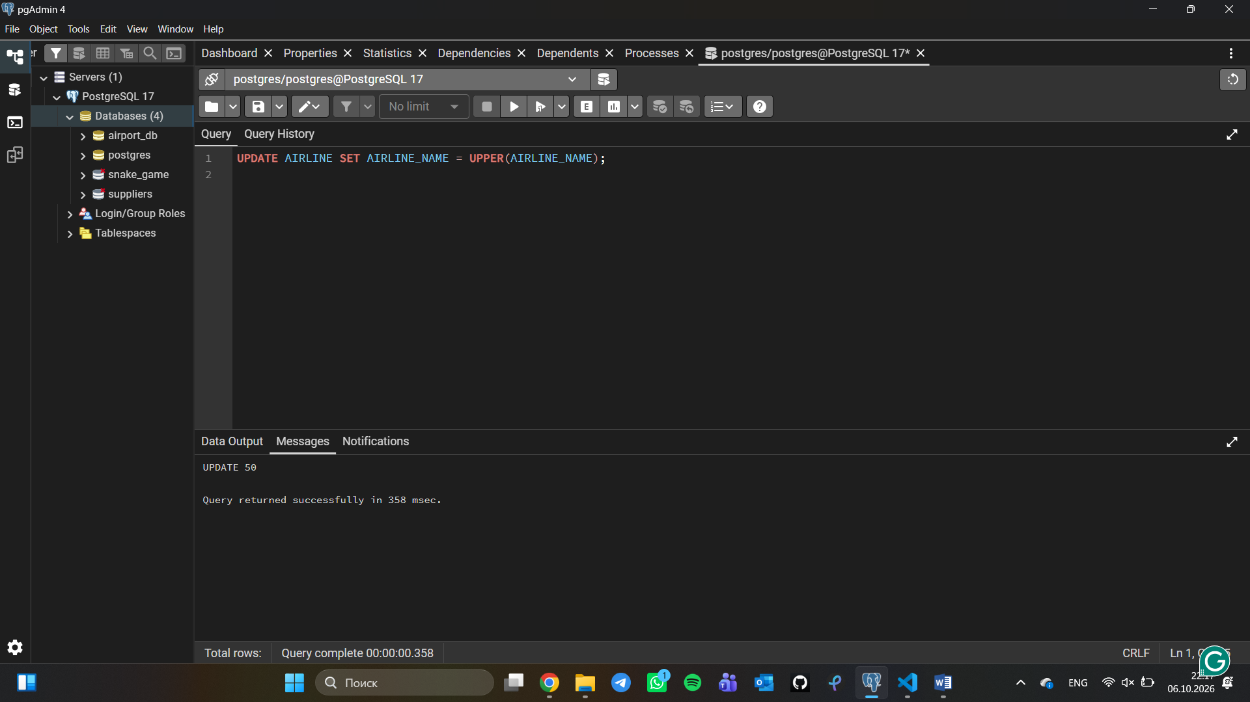
- Replace any occurrence of the word "Air" in airline names with "Aero".
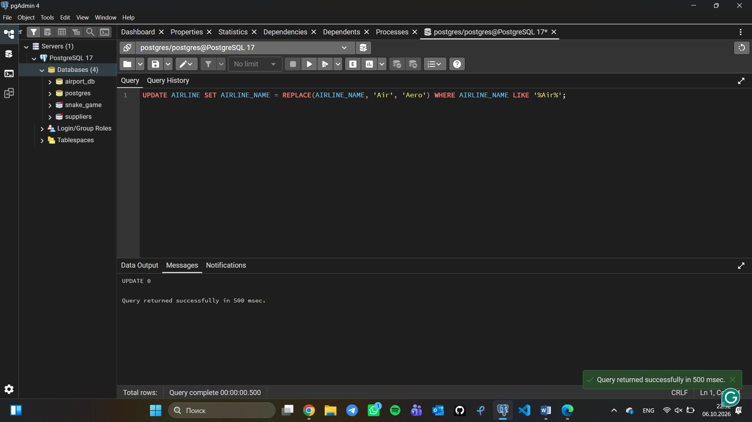
- Fing all flight numbers that coordinates with both airline 1 and airline 2.
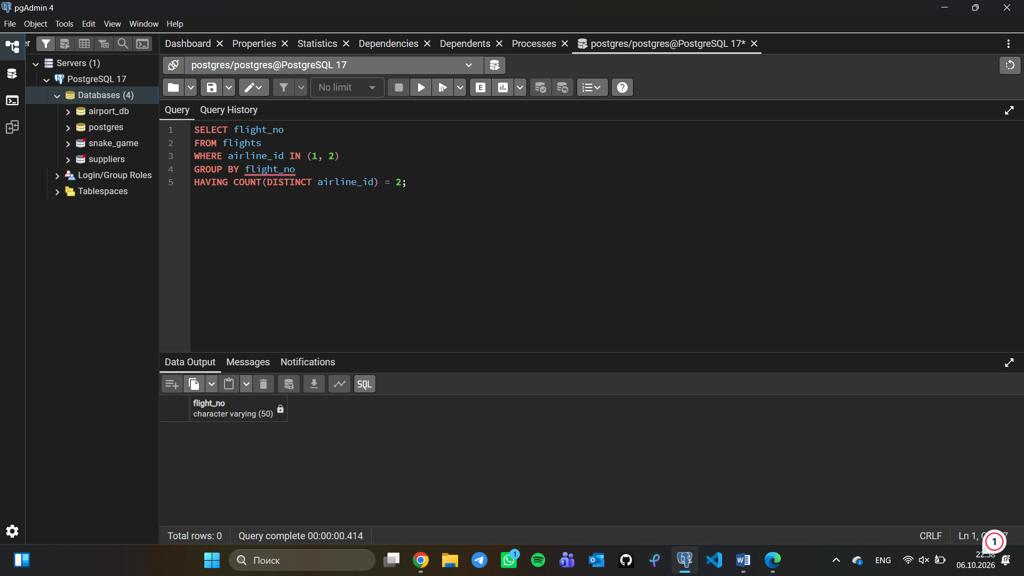
- Retrieve airports that contain the word "Reginal" and "Air" in their names.
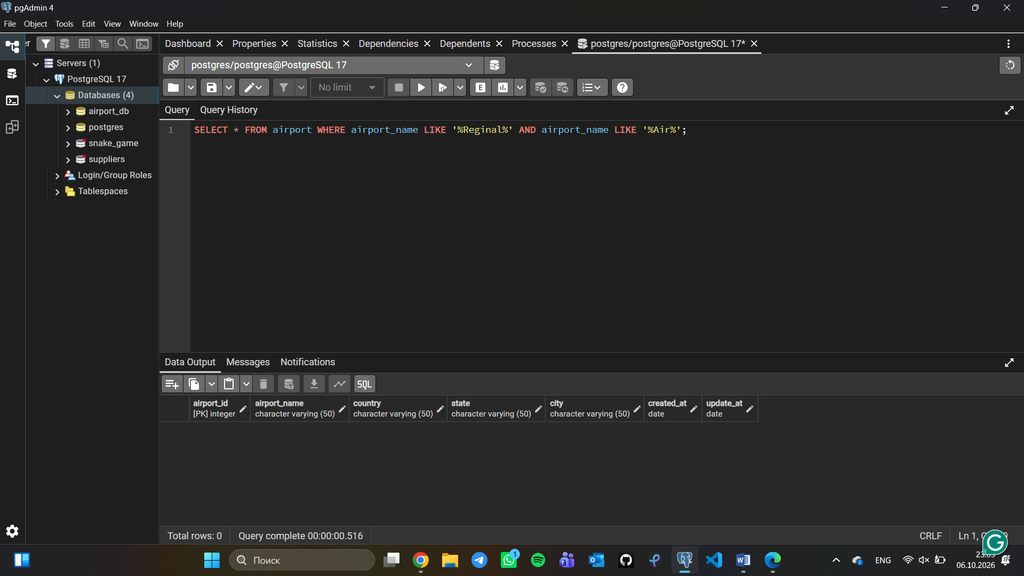

- Retrieve passenger names and format their birth dates as 'Month DD, YYYY'.
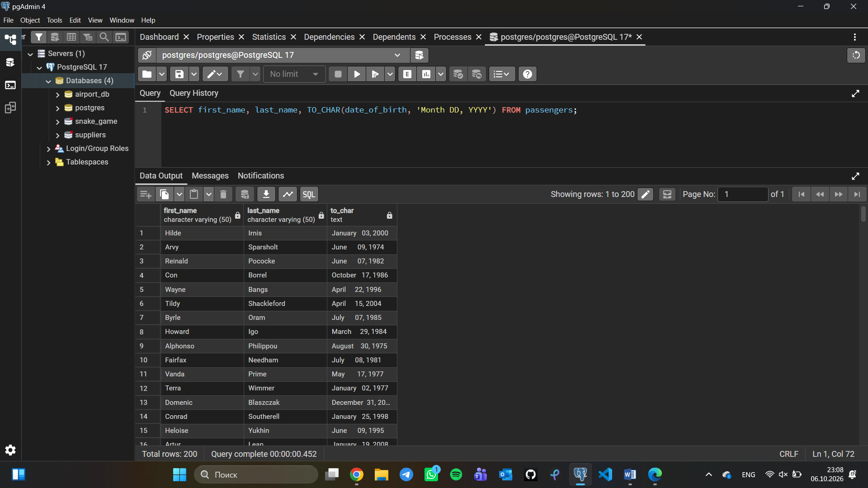
- Find flight numbers that have been delayed based on the actual arrival time.
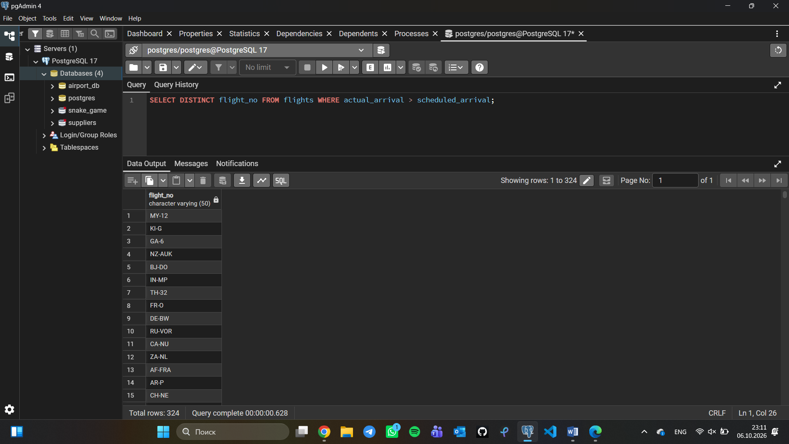

- Find flights that arrived late according to their actual arrival time compared to the scheduled arrival time.
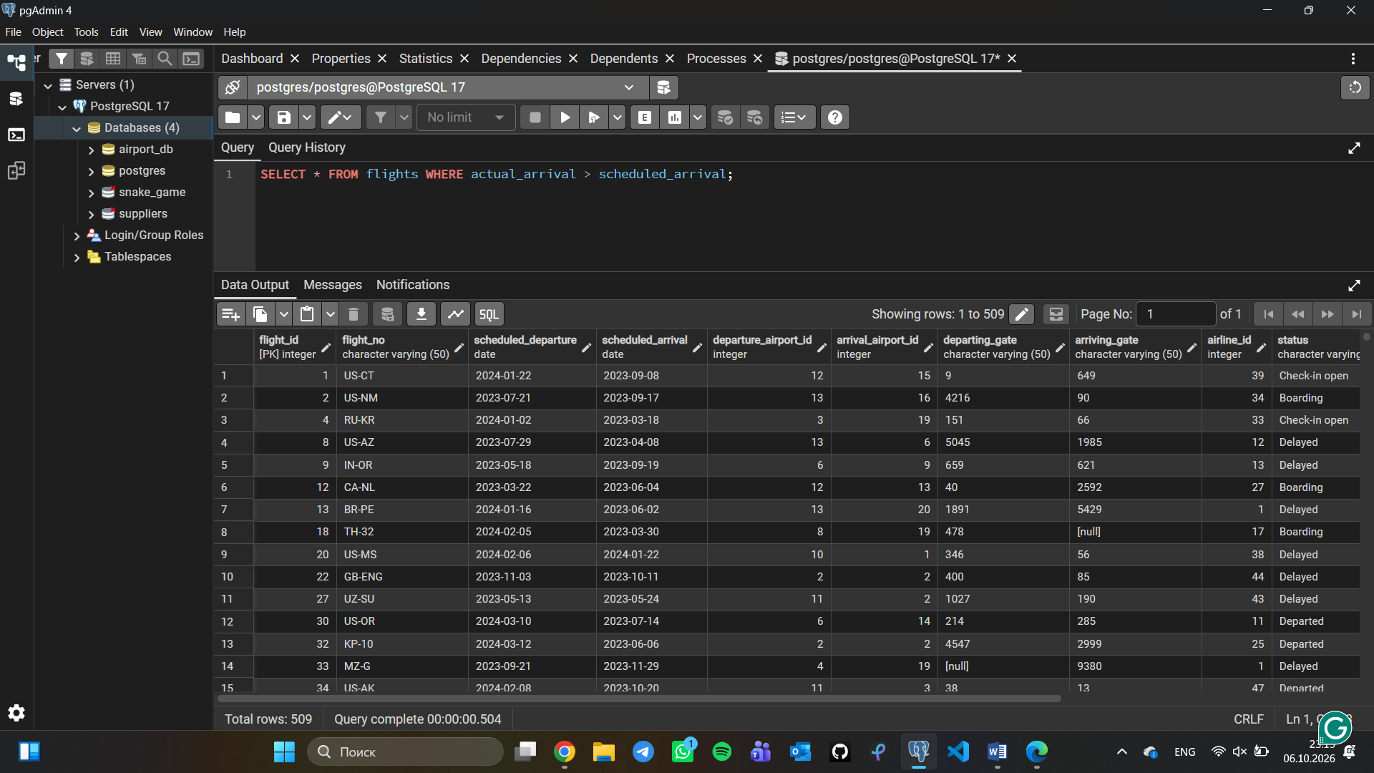
- Show airlines from any of: ('France','Portugal','Poland') created between '2023-11-01' and '2024-03-31'.
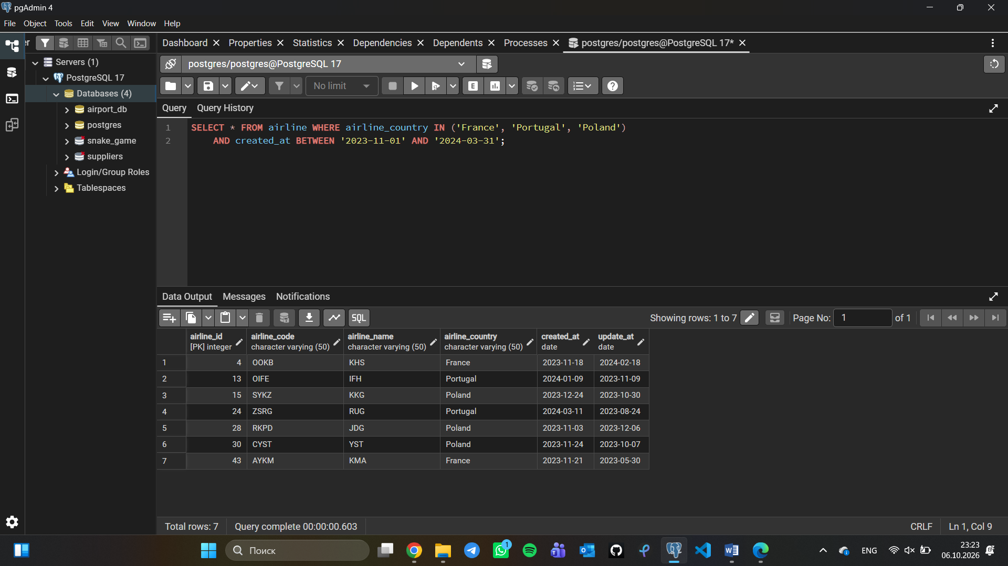

- Find top3 overweighted baggage with more than 25kg.
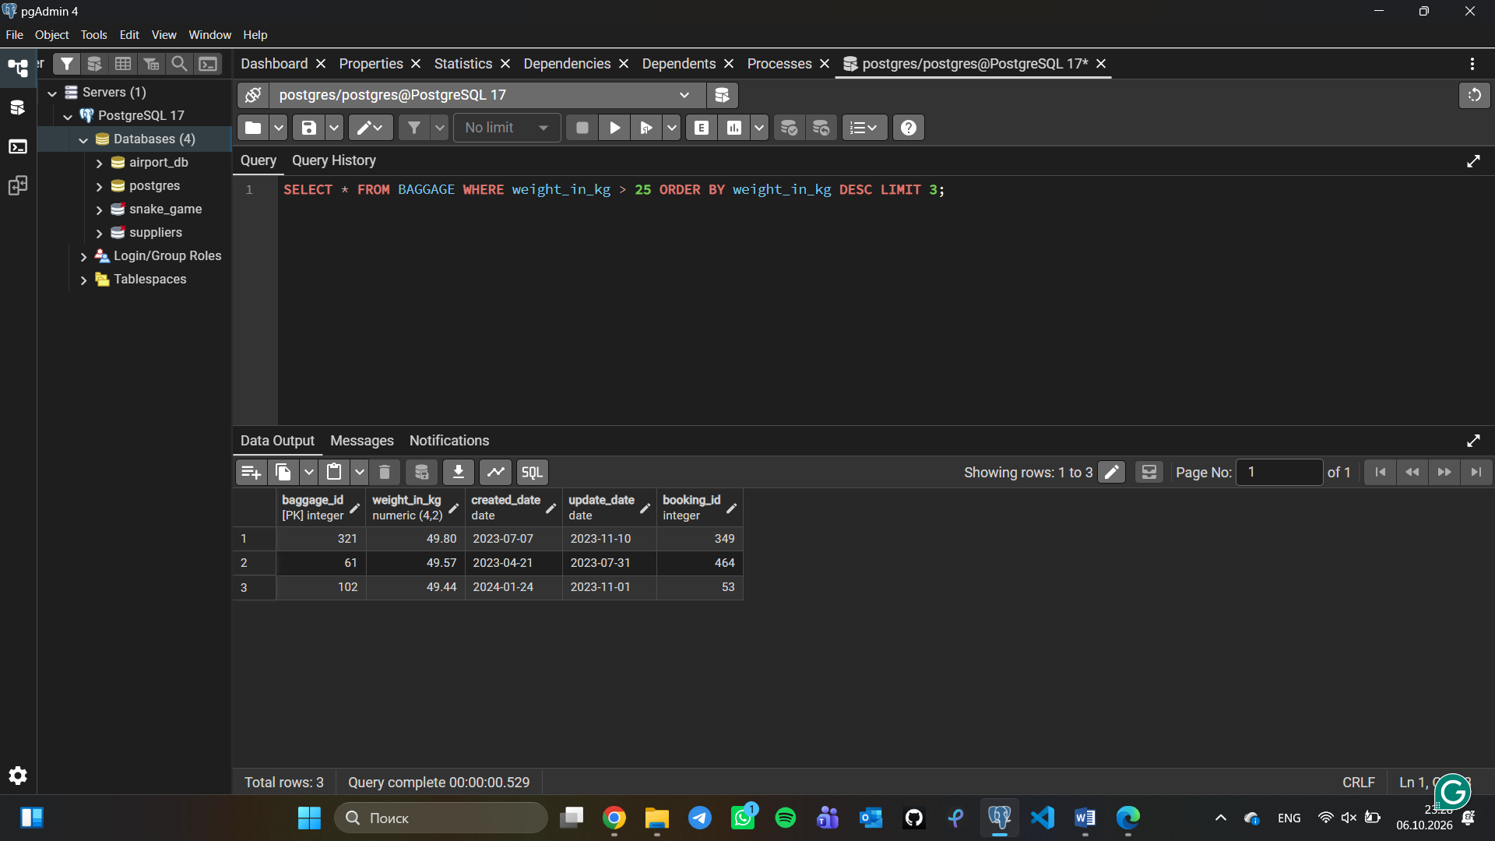
- Find the youngest passengers’ full name.
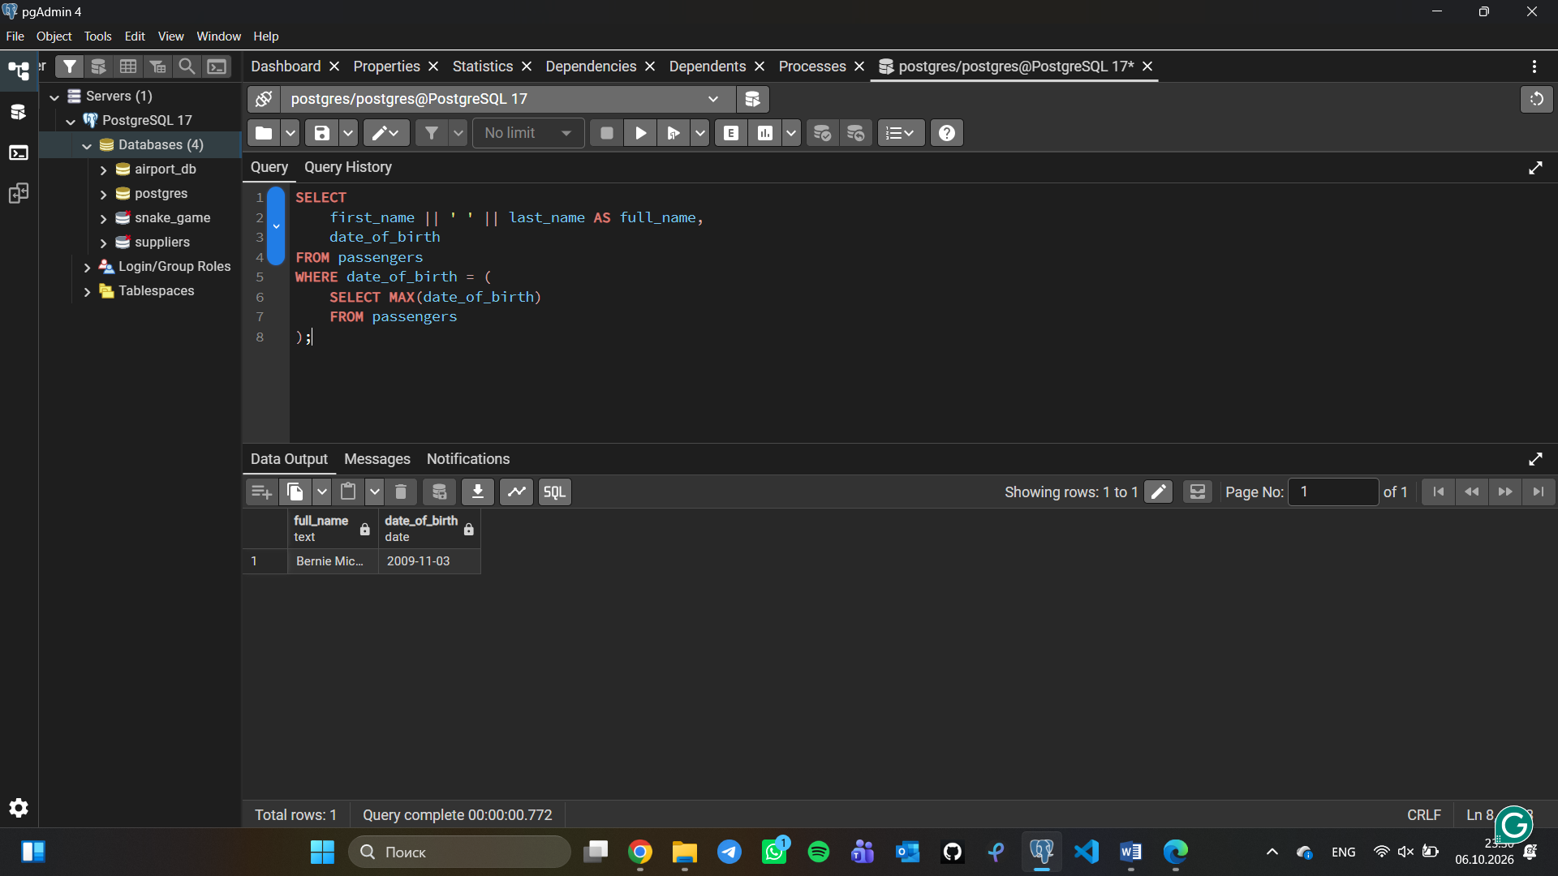

- Find the cheapest booking price on each booking platform.
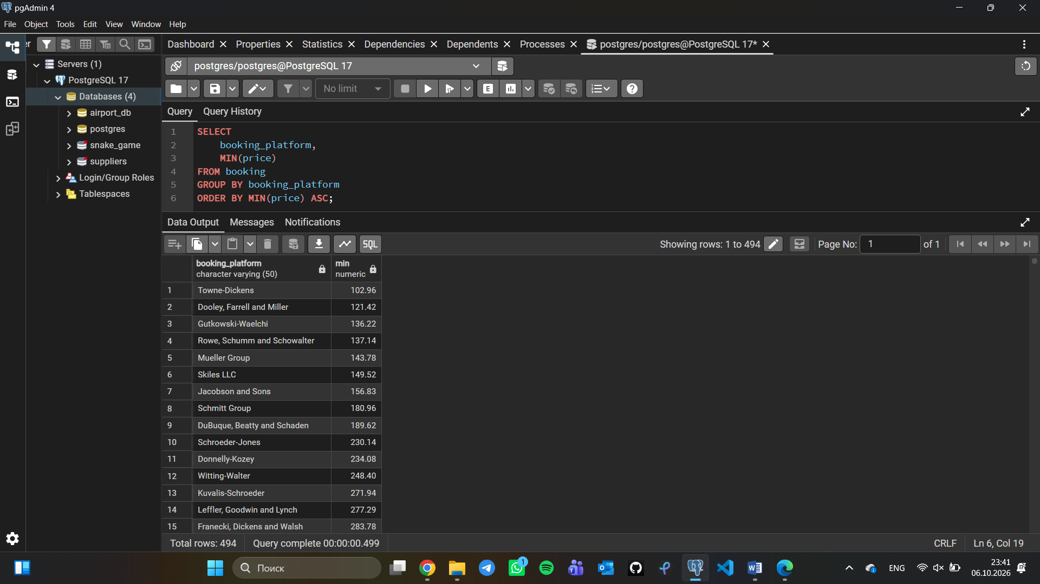
- Return airlines whose airline_code contains a digit.
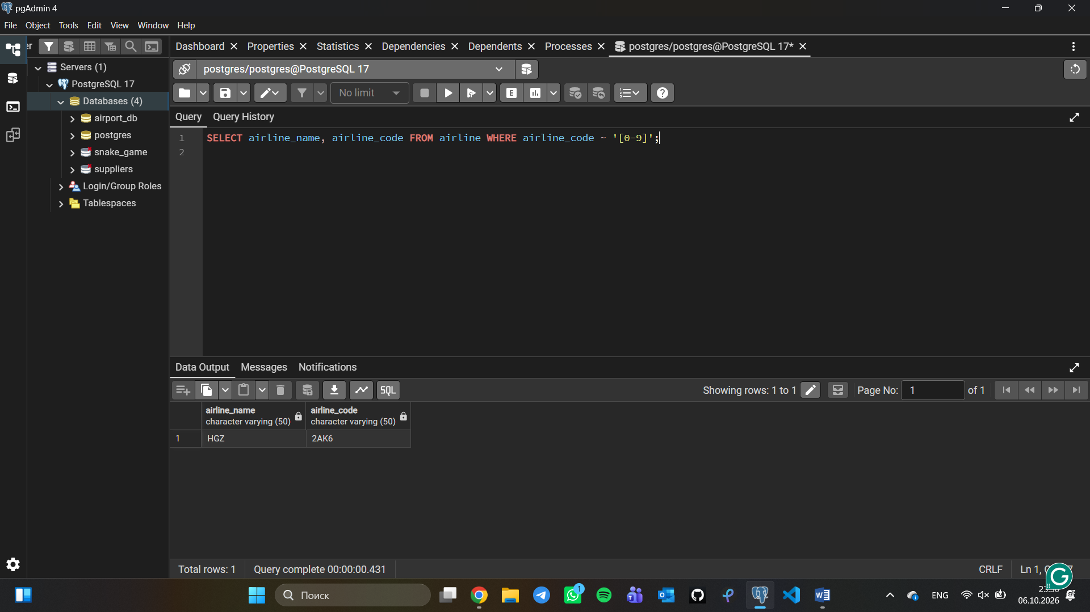

- List the top5 most recently created airlines.
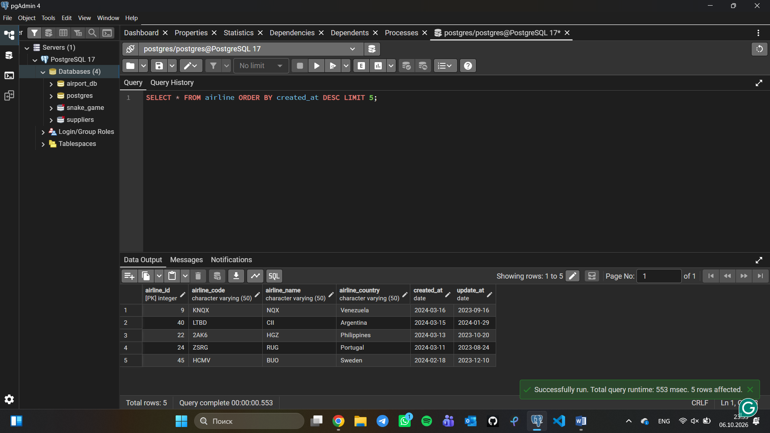
- Return all rows where booking_id is between 200 and 300 inclusive and check_result <> 'Checked'.
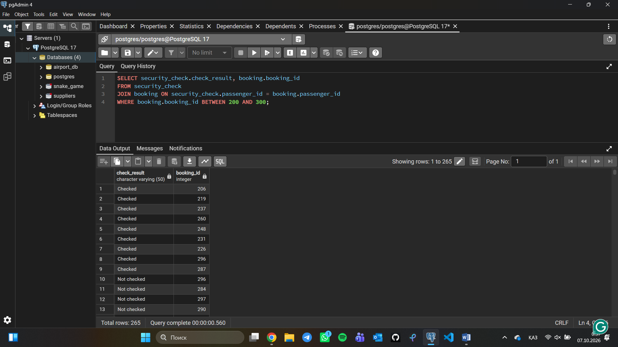

- Baggage checks where update_at is in the same month as created_at but occurs earlier than created_at.
