Laboratory work 3
We continue to work with the database from the previous laboratory works.
Take a full-page screenshot that covers the code and results of each task.

Tasks:
DML
- Generated 200 rows in summary and inserted it.
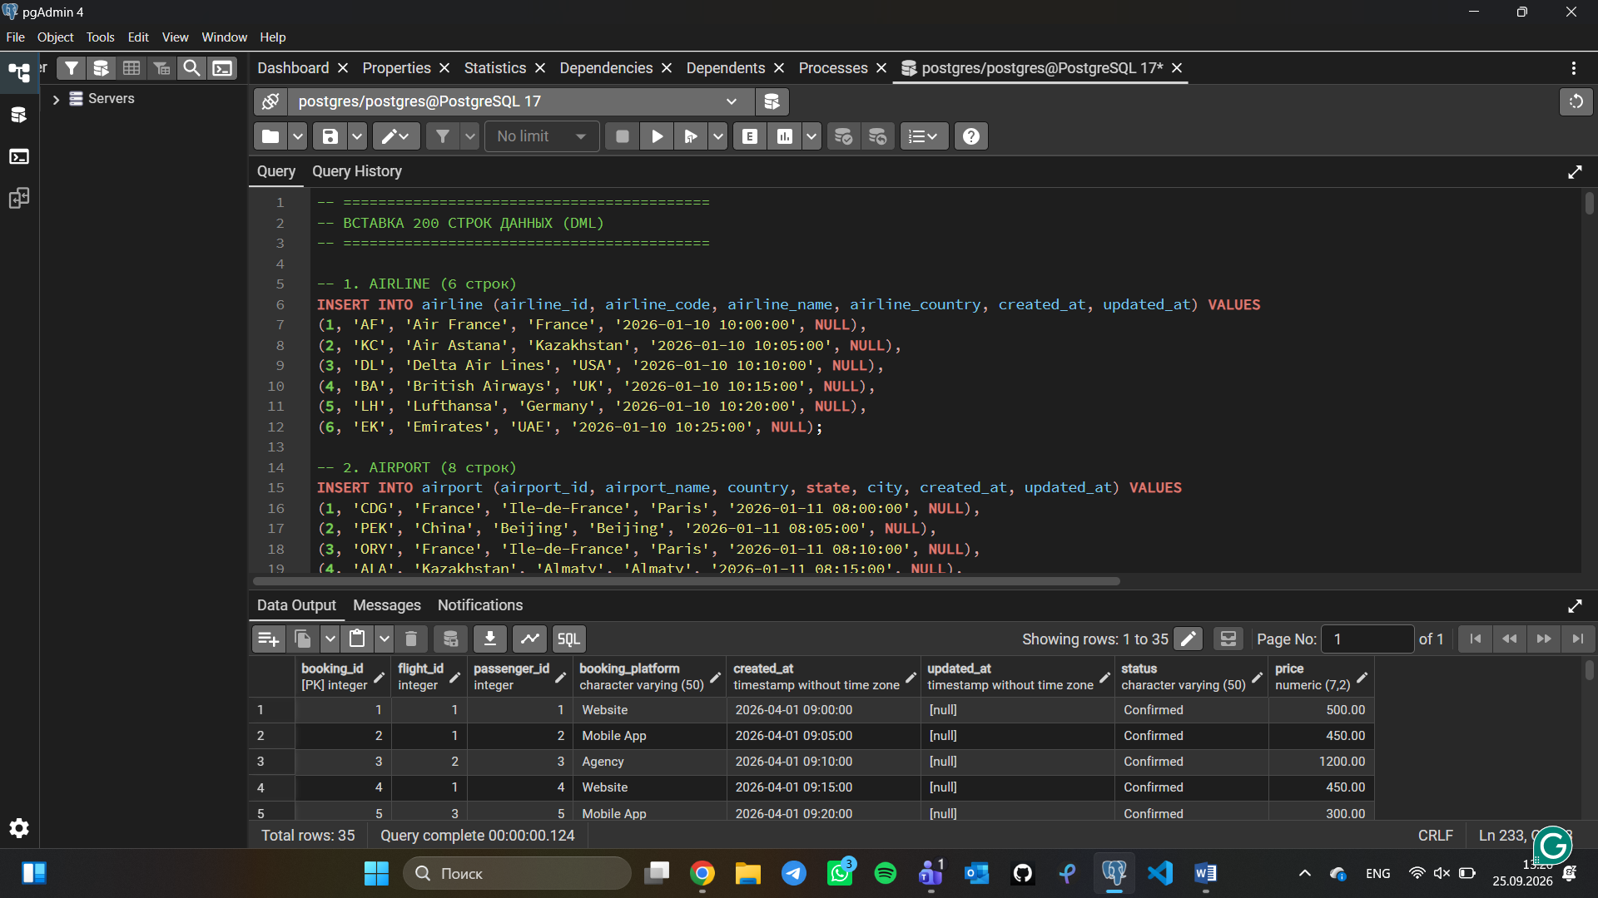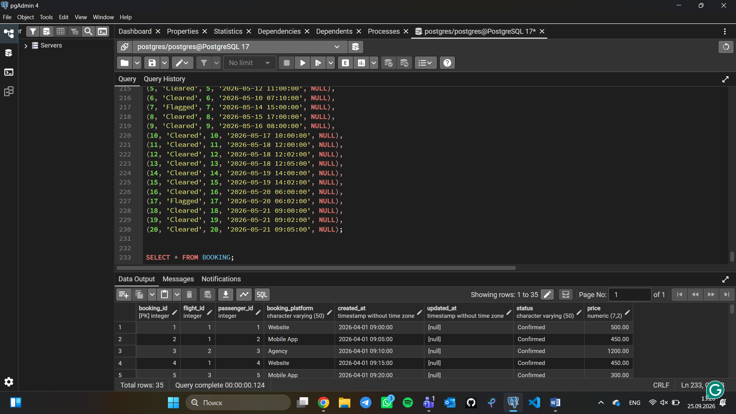
- Add a new airline named "KazAir" based in "Kazakhstan" to the airline table.
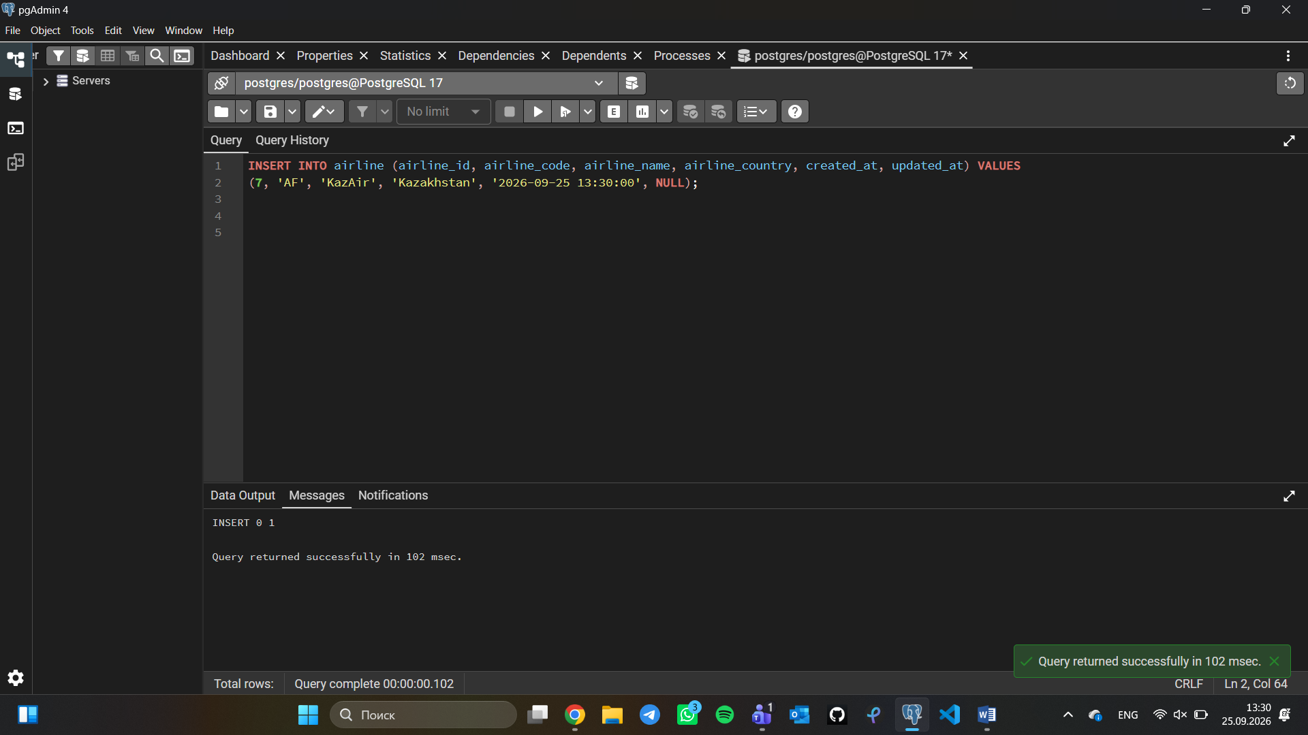
- Update the airline country "KazAir" to "Turkey".
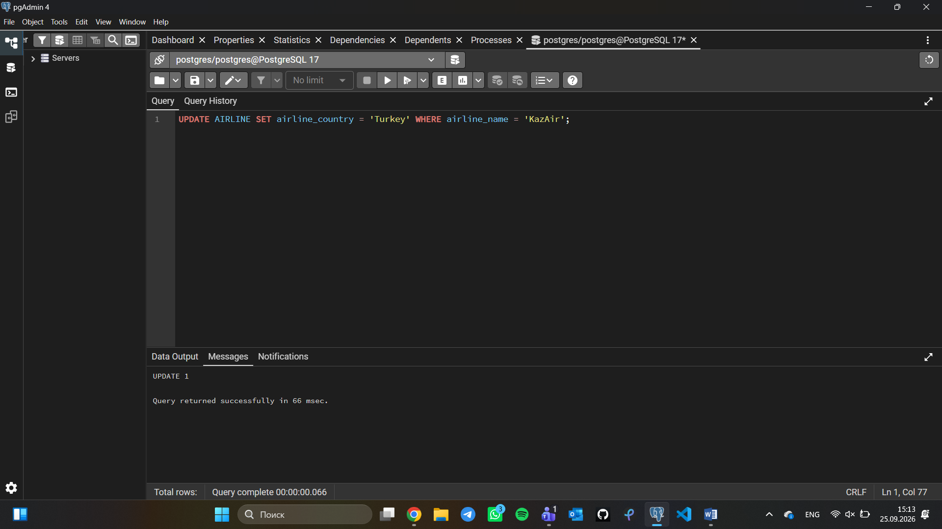

4.Add three airlines at once: "AirEasy" in "France", "FlyHigh" in "Brazil" and "FlyFly" in "Poland".
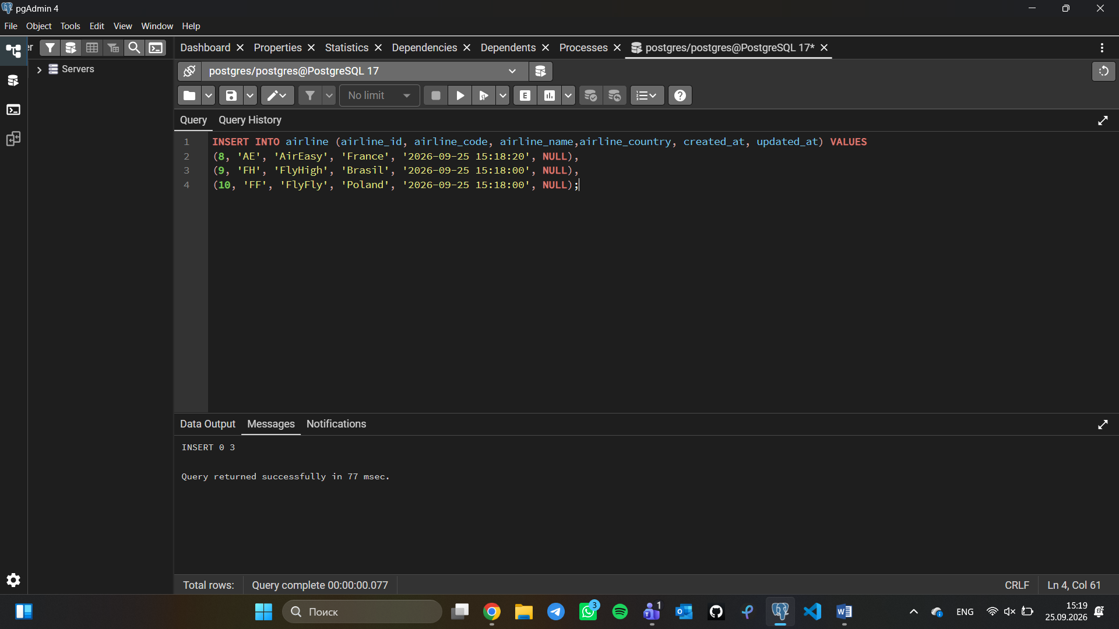
- Delete all flights whose arrival in 2024 year.
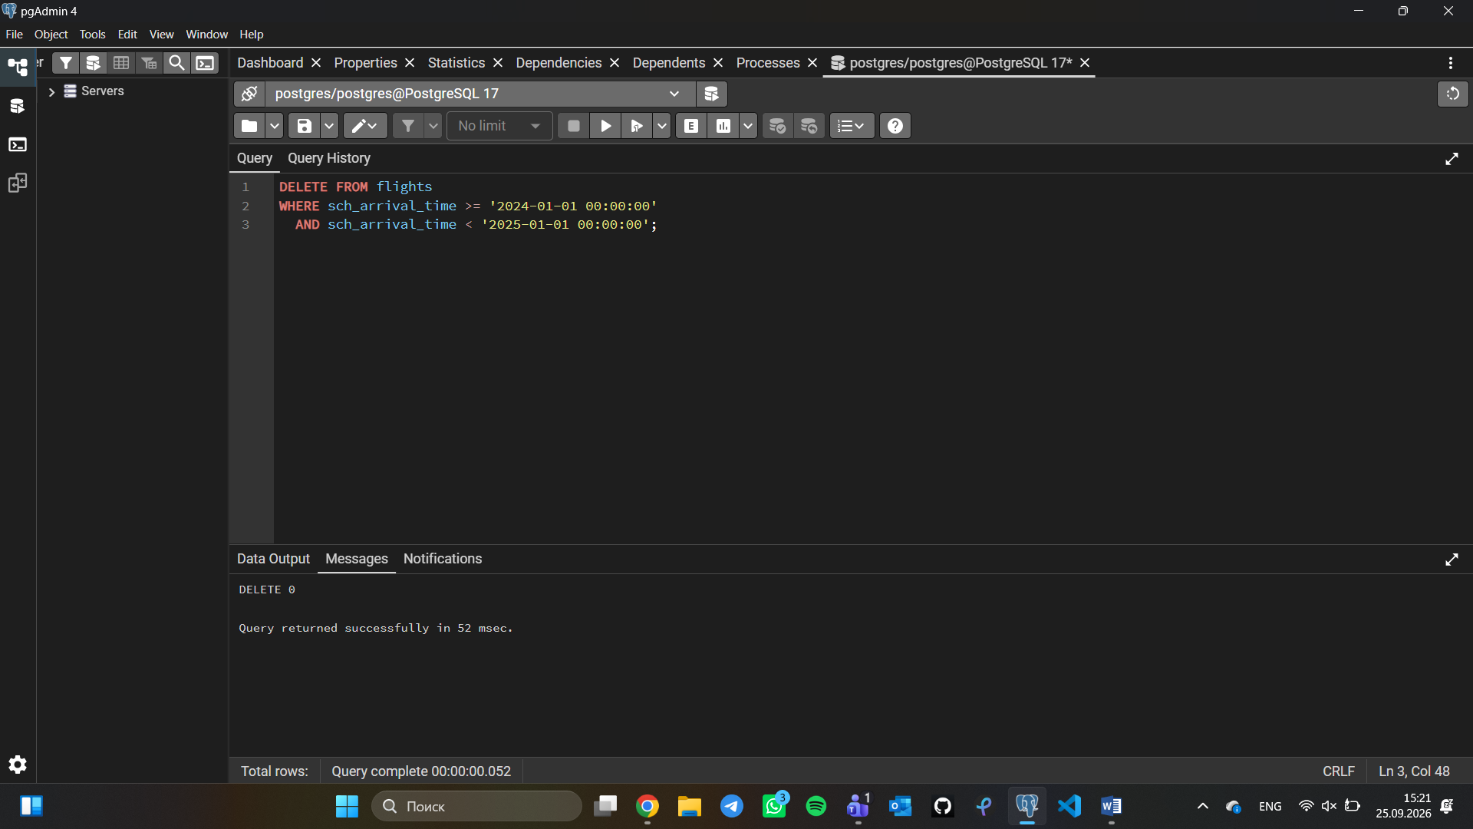

6.Increase the price of all tickets in booking table for flights by 15%.
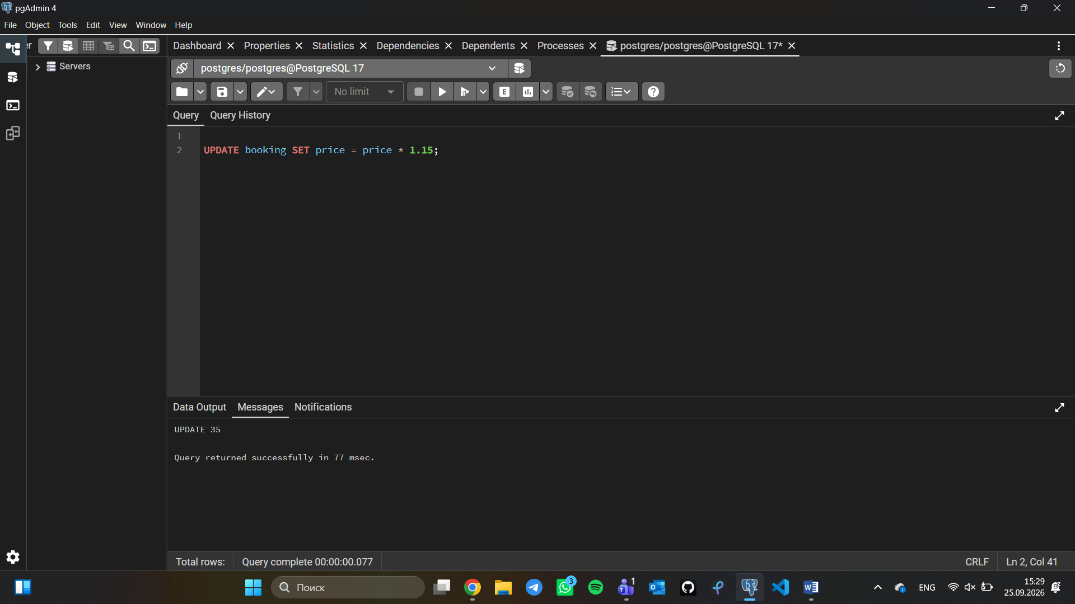
- Delete all tickets where price is less than 10000.
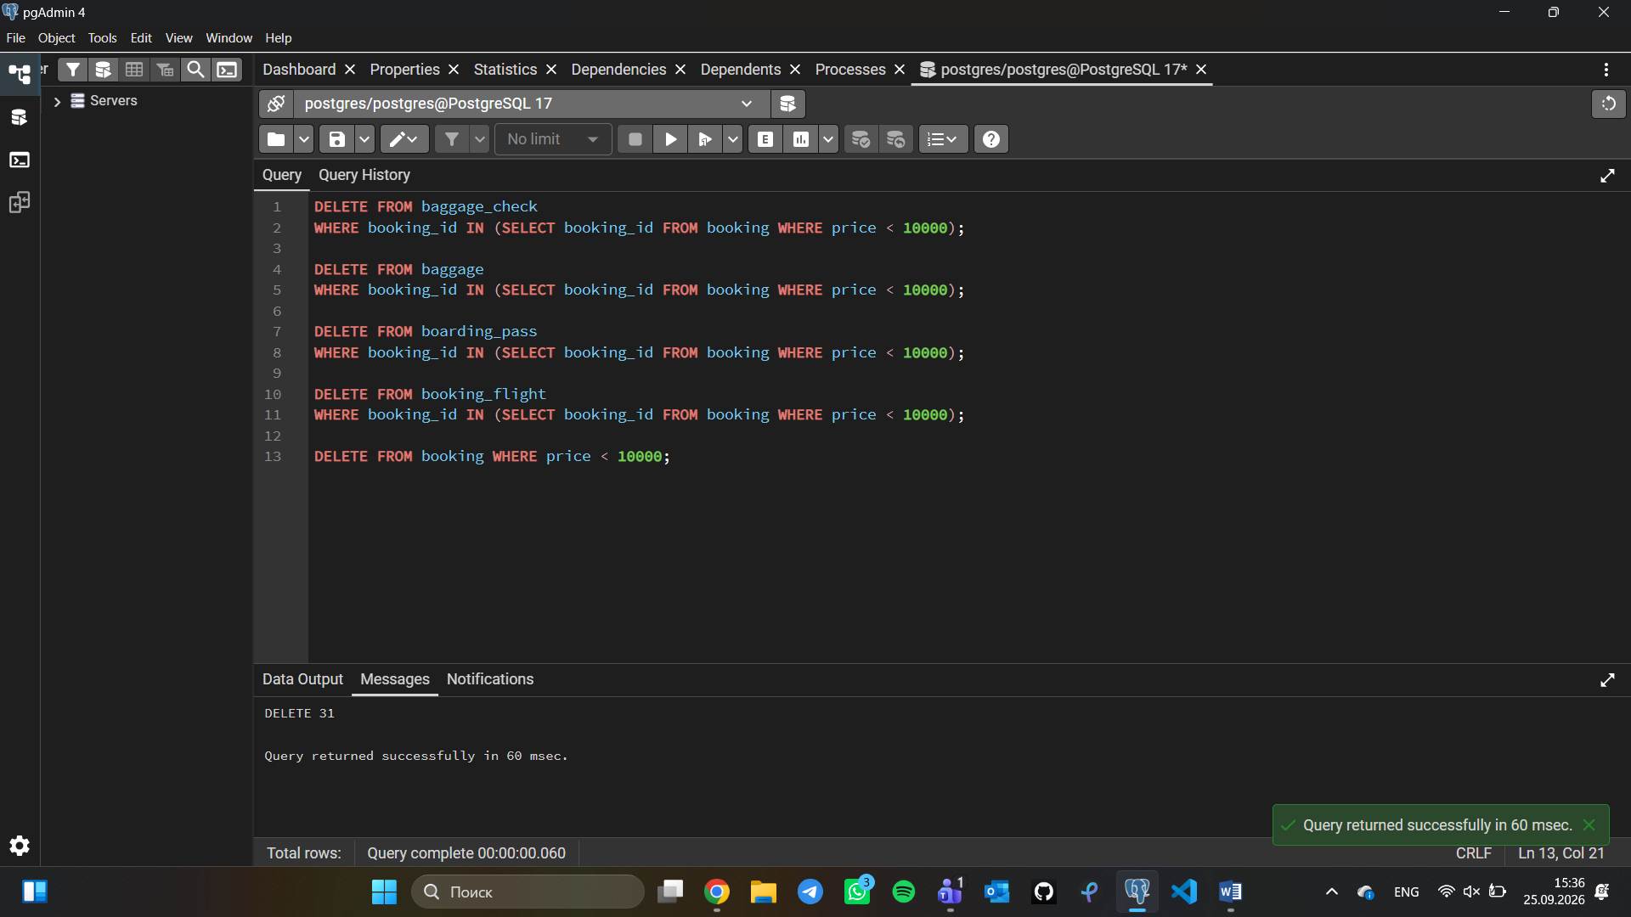

- Set a default code 'UNK' (Unknown) for any airline in the airline table where airline_code is missing (NULL).
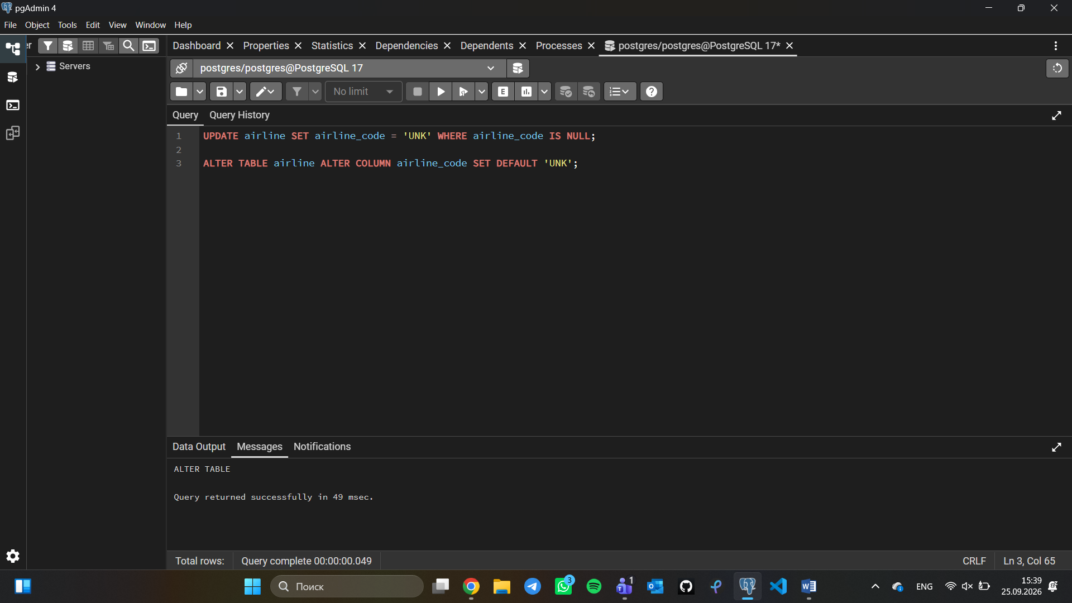
- Delete all baggage check records created before June 1, 2023, whose result is still 'Not checked'.
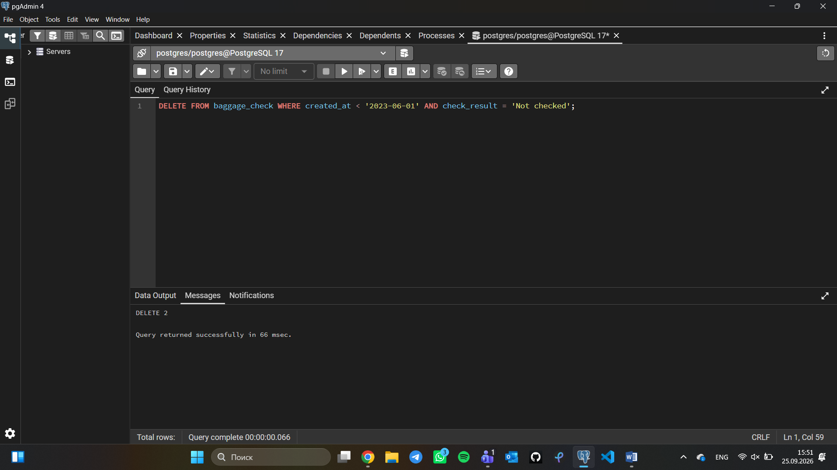

- Delete all entries from the airport table where state is missing (NULL) and the city is either 'Mlawe' or 'Kepuh'.
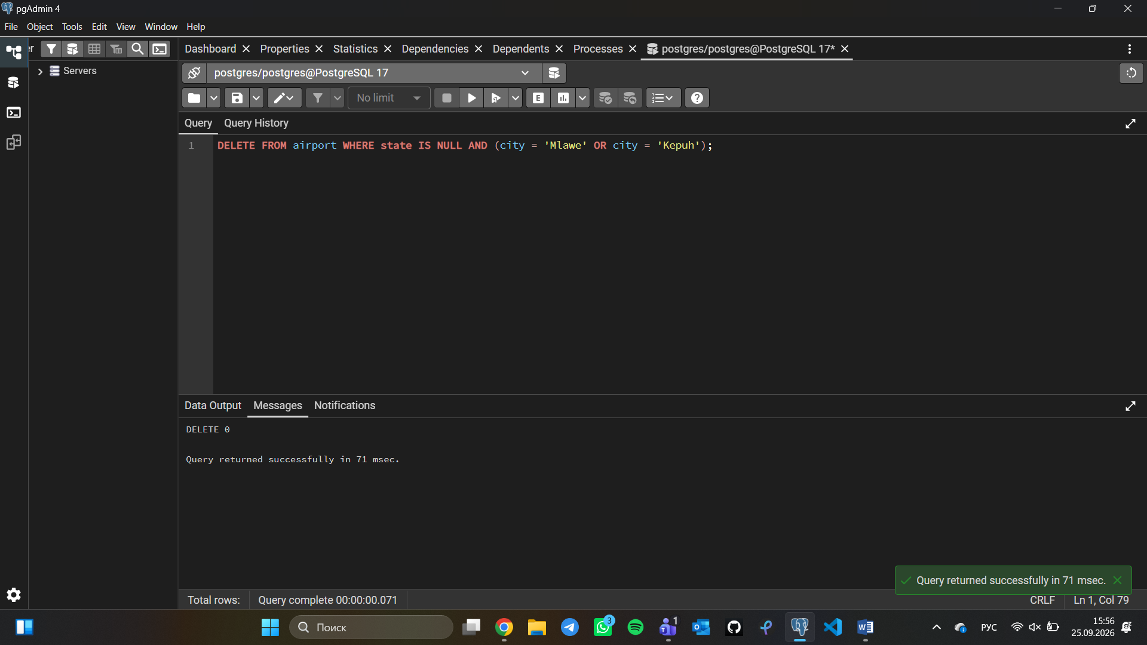
- Insert a new unchecked baggage inspection record and immediately return its newly generated baggage_check_id and created_at timestamp.
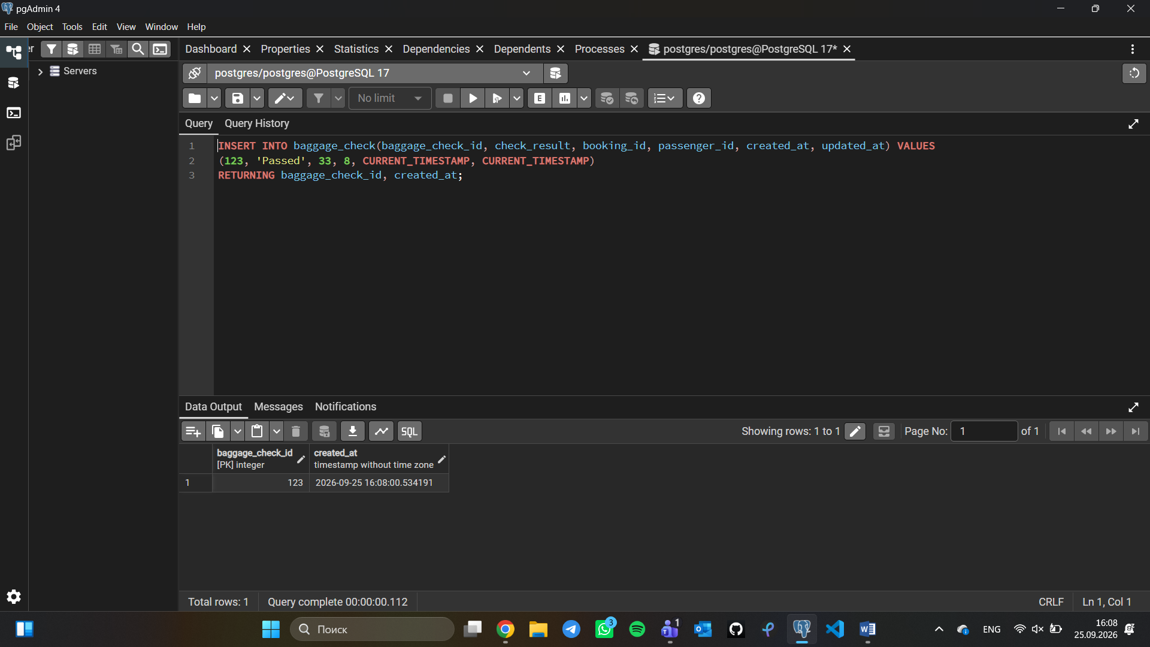

- Convert all country names in the airline table to uppercase to ensure data consistency.
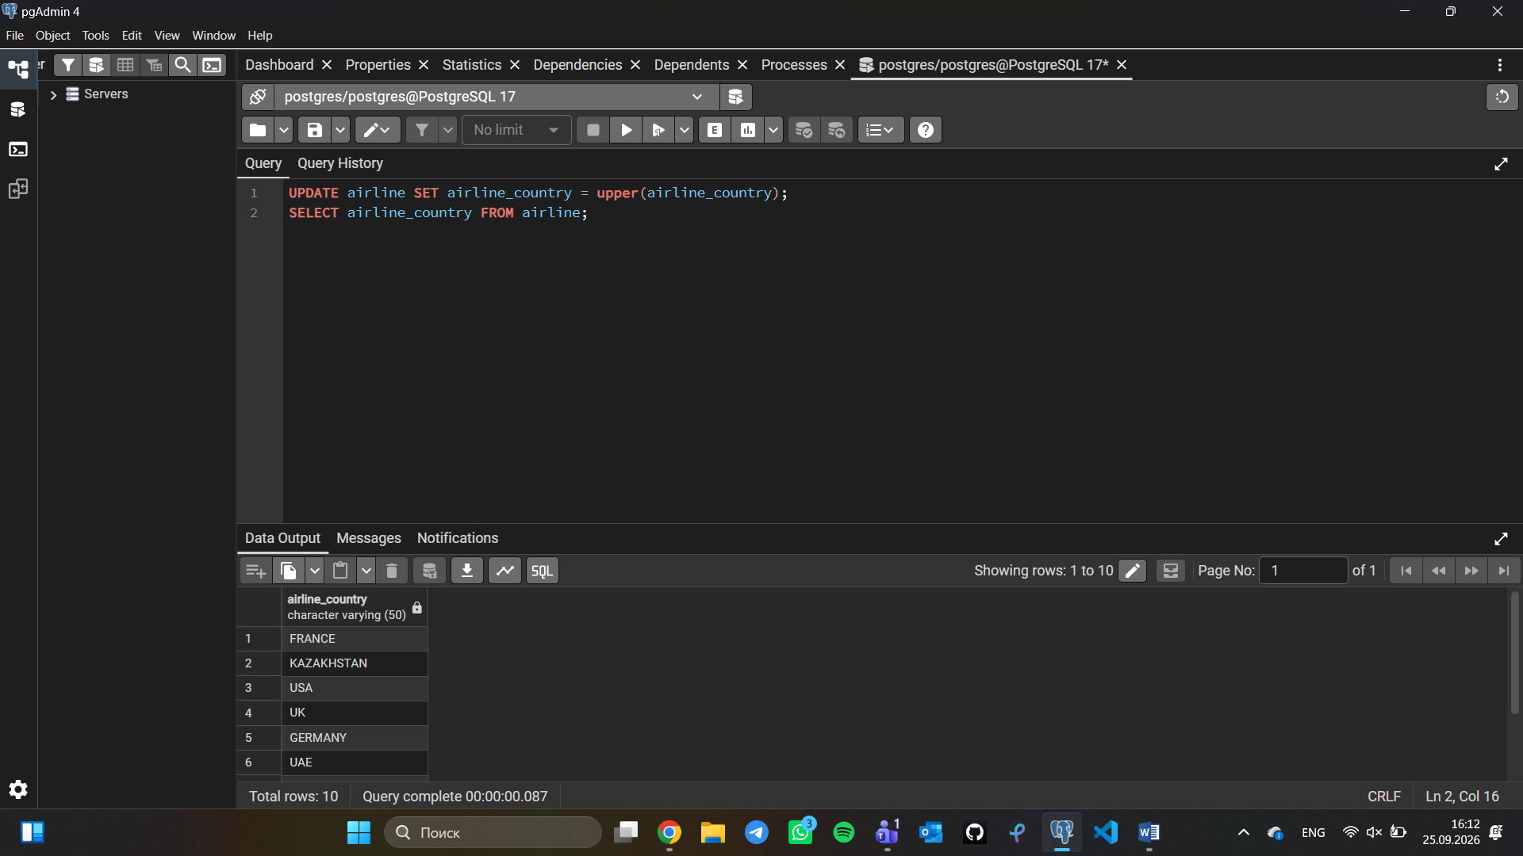
- Update both the name and country for the airline with airline_id = 5. Set the name to 'Global Airways' and the country to 'United Kingdom', while updating update_at to the current date.
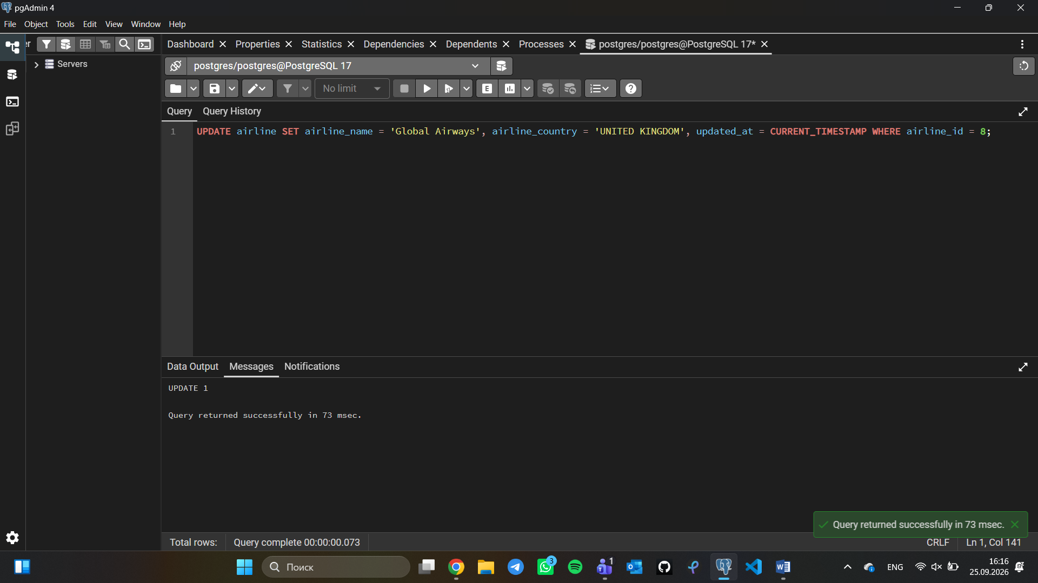

- Set the state field to 'Capital District' for airports located in specific cities: 'Astana', 'London', and 'Tokyo'
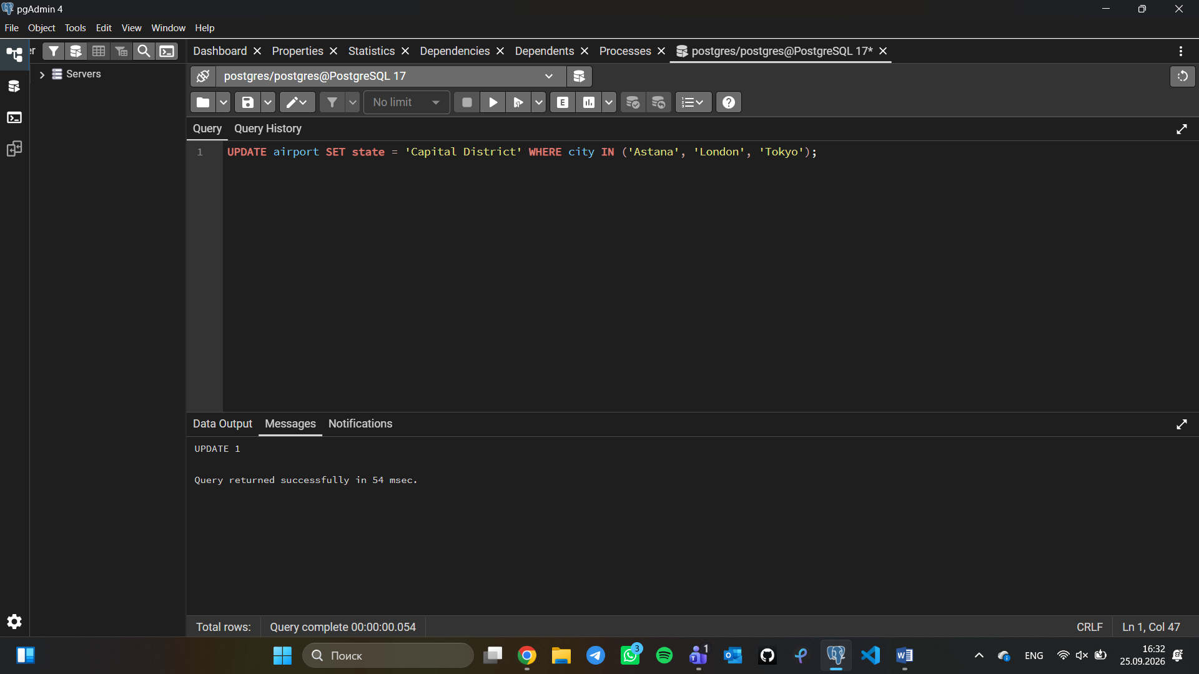
- Mark all baggage check records (baggage_check) created in March 2024 with a status of 'Not checked' as completed ('Checked').
