Name: M.Usman

Roll no: 20SW041

Topic: Power BI LAB 14

TASK 01:

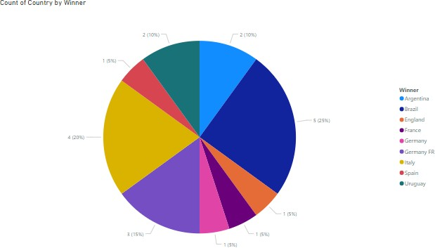

TASK 02:

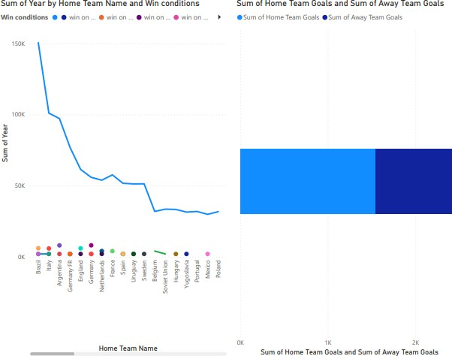

TASK 03:

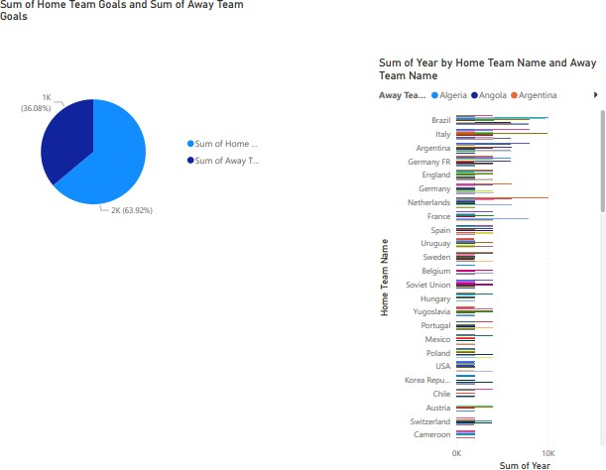

TASK 04:

