**Lab No 06**

**SQL for Data Analysis**

**Task#01 Run the following queries:**

**-- Query 1: Select id, account_id, and occurred_at columns for all orders in the orders table.**

SELECT id, account_id, occurred_at FROM orders;

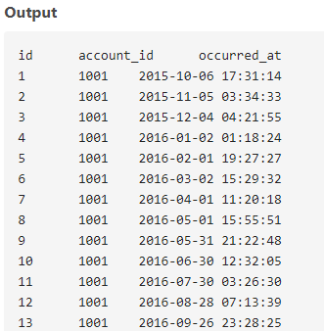

**-- Query 2: Return the 10 earliest orders with id, occurred_at, and total_amt_usd.**

SELECT id, occurred_at, total_amt_usd FROM orders ORDER BY occurred_at LIMIT 10;

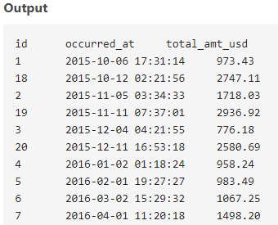

**-- Query 3: Return the top 5 orders with largest total_amt_usd and id, account_id.**

SELECT id, account_id, total_amt_usd FROM orders ORDER BY total_amt_usd DESC LIMIT 5;

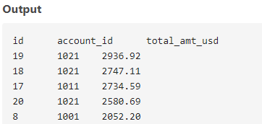

**-- Query 4: Return the bottom 20 orders with least total and id, account_id.**

SELECT id, account_id, total FROM orders ORDER BY total LIMIT 20;

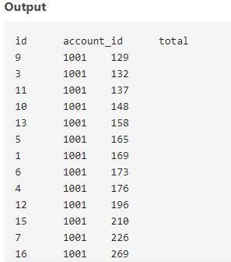

**-- Query 5: Return the top 5 rows from orders ordered by newest to oldest, with largest total_amt_usd for each date.**

SELECT id, account_id, occurred_at, total_amt_usd FROM

(SELECT *, ROW_NUMBER() OVER (PARTITION BY DATE(occurred_at)

ORDER BY total_amt_usd DESC)

AS row_num FROM orders ) ranked

WHERE row_num <= 5 ORDER BY occurred_at DESC;

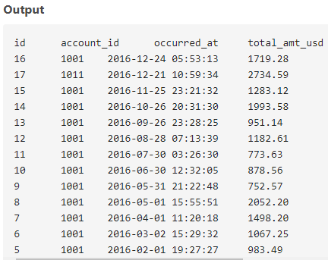

**-- Query 6: Return the top 10 rows from orders ordered by oldest to newest, with smallest total_amt_usd for each date.**

SELECT id, account_id, occurred_at, total_amt_usd

FROM ( SELECT *, ROW_NUMBER() OVER (PARTITION BY DATE(occurred_at) ORDER BY total_amt_usd)

AS row_num

FROM orders ) ranked

WHERE row_num <= 10

ORDER BY occurred_at;

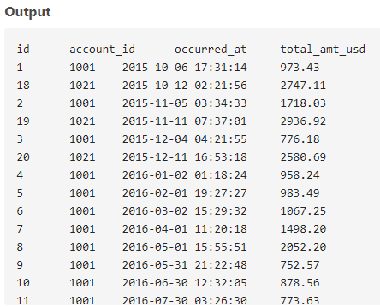

**-- Query 7: Pull the first 5 rows and all columns from the orders table with gloss_amt_usd >= 1000.**

SELECT * FROM orders WHERE gloss_amt_usd >= 1000 LIMIT 5;

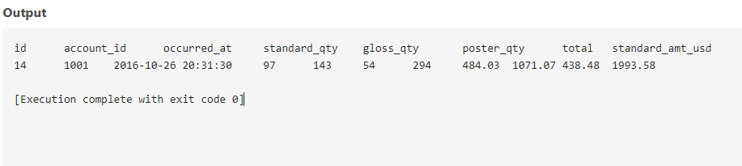

**-- Query 8: Pull the first 10 rows and all columns from the orders table with total_amt_usd < 500.**

SELECT * FROM orders WHERE total_amt_usd < 500 LIMIT 10;

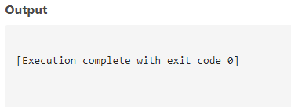

**-- Query 9: Create a column for unit price of standard paper for first 10 orders.**

SELECT id, account_id, standard_amt_usd / standard_qty AS unit_price FROM orders LIMIT 10;

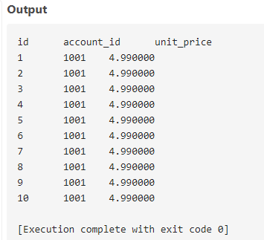

**-- Query 10: Find the percentage of revenue from poster paper for each order (with potential division workaround).**

SELECT id, account_id, (poster_amt_usd * 100.0) / NULLIF(total_amt_usd, 0) AS poster_percentage FROM orders;

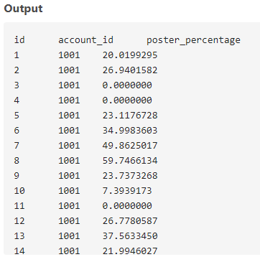

**-- Query 11: Use the accounts table to find all companies whose names start with 'C'.**

SELECT * FROM accounts WHERE name LIKE 'C%';

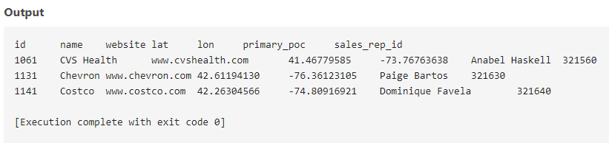

**-- Query 12: Use the accounts table to find all companies whose names contain the string 'one'.**

SELECT * FROM accounts WHERE name LIKE '%one%';

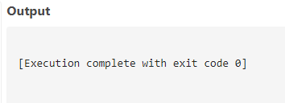

**-- Query 13: Use the accounts table to find all companies whose names end with 's'.**

SELECT * FROM accounts WHERE name LIKE '%s';

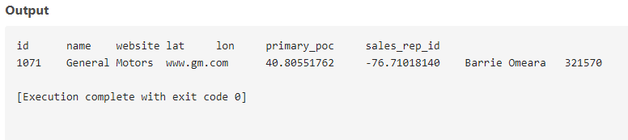

**-- Query 14: Use the accounts table to find the account name, primary_poc, and sales_rep_id for Walmart, Target, and Nordstrom.**

SELECT name, primary_poc, sales_rep_id FROM accounts WHERE name IN ('Walmart', 'Target', 'Nordstrom');

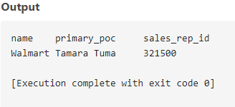

**-- Query 15: Use the web_events table to find all information regarding individuals contacted via the channel of organic or adwords.**

SELECT * FROM web_events WHERE channel IN ('organic', 'adwords');

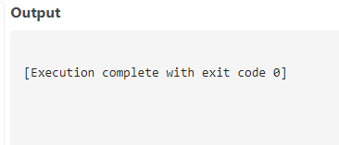

**-- Query 16 a: Use the accounts table to find account name, primary poc, and sales rep id for all stores except Walmart, Target, and Nordstrom.**

SELECT name, primary_poc, sales_rep_id

FROM accounts

WHERE name NOT IN ('Walmart', 'Target', 'Nordstrom');

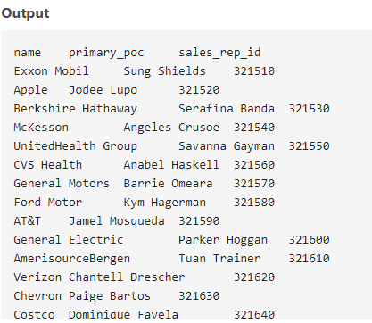

**-- Query 16 b: Use the web_events table to find all information regarding individuals who were contacted via any method except organic or adwords.**

SELECT *

FROM web_events

WHERE channel NOT IN ('organic', 'adwords');

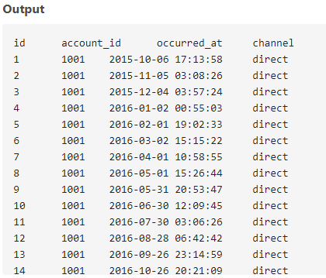

**-- Query 17 a: Use the accounts table to find all companies whose names do not start with 'C'.**

SELECT *

FROM accounts

WHERE name NOT LIKE 'C%';

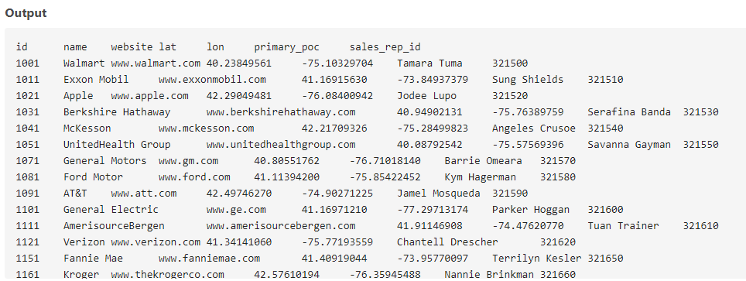

**-- Query 17 b: Use the accounts table to find all companies whose names do not contain the string 'one'.**

SELECT *

FROM accounts

WHERE name NOT LIKE '%one%';

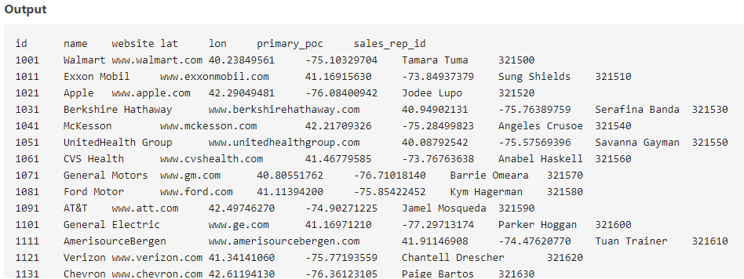

**-- Query 17 c: Use the accounts table to find all companies whose names do not end with 's'.**

SELECT *

FROM accounts

WHERE name NOT LIKE '%s';

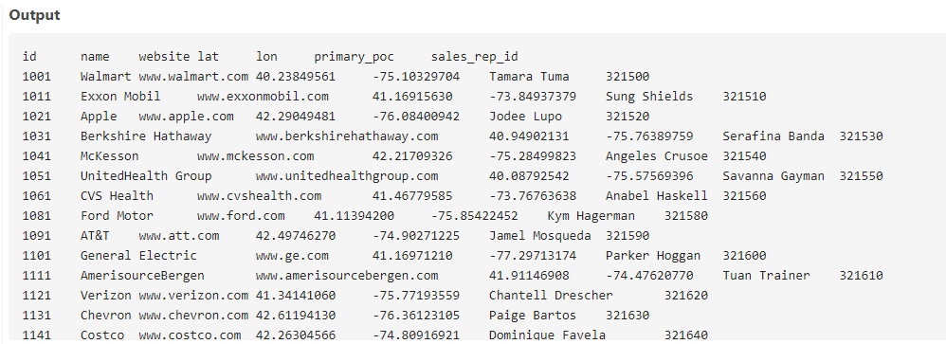

**-- Query 18: Write a query to return orders where standard_qty > 1000, poster_qty = 0, and gloss_qty = 0.**

SELECT *

FROM orders

WHERE standard_qty > 1000 AND poster_qty = 0 AND gloss_qty = 0;

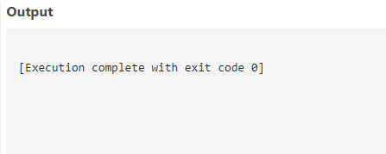

**-- Query 19: Use the accounts table to find companies whose names do not start with 'C' and end with 's'.**

SELECT *

FROM accounts

WHERE name NOT LIKE 'C%' AND name LIKE '%s';

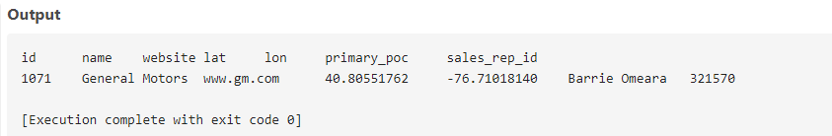

**-- Query 20: Use the web_events table to find information about individuals contacted via organic or adwords in 2016.**

SELECT *

FROM web_events

WHERE channel IN ('organic', 'adwords')

AND DATE(occurred_at) BETWEEN '2016-01-01' AND '2016-12-31'

ORDER BY occurred_at DESC;

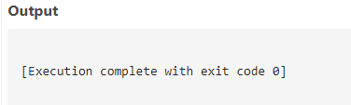

**-- Query 21: Return orders where standard_qty > 1000, poster_qty = 0, and gloss_qty = 0.**

SELECT *

FROM orders

WHERE standard_qty > 1000 AND poster_qty = 0 AND gloss_qty = 0;

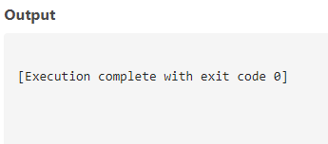

**-- Query 22: Use the accounts table to find companies whose names do not start with 'C' and end with 's'.**

SELECT *

FROM accounts

WHERE name NOT LIKE 'C%' AND name LIKE '%s';

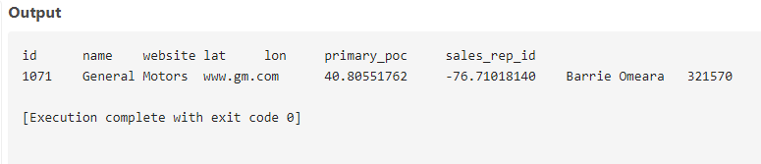

**-- Query 23: Use the web_events table to find information about individuals contacted via organic or adwords in 2016.**

SELECT *

FROM web_events

WHERE channel IN ('organic', 'adwords')

AND DATE(occurred_at) BETWEEN '2016-01-01' AND '2016-12-31'

ORDER BY occurred_at DESC;

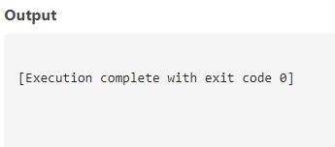

**[THE END]**