**ASSIGNMENT 2 REPORT**

**Base Cases:**

In the backtracking method, the way to reduce the number in the tree is used. For this reason, the number decreases to zero. This is checked on the left. If this is achieved, the program returns TRUE.

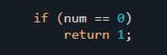

It also decreases with each function call to you. This part is used to check this. Otherwise, it returns FALSE.



This section allows any of the elements in the array to be IGNORE or REJECT if it is larger than the desired number.



They are the parts that are ignored while backtracking in the REJECTED tree. The process of ignoring happens when it is not subtracted from the desired number.



SELECTED: when including current element new num = num-curr. In this part I include the current element when processing the backtracking method.



SELECTED: when including current element new num = num-curr. In this part I include the current element, because

Diagram: CURR

/ \

S R

**OUTPUTS:**

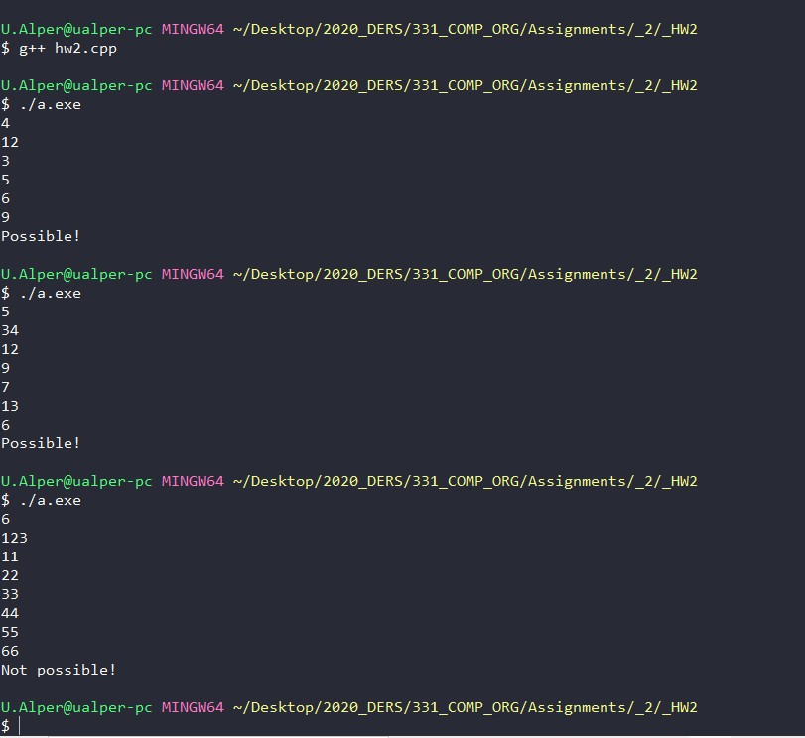

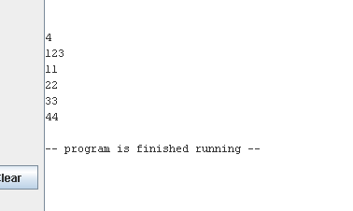

MIPS OUTPUT IN MARS

4 is arraySize

123 is the num

Other are array elements.

**Missing Parts:**

In the MIPS assembly I could not run the CheckSumPossibility () function that works in C ++. I had difficulties in the procedure call part, so that part is missing. I can only buy array elements in the matte.