**React Tutorials**

**The spread and rest operators:**

**Spread:**  Spread is used to integrate the new number in existing/old array.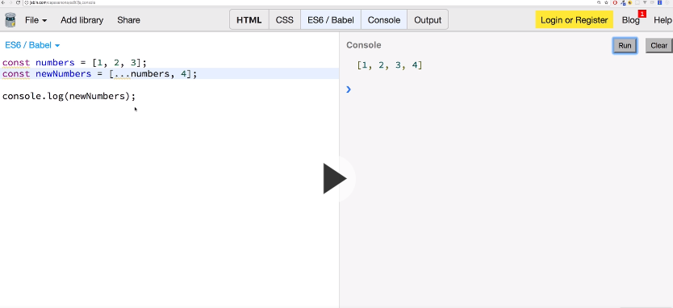

**Spread is also use to add new object to old objects**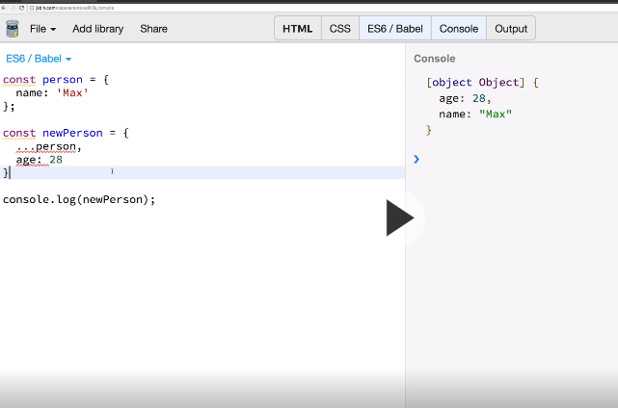

**Rest Operators:** 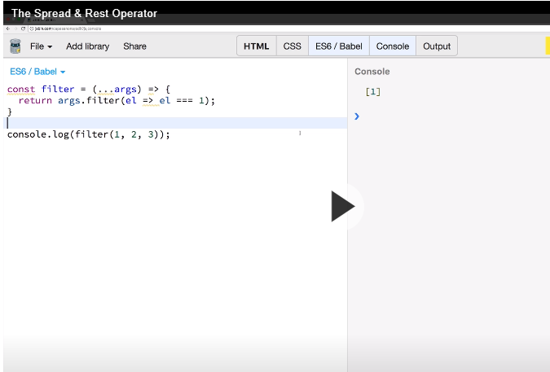

**Filters: Filter** method create new array for all arguments passing by provided function

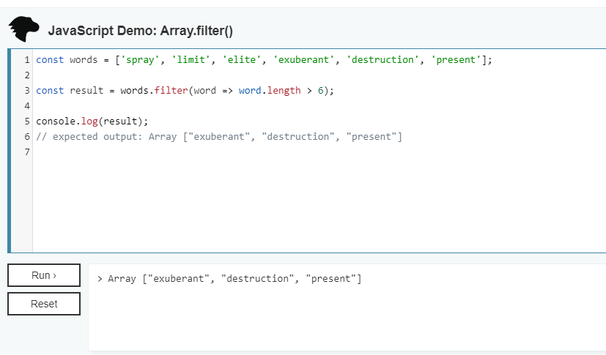

**Destucturing:** It allows easily extract elements and objects of array and store them into variables.

**ArrayDestructuring:**

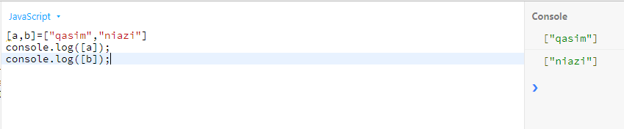

**OR**

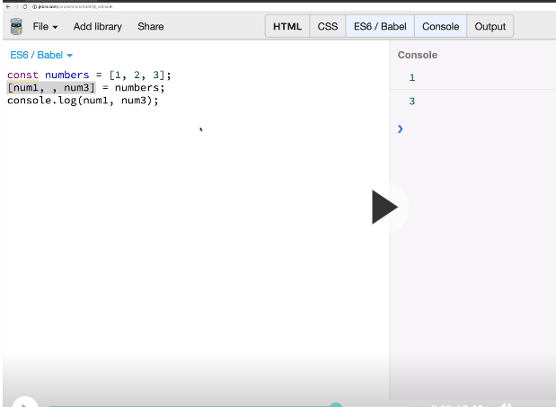

Use space to print the next num in array.

**Object Destructuring:**

In object destructuring we can

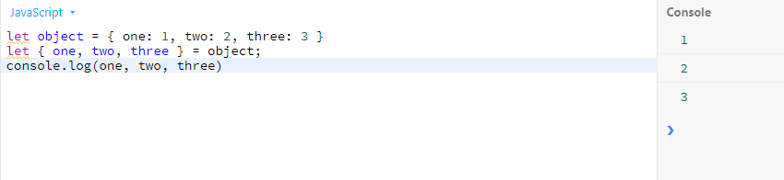

**Refreshing Array Function:**

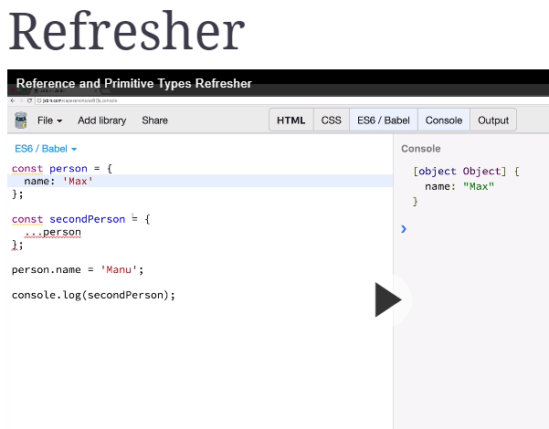

**Props:** props are special keyword in react which stand for “property” and its is being used for passing data from one component to other components. Furthermore, it is read only it means data coming from parent component is not change by child component.

*Props are set by the parent component.

*Props are immutable i.e. once set the props cannot be changed

**Parent component** but I named it a child:

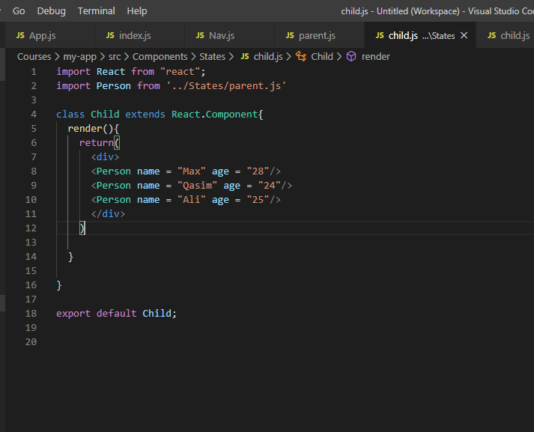

**Child component** but I name it parent:

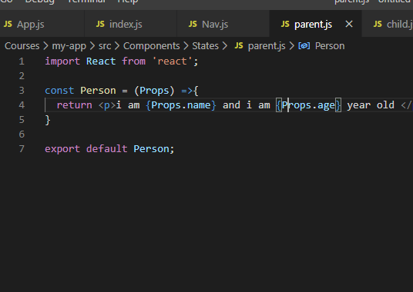

**States:**  state is an observable which holds data and change with the behavior, example when data change.

*States can only be used in class components.

*State is generally update by event handler.

**Child:**

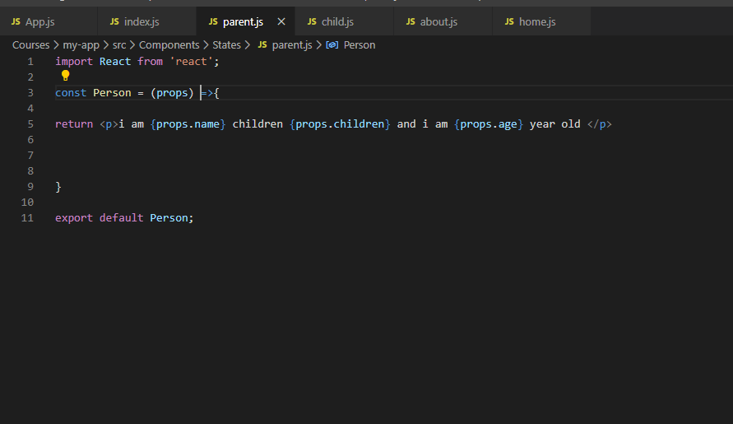

Parent:

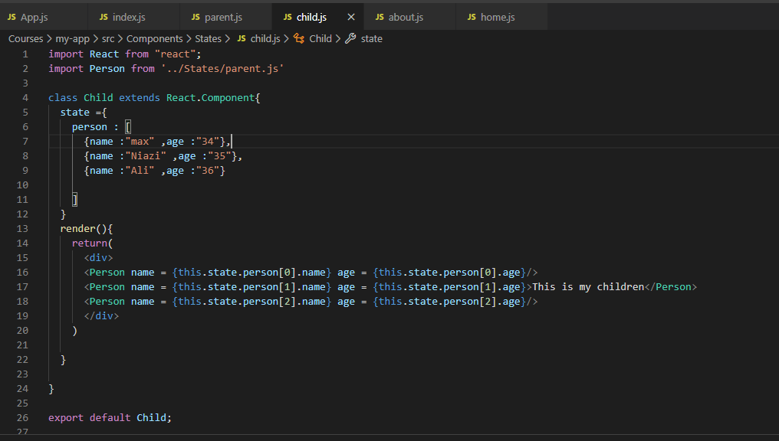

**Manipulating the state:** in this process we can change the value by using event handler.

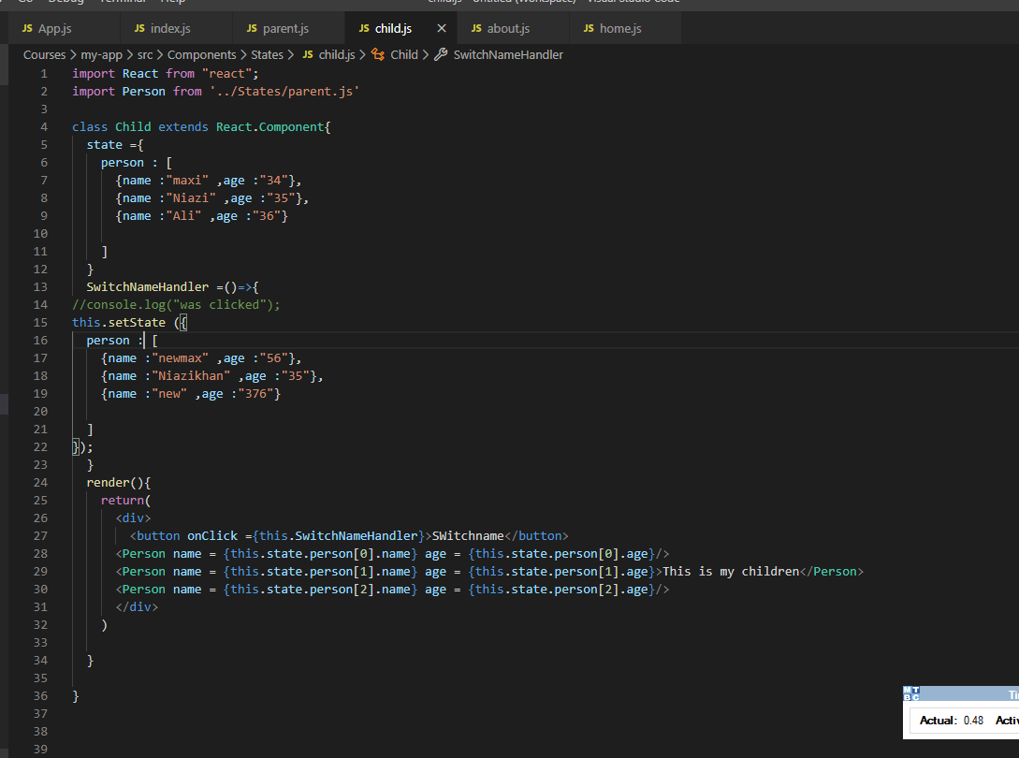

**Bind ().**

Bind method creates new function.

