uApply
uApply Agent
Immigration casework, from client folder to filled forms — run by an AI agent, on the consultant's own AI subscription.

Product concept and workflow overview for investors
September 2026 · Confidential

1. Executive summary
uApply already turns a client's immigration documents into structured case data and pre-filled IRCC forms for Regulated Canadian Immigration Consultants (RCICs). Today a consultant drives that through our web dashboard, and every AI step is billed to uApply.
uApply Agent changes who does the driving and who pays for the AI. The consultant points Claude Code or Codex — AI tools many professionals already subscribe to — at a client's folder and says “run this case”. The agent opens the case, uploads and classifies the documents, extracts the facts the forms need, settles doubts and conflicts with evidence, and prepares the auto-filled forms. The consultant confirms three things: the case setup, the legally significant decisions, and the final go-ahead.
Every AI call runs inside the consultant's own subscription. uApply's servers keep the rulebook, the quality control, the data and the audit trail — and pay nothing per case for AI.
Why it matters
Near-zero variable AI cost per case for uApply, which is the largest cost line in AI-heavy document products.
A new distribution channel: the product lives inside tools consultants already open every day.
The defensible part — pipeline, prompts, validation, form mappings, audit — stays on our servers. The commodity part — the model — is supplied by the customer.

2. The problem
A single study-permit or family application can involve 20–60 documents: passports, bank statements, employment letters, transcripts, marriage certificates, photos of documents taken on a phone. Much of an RCIC's billable week goes to reading them, re-typing facts into government forms, and chasing clients about the inconsistencies between them.
AI can do most of that reading and typing. The catch for a software company is cost: reading every page of every document with a capable model is expensive, and that cost scales with exactly the customers you want most — the busy ones.
- For the consultant: hours of data entry per case, errors that surface only when IRCC asks, and a separate web app to learn.
- For uApply: AI spend grows with usage, the model providers set the price, and margin is capped by it.
- For both: trust. A consultant is professionally liable for what is in the application; an AI that silently “decides” is not acceptable.

3. The idea
Consultants increasingly have a general-purpose AI agent on their computer — Claude Code from Anthropic or Codex from OpenAI — bought on a flat monthly subscription. These agents can read files, look at images, reason, and use tools that a vendor provides.
uApply Agent is that tool. We ship a small piece of software that plugs into Claude Code or Codex and gives it a safe, well-defined set of actions against a uApply case. The consultant's experience is one command in a folder:
cd ~/Clients/Zhang_Wei → /uapply:run
From there the agent does the work and stops to ask at the points that matter. When it finishes, the consultant has a fully populated case in uApply, a written report of what was decided and why, a list of questions to forward to the client, and forms ready for review and submission.

Three principles
- Local tokens. Every model call — reading a scanned page, naming a document, extracting a date, weighing two conflicting values — runs on the consultant's subscription. uApply makes no AI calls for that case.
- One pipeline. The agent is not a second product. It executes the same steps, with the same prompts and the same checks, as our web dashboard. Results land in the same database; the team sees them in the same screens.
- The consultant decides. The agent proposes; the RCIC approves anything with legal weight. Nothing is submitted to the government by the agent, ever.

4. How a case flows
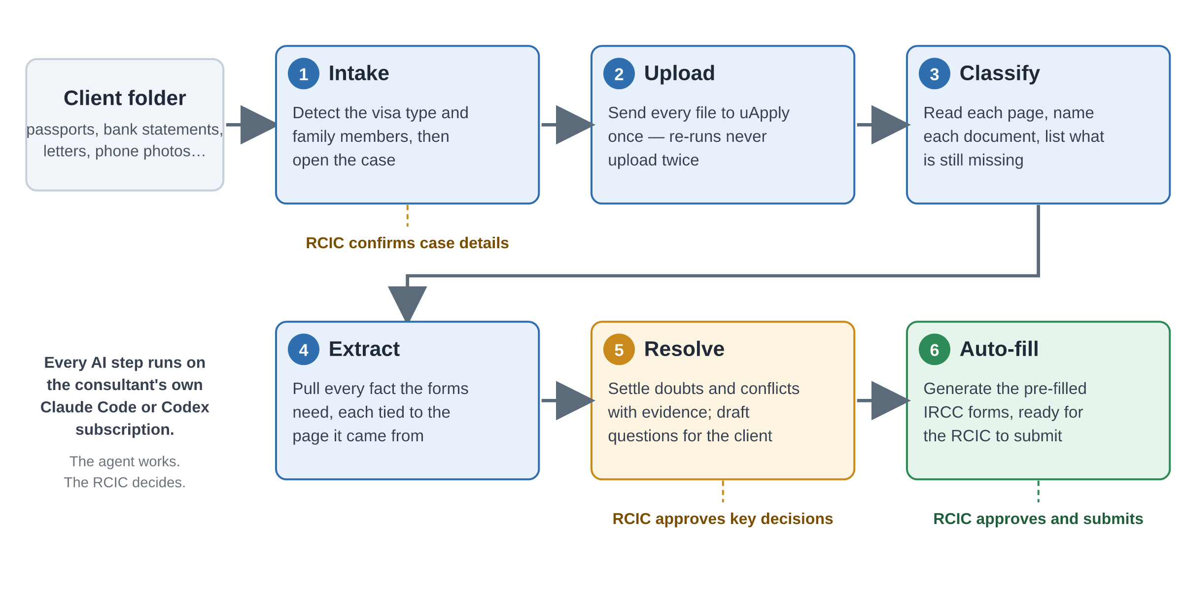
Figure 1 — The six stages. Amber and green stages end with an explicit consultant decision.
Stage | What the agent does | What the consultant does
1 Intake | Scans the folder, works out the likely visa type and family members, and proposes a case setup. | Confirms or corrects the proposal. The case is created only after a yes.
2 Upload | Sends each file to uApply once. Re-running later never uploads a file twice. | Nothing.
3 Classify | Reads every page, names each document (passport, bank statement, offer letter…), flags anything it is unsure of, and lists required documents that are missing. | Reviews the missing-documents list.
4 Extract | Pulls every fact the forms need — names, dates, addresses, employment and travel history, funds — each tied to the page and sentence it came from. | Nothing.
5 Resolve | Where documents disagree or a value is doubtful, weighs the evidence and either resolves it with a written rationale, or — for legally significant fields — proposes an answer. Drafts questions for the client where information is missing. | Approves or rejects proposals in one batch, in the chat or the dashboard. Forwards client questions.
6 Auto-fill | Checks the case is complete and conflict-free, then generates the pre-filled IRCC forms and data. | Approves the fill, reviews the forms, submits.

What “legally significant” means
Dates of birth, names, passport numbers and expiry, marital status, family relationships, refusal or criminal history, and any date that creates a gap in a travel, employment or education history.
The server, not the AI, holds this list. An agent cannot write these fields directly — it can only propose, and the consultant approves. This holds regardless of which AI is driving.

5. How it works under the hood
The system is split so that the customer supplies the expensive, commodity part (the model) and uApply keeps the differentiated part (the process, the rules and the data).
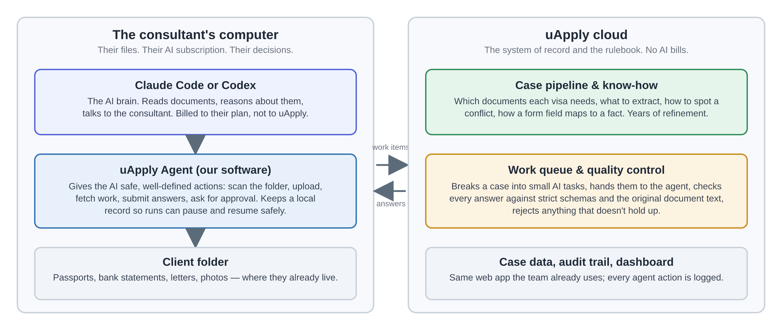
Figure 2 — What runs where.
The work queue is the key mechanism. When a case is set to run on the consultant's AI, uApply's pipeline does exactly what it does today — but at every point where it would call an AI model, it instead writes a small, self-contained work item: the exact instructions, the exact page or text to look at, and the exact shape the answer must take. The agent on the consultant's computer picks up the item, runs it on their model, and sends the answer back.
Quality control stays with us. Every returned answer is checked against a strict schema, and every quoted piece of evidence is verified against the original document text. Answers that do not hold up are rejected and re-run. A different AI cannot quietly change what ends up in a case.
It can pause for days. If the consultant closes their laptop or hits their subscription's usage limit, the case simply waits; nothing is lost and nothing on our side is tied up. When the agent comes back, it resumes exactly where it left off.
Two ways to run. Interactively — the consultant works inside Claude Code or Codex and answers questions as they come — or in batch, where a large family case is processed overnight and the consultant reviews the decisions in the morning.

6. Why this is good business
Dimension | Today (web dashboard) | With uApply Agent
AI cost per case | Paid by uApply to model providers; grows with usage. | Paid by the consultant through a subscription they already have. Near-zero for uApply.
Gross margin | Capped by provider pricing. | Software-like.
Distribution | Consultant must come to our web app. | Product lives inside Claude Code / Codex, where a growing share of professionals already work. Two ecosystems, one codebase.
Onboarding | Learn a new dashboard. | One command in the folder they already keep.
Data & lock-in | Case data in uApply. | Unchanged — plus a per-case audit trail of every agent decision, which the dashboard uses and competitors do not have.
Provider risk | Tied to specific model vendors and their prices. | Model-agnostic: whatever the consultant's tool runs. Server-side checks keep quality consistent across models.

What is defensible
- The rulebook. Which documents each visa type needs, what to extract from each, how facts map onto every field of every IRCC form, how to detect a conflict. This is years of refinement and it never leaves our servers.
- Validation. Schema and evidence checks that make any model's output trustworthy enough for a regulated professional to sign.
- The audit trail. Every value carries who set it — the AI, the consultant, or the consultant via the AI — with rationale and evidence. This is what makes AI usable in a liability-bearing profession.
- The whole loop. Intake to auto-fill, including the existing desktop form-filler. A coding-agent plugin alone does not replace that.

7. Trust, control and privacy
An AI acting on a client's immigration file needs stronger guardrails than a chatbot. Ours are enforced by our servers, not by asking the AI nicely.
Concern | How it is handled
The AI makes a wrong call | Non-critical values it resolves are logged with rationale and evidence and shown distinctly in the dashboard. Critical values it can only propose.
The AI acts beyond its remit | Agent access is scoped: it can work on cases in its own team; it cannot delete, bill, email a client, or submit to the government. Those actions do not exist for it.
A document contains malicious instructions | Work items are built by our servers and answers must fit a fixed shape; free text in a document cannot change what gets written. The worst case is a proposal the consultant sees.
Client privacy | Documents are read by the consultant's own AI account under their own terms. We say so in onboarding, recommend zero-retention plans, and offer a mode where the agent only sees the snippets our server provides.
Accountability | Append-only audit of every agent action, per case, visible in the dashboard.

8. Roadmap
Phase | Delivers | Proof point
0 Foundations | Backend groundwork: durable workflow engine, secure agent login, idempotent uploads, fixes to known rough edges. | Required for everything below.
1 Classification on local AI | First end-to-end slice: upload and classify a folder with zero uApply-side AI calls, from both Claude Code and Codex. | Ten mixed documents classified correctly on both tools.
2 Full pipeline | Reading, extraction and analysis on local AI; batch mode for large cases. | A 40-document family case completes overnight on a standard subscription, or pauses and resumes cleanly.
3 Intake & review | Case setup, the review queue, proposals and approvals, client questions, dashboard views. | ≥ 90 % of the agent's non-critical resolutions match the consultant's; 100 % of critical fields go through approval.
4 Auto-fill & release | Preflight, form generation, end-to-end /uapply:run, onboarding materials. | A consultant with no technical help completes a study-permit case from folder to forms.

Rollout: one internal team first, then three to five design-partner firms, then general availability after two evaluation cycles. The web dashboard remains available throughout, and any case can fall back to uApply-paid AI at any time.

9. Risks and how we address them
Risk | Mitigation
Different models give different quality (Claude vs GPT vs our current provider) | A fixed evaluation set of real cases, scored on every release for each tool. Steps that underperform on a given model can be kept on uApply's side per case.
Subscription usage limits interrupt long cases | Work pauses and resumes durably; batch mode spreads large cases; per-case fallback to uApply-paid AI is one setting.
Coding-agent tools change quickly | Tool-specific glue is isolated in one small module and re-tested each release; the workflow and rules are tool-agnostic.
Our prompts become visible on the consultant's machine | Steps we regard as core IP can stay server-side; the rulebook, form mappings and validation never leave our servers.
Consultants are cautious about AI acting on files | Explicit gates, full audit trail, no government submission, privacy-conscious defaults, and a server-only evidence mode.

10. In one paragraph
uApply Agent lets an immigration consultant hand a client's folder to the AI assistant they already pay for and get back a complete, evidence-backed, audit-logged case with forms ready to submit — while uApply keeps the rulebook, the quality control and the data, and stops paying for AI per case. It turns our biggest variable cost into the customer's fixed cost, and puts the product inside the tools professionals are moving to.

Contact: contact@uapply.io
Technical design documentation for this concept is maintained in the uApply engineering repository.

