# Scenario 3: Odds in the game do not appear to be correct.

## Scenario Description

Crown and Anchor games have an approximate 8% bias to the house. So the win ratio should approximately equal 0.42. This does not appear to be the case in multiple runs.

## Version Control

|  |  |  |  |
| --- | --- | --- | --- |
| Version # | Date | Author | Description |
| 0.1 | 12/10/2016 | Upama Aryal | Initial Version |
| 0.2 | 20/10/2016 | Upama Aryal | Final Version |

## Test Scripts

* Win Ratio

## Use Case

Player Loses

## Test Components/Requirements

Dice

Game

Player

## Script 1: Normal Play – Player cannot reach betting limit

### Script Description

Player plays one match and loses but the win ratio is not approx. 0.42 as Crown and Anchor games have an approx. 8% bias to the house.

### Testing Requirements

Play with three identical dice with the faces of each dice marked with the symbols of a crown, anchor, heart, diamond, club and spade.

### Script Steps

| **Step #** | **Test Action** | **Expected Results** | **Pass/ Fail** |
| --- | --- | --- | --- |
| 1 | Dealer throws the dice |  |  |
| 2 | Symbol doesn’t appear on one or more of the uppermost face of the three dice |  |  |
| 3 | Player wins and loses various turns in one game. | Win ratio should be approx. 0.42 | Fail |

### Output from the Automated Test

Figure 3 and figure 4 shows that Fred win ratio is 0.61 in one run and 0.40 in another run where as it should have been 0.42.

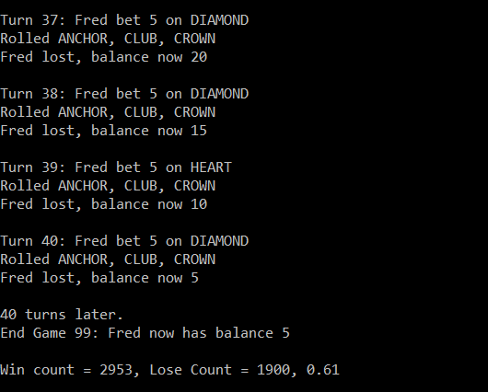

Figure 3 – Bug 3 (a)

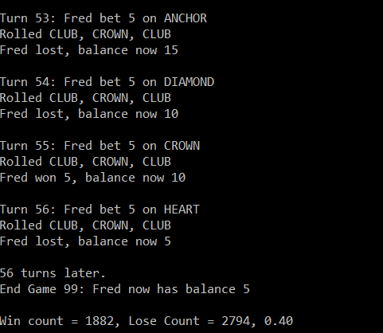

Figure 4 - Bug 3 (b)