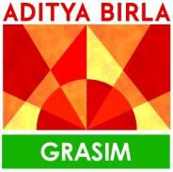

May 18, 2026

To whomsoever it may concern

This is to certify that Mr. Anurag Yadav, a student of Mumbai University has successfully completed his Internship at TRADC (Grasim Industries Limited), for the period of 5 weeks starting from 17th April 2026 to 18th May 2026.

During his tenure with us as Intern his conduct was good.

The project undertaken was “HRMS” under the guidance of Urvish sangvi.

We wish his all the best in his future endeavor. For Grasim Industries Ltd.
Sheba Banerjee

Head – Human Resources TRADC

Sensitivity: General
Grasim Industries Limited
Aditya Birla Centre, ‘A’ wing, 2nd Floor, S.K. Ahire Marg, Worli, Mumbai 400 030, India T: +91 22 6652 5000 / 2499 5000 | F: +91 22 6652 5114 / 2499 5114
E: grasimcfd@adityabirla.com | W: www.grasim.com | CIN: L17124MP1947PLC000410 Regd. Office : P.O. Birlagram, Nagda – 456 331 (M.P.)

