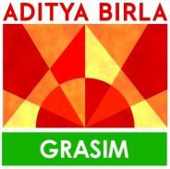

May 26, 2026

To whomsoever it may concern

This is to certify that Mr. Varun xyz, a student of ASBM has successfully completed his Internship at MBDD (Grasim Industries Limited), for the period of 5 weeks starting from 20th April 2026 to 25th May 2026.

During his tenure with us as Intern his conduct was good.

The project undertaken was “xyz” under the guidance of Gaurav Shrivastava.

We wish his all the best in his future endeavor. For Grasim Industries Ltd.
Sheba Banerjee

Head – Human Resources MBDD

Sensitivity: General
Grasim Industries Limited
Aditya Birla Centre, ‘A’ wing, 2nd Floor, S.K. Ahire Marg, Worli, Mumbai 400 030, India T: +91 22 6652 5000 / 2499 5000 | F: +91 22 6652 5114 / 2499 5114
E: grasimcfd@adityabirla.com | W: www.grasim.com | CIN: L17124MP1947PLC000410 Regd. Office : P.O. Birlagram, Nagda – 456 331 (M.P.)

