Covid Cases for April May June in NL BE

Marc A.T. Teunis

r Sys.time()

## Data  
#read the Dataset sheet into “R”. The dataset will be called "data".  
#data <- read_csv(  
# "https://opendata.ecdc.europa.eu/covid19/casedistribution/csv",   
# na = "")  
source(  
 here::here(  
 "data-raw",  
 "D010",  
 "supporting",  
 "covid_ecdc_cases_geography.R"))

## Cases

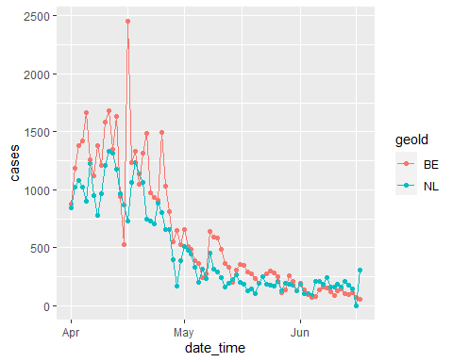

Cases for April May June and Belgium, Netherlands

## Deaths

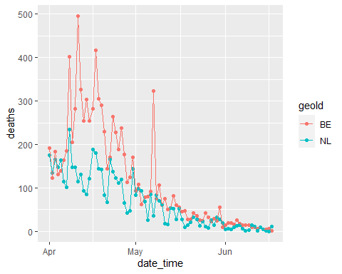

Deaths for April May June and Belgium, Netherlands