**Vendor Analysis through Google API**

The Google Places API Web Service is a service that returns information about places defined within this API as establishments, geographic locations, or prominent points of interest using HTTP requests.

Developed for Risk Management the objective is to utilize this information to strengthen auditing process when investigating vendors and looking for potential fraud.

The API Web Service is available free of cost with a daily quota of 1000 requests per day. This quota can be increased to 150,000 requests by creating a billing account and registering a credit card on the google developer console. This is done purely for identification purposes and the billing account holder will not bear any charges.

**Setup & Tools:**

* Sign in to google developer console from your google account, and follow instructions on creating a project and generating the required API key [https://console.developers.google.com](https://console.developers.google.com/)
* The Places API key is used by a Python (Scripting Language) program capable of generating any number of HTTP request depending upon the vendor records provided as input
* The program scrapes the required information from the JSON pages generated for each request and spits out one spreadsheet with all the output

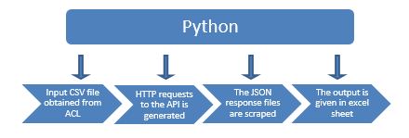

**Output:**

* The API generates information like geographic location, whether the input is a business or a street address and the type of business it is example restaurant, lawyer, insurance agency etc.

Limitations:

* The API is capable of handling 150,000 requests per day, it is a paid service for larger quota
* The API is only capable of returning information provided by google as per its regulations which are subject to change