| **Experiment No. – 1** | | | | |
| --- | --- | --- | --- | --- |
| **Date of Performance:** | **8/1/2025** | | | |
| **Date of Submission:** | **15/1/2025** | | | |
| Program Execution/  formation/  correction/  ethical practices  (06) | Timely  Submission  (01) | Viva  (03) | Experiment  Total (10) | Sign with Date |
|  |  |  |  |  |

**Experiment No. 1**

**Web Analytics using open source tool Matomo.**

**1.1 Aim:** Study Web Analytics using open source tool Matomo.

**1.2 Course Outcome: 3.ITLR0603.1** Understand the basic concepts related to web analytics and semantic web.

**1.3 Learning Objectives:** Study and install Web analytic tools like Matomo, Open Web Analytics, AWStats, Countly, Plausible and measure the metrics of websites.

**1.4 Requirement:**

1.5 Related Theory:

**What is Web Analytics?**

Web Analytics or Online Analytics refers to the analysis of quantifiable and measurable data of your website with the aim of understanding and optimizing the web usage.

Web analytics focuses on various issues. For example,

* Detailed comparison of visitor data, and Affiliate or referral data.
* Website navigation patterns.
* The amount of traffic your website received over a specified period of time.
* Search engine data.

Web analytics improves online experience for your customers and elevates your business prospects. There are various Web Analytics tools available in the market. For example, Google Analytics, Kissmetrics, Optimizely, etc.

**Metrics of Web Analytics:**

**Count**

It is the most basic metric of measurement. It is represented as a whole number or a fraction. For example,

* Number of visitors = 12999, Number of likes = 3060, etc.
* Total sales of merchandise = $54,396.18.

**Ratio**

It is typically a count divided by some other count. For example, Page views per visit.

**Key Performance Indicator (KPI)**

It depends upon the business type and strategy. KPI varies from one business to another.

**Measurements conducted in web analytics**

**Engagement Rate**

It shows how long a person stays on your web page. What all pages he surf. To make your web pages more engaging, include informative content, visuals, fonts and bullets.

**Bounce Rate**

If a person leaves your website within a span of 30 sec, it is considered as a bounce. The rate at which users spin back is called the bounce rate.

To minimize bounce rate include related posts, clear call-to-action and backlinks in your webpages.

**Dashboards**

Dashboard is single page view of information important to user. You can create your own dashboards keeping in mind your requirements. You may keep only frequently viewed data on dashboard.

**Event Tracking**

Event tracking allows you to track other activities on your website. For example, you can track downloads and sign-ups through event tracking.

**Traffic Source**

You can overview traffic sources. You can even filter it further. Figuring out the key areas can help you learn about the area of improvement.

**Annotations**

It allows you to view a traffic report for past time. You can click on graph and type in to save it for future study.

**Visitor Flow**

It gives you a clear picture of pages visited and the sequence of the same. Understanding users’ path may help you in re-navigation in order to give customers hassle-free navigation.

**Content**

It gives you insight about the website's content section. You can see how each page is doing, website loading speed, etc.

**Conversions**

Analytics lets you track goals and path used to achieve these goals. You can get details regarding, product performances, purchase amount, and mode of billing.

Web Analytics offer you more than this. All you need is to analyze things minutely and keep patience.

**Page Load Time**

More is the load time, the more is bounce rate. Tracking page load time is equally important.

**Behavior**

Behavior lets you know page views and time spent on website. You can find out how customer behaves once he is on your website.

**Web analytics tools**

Web analytics tools are **tools designed to track, measure, and report on website activity including site traffic, visitor source, and user clicks**. Using web analytics tools helps you understand what's happening on your website and get insights on what's working and what's not.

## Matomo

It is free and open-source traffic analytics. It is used for measuring website traffic and user behaviour. it is free for self-hosted users.

Used by 2% of polled experts, Matomo (formerly known as Piwik) is a privacy-focused free analytics platform. You can self-host Matomo on your own server or WordPress installation, or pay for a cloud account.

**1.6 Procedure:**

**Installation of Matomo Tool**

**Step 1:**

**Installing XAMPP**

* Download XAMPP and Install
* Open **XAMPP Control Panel** and start Apache and MySQL

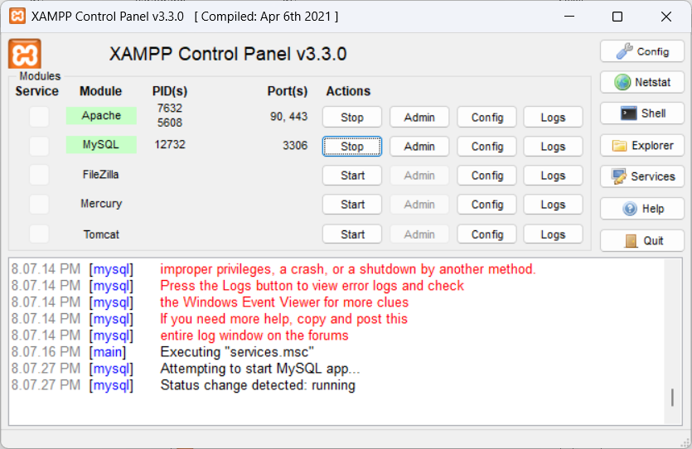

* Assuming you installed xampp under **C:\xampp** folder
* Create a folder which contains your website under *htdocs* -  **C:\xampp\htdocs\Shopping List**
* It should contain the important files, viz index.html, style.css & index.js, required for a website to run.

**Step 2:**

* Open the link: <http://localhost/phpmyadmin/>

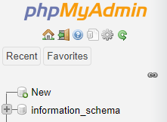

**Step 3:**

* Click **New** (from left panel) to create a database

| https://lh4.googleusercontent.com/8oltlt7NFBppmEU3JGTQXrAIDxhRsGpZ8-vPK7nOaRkuoy1pL418SG7wyaRT-4QMyDOYSdFIL3DS5tHYAzMMyDDKaUc3dfxwZrVZadmAlEoySQJ6s5bYDd1yvkfdmF3Y36ZgSydN |
| --- |

* Enter database name **matomodb** and click on the **Create** button
* This database name will be used when installing Matomo

**Step 4:**

**Installing Matomo**

* [Download Matomo On-Premise Zip file](https://matomo.org/download/)
* Copy extracted **matomo** folder under **C:\xampp\htdocs**
* Now visit following link in the browser: <http://localhost/matomo>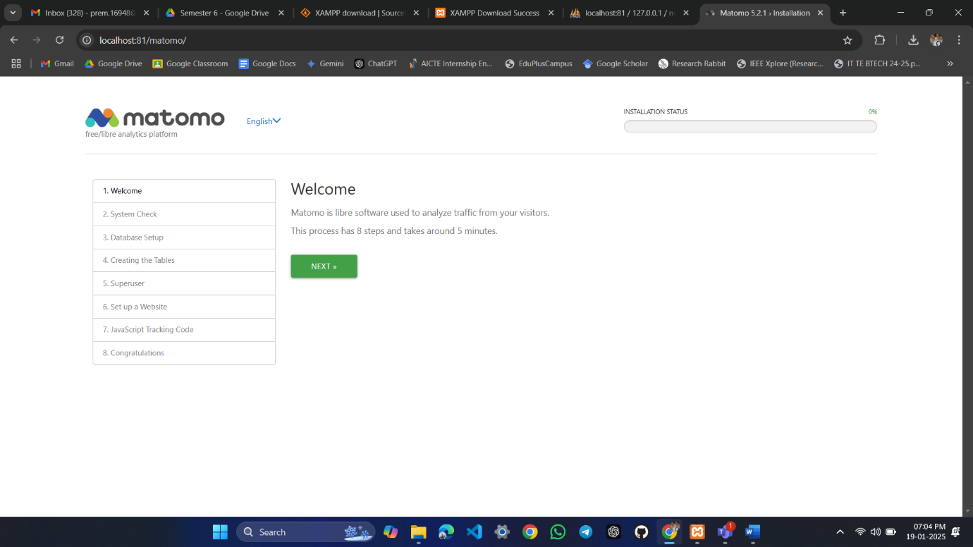

**Step 5:**

* Click **NEXT**
* For **System Check** click **NEXT**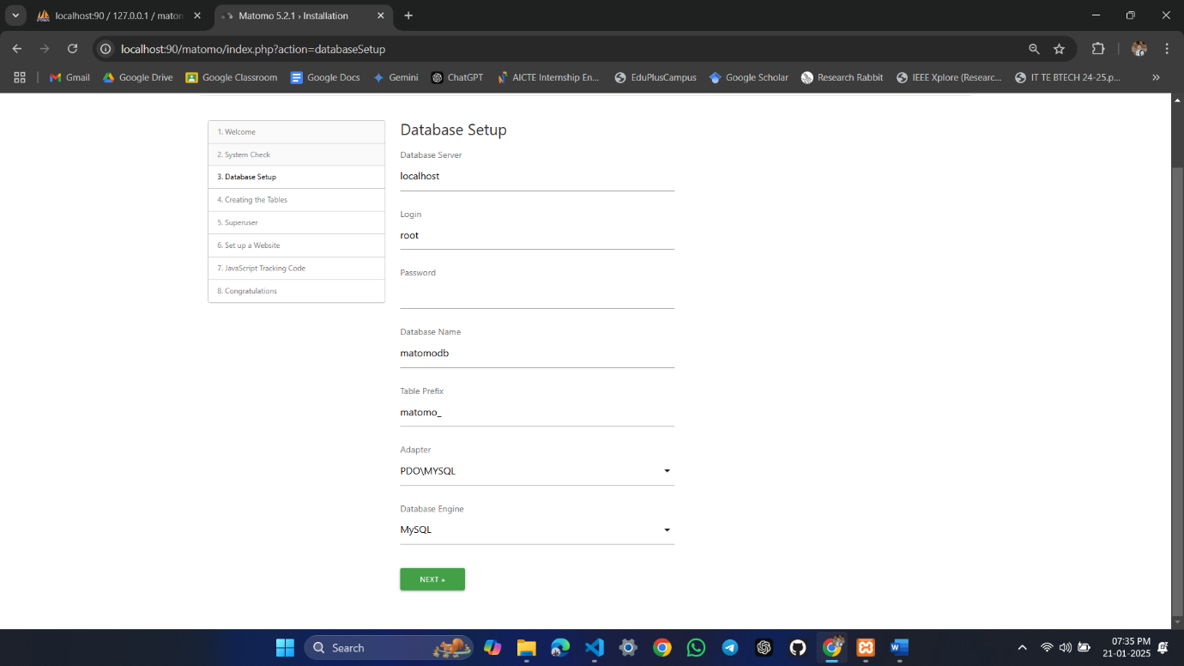

**Step 6:**

* Use the above settings for **Database Setup** and click **NEXT**
* For **Creating the Tables** click **NEXT**

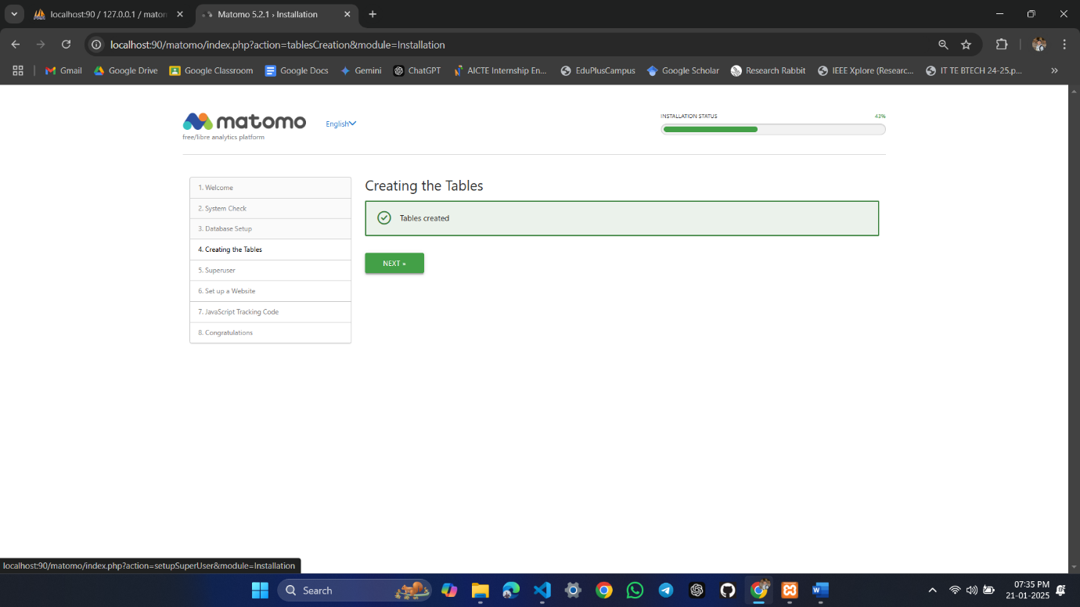

**Step 7:**

* For Super User enter any Super user login name, enter password (more than 6 characters) and email and then click **NEXT**

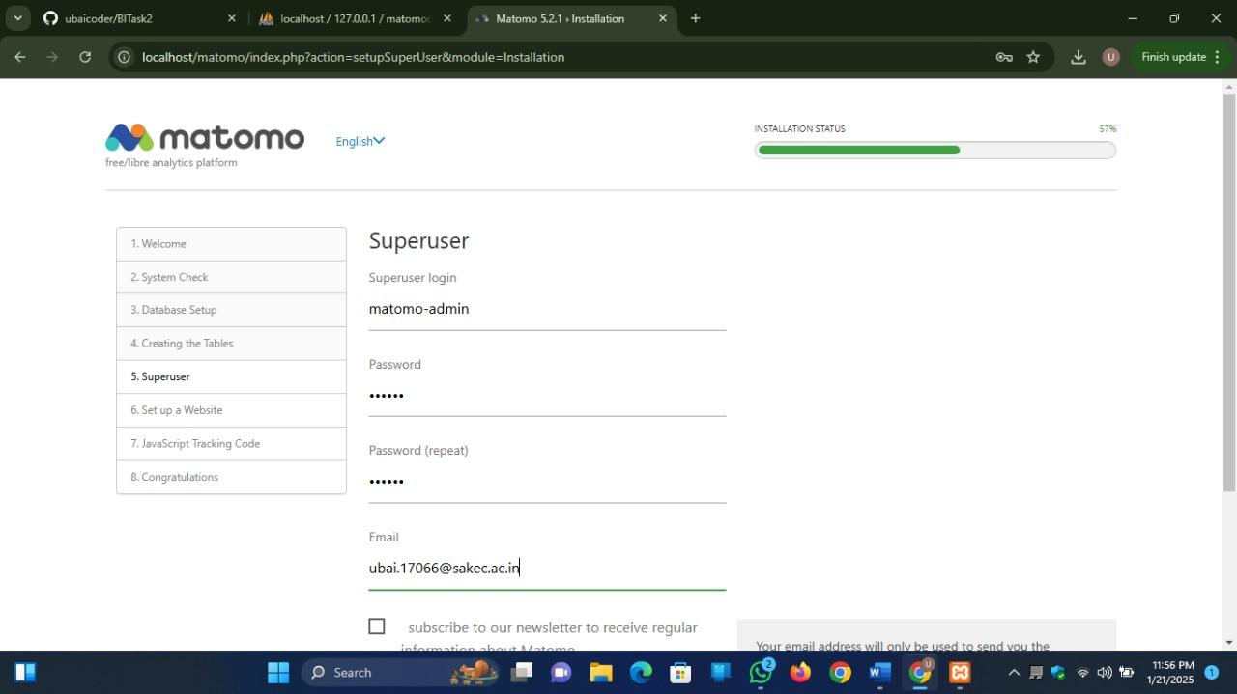

**Step 8:**

* For **Setup a Website** enter the given details and click **NEXT**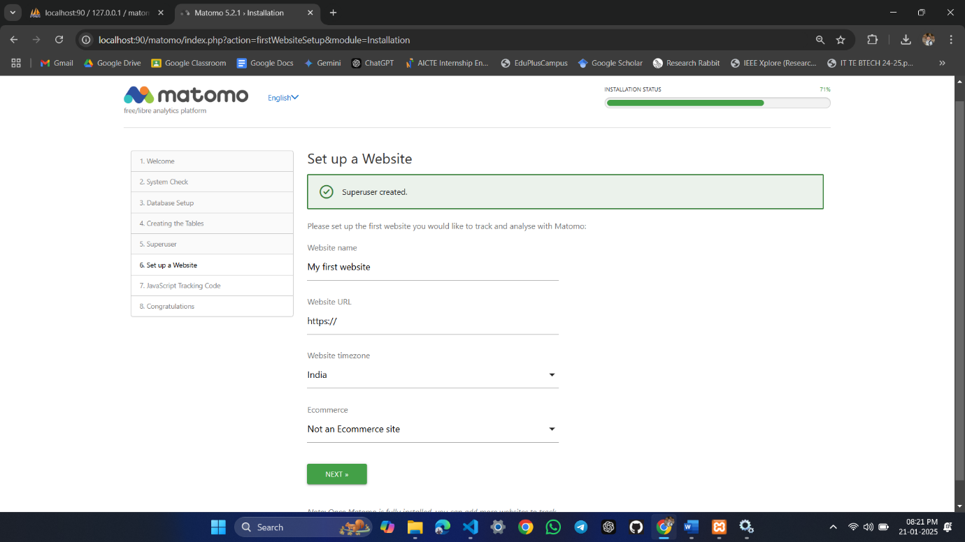
* Copy the JavaScript tracking code to the **index.html** file inside the **<head>** tag as shown below. The same code will be given by Matomo after giving our website name and URL.

**Code:**

<!-- Matomo -->

<script>

var _paq = window._paq = window._paq || [];

/* tracker methods like "setCustomDimension" should be called before "trackPageView" */

_paq.push(['trackPageView']);

_paq.push(['enableLinkTracking']);

(function() {

var u="//localhost:90/matomo/";

_paq.push(['setTrackerUrl', u+'matomo.php']);

_paq.push(['setSiteId', '2']);

var d=document, g=d.createElement('script'), s=d.getElementsByTagName('script')[0];

g.async=true; g.src=u+'matomo.js'; s.parentNode.insertBefore(g,s);

})();

</script>

<!-- End Matomo Code -->

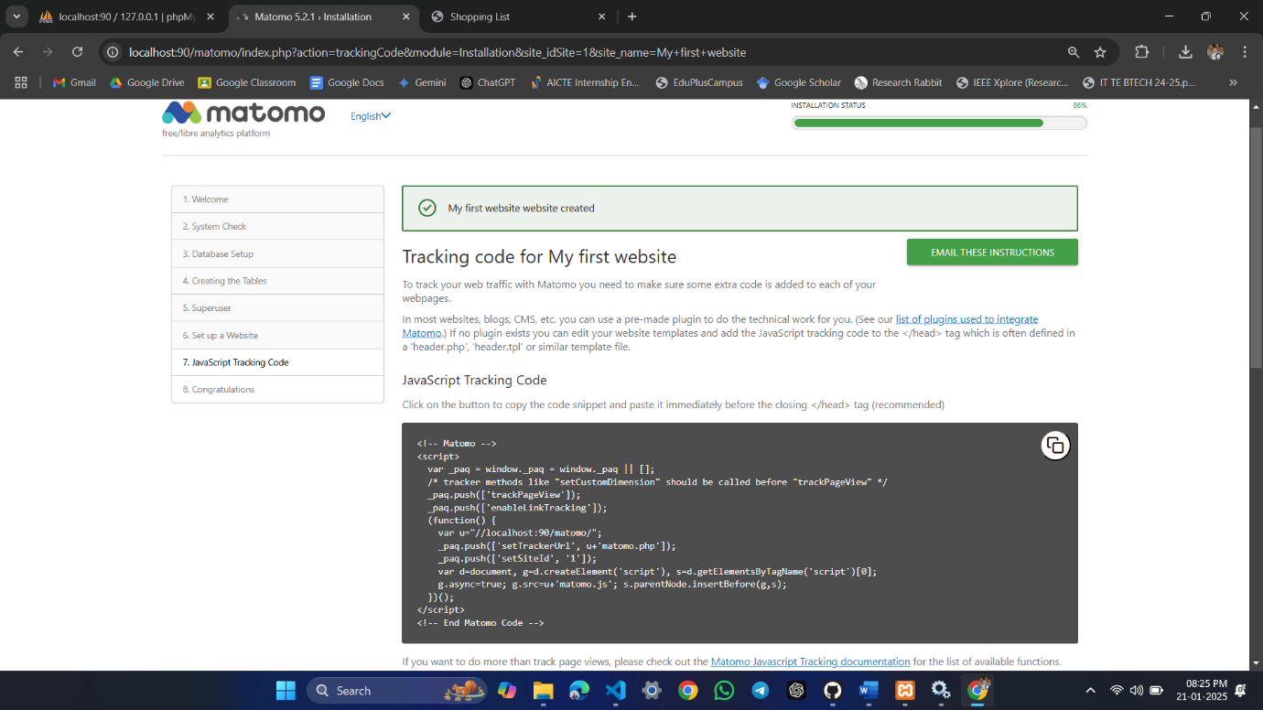

**Step 9:**

* Click **NEXT**
* Click **CONTINUE TO MATOMO**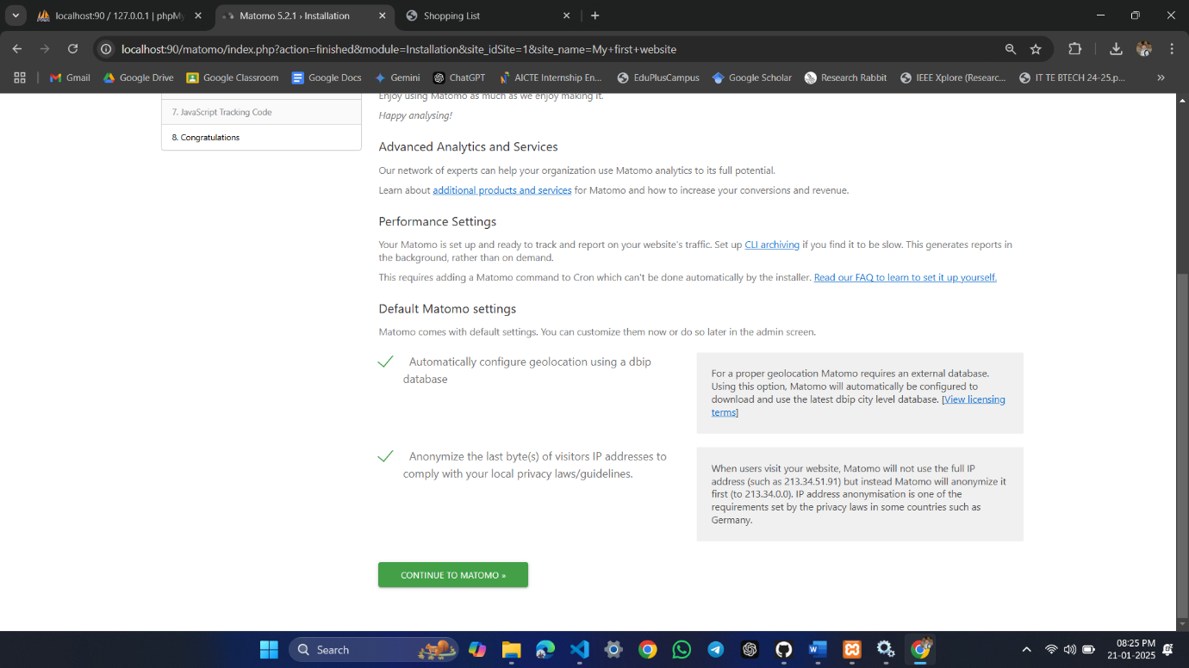
* Use Super user login name and password for login

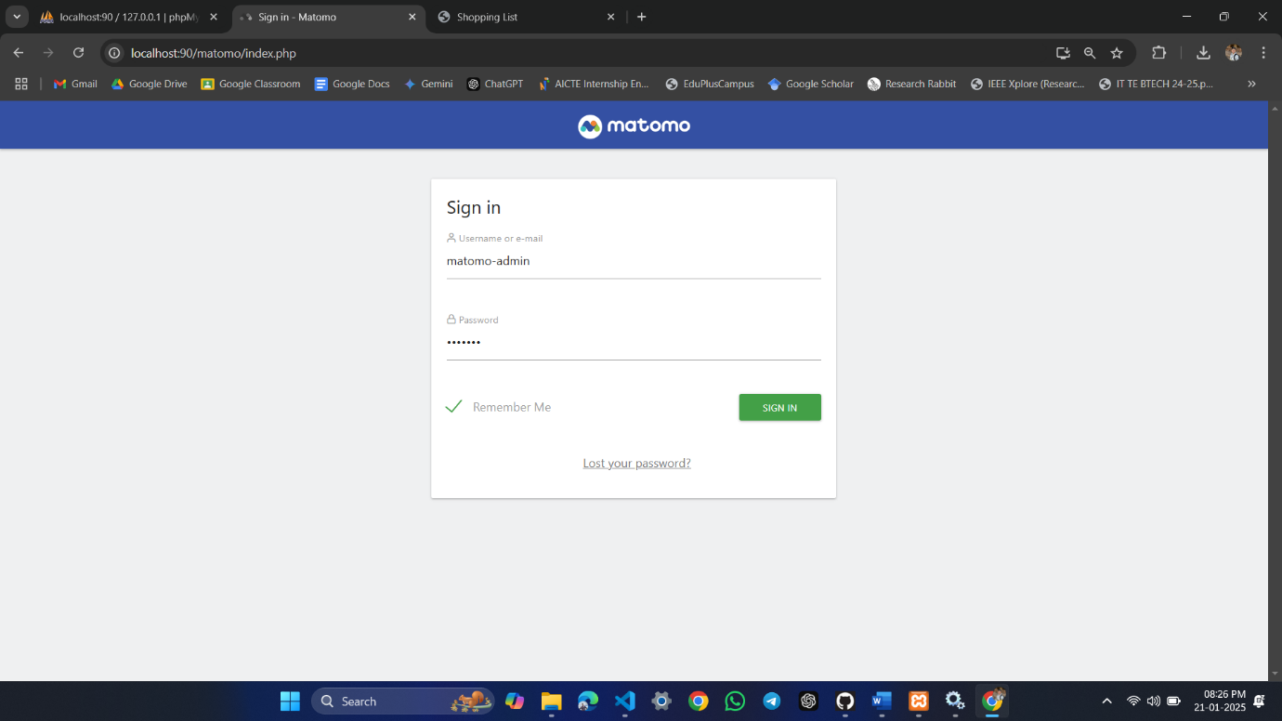

* Check **All Website** and **Dashboard** links

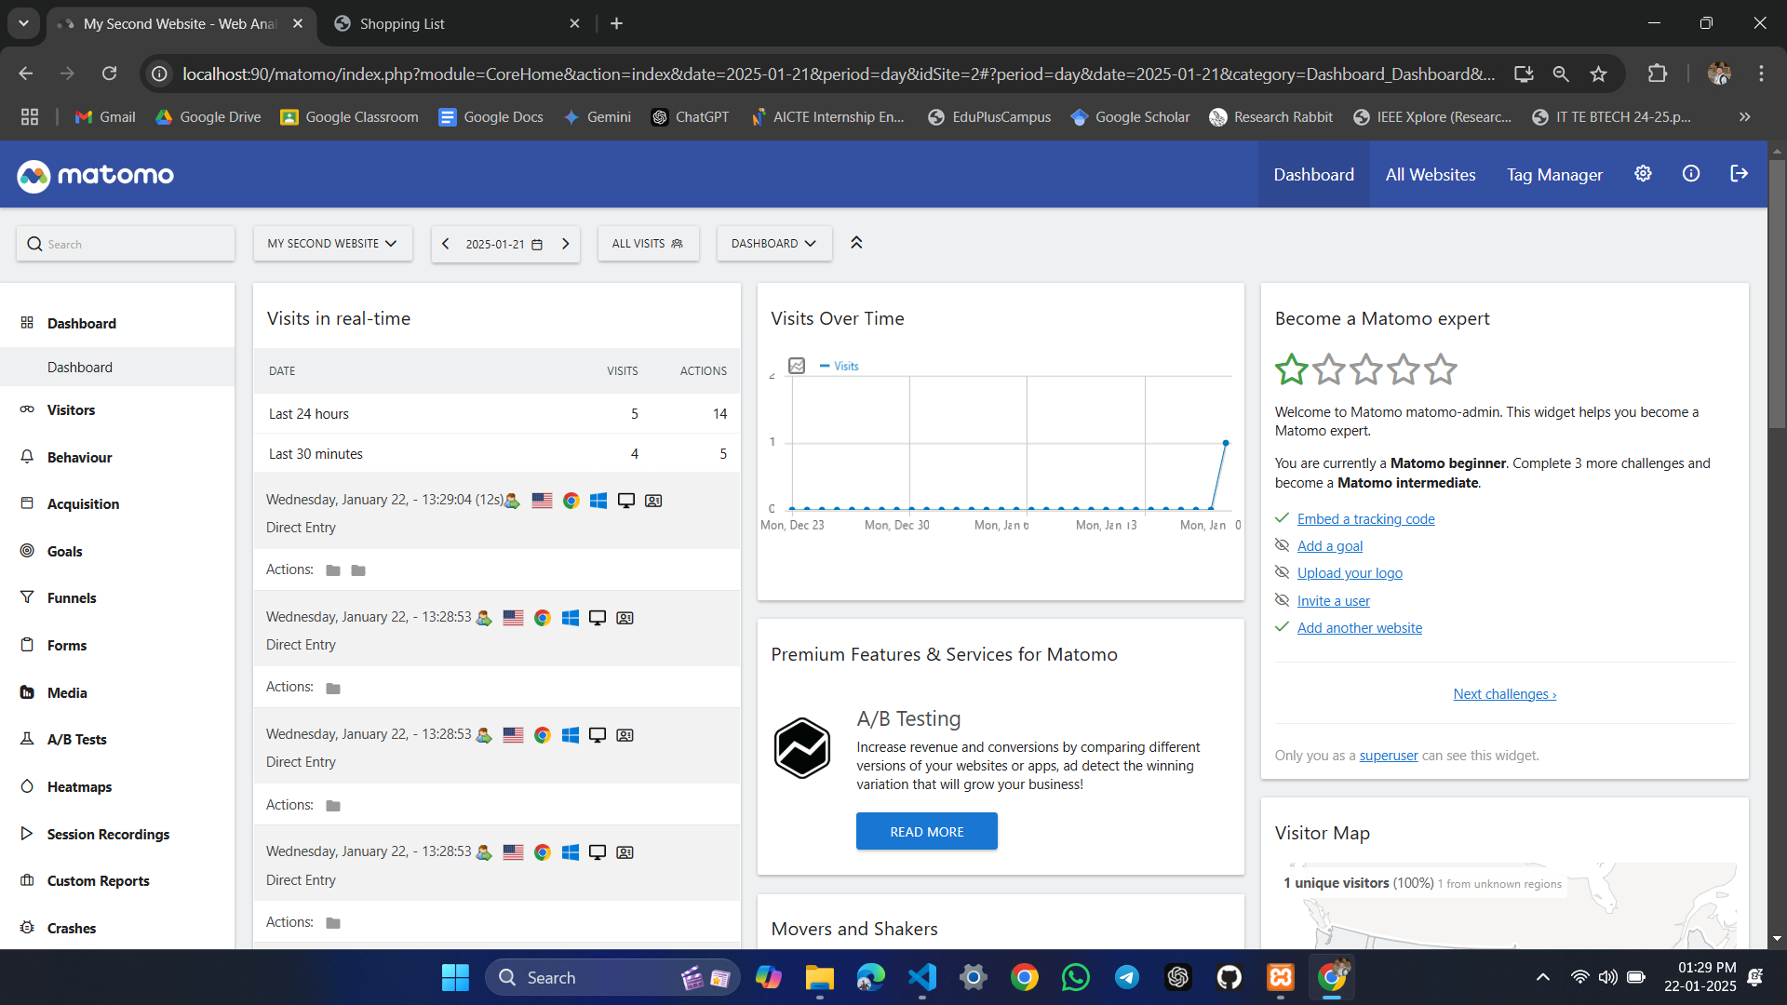

**1.8 Conclusion:**: Thus we have studied the Matomo Web Analytic tool for measuring website traffic and user behaviour.

**1.9 Questions:**

1. **What is web analytics?**

Web analytics is the process of collecting, measuring, analyzing, and reporting on web data to understand and optimize website usage.

1. **What key metric in Matomo tells how engaging a website content is for visitors?**

Metrics like "Average Time on Page" and "Bounce Rate" can indicate engagement. Higher time on page and lower bounce rates generally suggest more engaging content.

1. **What information does Matomo provide about the technology used by website visitors?**

In the "Visitors" section, reports like "Operating System," "Browser," and "Screen Resolution" show the different technologies your audience uses to access your site. This can inform your design and development decisions.