| **Experiment No. – 4** | | | | |
| --- | --- | --- | --- | --- |
| **Date of Performance:** | **29/1/25** | | | |
| **Date of Submission:** | **5/2/25** | | | |
| Program Execution/  formation/  correction/  ethical practices  (06) | Timely  Submission  (01) | Viva  (03) | Experiment  Total (10) | Sign with Date |
|  |  |  |  |  |

**Experiment No. 4**

**4.1 Aim:**  Design a single page Web application using AngularJS Framework.

**4.2 Course Outcome:** CO2: Understand how TypeScript and AngularJS framework can build dynamic, responsive single-page web applications

**4.3 Learning Objectives:** To learn how to create a responsive single-page application using AngularJS, understand the structure of AngularJS modules, controllers, and two-way data binding, and implement dynamic rendering of content.

**4.4 Requirement:**

* Visual Studio Code / Any IDE
* AngularJS Library (CDN)
* Browser (Chrome/Edge/Firefox)
* Basic HTML/CSS knowledge

4.5 Related Theory:

AngularJS is a JavaScript-based open-source front-end web framework maintained by Google. It enables developers to create dynamic single-page applications (SPAs). SPAs load a single HTML page and dynamically update content as the user interacts with the app.

Key Concepts in AngularJs:

1. Modules: Define the main application module using angular.module.
2. **Controllers:** Logic handlers tied to the HTML view using ng-controller.
3. **Data Binding:** Two-way binding using ng-model.
4. **Directives:** Built-in tags like ng-repeat, ng-click, and custom directives for reusable components.
5. **Single Page Structure:** Uses routing to change views without reloading the page.

4.6 Procedure:

Step 1: Include AngularJS library via CDN in the HTML file.

Step 2: Define a module and a controller in the script.

Step 3: Use AngularJS directives for data binding and user interaction.

Step 4: Display dynamic content based on user input.

Step 5: Run the application in a browser and test the SPA behavior.

**4.7 Program and Output:**

<!DOCTYPE html>

<html lang="en">

<head>

<meta charset="UTF-8" />

<meta name="viewport" content="width=device-width, initial-scale=1.0" />

<title>Grade Card</title>

<link href="https://cdn.jsdelivr.net/npm/bootstrap@5.3.3/dist/css/bootstrap.min.css" rel="stylesheet" />

<script src="https://ajax.googleapis.com/ajax/libs/angularjs/1.6.9/angular.min.js"></script>

</head>

<body>

<h1 class="text-center mt-3">Grade Card</h1>

<h2 class="text-center mt-5 fw-bold">B.TECH INFORMATION TECHNOLOGY</h2>

<div class="container mt-5">

<p><strong>Permanent Register Number:</strong> 22UF17066IT045</p>

<p><strong>Name of Student:</strong> Ubai Faiyaz Ratangiri</p>

<p><strong>Seat No:</strong> RWI5090</p>

<p><strong>Month and Year of Examination:</strong> Dec 2024</p>

</div>

<!-- AngularJS App & Initialization Starts Here -->

<div class="container" ng-app="" ng-init="

se=[3,21]; cns=[3,24]; ip=[3,21];

eeb=[2,20]; sel=[1,10]; cnsl=[1,10];

ipl=[1,10]; devo=[2,20]; pce=[1,9];

mini=[2,20]; datas=[3,24];

creditT=se[0]+cns[0]+ip[0]+eeb[0]+sel[0]+cnsl[0]+ipl[0]+devo[0]+pce[0]+mini[0]+datas[0];

creditP=se[1]+cns[1]+ip[1]+eeb[1]+sel[1]+cnsl[1]+ipl[1]+devo[1]+pce[1]+mini[1]+datas[1];

">

<table class="table table-bordered text-center">

<thead class="table-dark">

<tr>

<th>Sr.No.</th>

<th>Course Code</th>

<th>Course Title</th>

<th>Awarded Grade</th>

<th>Grade Point (G)</th>

<th>Course Credit (C)</th>

<th>Credit Point (G x C)</th>

</tr>

</thead>

<tbody>

<tr><td>1</td><td>ITCR0501</td><td>SOFTWARE ENGINEERING</td><td>C</td><td>7</td><td>3</td><td>21</td></tr>

<tr><td>2</td><td>ITCR0502</td><td>CRYPTOGRAPHY AND NETWORK SECURITY</td><td>B</td><td>8</td><td>3</td><td>24</td></tr>

<tr><td>3</td><td>ITCR0503</td><td>INTERNET PROGRAMMING</td><td>C</td><td>7</td><td>3</td><td>21</td></tr>

<tr><td>4</td><td>ITCR0504</td><td>ENTREPRENEURSHIP AND E-BUSINESS</td><td>O</td><td>10</td><td>2</td><td>20</td></tr>

<tr><td>5</td><td>ITCR0505</td><td>SOFTWARE ENGINEERING LAB</td><td>O</td><td>10</td><td>1</td><td>10</td></tr>

<tr><td>6</td><td>ITCR0506</td><td>CRYPTOGRAPHY AND NETWORK SECURITY LAB</td><td>O</td><td>10</td><td>1</td><td>10</td></tr>

<tr><td>7</td><td>ITCR0507</td><td>INTERNET PROGRAMMING LAB</td><td>O</td><td>10</td><td>1</td><td>10</td></tr>

<tr><td>8</td><td>ITCR0508</td><td>DEVOPS LAB (SKILL BASED LAB)</td><td>O</td><td>10</td><td>2</td><td>20</td></tr>

<tr><td>9</td><td>ITCR0509</td><td>PROFESSIONAL COMMUNICATION & ETHICS-2</td><td>A</td><td>9</td><td>1</td><td>9</td></tr>

<tr><td>10</td><td>ITCR0510</td><td>MINI PROJECT 2A - WEB BASED</td><td>O</td><td>10</td><td>2</td><td>20</td></tr>

<tr><td>11</td><td>ITCR0511</td><td>ADVANCED DATA STRUCTURES</td><td>B</td><td>8</td><td>3</td><td>24</td></tr>

<tr class="table-secondary fw-bold">

<td colspan="5" class="text-center">Total</td>

<td>{{creditT}}</td>

<td>{{creditP}}</td>

</tr>

</tbody>

</table>

<h3 class="mt-4">CGPA: {{ (creditP / creditT).toFixed(2) }}</h3>

</div>

<script src="https://cdn.jsdelivr.net/npm/bootstrap@5.3.3/dist/js/bootstrap.bundle.min.js"></script>

</body>

</html>

Output:

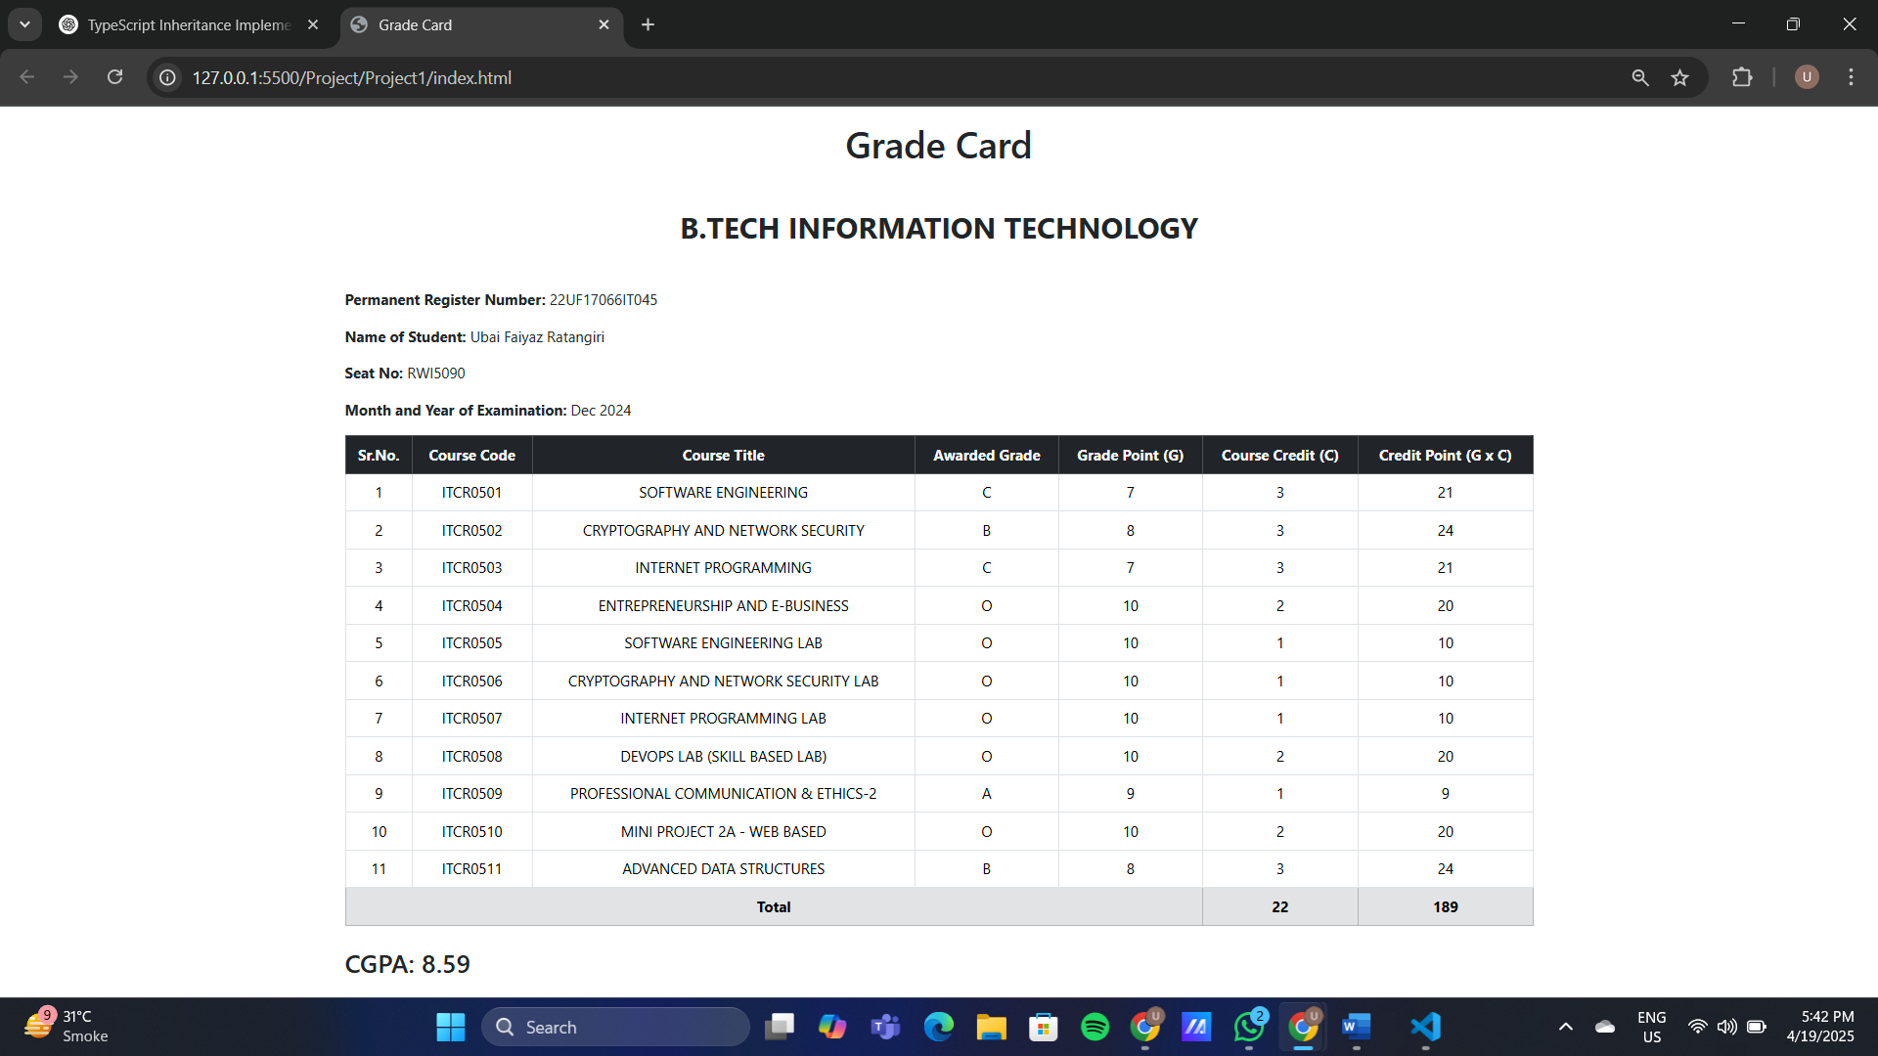

**4.8 Conclusion:** The experiment successfully demonstrated the creation of a single-page web application using AngularJS. It showcased the dynamic rendering of content, two-way data binding, and the use of modules and controllers to maintain a clean structure.

**4.9 Questions:**

1. What is the role of ng-model in AngularJS?

ng-model binds the input field to a variable in the controller, enabling two-way data binding.

1. How does AngularJS enable single-page applications?

AngularJs loads a single HTML page and updates only parts of it dynamically using routing and data binding, avoiding full-page reloads.

1. What is the difference between a controller and a module in AngularJS?

A module defines the main container for an AngularJS app, while controllers handle the business logic and data within a specific scope of the app..