Comsats University Islamabad

MOBILE APPLICATION DEVELOPMENT ASSIGNMENT 02

**NAME: Ubaid Khan Khalil**

**REG. NO: SP20-BSE-027**

**CLASS: BSE-7A**

**SUBMITTED TO: MR. MUHAMMAD KAMRAN**

**DATE: 15-APRIL-2023**

**Q1: Array functions in JavaScript with examples.**

1. push

This method adds one or more elements to the end of an array and returns the new length of the array.

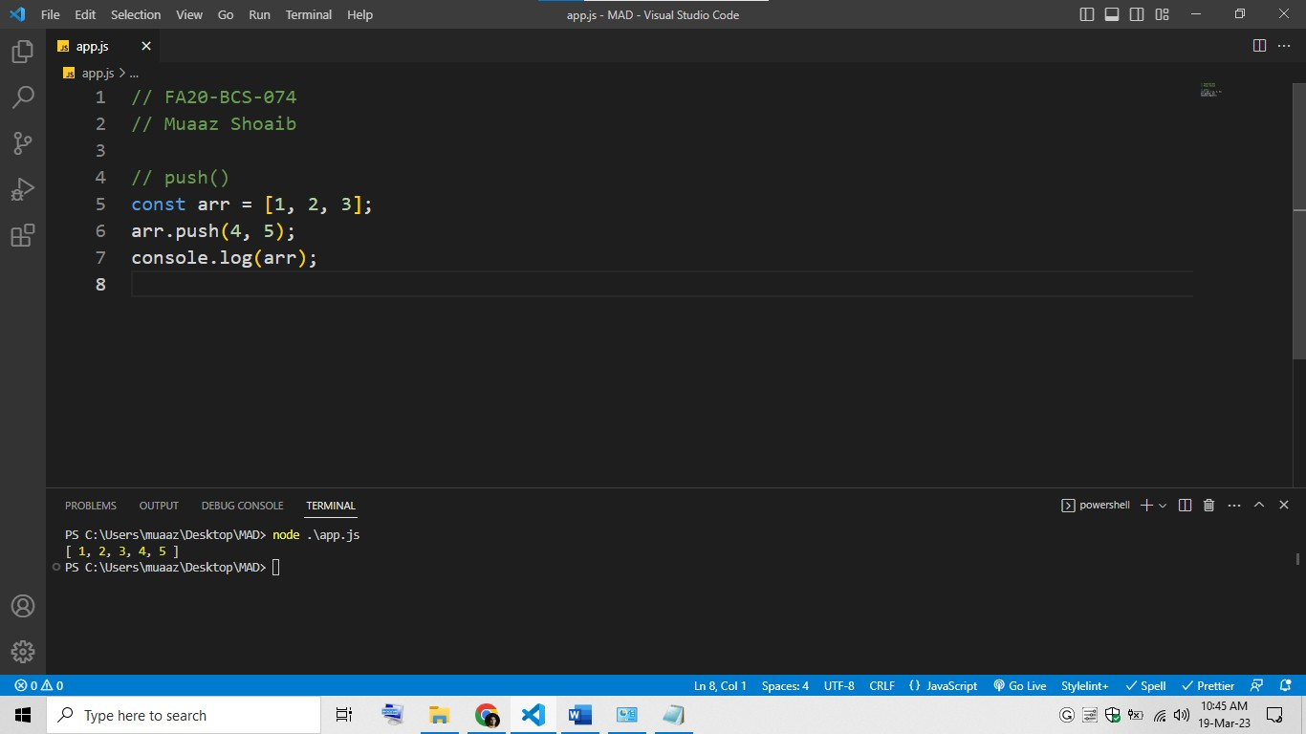

const arr = [1, 2, 3];

arr.push(4, 5); console.log(arr);

1. pop

This method removes the last element from an array and returns that element.

const arr = [1, 2, 3];

const lastElement = arr.pop(); console.log(lastElement); console.log(arr);

shift

This method removes the first element from an array and returns that element.

const arr = [1, 2, 3];

const firstElement = arr.shift(); console.log(firstElement); console.log(arr);

unshift

This method adds one or more elements to the beginning of an array and returns the new length of the array.

// FA20-BCS-074

// Muaaz Shoaib

// unshift()

const arr = [1, 2, 3];

arr.unshift(0, -1); console.log(arr);

slice

This method returns a shallow copy of a portion of an array into a new array.

// FA20-BCS-074

// Muaaz Shoaib

// slice()

const arr = [1, 2, 3, 4, 5];

const slicedArr = arr.slice(1, 4); console.log(slicedArr);

splice

This method changes the contents of an array by removing or replacing existing elements and/or adding new elements.

// FA20-BCS-074

// Muaaz Shoaib

// splice()

const arr = [1, 2, 3, 4, 5]; arr.splice(2, 1, "a", "b"); console.log(arr);

reverse

This method reverses the order of the elements in an array.

// reverse()

const arr = [1, 2, 3, 4, 5]; arr.reverse(); console.log(arr);

join

This method joins all elements of an array into a string.

// join()

const arr = ["a", "b", "c"]; const str = arr.join("-"); console.log(str);

**Q2: String functions in JavaScript with example.**

length

This property returns the length of a string.

// length()

const str = "Hello, world!"; const length = str.length;

console.log(length);

charAt

This method returns the character at a specified index in a string.

// charAt()

const str = "Hello, world!"; const char = str.charAt(1); console.log(char);

concat

This method concatenates two or more strings and returns the new string.

// concat()

const str1 = "Hello, "; const str2 = "world!";

const newStr = str1.concat(str2);

console.log(newStr);

slice

This method returns a portion of a string into a new string.

// slice()

const str = "Hello, world!"; const newStr = str.slice(7, 12); console.log(newStr);

toLowerCase

This method returns a new string with all characters in lowercase.

// toLowerCase()

const str = "HELLO, WORLD!"; const newStr = str.toLowerCase(); console.log(newStr);

toUpperCase

This method returns a new string with all characters in uppercase.

// FA20-BCS-074

// Muaaz Shoaib

// toUpperCase()

const str = "Hello, world!"; const newStr = str.toUpperCase(); console.log(newStr);

trim

This method removes whitespace from both ends of a string.

// FA20-BCS-074

// Muaaz Shoaib

// trim()

const str = "

Hello, world!

";

const newStr = str.trim();

console.log(newStr);

indexOf

This method returns the index of the first occurrence of a specified value in a string, or -1 if it is not foun

// FA20-BCS-074

// Muaaz Shoaib

// indexOf()

const str = "Hello, world!";

const index = str.indexOf("world"); console.log(index);