**UX/ UI Designing**

**Brief Overview:**

I have an idea to make a project on web using this framework. This project is about the online store of products. Where Customers meet Shopkeepers or buy products. Shop keeper can easily buy products by viewing all the products of shopkeeper. This is just a basic idea. Lot of work have to do on this project.

**Some User Interfacs:**

Some of the ui’s for this project are:

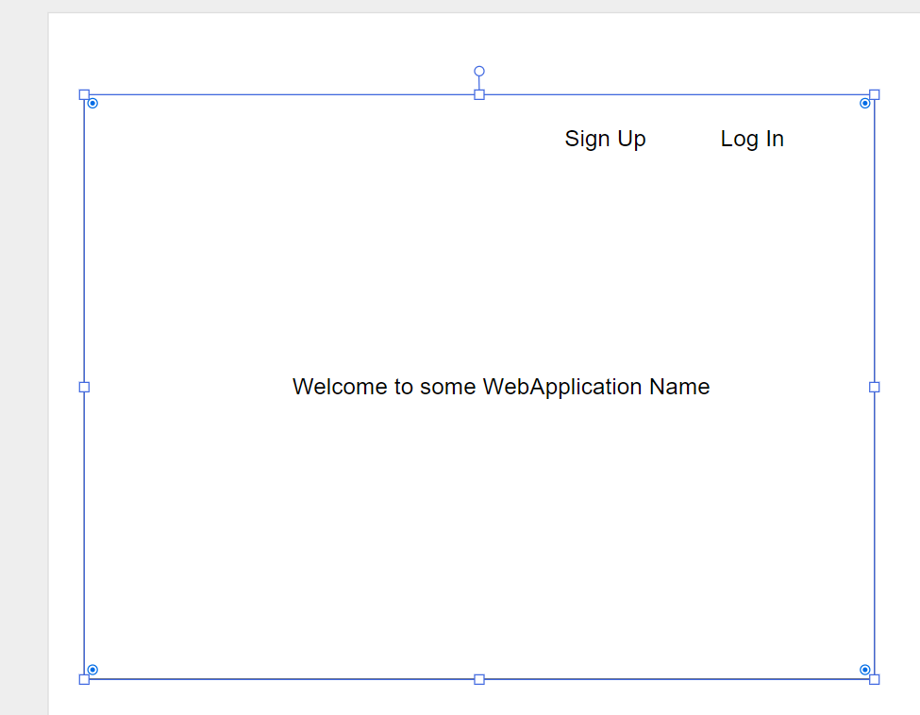

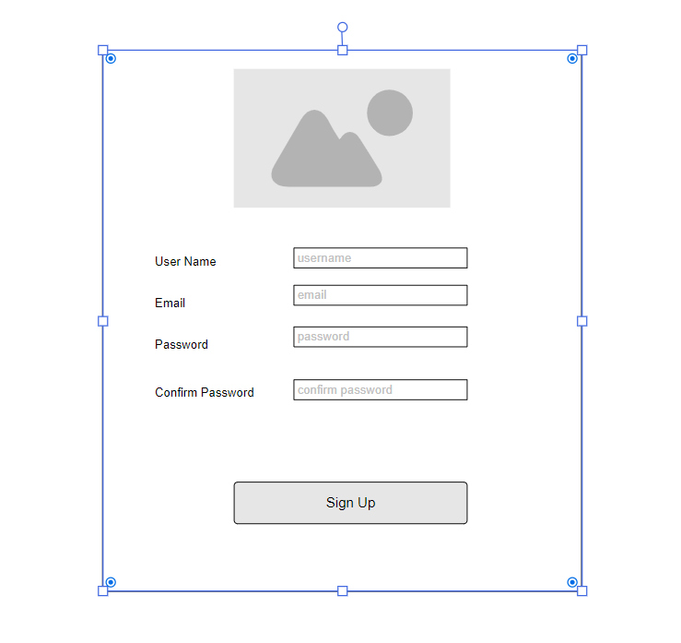

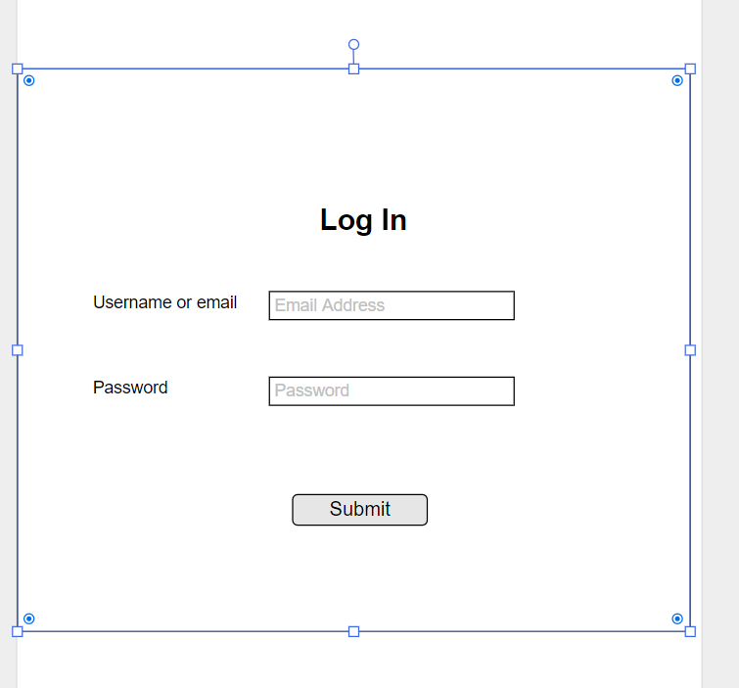

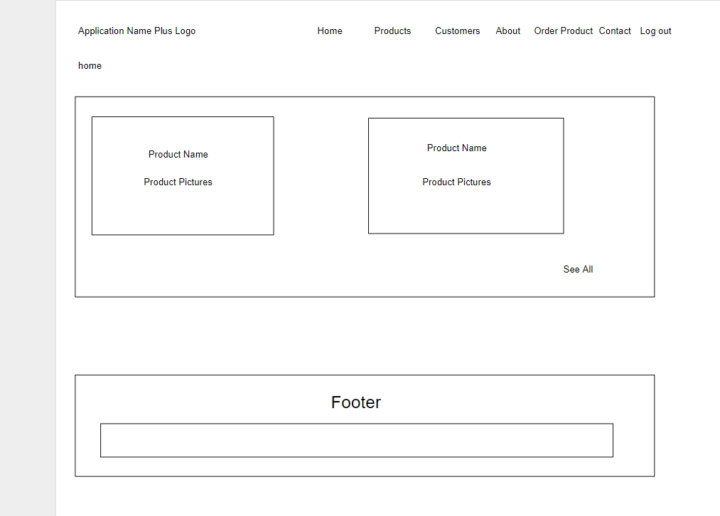

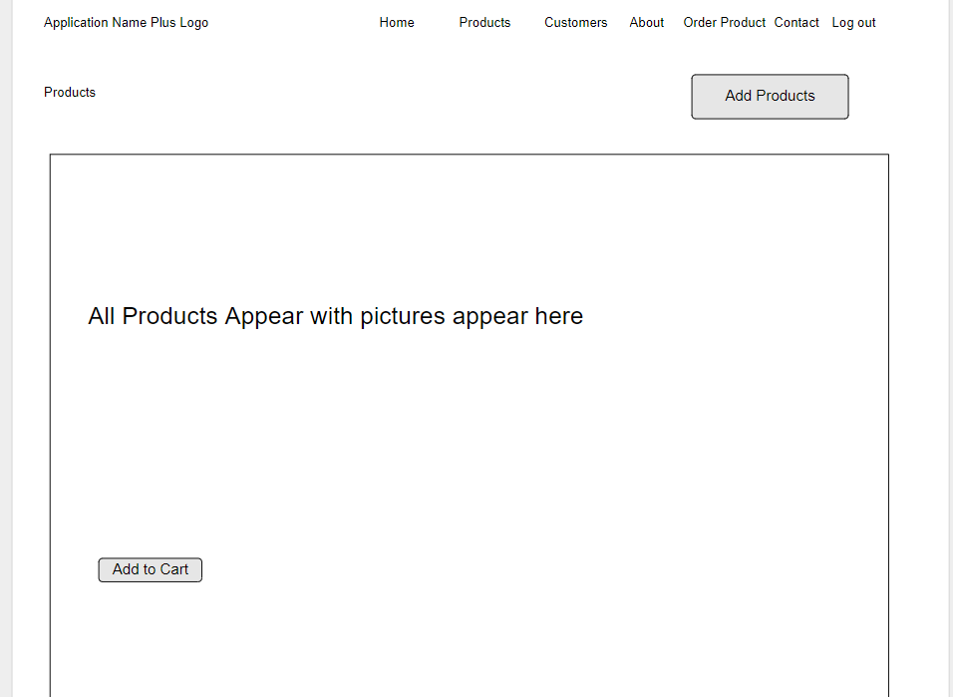

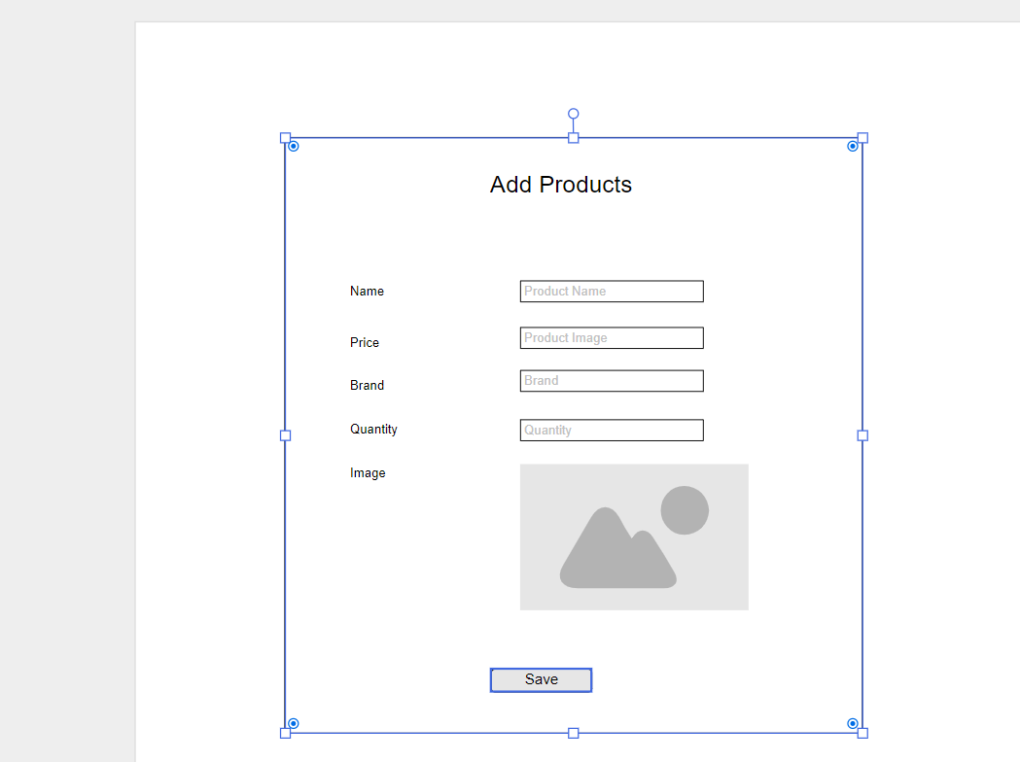

**Basic Structure:**

This app start with login Screen. User is added by simple sign up.A home screen appear with highlight of products. Navigation Links of customers, products, home and many other. A shopkeeper add any product.A shop keeper add it’s customers.

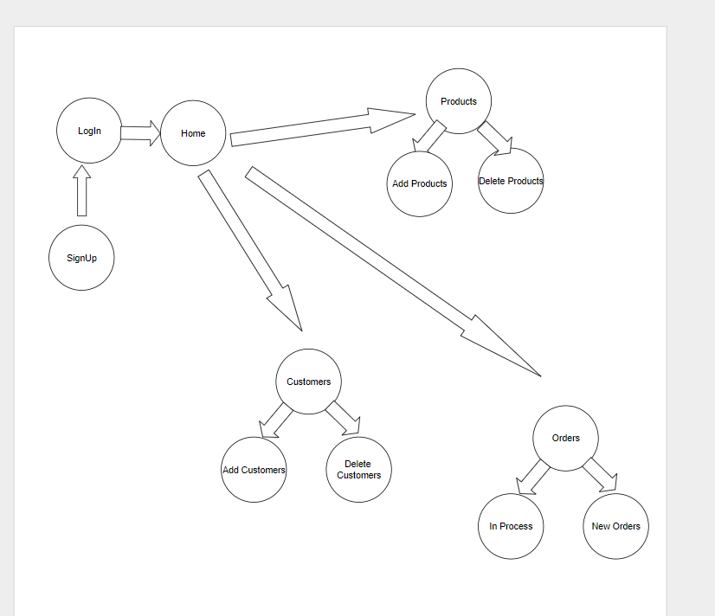

**Sources Provide:**

At that time sources is N/A. But it can be available after dome sort of time.