**­­**

**­­­­­­­**

**ASSIGNMENT # 01**

|  |  |
| --- | --- |
| **SUBMITTED BY** | **­­­M. Ubaidullah**  **Umaima Ghazal**  **Syed Zain Raza Kazmi** |
| **SUBMITTED TO** | **Dr Adnan Iqbal** |
| **REGISTRATION NO.** | **B23F0001AI057**  **B23F0001AI071**  **B23F0045AI085** |

**­**

# **TASK # 04:**

**For HTTP based Website**

1. **What is the name of website?**

The website which we find that is working on http is [**http://speedtest.tele2.net/**](http://speedtest.tele2.net/)

1. **Find the packet that contains the first GET request for the website you have accessed**

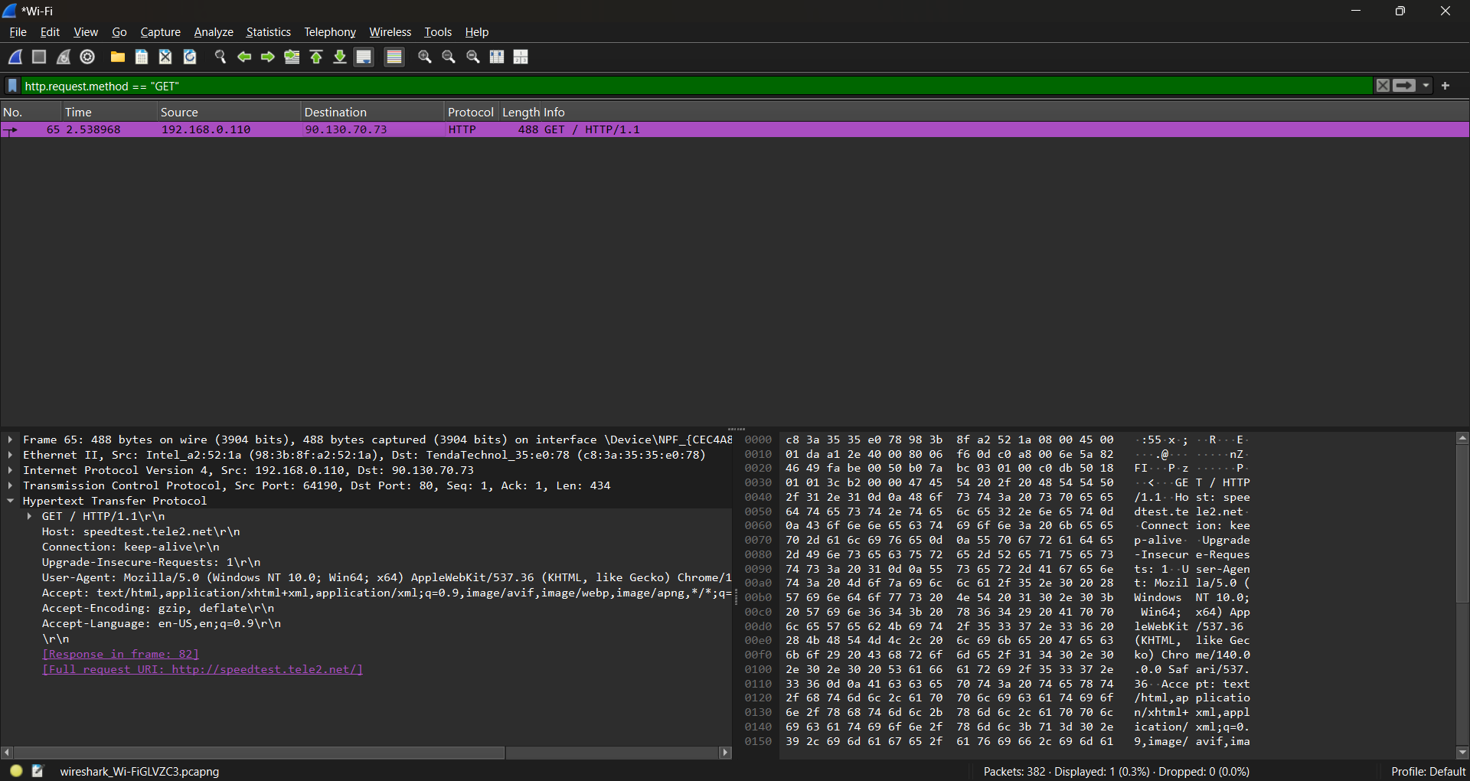

1. **Describe all headers and their values in this GET request message.**

* **Host: speedtest.tele2.net\r\n**

**Header:** host

**Value:** speedtest.tele2.net\r\n

**Description:** It shows the domain name of the server being contacted.

* **Connection: keep-alive\r\n**

**Header:** Connection

**Value:** keep-alive

**Description:** It tells the server to keep this TCP connection open after this request / response So, we can send more requests without reopening a new connection.

* **Upgrade-Insecure-Requests: 1\r\n**

**Header:** Upgrade-Insecure-Requests

**Value:** 1(yes)

**Description:** It tells that I’m currently making an HTTP request but I prefer a secure (HTTPS) version if you support it.

* **User-Agent: Mozilla/5.0 (Windows NT 10.0; Win64; x64) AppleWebKit/537.36 (KHTML, like Gecko) Chrome/140.0.0.0 Safari/537.36\r\n**

**Header:** User-Agent

**Value:** Mozilla/5.0 (Windows NT 10.0; Win64; x64) AppleWebKit/537.36 (KHTML, like Gecko) Chrome/140.0.0.0 Safari/537.36\r\n

**Description:** The User-Agent header is our browser’s ID card in an HTTP request telling the server that *I’m* Chrome140running on Windows 10 (64-bit), using the WebKit engine*.*

* **Accept: text/html,application/xhtml+xml,application/xml;q=0.9,image/avif,image/webp,image/apng,*/*;q=0.8,application/signed-exchange;v=b3;q=0.7\r\n**

**Header:** Accept

**Value:**text/html,application/xhtml+xml,application/xml;q=0.9,image/avif,image/webp,image/apng,*/*;q=0.8,application/signed-exchange;v=b3;q=0.7\r\n

**Description:** This tell the server that I can handle the response in those format send the response in one of these formats.

* **Accept-Encoding: gzip, deflate\r\n**

**Header:** Accept-encoding

**Value:** gzip, deflate

**Description:** It tells the server which content-encoding (compression) methods the client can handle.

* **Accept-Language: en-US,en;q=0.9\r\n**

**Header:** Accept-language

**Value:** en-US,en;q=0.9

**Description:** It shows we want English language in response as ES-US top preference and secondary preference any variant of English with the quality of 0.9.

1. **Identify the status code in the first server response.**

We find the status code by this filter: **http.response.code == 200** This shows the https response if it was okay if the request was rejected then the response would be 404.

**Status Code**: 200

[Status Code Description: OK]

Response Phrase: OK

1. **How many HTTP response messages are exchanged in total?**

There is only 1 response in this packets which I have captured.

1. **Determine whether the connection is persistent or not. Justify with evidence from packet captures.**

The connection is persistent because of 2 reasons

* All packets use the same source/destination IPs and ports and the server replied with 200 OK and continues sending data over the same TCP connection, with no immediate connection-closing packets.

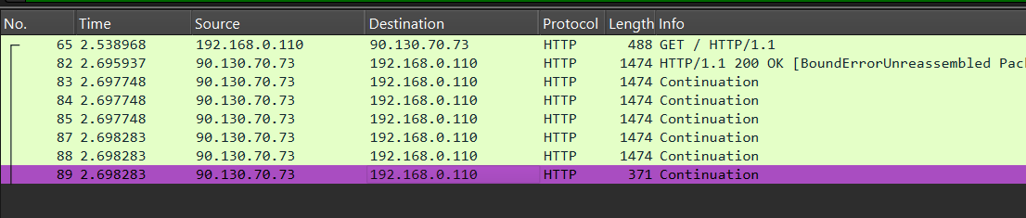

* The HTTP Connection header If it says **keep-alive.**

