**­­**

**­­­­­­­**

**ASSIGNMENT # 01**

|  |  |
| --- | --- |
| **SUBMITTED BY** | **­­­M. Ubaidullah**  **Umaima Ghazal**  **Syed Zain Raza Kazmi** |
| **SUBMITTED TO** | **Dr Adnan Iqbal** |
| **REGISTRATION NO.** | **B23F0001AI057**  **B23F0001AI071**  **B23F0045AI085** |

**­**

# **TASK # 05:**

**For HTTPS based Website**

1. **What is the name of website?**

The website which we find that is working on https is <https://colab.research.google.com/>

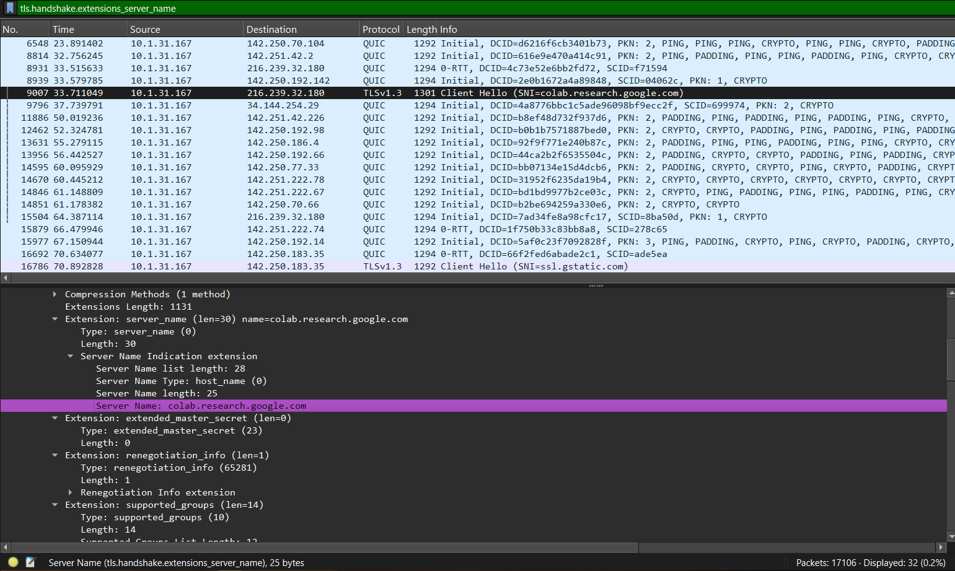

1. **Find the packet that contains the ClientHello message for the website you are accessing**

We have find the clienthello message through this filter **ssl.handshake.type == 1.**

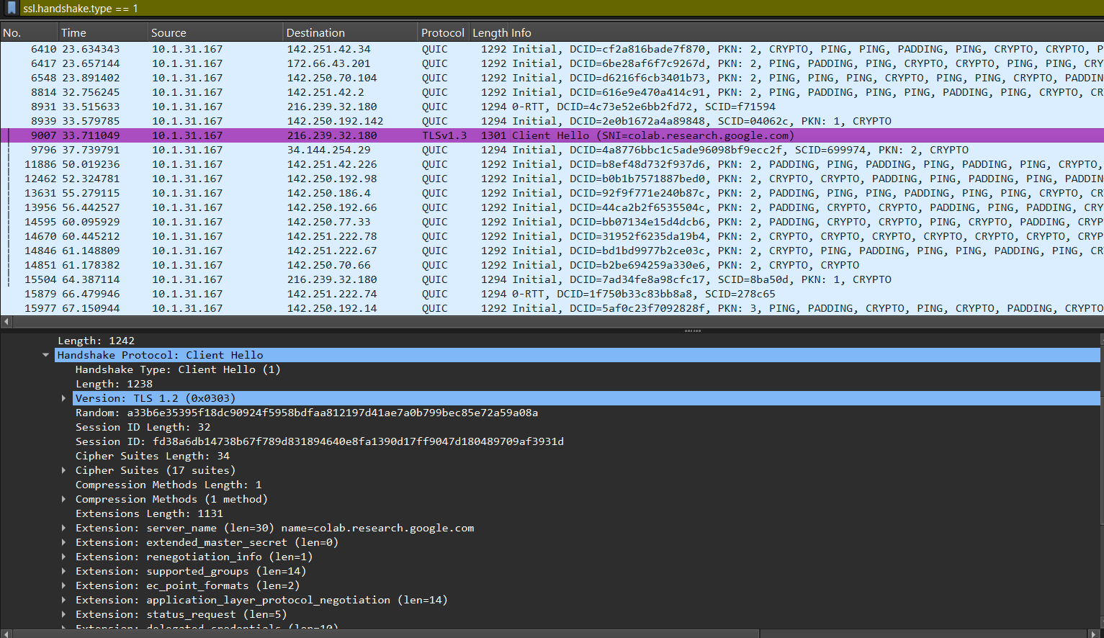

1. **List all the TLS extensions included in the ClientHello.**

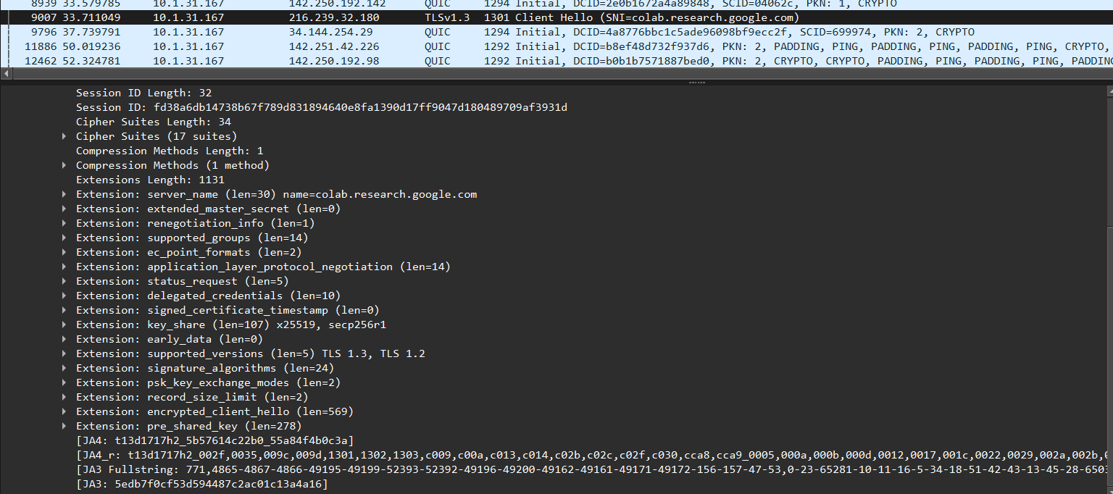

1. **Identify the ServerHello message. What cipher suite is chosen by the server?**

We can identify the ServerHello message by this filter **ssl.handshake.type == 2**

And the Cipher chosen by the Server is

**Cipher Suite:**TLS_AES_128_GCM_SHA256 (0x1301)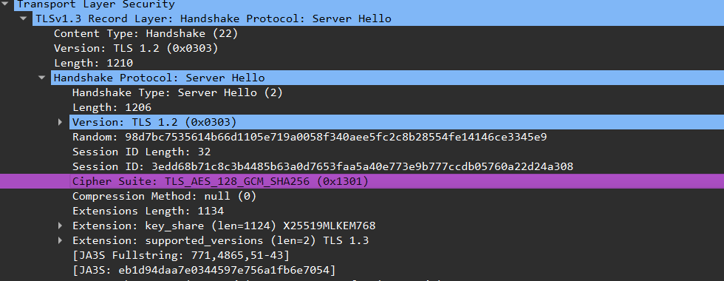

1. **Locate the Certificate message. Extract the server’s certificate information (issuer, subject, validity dates).**

**Issuer:**

**Subject:**

**Validity:**

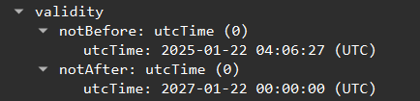

1. **After the TLS handshake, identify the first encrypted application data packet. Why can’t you directly see the HTTP headers in this packet?**

This is the first encrypted application data packet we filter it by **tls.record.content_type == 23**  and the first packet which appeared is encrypted is this one

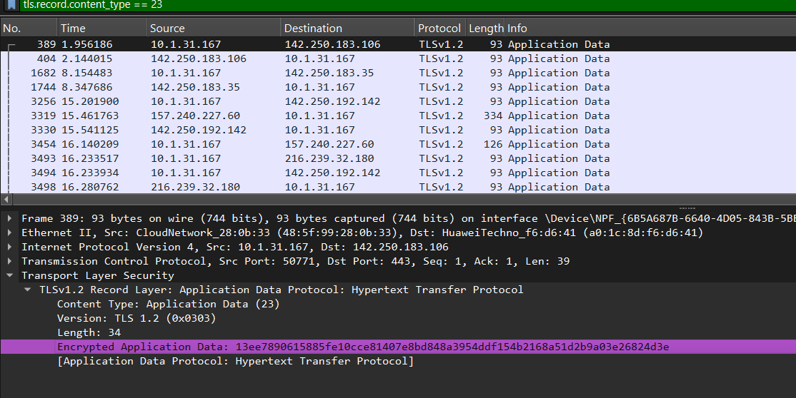

You can’t directly see the HTTP headers in the packet because TLS encrypts all application-layer data, including headers and content, before sending it over the network. As a result, Wireshark only sees “Encrypted Application Data,” and the actual HTTP headers remain hidden unless you provide the session’s encryption keys to decrypt the traffic.

* Internet Society. (n.d.). *TLS basics*. Internet Society. Retrieved September 20, 2025, from [https://www.internetsociety.org/deploy360/tls/basics/](https://www.internetsociety.org/deploy360/tls/basics/?utm_source=chatgpt.com)