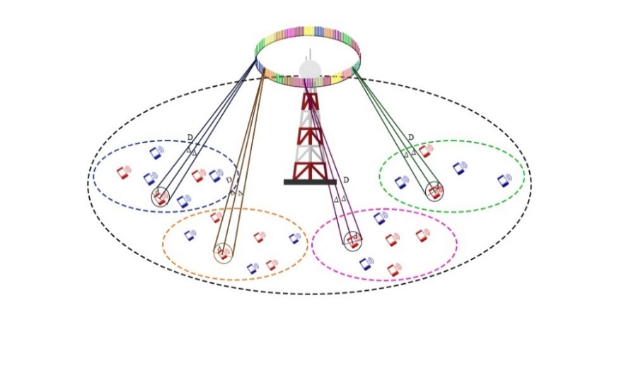
Figure 1: Ring Channel Model with sub-circles in Massive MIMO (with sporadic behavior of the users)
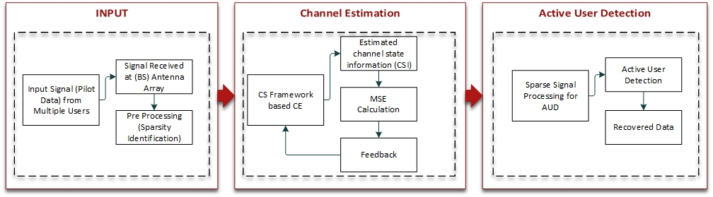
Figure 2: System flow diagram for Active User Detection
Figure 3: Minimum Square Error of Channel Estimation for 16 groups of 8 antennas

Figure 4: Active User Detection for 16 Antenna Groups of 8 Antennas each @ SNR=30dB
Figure 5: Histogram of User Identification for 16 Antenna Groups of 8 Antennas each @ SNR=30dB
Figure 6: False Positives and False Negatives of User Identification
Figure 7: Active User Detection for 16 Antenna Groups of 16 Antennas each @ SNR=30dB
Figure 8: Active User Detection for 32 Antenna Groups of 16 Antennas each @ SNR=30dB
Figure 9: Active User Detection for 16 Antenna Groups of 32 Antennas each @ SNR=30dB
Figure 10: Active User Detection for 16 Antenna Groups of 8 Antennas each @ SNR=22dB
Figure 11: AUD for 16 Antenna Groups of 32 Antennas each @ SNR=30dB & Active Users = 24
Figure 12: AUD for 16 Antenna Groups of 32 Antennas each @ SNR=30dB & Active Users = 32

