**THE CODE SCHOOL**

**Project Synopsis**

**In-house Project** (BCA660)

Degree

**BACHELOR OF COMPUTER APPLICATION**

|  |  |
| --- | --- |
| PROJECT GUIDE:  **Project Guide Name** | SUBMITTED BY:  **Mohd Ubaish (TCA2001096)**  **Naman Jain (Student ID)**  **Paras Jain (Student ID)** |

April, 2023



**FACULTY OF ENGINEERING & COMPUTING SCIENCES**

**TEERTHANKER MAHAVEER UNIVERSITY, MORADABAD**

Table of Contents

1 Project Title 3

2 Domain 3

3 Problem Statement 3

4 Project Description 3

4.1 Scope of the Work 3

4.2 Project Modules 3

5 Implementation Methodology 3

6 Technologies to be used 4

6.1 Software Platform 4

6.2 Hardware Platform 4

6.3 Tools 4

7 Advantages of this Project 4

8 Future Scope and further enhancement of the Project 4

9 Team Details 4

10 Conclusion 5

11 References 5

# Project Title

**The Code School** – A Subscription based learning platform (Computer science specific)

# Domain

* *Web Application*

# Problem Statement

*The field of computer science education is facing a number of challenges and limitations that are preventing students from accessing high-quality, comprehensive learning opportunities. Traditional classroom-based courses may not be able to accommodate the schedules of working students or those with other commitments. Additionally, many students may not have access to quality courses due to financial constraints or geographic limitations. Even when students are able to access courses, they may struggle to find the right resources and support to supplement their learning and acquire practical skills. Furthermore, the rapid pace of change in the field of computer science means that traditional courses may not be able to keep up with the latest trends and technologies, leaving students ill-prepared for the demands of the workforce.*

*To address these challenges, this ed tech website seeks to provide a flexible and comprehensive platform for computer science education, offering up-to-date courses, resources, and support to students on a subscription basis. By providing a solution to these challenges, this project aims to offer a valuable resource to students seeking to acquire the skills and knowledge necessary to thrive in the field of computer science.*

# Project Description

*The Code School website is a comprehensive platform that provides computer science courses to students seeking to acquire practical skills and knowledge in this field. With a focus on accessibility, flexibility, and quality, the platform offers a range of courses that are designed to meet the needs of learners at all levels, from beginner to advanced.*

*One of the key features of this website is its subscription-based model, which enables students to access courses on a flexible basis that fits with their schedule and budget. This makes it an ideal solution for students who may be working or have other commitments, as they can access high-quality courses from anywhere, at any time.*

## Scope of the Work

* *Users can explore the courses without logging in to the platform.*
* *To access the lectures, a user must have an active subscription.*
* *Users are not allowed to download any lectures.*
* *Users can update their profile at any time.*
* *Users can cancel their subscription at any time.*
* *If a user cancels their subscription within 7 days of signing up, they will receive a refund.*
* *Users can request new courses to be added to the platform.*
* *The admin can view statistics and analytics charts.*
* *The admin can monitor and visualize the growth of the website by checking analytics.*
* *The admin has the ability to grant admin privileges to any user.*
* *Only the admin is allowed to upload lectures or create courses.*

## Project Modules

1. **Client**

* *Home*
* *Admin*
* *Authentication*
* *Contact*
* *Course Page*
* *Courses*
* *Layout*
* *Payments*
* *Profile*
* *Request*

1. **Server**

* *Config*
* *Middleware’s*
* *Models*
* *Routes*
* *Utils*
* *App.js*
* *Server.js*

# Implementation Methodology

1. **Frontend Development:** This is the first and most important part of the implementation, as it establishes the basic functionality of the website. We will develop the entire frontend of the application, including the user interface, design, and layout. This includes creating individual pages for each course, creating a login and registration system, and implementing a payment gateway for the subscription-based model. We will use modern web technologies such as HTML5, CSS3, and JavaScript to create a responsive and user-friendly interface.
2. **Backend Development**: In the second step, we will develop the backend of the website, including the database, server-side scripting, and APIs. This includes developing the functionality to authenticate users, manage subscriptions, and store user data, course data, and payment data. We will use a scalable and secure backend framework (Node.js) to ensure that the website can handle a large number of users and transactions.
3. **Integration**: As the third step, we will integrate the frontend, backend, and content together to create a fully functional system. This includes ensuring that the login and registration system, payment gateway, and course content delivery all work together seamlessly. We will use RESTful APIs to connect the frontend and backend, and ensure that data is transferred securely and efficiently.
4. **Testing**: In the final step, we will perform unit and integration testing for the entire system for bugs and glitches. This includes testing the login and registration system, payment gateway, and course content delivery, reliable, and meets the needs of its users. Once testing is complete, the platform will be ready for launch.
5. By dividing the implementation into these four parts and using modern web technologies and development methodologies, we can ensure that the final product is scalable, secure, and meets the needs of its users.

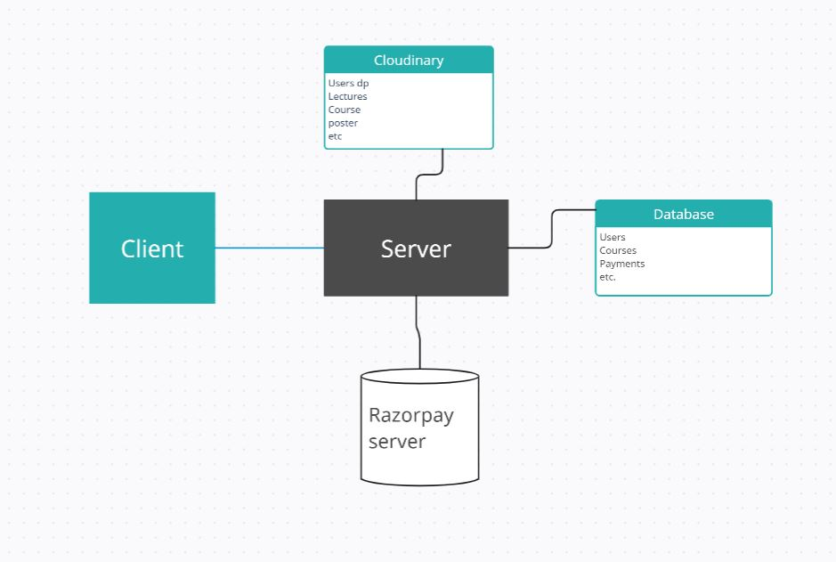

# Technologies to be used

## Software Platform

1. **Front-end**
   * *Chakra Ui*
   * *React*
   * *Redux*
   * *Cookies*
   * *JavaScript*
2. **Back-end**

* *NodeJS*
* *ExpressJs*
* *Mongo DB*
* *Razor Pay*
* *Node Mailer*
* *Json Web Token*
* *Cloudinary*

## Tools

1. *Visual studio code*
2. *Postman*
3. *Git*
4. *GitHub*
5. *Redux dev tools*

# Advantages of this Project

1. *Convenient access to high-quality computer science courses from anywhere, at any time.*
2. *A flexible subscription-based model that allows students to learn at their own pace and on their own schedule.*
3. *Easy and hassle-free cancellation of subscriptions.*
4. *Refunds available for cancellations made within 7 days of signing up.*
5. *Students can request new courses to be added to the platform, ensuring that the platform stays relevant and up-to-date.*
6. *Admin can easily monitor website growth and user engagement through analytics.*
7. *Users have the ability to update their profiles and access their course history.*
8. *Admin has complete control over user permissions and content creation.*
9. *Overall, the project aims to provide an accessible and high-quality education solution for students seeking to acquire practical skills and knowledge in the field of computer science.*

# Future Scope and further enhancement of the Project

1. **Interactive Elements**: Add interactive elements such as quizzes, coding challenges, and projects to reinforce concepts learned in the lectures.
2. **Collaborative Learning**: Add collaborative learning features, such as forums or chatrooms, where students can connect with each other and work on group projects.
3. **Artificial Intelligence:** Incorporate artificial intelligence (AI) into the platform to personalize the learning experience for each student and provide them with personalized feedback and suggestions.
4. **Mobile App**: Develop a mobile app version of the website to provide students with a seamless learning experience on their smartphones or tablets.
5. **Multi-language Support:** Add support for multiple languages to attract a wider range of learners from different parts of the world.

# Team Details

| **Project Name & ID** | **Course Name** | **Student ID** | **Student Name** | **Role** | **Signature** |
| --- | --- | --- | --- | --- | --- |
| ***THE CODE SCHOOL*** | ***Bachelor of Computer Applications*** | *TCA2001096* | *Mohd Ubaish* | *Backend Developer* | *Ubaish* |
|  | *Naman Jain* | *Frontend developer* |  |
|  | *Paras Jain* | *Developer/tester* |  |

# 

# Conclusion

*In conclusion, The Code School aims to provide an accessible and flexible learning platform for students seeking to acquire practical skills and knowledge in the field of computer science. By offering a wide range of courses, a flexible subscription-based model, and engaging course content, the platform can cater to learners of all levels and interests. The easy cancellation and refund policy, along with the ability to request new courses, ensures that the platform is user-friendly and continually improving to meet the needs of its users. With the potential future enhancements, such as gamification, AI, and certification programs, the platform can continue to evolve and provide an even more engaging and valuable learning experience for its users.*

# References

* [*https://chakra-ui.com*](https://chakra-ui.com)
* *https://legacy.reactjs.org/docs*
* [*https://nodejs.org/en/docs*](https://nodejs.org/en/docs)
* [*https://expressjs.com*](https://expressjs.com)
* [*https://razorpay.com/docs*](https://razorpay.com/docs)
* [*https://www.mongodb.com/docs*](https://www.mongodb.com/docs/)
* [*https://stackoverflow.com*](https://stackoverflow.com)
* *https://cloudinary.com/documentation*